SECURITIES AND EXCHANGE COMMISSION Washington, D.C. 20549

SCHEDULE 13D

Under the Securities Exchange Act of 1934

(Amendment No. 5)*

Repay Holdings Corp

(Name of Issuer)

Class A Common Stock, par value $0.0001 per share

(Title of Class of Securities)

(CUSIP Number)

Robert MacArthur

c/o Forager Fund, L.P., 2025 3rd Avenue North, Suite 350
Birmingham, AL, 35203
205-383-4763

(Name, Address and Telephone Number of Person Authorized to Receive Notices and Communications)

05/27/2026

(Date of Event Which Requires Filing of This Statement)

If the filing person has previously filed a statement on Schedule 13G to report the acquisition that is the subject of this Schedule 13D, and is filing this schedule because of §§ 240.13d-1(e), 240.13d-1(f) or 240.13d-1(g), check the following box.

The information required on the remainder of this cover page shall not be deemed to be “filed” for the purpose of Section 18 of the Securities Exchange Act of 1934 (“Act”) or otherwise subject to the liabilities of that section of the Act but shall be subject to all other provisions of the Act (however, see the Notes).

SCHEDULE 13D

CUSIP No.

Name of reporting person

1
Forager Fund, L.P.

Check the appropriate box if a member of a Group (See Instructions)

- (a)
(b)

- SEC use only

Source of funds (See Instructions)

4
WC

5

6

Number of

Shares
Beneficially
Owned by
Each
Reporting
Person
With:

11

12

13

14

Check if disclosure of legal proceedings is required pursuant to Items 2(d) or 2(e)

Citizenship or place of organization

DELAWARE

Sole Voting Power

7
11,106,548.00

Shared Voting Power

8
0.00

Sole Dispositive Power

9
11,106,548.00

Shared Dispositive Power

10
0.00

Aggregate amount beneficially owned by each reporting person

11,106,548.00

Check if the aggregate amount in Row (11) excludes certain shares (See Instructions)

Percent of class represented by amount in Row (11)

12.4 %

Type of Reporting Person (See Instructions)

PN

SCHEDULE 13D

CUSIP No.

Name of reporting person

1
Forager Capital Management, LLC

Check the appropriate box if a member of a Group (See Instructions)

2

3

4

5

6

Number of

Shares
Beneficially
Owned by
Each
Reporting
Person
With:

(a)

(b)

SEC use only

Source of funds (See Instructions)

WC

Check if disclosure of legal proceedings is required pursuant to Items 2(d) or 2(e)

Citizenship or place of organization

DELAWARE

Sole Voting Power

7
11,106,648.00

Shared Voting Power

8
0.00

Sole Dispositive Power

9
11,106,648.00

Shared Dispositive Power

10

0.00

- Aggregate amount beneficially owned by each reporting person 11,106,648.00
Check if the aggregate amount in Row (11) excludes certain shares (See Instructions)

12

Percent of class represented by amount in Row (11)

13
12.4 %

Type of Reporting Person (See Instructions)

14
IA

SCHEDULE 13D

CUSIP No.

Name of reporting person

1
Edward Kissel

Check the appropriate box if a member of a Group (See Instructions)

2

3

4

5

6

Number of

Shares
Beneficially
Owned by
Each
Reporting
Person
With:

11

12

13

14

(a)

(b)

SEC use only

Source of funds (See Instructions)

AF

Check if disclosure of legal proceedings is required pursuant to Items 2(d) or 2(e)

Citizenship or place of organization

UNITED STATES

Sole Voting Power

7
0.00

Shared Voting Power

8
11,106,648.00

Sole Dispositive Power

9
0.00

Shared Dispositive Power

10
11,106,648.00

Aggregate amount beneficially owned by each reporting person

11,106,648.00

Check if the aggregate amount in Row (11) excludes certain shares (See Instructions)

Percent of class represented by amount in Row (11)

12.4 %

Type of Reporting Person (See Instructions)

IN, HC

SCHEDULE 13D

CUSIP No.

Name of reporting person

1
Robert MacArthur

Check the appropriate box if a member of a Group (See Instructions)

- (a)
(b)

3

4

5

6

Number of

Shares
Beneficially
Owned by
Each
Reporting
Person
With:

11

12

13

14

SEC use only

Source of funds (See Instructions)

AF

Check if disclosure of legal proceedings is required pursuant to Items 2(d) or 2(e)

Citizenship or place of organization

UNITED STATES

Sole Voting Power

7
0.00

Shared Voting Power

8
11,106,648.00

Sole Dispositive Power

9
0.00

Shared Dispositive Power

10
11,106,648.00

Aggregate amount beneficially owned by each reporting person

11,106,648.00

Check if the aggregate amount in Row (11) excludes certain shares (See Instructions)

Percent of class represented by amount in Row (11)

12.4 %

Type of Reporting Person (See Instructions)

IN, HC

SCHEDULE 13D

Item 1. Security and Issuer

Title of Class of Securities:

(a)
Class A Common Stock, par value $0.0001 per share

Name of Issuer:

(b)
Repay Holdings Corp

Address of Issuer's Principal Executive Offices:

(c)
3060 PEACHTREE ROAD NW, SUITE 1100, ATLANTA, GEORGIA , 30305.

Item 1 The aggregate percentage of shares owned by each person named herein is based on 89,672,978 shares of Common Stock Comment: outstanding as of April 29, 2026, as reported in the Issuer's Quarterly Report on Form 10Q for the fiscal quarter ended March 31,

2026, filed with the Securities and Exchange Commission on May 4, 2026.

Item 2. Identity and Background

Item 3. Source and Amount of Funds or Other Consideration

Item 4. Purpose of Transaction

On May 27, 2026, the Reporting Person issued a public letter to stockholders of the Issuer regarding the Issuer Board of Directors' response to the Reporting Person's non-binding proposal to acquire all outstanding shares of the Issuer for $4.80 per

share in cash. The Reporting Person continues to believe that a transaction involving the Issuer may be in the best interests of stockholders and remains willing to engage in discussions regarding a potential transaction. A copy of the letter is filed as Exhibit 99.4 hereto and incorporated herein by reference. There can be no assurance that any discussions that may occur between the Reporting Persons and the Issuer with respect to the proposal will result in the entry into a definitive agreement concerning a transaction or, if such a definitive agreement is reached, will result in the consummation of a transaction provided for in such definitive agreement. Discussions concerning a transaction may be terminated at any time and without prior notice. Entry into a definitive agreement concerning a transaction and the consummation of any such transaction will be subject to a number of contingencies that are beyond the control of the Reporting Persons, including the approval of the Board of Directors of the Issuer, and the satisfaction of any conditions to the consummation of a transaction set forth in any such definitive agreement.

Item 5. Interest in Securities of the Issuer

Item 6. Contracts, Arrangements, Understandings or Relationships With Respect to Securities of the Issuer

Item 7. Material to be Filed as Exhibits.

Item 7 of the Schedule 13D is hereby amended and supplemented to incorporate the following: The following document is filed

as an exhibit: Exhibit 99.4 - Letter to Stockholders, dated May 27, 2026

SIGNATURE

After reasonable inquiry and to the best of my knowledge and belief, I certify that the information set forth in this statement is true, complete and correct.

Forager Fund, L.P.

Signature: /s/ Robert MacArthur

Name/Title: Managing Partner

Date: 05/27/2026

Forager Capital Management, LLC

Signature: /s/ Robert MacArthur

Name/Title: Managing Partner

Date: 05/27/2026

Edward Kissel

Signature: /s/ Edward Kissel

Name/Title: Edward Kissel

Date: 05/27/2026

Robert MacArthur

Signature: /s/ Robert MacArthur

Name/Title: Robert MacArthur

Date: 05/27/2026

EXHIBIT 99.4
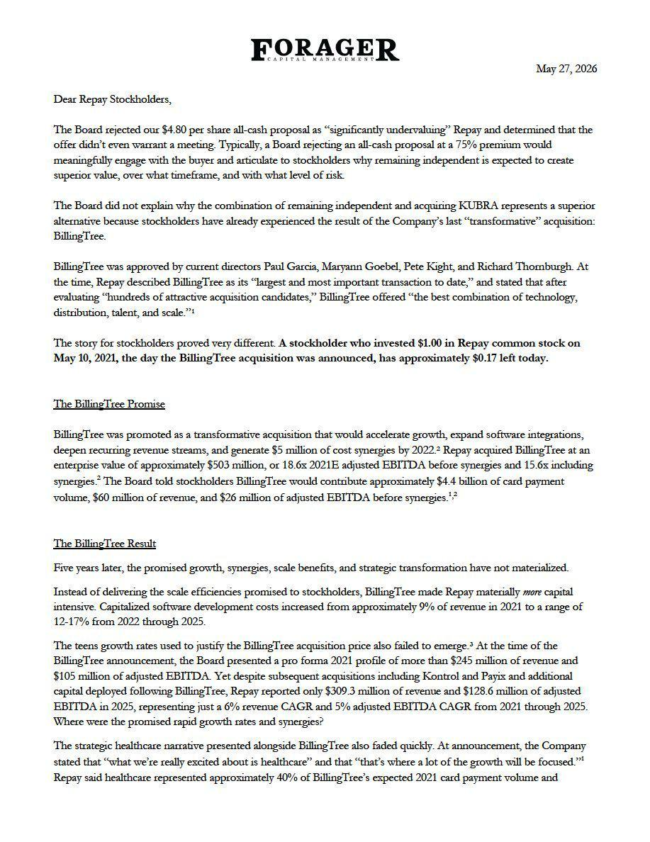

1

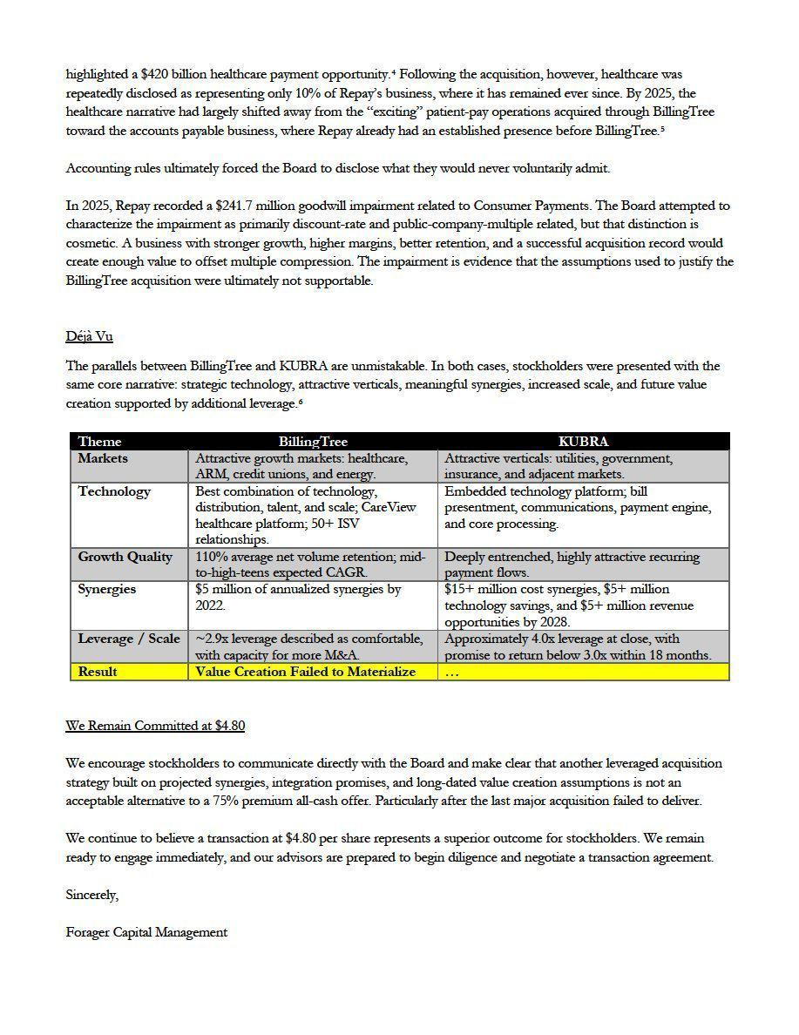

2

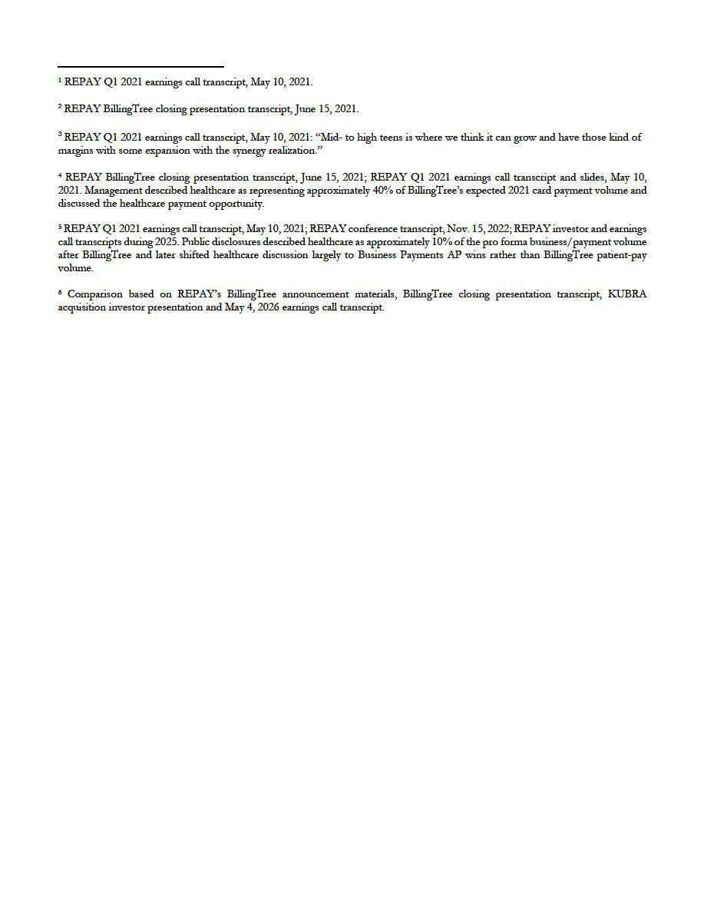

3

