Table of Contents
PRELIMINARY PROXY STATEMENT – SUBJECT TO COMPLETION
DATED MAY 1, 2026

UNITED STATES
SECURITIES AND EXCHANGE COMMISSION
Washington, D.C. 20549
SCHEDULE 14A INFORMATION
Proxy Statement Pursuant to Section 14(a) of the Securities
Exchange Act of 1934

(Amendment No. )
Filed by the Registrant ☒
Filed by a Party other than the Registrant ☐
Check the appropriate box:

☒ | Preliminary Proxy Statement
☐ | Confidential, for Use of the Commission Only (as permitted by Rule 14a-6(e)(2))
☐ | Definitive Proxy Statement
☐ | Definitive Additional Materials
☐ | Soliciting Material Pursuant to § 240.14a-12

REPAY HOLDINGS CORPORATION
(Name of Registrant as Specified in its Charter)
(Name of Person(s) Filing Proxy Statement, if other than the Registrant)
Payment of Filing Fee (Check all boxes that apply):

☒ | No fee required
☐ | Fee paid previously with preliminary materials
☐ | Fee computed on table in exhibit required by Item 25(b) per Exchange Act Rules 14a-6(i)(1) and 0-11

Table of Contents

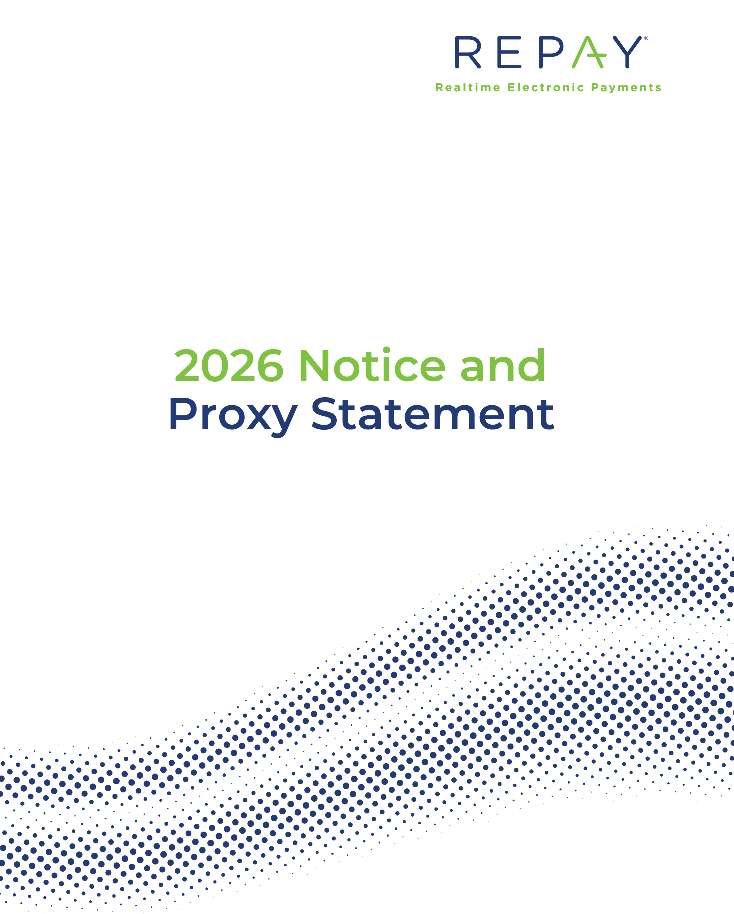

Table of Contents
PRELIMINARY PROXY STATEMENT – SUBJECT TO COMPLETION
DATED MAY 1, 2026

LETTER FROM OUR
CHIEF EXECUTIVE OFFICER
AND CHAIRMAN

[●], 2026

 |  | Dear Stockholder:
  John Morris  Chief Executive  Officer and Director |  | On behalf of the Board of Directors, we cordially invite you to attend the Annual Meeting of Stockholders of Repay Holdings Corporation, which will be held virtually on [●], commencing at [●], Eastern Time. To attend the Annual Meeting, you must register in advance at www.proxydocs.com/RPAY. The meeting can be accessed through the link you receive following registration, where you will be able to listen to the meeting live, submit questions and vote online. The matters to be acted upon at the meeting are described in the attached Notice of Annual Meeting of Stockholders and Proxy Statement.  We would like to take this opportunity to highlight some important updates and achievements for Repay this year:
  Peter Kight  Chairman |  | 2025 Business Highlights & Recent Updates  Repay delivered on our promise to sequentially improve growth. This performance underscores the progress of REPAY’s strategic initiatives and operational improvements for a scaled future. The company returned to solid, normalized growth while continuing to generate strong profitability and Free Cash Flow.  During 2025, REPAY undertook meaningful actions to strengthen our operations, go-to-market, and overall organization leadership. Notably, we implemented significant changes to our executive leadership team, including hiring a new Chief Financial Officer with 24 years of public company finance experience and 12 years of payments experience, appointing a new head of corporate development with 25 years of payments experience, and restructuring the reporting relationship of our RCS division, which resulted in the elimination of the President position. We also recently announced the hiring of a new leader for our Consumer Payments business with over 13 years of payments experience. In parallel, we focused on streamlining processes, worked on ways to deploy automation and AI, and rolled out many new product capabilities.  In 2025, we deployed capital by repurchasing approximately $38 million of our Class A shares, which reduced fully diluted shares outstanding by approximately 8%. In August 2025, we opportunistically reduced debt outstanding by retiring $74 million of our 2026 convertible notes at a discount to principal value. Since year end, we addressed the remaining 2026 convertible notes at maturity using a combination of cash on our balance sheet and our revolving credit facility.  In March 2026, we announced signing a definitive agreement to acquire KUBRA Data Transfer, Ltd. With this acquisition, which supports

Table of Contents

our strategy and is targeted to close later this quarter, we are excited to create a scaled bill payment provider with the breadth, technology, and market position to compete in the next chapter of digital bill payments across North America.
We are committed to creating long-term value for our stockholders by allocating capital towards organic growth and strategic, accretive M&A opportunities for a scaled future.

All of our stockholders of record at the close of business on [●] are entitled to attend and vote at the Annual Meeting. If you were a beneficial holder as of the record date (i.e., you hold your shares in “street name” through an intermediary, such as a bank or broker), you must show proof of ownership to attend the Annual Meeting, and you must obtain a legal proxy, executed in your favor, from the holder of record in order to vote at the Annual Meeting.
In order to attend or vote at the Annual Meeting, you must register in advance at www.proxydocs.com/RPAY prior to the deadline of [●], at 11:59 p.m., Eastern Time. Upon completing your registration, you will receive further instructions that will allow you access to the meeting, to submit questions during the meeting and to vote at the meeting. You will not be able to attend the Annual Meeting in person.
Your vote on the business to be considered at the meeting is important, regardless of the number of shares you own. Whether or not you plan to attend the meeting, please submit your WHITE proxy card or WHITE voting instructions form using one of the voting methods described in the accompanying Proxy Statement so that your shares may be represented at the meeting. Submitting your WHITE proxy card or WHITE voting instructions form by any of these methods will not affect your right to attend the virtual meeting and for stockholders of record to vote your shares at the virtual meeting if you wish to do so.
On behalf of the Board of Directors, we would like to thank you for your continued support and investment in Repay.
Sincerely yours,

John Morris  Chief Executive Officer and Director |  | Peter Kight  Chairman

Table of Contents
PRELIMINARY PROXY STATEMENT – SUBJECT TO COMPLETION
DATED MAY 1, 2026

NOTICE OF ANNUAL MEETING OF STOCKHOLDERS  TO BE HELD ON [●] | 

 |  |  |  | 
Date and Time |  | Virtual Address |  | Record Date
[●]  [●], Eastern Time |  | www.proxydocs.com/RPAY |  | End of Business  [●]

Notice is hereby given that the Annual Meeting of Stockholders of Repay Holdings Corporation, a Delaware corporation, will be held virtually on [●] at [●], Eastern Time. The meeting can be accessed through the link provided following registration where you will be able to listen to the meeting live, submit questions and vote online. If you plan to attend the virtual Annual Meeting, please see the instructions beginning on page 4 of the attached Proxy Statement. You will be required to register in advance at www.proxydocs.com/RPAY prior to the deadline of [●] at 11:59 p.m., Eastern Time in order to attend the meeting. There will be no physical location for stockholders to attend. Stockholders may participate only by logging in via the link provided following pre-registration. We are committed to ensuring that stockholders will be afforded the same rights and opportunities to participate at the Annual Meeting as they would at an in-person meeting. Additionally, we believe that a virtual Annual Meeting provides greater access to those who want to attend, and therefore have chosen this format over an in-person meeting. The virtual meeting format for the Annual Meeting enables full and equal participation by all our stockholders from any place in the world with an internet connection at little to no cost.
At the Annual Meeting, stockholders will be asked to consider and vote upon the following proposals:
1.
To elect six directors for terms expiring at the 2027 Annual Meeting of Stockholders;
2.
To approve, on a non-binding advisory basis, the compensation of our named executive officers (as defined in this Proxy Statement);
3.
To approve and adopt an amendment and restatement of our Omnibus Incentive Plan (the “Third Amended and Restated Plan”);
4.
To ratify the appointment of Grant Thornton LLP as our independent registered public accounting firm for the fiscal year ending December 31, 2026; and
5.
To transact such other business as may properly come before the meeting or any adjournment thereof.
Our Board of Directors recommends that you vote “FOR” each of the nominees for directors (Proposal One), “FOR” the approval of the compensation of our named executive officers (Proposal Two), “FOR” the approval of the Third Amended and Restated Plan (Proposal

Table of Contents

Three) and “FOR” ratification of the proposed independent registered public accounting firm (Proposal Four).
Our Board of Directors has fixed the close of business on [●] as the record date for determining the stockholders entitled to notice of, and to vote at, the Annual Meeting or any adjournments. For a period of 10 days ending on the day before the Annual Meeting, a list of such stockholders will be available for inspection by any stockholder at our principal executive offices during normal business hours.
If you were a beneficial holder as of [●] (i.e., you hold your shares in “street name” through an intermediary, such as a bank or broker), you must obtain a legal proxy, executed in your favor, from the holder of record in order to vote at the Annual Meeting.
We encourage you to access the Annual Meeting before the start time of [●], Eastern Time, on [●]. Please allow ample time for online check-in, which will begin at [●], Eastern Time, on [●].
You may receive solicitation materials, including proxy statements and proxy cards, from Veradace Partners L.P. (“Veradace”), an activist investment fund. On April 25, 2026, Veradace sent a letter to the Company’s Corporate Secretary requesting the Board waive the Nomination Deadline (as defined in this Proxy Statement) and indicating its intent to submit nominations for two individuals to stand for election as directors to the Board at the Annual Meeting. The Company informed Veradace that the Board determined to deny Veradace’s request for the Board to waive the Nomination Deadline. Veradace’s purported notice failed to comply with the requirements set forth in Article I, Section 12 of the Company’s Second Amended and Restated Bylaws (the “Bylaws”), and, as a result, Veradace is not entitled to make lawful nominations for election to the Board at the Annual Meeting.
At this time, we have no knowledge as to whether Veradace will attempt to pursue a solicitation for the election of a slate of director nominees at the Annual Meeting or will attempt to propose nominees for election at the Annual Meeting. As the Company informed Veradace, due to its failure to deliver to the Company a compliant notice of nominations for the Annual Meeting, any attempt by Veradace to pursue such a solicitation would be inconsistent with the Bylaws, as well as potentially unlawful under relevant federal and state law.
THE BOARD URGES YOU NOT TO SUBMIT ANY PURPORTED PROXY CARD THAT MAY BE SENT TO YOU BY, OR ON BEHALF OF, VERADACE, EVEN AS A PROTEST VOTE. THE BOARD UNANIMOUSLY RECOMMENDS A VOTE “FOR” THE ELECTION OF EACH OF THE BOARD’S NOMINEES ON THE WHITE PROXY CARD.
As the Company has not received any compliant notice of nominations from Veradace, the attached WHITE proxy card contains only the Company’s nominees and is not a “universal” proxy card that includes candidates purportedly nominated by Veradace. If you already have submitted a proxy card sent to you by, or on behalf of, Veradace, the Board recommends that you complete, date, sign and return the enclosed WHITE proxy card. Only the most recently dated proxy you submit will be counted. Any proxy you submit may be revoked at any time prior to its exercise at the Annual Meeting as described in the accompanying Proxy Statement.
Whether or not you plan to attend the virtual Annual Meeting, our Board of Directors urges you to read the attached Proxy Statement and submit a WHITE proxy card or WHITE voting instructions form for your shares via the internet or by telephone, or complete, date, sign and return your proxy card or voting instruction form in the pre-addressed, postage-paid envelope provided. We encourage you to submit your WHITE proxy card or WHITE voting instructions form via the internet, which is convenient, helps reduce the environmental impact of our Annual Meeting and saves us significant postage and processing costs. For instructions on how to submit your WHITE proxy card or WHITE voting instructions form, please refer to “General Information — Voting Methods” beginning on page 4 of the attached Proxy Statement.

Table of Contents

By Order of the Board of Directors,

Tyler B. Dempsey
General Counsel and Secretary
Atlanta, Georgia
[●]

Table of Contents

TABLE OF CONTENTS
 | PAGE
GENERAL INFORMATION | 1
PROPOSAL ONE: ELECTION OF DIRECTORS | 9
EXECUTIVE OFFICERS OF REPAY | 14
CORPORATE GOVERNANCE | 16
REPORT OF AUDIT COMMITTEE | 27
COMPENSATION DISCUSSION AND ANALYSIS | 31
Executive Summary | 31
Process for Determining Named Executive Officers’ Compensation | 40
Named Executive Officers’ Compensation in 2025 | 42
Other Important Compensation Policies Affecting the Named Executive Officers | 50
Additional Compensation Matters | 58
EXECUTIVE COMPENSATION | 59
Summary Executive Compensation Table | 59
Grants of Plan-Based Awards Table | 60
Narrative Disclosure to Summary Executive Compensation Table and Grants of Plan-Based Awards Table | 61
Outstanding Equity Awards at Fiscal Year-End | 61
Option Exercises and Stock Vested Table | 63
Potential Payments Upon Termination or Change-In-Control | 64
Pay Ratio Disclosure | 66
Pay Versus Performance | 66
DIRECTOR COMPENSATION | 73
2025 Director Compensation Table | 73
Narrative Disclosure to Director Compensation Table | 73
COMPENSATION COMMITTEE INTERLOCKS AND INSIDER PARTICIPATION | 75
COMPENSATION COMMITTEE REPORT | 76
SECURITY OWNERSHIP OF CERTAIN BENEFICIAL OWNERS AND MANAGEMENT | 77
DELINQUENT SECTION 16(a) REPORTS | 82
RELATED PARTY TRANSACTIONS | 83
AUDITOR FEES | 87
PROPOSAL TWO: ADVISORY VOTE ON EXECUTIVE COMPENSATION | 88
PROPOSAL THREE: APPROVAL OF THE AMENDMENT AND RESTATEMENT OF THE COMPANY’S OMNIBUS INCENTIVE PLAN | 89
PROPOSAL FOUR: RATIFICATION OF SELECTION OF INDEPENDENT REGISTERED PUBLIC ACCOUNTING FIRM | 102
STOCKHOLDER PROPOSALS | 103
ANNEX A REPAY HOLDINGS CORPORATION THIRD AMENDED AND RESTATED OMNIBUS INCENTIVE PLAN | A-1
ANNEX B NON-GAAP RECONCILIATION | B-1
ANNEX C ADDITIONAL INFORMATION REGARDING PARTICIPANTS IN THE SOLICITATION | C-1

i

Table of Contents
PRELIMINARY PROXY STATEMENT – SUBJECT TO COMPLETION
DATED MAY 1, 2026

REPAY HOLDINGS CORPORATION
3060 Peachtree Road NW, Suite 1100
Atlanta, Georgia 30305
(404) 504-7472

PROXY STATEMENT

ANNUAL MEETING OF STOCKHOLDERS

TO BE HELD ON [●]

GENERAL INFORMATION

Introduction
We are furnishing this Proxy Statement on behalf of the Board of Directors of Repay Holdings Corporation, a Delaware corporation, for use at our 2026 Annual Meeting of Stockholders, or at any adjournment or postponement of the meeting (the “Annual Meeting”), for the purposes set forth below and in the accompanying Notice of Annual Meeting of Stockholders. The Annual Meeting will be held virtually at [●], Eastern Time, on [●]. The meeting can be accessed through the link provided following registration, where you will be able to listen to the meeting live, submit questions and vote online. If you plan to attend the virtual Annual Meeting, please see “General Information — Attendance at the Virtual Annual Meeting.” You will be required to register in advance at www.proxydocs.com/RPAY prior to the deadline of [●] at [●], Eastern Time in order to attend the meeting. There will be no physical location for stockholders to attend. Stockholders may participate only by logging in through the link provided following registration.
Repay Holdings Corporation was formed upon the closing (the “Closing”) of the merger (the “Business Combination”) of Hawk Parent Holdings LLC (“Hawk Parent”) with a subsidiary of Thunder Bridge Acquisition, Ltd. (“Thunder Bridge”), a special purpose acquisition company, on July 11, 2019. In connection with the Closing, Thunder Bridge changed its name to “Repay Holdings Corporation.”
We are headquartered in Atlanta, Georgia. Our legacy business (sometimes referred to as “REPAY LLC”) was founded in 2006. As used in this Proxy Statement, unless otherwise noted or unless the context otherwise requires, the terms “we”, “us”, “Repay” and the “Company” and similar references refer to Repay Holdings Corporation and its consolidated subsidiaries. The term “Board” refers to our Board of Directors.
The approximate date on which we expect that this Proxy Statement, the WHITE proxy card and the enclosed proxy materials are first being sent or given to our stockholders is [●].

Important Notice Regarding the Availability of Proxy Materials for the Stockholder Meeting to Be Held on [●]:

This Proxy Statement, our Annual Report on Form 10-K and our amended Annual Report on Form 10-K/A are available, free of charge, for viewing and downloading at www.proxydocs.com/RPAY and at the SEC’s website, https://www.edgar.sec.gov
You may receive solicitation materials, including proxy statements and proxy cards, from Veradace Partners L.P. (“Veradace”), an activist investment fund. On April 25, 2026, Veradace sent a letter to the Company’s Secretary requesting the Board waive the

Table of Contents

deadline for submission of notice of intent to nominate directors for election to the Board pursuant to Article I, Section 12 of the Company’s Second Amended and Restated Bylaws (the “Bylaws”) (such deadline, the “Nomination Deadline”) and indicating its intent to submit nominations for two individuals to stand for election as directors to the Board at the Annual Meeting. The Company informed Veradace that the Board determined to deny Veradace’s request for the Board to waive the Nomination Deadline. Veradace’s purported notice failed to comply with the requirements set forth in Article I, Section 12 of the Bylaws, and, as a result, Veradace is not entitled to make lawful nominations for election to the Board at the Annual Meeting.
At this time, we have no knowledge as to whether Veradace will attempt to pursue a solicitation for the election of a slate of director nominees at the Annual Meeting or will attempt to propose nominees for election at the Annual Meeting. As the Company informed Veradace, due to its failure to deliver to the Company a compliant notice of nominations for the Annual Meeting, any attempt by Veradace to pursue such a solicitation would be inconsistent with the Bylaws, as well as potentially unlawful under relevant federal and state law.
THE BOARD URGES YOU NOT TO SUBMIT ANY PURPORTED PROXY CARD THAT MAY BE SENT TO YOU BY, OR ON BEHALF OF, VERADACE, EVEN AS A PROTEST VOTE. THE BOARD UNANIMOUSLY RECOMMENDS A VOTE “FOR” THE ELECTION OF EACH OF THE BOARD’S NOMINEES ON THE WHITE PROXY CARD.
As the Company has not received any compliant notice of nominations from Veradace, the attached WHITE proxy card contains only the Company’s nominees and is not a “universal” proxy card that includes candidates purportedly nominated by Veradace. If you already have submitted a proxy card sent to you by, or on behalf of, Veradace, the Board recommends that you complete, date, sign and return the enclosed WHITE proxy card. Only the most recently dated proxy you submit will be counted. Any proxy you submit may be revoked at any time prior to its exercise at the Annual Meeting as described in this Proxy Statement.

Voting Rights
We have two classes of common stock: Class A, which has one vote per share, and Class V, which has the number of votes equal to the number of limited liability company interests in Hawk Parent (“Post-Merger Repay Units”) (as adjusted pursuant to the Exchange Agreement to reflect the then-current conversion ratio of Post-Merger Repay Units into shares of Class A common stock, all as described in “Related Party Transactions-Hawk Parent Related Party Transactions”) held by such Class V holder at the time of such vote. The Class A common stock and Class V common stock generally vote together as a single class on all matters submitted to a vote of stockholders, except as otherwise required by applicable law or our organizational documents. There are no cumulative voting rights in connection with the election of directors.
The close of business on [●], has been fixed as the record date for the determination of our stockholders entitled to notice of, and to vote at, the Annual Meeting. On the record date, we had outstanding 89,683,117 shares of Class A common stock (including 6,882,165 shares of unvested restricted stock that have voting rights) and 14 shares of Class V common stock, representing 5,285,883 votes on behalf of Class V common stockholders. A summary of the voting shares as of the record date is as follows:

2

Table of Contents

 |  | As of [●]
Class A common stock |  |  |  | 89,683,117
Class V common stock/Post-Merger Repay Units |  |  |  | 5,285,883
Total Common Shares Outstanding (Voting Power) |  |  |  | 94,969,000

Quorum
For each proposal to be considered at the Annual Meeting, the holders of a majority in voting power of the stock issued and outstanding and entitled to vote at the meeting, present in person or by proxy, will constitute a quorum. Abstentions will be treated as present for purposes of determining a quorum. Unless Veradace or another stockholder provides a beneficial owner with competing proxy materials (in addition to the Company’s proxy materials), “broker non-votes” will also be treated as present for purposes of determining a quorum. A “broker non-vote,” however, does not count as a vote in favor of or against a particular proposal for which the broker has no discretionary voting authority. “Broker non-votes” are votes that brokers holding shares of record for their customers (i.e., in “street name”) are not permitted to cast under applicable stock market regulations because the brokers have not received instructions (or have received incomplete instructions) from their customers as to certain proposals. For additional information regarding broker non-votes, please see the section titled “Voting Requirements” below.

Distinction Between Holding Shares as a Stockholder of Record and as a Beneficial Owner
Some of our stockholders hold their shares through a broker, trustee, or other nominee rather than directly in their own name. As summarized below, there are some distinctions between shares held of record and those shares owned beneficially.
Stockholder of Record. If your shares are registered directly in your name with our transfer agent, Continental Stock Transfer & Trust Company, or if you hold a share of Class V common stock, then you are considered, with respect to those shares, the “stockholder of record.” As the stockholder of record, you have the right to grant your voting proxy directly to us or to a third party, or to vote your shares at the Annual Meeting, provided you have properly pre-registered for the meeting. If you hold unvested shares of restricted stock granted under our equity incentive plan, you will be deemed to be a stockholder of record of those shares.
Beneficial Owner. If your shares are held in a brokerage account, by a trustee or by another nominee, then you are considered the “beneficial owner” of those shares. As the beneficial owner of those shares, you have the right to direct your broker, trustee, or nominee how to vote and you also are invited to attend the Annual Meeting. In order to attend the Annual Meeting, you will need to provide proof of ownership, which must be uploaded during the registration process. Because a beneficial owner is not the stockholder of record, you may not vote these shares during the Annual Meeting unless you obtain a “legal proxy” from the broker, trustee or nominee that holds your shares, giving you the right to vote the shares at the Annual Meeting. Upon receipt, you will need to upload the legal proxy during the registration process at the time you register to attend the Annual Meeting. A unique virtual control number will be generated which will allow you to vote your shares at the Annual Meeting.
If you are not a stockholder of record, please understand that we do not know that you are a stockholder or how many shares you own.
3

Table of Contents

Attendance at the Virtual Annual Meeting
The Annual Meeting will be conducted completely online via the internet. Stockholders may attend and participate in the meeting by clicking on the link provided in your invite which will be delivered to you via email following registration. In order to participate in the Annual Meeting, you must register in advance at www.proxydocs.com/RPAY by [●] at 11:59 p.m., Eastern Time.
We encourage you to access the Annual Meeting before the start time of [●], Eastern Time, on [●]. Please allow ample time for online check-in, which will begin at [●], Eastern Time, on [●].
Stockholders who participate in the virtual Annual Meeting by way of the website above or the link provided following registration will be considered to have attended the meeting “in person,” including for purposes of determining a quorum and counting votes.
By conducting our Annual Meeting completely online via the internet, we eliminate many of the costs associated with a physical meeting. We are committed to ensuring that stockholders will be afforded the same rights and opportunities to participate at the Annual Meeting as they would at an in-person meeting. In addition, we believe that a virtual meeting will provide greater access to those stockholders who want to attend and improve our ability to communicate more effectively with our stockholders during the meeting. We believe this format enhances stockholder access, participation and communication. The virtual meeting format for the Annual Meeting enables full and equal participation by all our stockholders from any place in the world with an internet connection at little to no cost.
Stockholders as of our record date who attend and participate in our virtual Annual Meeting will have an opportunity to submit questions live via the internet during a designated portion of the meeting. These stockholders may also submit a question in advance of the Annual Meeting during the registration process. Only questions that are relevant to the matters presented at the Annual Meeting will be addressed during the Annual Meeting as deemed appropriate.
If you have any questions about the Annual Meeting or how to submit or revoke your proxy, or to request an invitation to the Annual Meeting, contact our Corporate Secretary at the Company’s address set forth in the 2026 Notice of Annual Meeting or by calling us at 404-504-7472.

Voting Methods
The procedures for voting are as follows:
Stockholder of Record. If you are a stockholder of record, you may vote during attendance at the virtual Annual Meeting, vote by proxy using a proxy card, vote by proxy over the telephone, or vote by proxy via the internet. Whether or not you plan to attend the virtual Annual Meeting, we urge you to vote by proxy to ensure your vote is counted. You may still attend the virtual Annual Meeting and vote during the Annual Meeting, even if you have already voted by proxy. The vote you cast during attendance will supersede any previous votes that you may have submitted.
•
Via the Internet: To vote through the internet, go to www.proxypush.com/RPAY and follow the onscreen instructions.
•
By Telephone: To vote by telephone, dial toll-free 866-509-2155 using a touch-tone phone and follow the recorded instructions. You will be asked to provide the company number and control number from your WHITE proxy card or WHITE voting instructions form.
4

Table of Contents

•
By Mail: To vote using the WHITE proxy card, simply complete, sign and date the WHITE proxy card and return it promptly in the envelope provided. If you return your signed WHITE proxy card to us before the Annual Meeting, we will vote your shares as you direct.
•
During Attendance at the Annual Meeting: To vote during attendance at the Annual Meeting, attend and vote at the virtual Annual Meeting through the link provided following registration (you will need the virtual control number included on your WHITE proxy card to vote during the meeting).
Beneficial Owner. If you are a beneficial owner of shares registered in the name of your broker, trustee, or other nominee, you should have received a notice containing voting instructions from that organization rather than from us. Simply follow the voting instructions in that notice to ensure that your vote is counted. In order to attend the Annual Meeting, you will need to provide proof of ownership, which may be uploaded during the registration process at the time you register. Because a beneficial owner is not the stockholder of record, you may not vote these shares during attendance at the Annual Meeting unless you obtain a “legal proxy” from the broker, trustee or nominee that holds your shares, giving you the right to vote the shares at the Annual Meeting. You will then need to upload the legal proxy during the registration process at the time you register to attend the Annual Meeting in order to receive the virtual control number which will allow you to vote your shares at the Annual Meeting. If you have properly submitted a legal proxy, you may vote at the Annual Meeting while the polls are open (you will need the virtual control number assigned to you in your registration confirmation email to vote during the meeting).

Voting Requirements
At the Annual Meeting, stockholders will consider and act upon (1) the election of six directors for terms expiring at the 2027 Annual Meeting of Stockholders, (2) the approval, on an advisory basis, of the compensation of our named executive officers (as defined in this Proxy Statement), (3) the approval and adoption of the Third Amended and Restated Plan, (4) the ratification of the appointment of Grant Thornton LLP as our independent registered public accounting firm for the fiscal year ending December 31, 2026; and (5) such other business as may properly come before the Annual Meeting.
With regard to Proposal One (Election of Directors), votes may be cast “FOR” the nominees or may be withheld. The Nominating and Corporate Governance Committee of the Board has evaluated and recommended to the full Board each director nominee named in this Proxy Statement for election to the Board. The election of directors requires a plurality of the votes cast, and the six nominees receiving the greatest number of votes will be elected. Votes that are withheld and broker non-votes, if any, are not considered “votes cast” and therefore will have no effect on the outcome of Proposal One.
With regard to Proposal Two (Say-on-Pay Advisory Vote), the affirmative vote of a majority of the votes cast is required to approve, on an advisory basis, the compensation of our named executive officers (as defined in this Proxy Statement). Abstentions and broker non-votes, if any, are not treated as votes cast, and therefore will have no effect on the outcome of the vote on this proposal. Because your vote is advisory, it will not be binding on the Company, the Board or the compensation committee of the Board (the “Compensation Committee”). However, the Board and the Compensation Committee will consider the outcome of the vote when making future compensation decisions for our executive officers.
With regard to Proposal Three (Approval of Third Amended and Restated Plan), the affirmative vote of a majority of the votes cast is required to approve and adopt the Third
5

Table of Contents

Amended and Restated Plan. Abstentions and broker non-votes, if any, are not treated as votes cast, and therefore will have no effect on the outcome of the vote on this proposal.
With regard to Proposal Four (Auditor Ratification), the affirmative vote of a majority of the votes cast is required to ratify the selection of Grant Thornton LLP (“Grant Thornton”) as our independent registered public accounting firm. Abstentions will have no effect on the results of this vote. Brokerage firms have authority to vote shares held in street name on this proposal without instructions from beneficial owners. As a result, we do not expect there will be any broker non-votes on this matter. We are not required to obtain the approval of our stockholders to select our independent registered public accounting firm. However, if our stockholders do not ratify the selection of Grant Thornton as our independent registered public accounting firm for the fiscal year ending December 31, 2026, the audit committee of the Board (the “Audit Committee”) will reconsider its selection. Even if the appointment is ratified, the Audit Committee may, in its discretion, appoint a different independent auditor at any time during the year if the Audit Committee determines that such change would be in the best interest of the Company.
The Company does not believe that the Annual Meeting will feature any matter of business that is the subject of a contested solicitation. However, despite the Company informing Veradace that the Board determined to deny Veradace’s request for the Board to waive the Nomination Deadline, Veradace may attempt to proceed with a solicitation of stockholders. Any such attempt by Veradace to bring nominations before stockholders at the Annual Meeting would not guarantee that such an attempt by Veradace was lawful under or consistent with relevant federal and state law. At this time, we have no knowledge as to whether Veradace will attempt to pursue a solicitation for the election of a slate of director nominees at the Annual Meeting or will attempt to propose nominees for election at the Annual Meeting.
When a matter to be voted on at a meeting of stockholders is the subject of a contested solicitation, banks, brokers and other nominees do not have discretion to vote your shares on that matter. Accordingly, if Veradace or another stockholder provides a beneficial owner with competing proxy materials (in addition to the Company’s proxy materials), then all the proposals described in this Proxy Statement will be deemed “non-routine” matters, and banks, brokers and other nominees will not be permitted to vote your shares on any of those proposals without your specific instructions. Additionally, broker non-votes would have no impact on any proposal, and would not be counted for purposes of determining whether a quorum is present at the Annual Meeting.

Treatment of Voting Instructions
If you provide specific voting instructions, then your shares will be voted as instructed.
If you hold shares as the stockholder of record and submit a proxy without giving specific voting instructions, then your shares will be voted in accordance with the recommendations of our Board. Our Board recommends voting “FOR” all nominees listed in Proposal One, “FOR” the approval of the compensation of our named executive officers in Proposal Two, “FOR” the approval of the Third Amended and Restated Plan in Proposal Three, “FOR” the ratification of Grant Thornton as our independent registered public accounting firm for the year ending December 31, 2026 in Proposal Four and in accordance with the discretion of the named proxies on other matters brought before the Annual Meeting.
You may have granted to your broker, trustee, or other nominee discretionary voting authority over your account. Your broker, trustee, or other nominee may be able to vote your shares depending on the terms of the agreement you have with your broker, trustee, or other nominee.
6

Table of Contents

The persons identified as having the authority to vote the proxies also will have discretionary authority to vote, to the extent permitted by applicable law, on such other business as may properly come before the Annual Meeting and any postponement or adjournment. The Board is not aware of any other matters that are likely to be brought before the Annual Meeting. If any other matter is properly presented for action at the Annual Meeting, including a proposal to adjourn or postpone the Annual Meeting to permit us to solicit additional proxies in favor of any proposal, the persons identified as having the authority to vote the proxies will vote on such matter in their own discretion.

Revocability of Proxies
A stockholder of record who has given a proxy may revoke it at any time prior to its exercise at the Annual Meeting by (i) giving written notice of revocation to our Corporate Secretary, (ii) properly submitting a later proxy via the internet or by telephone, (iii) properly submitting a duly executed proxy bearing a later date, or (iv) voting your shares at the virtual Annual Meeting.
If you are the beneficial owner of shares held through a broker, trustee, or other nominee, then you must follow the specific instructions provided to you by your broker, trustee, or other nominee to change or revoke any instructions you have already provided to your broker, trustee, or other nominee.
Attendance at the Annual Meeting, in and of itself, will not constitute a revocation of a proxy.
IF YOU HAVE ALREADY VOTED USING A PROXY CARD PROVIDED TO YOU BY, OR ON BEHALF OF, VERADACE, WE URGE YOU TO REVOKE THAT VOTE BY USING THE ENCLOSED WHITE PROXY CARD OR WHITE VOTING INSTRUCTIONS FORM TO VOTE “FOR” THE COMPANY NOMINEES AND “FOR” THE OTHER PROPOSALS. ONLY YOUR LATEST-DATED VOTE WILL COUNT.

Costs of Proxy Solicitation
Repay will bear the expense of preparing this Proxy Statement and soliciting the proxies it is seeking. In addition to the use of the mail, proxies may be solicited by our officers, directors and employees, in person or by telephone, e-mail or facsimile transmission. Our officers, directors and employees will receive no additional compensation for any such solicitations.
We have also retained Sodali & Co. (“Sodali”) to assist in the solicitation of proxies for an estimated fee of $20,000, plus reimbursement of out-of-pocket expenses. In the event there is a contested proxy solicitation, Sodali expects that approximately 20 of its employees will assist in the solicitation. Further, in the event there is a contested proxy solicitation, our aggregate expenses, including those of Sodali, our outside legal counsel and other outside advisors, related to our solicitation of proxies in connection with the Annual Meeting, and excluding salaries and wages of our regular employees and officers, as well as excluding the amount of costs represented by the amount
normally expended for a solicitation in the absence of a contest, are expected to be approximately $125,000. The actual amount could be higher or lower depending on the facts and circumstances arising in connection with a contested solicitation. The additional solicitation costs may include: the fee payable to our proxy solicitor; increased mailing costs, such as the costs of additional mailings of solicitation material to stockholders, including printing costs, mailing costs and the reimbursement of reasonable expenses of brokerage firms, banks and other agents incurred in forwarding solicitation materials; and the costs of retaining an independent inspector of election. To date, we have incurred approximately $10,000 in costs associated with the solicitation.
7

Table of Contents

We also will request brokerage firms, banks, nominees, custodians and fiduciaries to forward proxy materials to the beneficial owners of the underlying shares as of the record date and will reimburse the cost of forwarding the proxy materials in accordance with customary practice. Your cooperation in promptly voting by proxy will help to avoid additional expense.

Householding
Under the rules adopted by the SEC, only one copy of this Proxy Statement is being delivered to multiple stockholders residing at the same address unless the Company has received contrary instructions from one or more of the stockholders. This delivery method is referred to as “householding” and can result in significant cost savings. If you are a stockholder who resides in the same household with another stockholder and you wish to receive a separate copy of the proxy materials for each account, please contact your broker (if applicable) or direct your written request to our Corporate Secretary at our headquarters located at 3060 Peachtree Road NW, Suite 1100, Atlanta, Georgia 30305. Any stockholder making such request will promptly receive a separate copy of the relevant materials, and separate copies of all future relevant proxy materials. Any stockholder currently sharing an address with another stockholder, but nonetheless receiving separate copies of the materials, may request delivery of a single copy in the future by contacting your broker (if applicable) or our Corporate Secretary by mail as indicated above.
8

Table of Contents

PROPOSAL ONE:

ELECTION OF DIRECTORS
The Board is currently fixed at six members. Each director’s term expires at the Annual Meeting. Each director elected at the Annual Meeting will serve for a term of one year, and until his or her successor is elected and qualified.
The Board has no reason to believe that any of the nominees for director will not be available to stand for election as director. However, if some unexpected occurrence should require the substitution by the Board of some other person or persons for any one or more of the nominees, then the proxies may be voted in accordance with the discretion of the named proxies “FOR” such substitute nominees.
On April 25, 2026, Veradace sent a letter to the Company requesting the Board waive the Nomination Deadline and indicating its intent to submit nominations for two individuals to stand for election as directors to the Board at the Annual Meeting. The Company informed Veradace that the Board determined to deny Veradace’s request for the Board to waive the Nomination Deadline. Veradace’s purported notice failed to comply with the requirements set forth in Article I, Section 12 of the Bylaws, and, as a result, Veradace is not entitled to make lawful nominations for election to the Board at the Annual Meeting.
The name, age as of the record date, principal occupation for the last five years, selected biographical information and period of service as a director of Repay of the nominees for election as directors are set forth below.

Nominees for Election for Terms Expiring at the 2027 Annual Meeting of Stockholders

 | Paul R. Garcia  Independent Director  Age: 73  Committee Memberships:  •  Audit Committee  •  Compensation Committee (Chair) | Value to the Board:  We believe that Mr. Garcia is well-qualified to serve as a member of our Board due to his extensive experience in the payment services industry.
Biographical Information:
Mr. Garcia has served as a director since the Business Combination. Mr. Garcia served as chairman and CEO of Global Payments Inc. (NYSE: GPN) (“Global Payments”), a leading provider of credit card processing, check authorization and other electronic payment processing services, from June 1999 to May 2014. Mr. Garcia has served as a director of Deluxe Corporation (NYSE: DLX) since August 2020 and as a director of UnitedHealth Group Incorporated (NYSE: UNH) since November 2021. Mr. Garcia also serves as a director of AssuranceAmerica Corporation. He previously served on the board of directors of The Dun & Bradstreet Corporation from May 2012 until February 2019, West Corporation from March 2013 until October 2017, Global Payments from February 2001 until May 2014, and Truist Financial Corp. and its predecessor SunTrust Banks, Inc. from August 2014 until October 2021.

9

Table of Contents

 | Maryann Goebel  Independent Director  Age: 75  Committee Memberships:  •  Technology Committee (Chair) | Value to the Board:  We believe that Ms. Goebel is well-qualified to serve as a member of our Board due to her extensive experience in the information technology industry.
Biographical Information:
Ms. Goebel has served as a director since the Business Combination. Ms. Goebel has been an IT management consultant, providing assessments and recommendations regarding IT management and coaching to chief information officers, since July 2012. Ms. Goebel has served as a director of Seacoast Banking Corporation of Florida (“Seacoast”) (NASDAQ: SBCF), a bank holding company, since February 2014. She is also a member of Seacoast’s audit committee, enterprise risk management committee and information technology committee and chairs its compensation and governance committee. From June 2009 to July 2012, Ms. Goebel served as Executive Vice President and Chief Information Officer of Fiserv, Inc. (“Fiserv”) (NASDAQ: FISV), where she was responsible for all internal Fiserv IT systems, as well as IT infrastructure, operations, engineering and middleware services for clients who chose to outsource their processing to Fiserv. Ms. Goebel previously served on the Arts and Sciences Advisory Board of her alma mater, Worcester Polytechnic Institute. In 2017, Ms. Goebel was awarded the CERT Certificate in Cybersecurity Oversight by the NACD.

10

Table of Contents

 | Peter "Pete" J. Kight  Independent Chairman  Age: 70  Committee Memberships:  •  Nominating and Corporate Governance Committee  •  Technology Committee | Value to the Board:  We believe that Mr. Kight is well-qualified to serve as a member of our Board due to his extensive financial services, operational, management and investment experience.
Biographical Information:
Mr. Kight has been the Chairman of our Board since the Business Combination and previously served as the Executive Chairman of Thunder Bridge since June 2018. Mr. Kight has 35 years of industry experience. Mr. Kight previously served as a co-chairman and Managing Partner at Comvest Partners, a mid-market private investment firm, from 2010 to 2013, and then as a Senior Advisor at Comvest Partners from 2013 to 2015. He was the founder, chairman, and Chief Executive Officer of CheckFree Corporation (NASDAQ: CKFR), a provider of financial services technology, from 1981 until it was acquired by Fiserv (NASDAQ: FISV) in 2007. Mr. Kight then served as director and vice chairman of Fiserv following Fiserv’s acquisition of CheckFree from 2007 to 2012 (Vice Chairman from 2007 to 2010). Mr. Kight previously served as a director of Bill.com Holdings, Inc. (NYSE: BILL), a provider of software that digitizes and automates back-office financial operations, from May 2019 to January 2025 and as a director of indie Semiconductor, Inc. (NASDAQ: INDI), an Autotech solutions innovator, from June 2021 to June 2024. Mr. Kight previously served on the boards of directors of Akamai Technologies, Inc. (NASDAQ GS: AKAM), distributor of computing solutions and services, from 2004 to 2012, Manhattan Associates, Inc., (NASDAQ: MANH) a provider of supply chain planning and execution solutions, from 2007 to 2011, Kabbage, Inc., a technology-driven SME lending company, from 2015 to November 2017, Blackbaud, Inc. (NASDAQ: BLKB), a supplier of software and services specifically designed for nonprofit organizations, from 2014 to 2020, and Huntington Bancshares Incorporated (NASDAQ: HBAN), a regional bank holding company, from 2012 to 2020. He has been a Principal of Thunder Bridge Capital, LLC, since 2017. He holds more than a dozen patents and publications for electronic banking and payment systems.

11

Table of Contents

 | John Morris  Chief Executive Officer and Co-Founder, Director  Age: 57  Committee Memberships:  •  None | Value to the Board:  We believe that Mr. Morris is well-qualified to serve as a member of our Board because of the experience that he brings as a co-founder as well as his over 20 years of experience in the payments industry.
Biographical Information:
Mr. Morris has served as our Chief Executive Officer and a director since the Business Combination. He co-founded REPAY LLC and has served as its Chief Executive Officer since 2010. From its formation in September 2016 through the Business Combination, Mr. Morris served as a member of the board of directors of Hawk Parent. Mr. Morris has also been a member of the board of directors of Repay Holdings, LLC since its formation in September 2013. From 1997 to 2008, Mr. Morris served as President of Security Check Atlanta, a check processing and recovery solutions company, until its acquisition by Payliance, where he served as Executive Vice President of Sales and Marketing prior to commencing his role as Chief Executive Officer of REPAY LLC. From 1994 to 1997, Mr. Morris served in several corporate finance positions for Bass Hotels and Resorts, including Director of Corporate Finance.

 | Emnet Rios  Independent Director  Age: 48  Committee Memberships:  •  Audit Committee (Chair)  •  Technology Committee | Value to the Board:  We believe that Ms. Rios is well-qualified to serve as a member of our Board because of her extensive combined experience of leading the finance, HR and operations functions of high growth organizations and her background in both the financial services and technology industries.
Biographical Information:
Ms. Rios has served as a director since January 2022. Since October 2025, Ms. Rios has served as Chief Operating Officer of Digital Asset Holdings, LLC (“Digital Asset”), which designs and delivers blockchain technology products for institutional clients globally. From July 2018 to October 2025, she also served as Chief Financial Officer of Digital Asset. From May 2016 to July 2018, Ms. Rios served as the Controller and Global Head of Operations of Digital Asset. Prior to joining Digital Asset, Ms. Rios served in various finance roles for NatWest Group (formerly the Royal Bank of Scotland) where she was heavily involved in the bank’s restructuring efforts following the 2008 global financial crisis. Earlier on, Ms. Rios spent over five years at IBM in various leadership roles from the firm’s corporate headquarters in New York.

12

Table of Contents

 | Richard E. Thornburgh  Independent Director  Age: 73  Committee Memberships:  •  Compensation Committee  •  Nominating and Corporate Governance Committee (Chair) | Value to the Board:  We believe Mr. Thornburgh is well-qualified to serve on our Board because of his familiarity with the capital markets and strategic transactions obtained through executive-level positions in investment banking and private equity, as well as his extensive experience in the financial services industry.
Biographical Information:
Mr. Thornburgh has served as a director since the Business Combination. Mr. Thornburgh also serves as the chair of the board of directors of Jackson Hewitt Tax Service Inc., a company that provides assisted tax preparation services and related financial products and which is a portfolio company of Corsair Capital LLC. He has held this position since June 2018. He previously served as a director of S&P Global, Inc. (NYSE: SPGI) (“S&P”), a financial information and analytics company, from December 2011 to May 2025, where he most recently served as the chair of the board and chair of the executive committee and as a member of the compensation and leadership development committee and the nominating and governance committee. Prior to serving as chair of the board of S&P, he served as chair of its finance committee and as member of its audit committee. He also previously served as a director of Capstar Financial Holdings, Inc., a publicly-traded bank holding company, from December 2008 to December 2019, and NewStar Financial, a commercial finance company, from December 2006 until December 2017, both of which were portfolio companies of Corsair Capital, LLC during his service. He also previously served as a director of Dollar General Corporation, National City Corporation and Reynolds America, Inc. In addition, from May 2006 to April 2018, Mr. Thornburgh served on the board of directors of Credit Suisse AG, a publicly traded global financial institution. He served as vice chairman of the board, chair of its risk committee, member of the audit and nominations and governance committees. From 1995 to 2005, he held a variety of executive and other board responsibilities at Credit Suisse Group AG, including Chief Financial Officer and Chief Risk Officer. Mr. Thornburgh was also the chairman of the board of directors of Credit Suisse Holdings USA from December 2015 to April 2018. Mr. Thornburgh is a Senior Advisor and member of the investment committee of Corsair Capital LLC, which he joined in 2006.
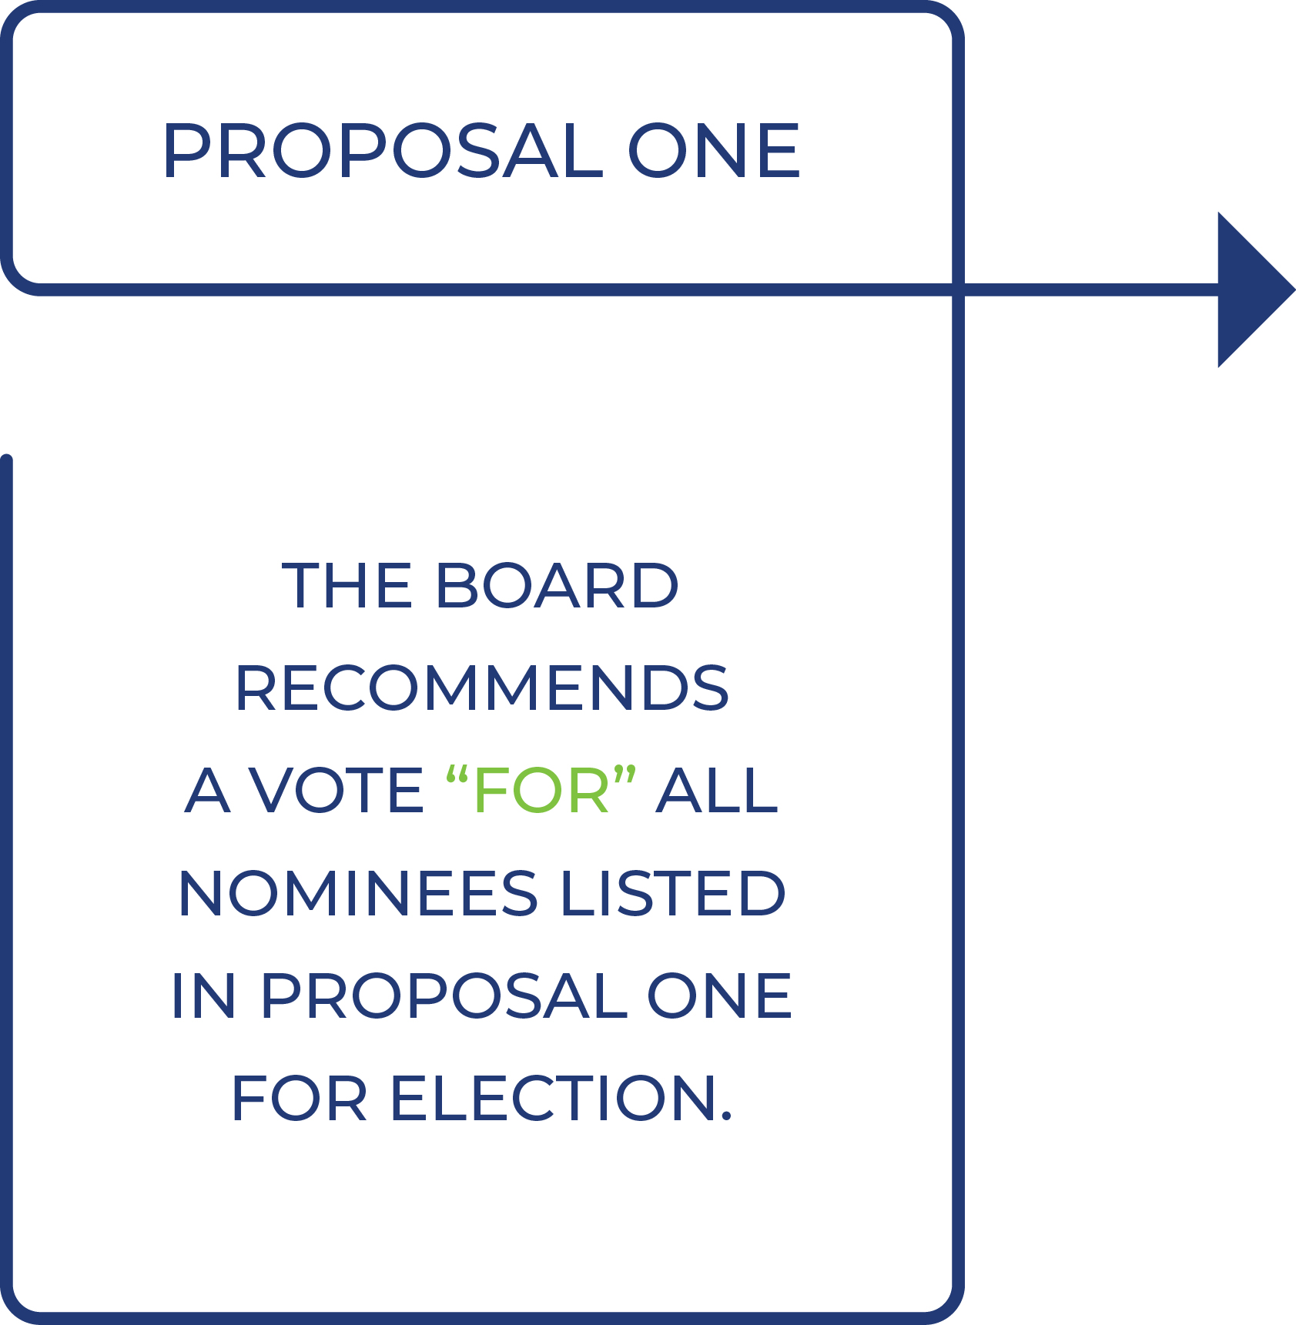
13

Table of Contents

EXECUTIVE OFFICERS OF REPAY
Our executive officers are elected annually and serve at the pleasure of the Board. The following sets forth the name, age as of the record date, position(s) with Repay and selected biographical information for our executive officers. The biography of Mr. Morris is provided above under “Proposal One: Election of Directors.”

 | Name |  |  | Age |  |  | Position
 | John Morris |  |  | 57 |  |  | Chief Executive Officer and Co-Founder, Director
 | Naomi Barnett |  |  | 35 |  |  | Executive Vice President, Human Resources
 | Tyler B. Dempsey |  |  | 52 |  |  | General Counsel
 | David Guthrie |  |  | 59 |  |  | Chief Technology Officer
 | Robert S. Houser |  |  | 51 |  |  | Chief Financial Officer

Naomi Barnett has served as our Executive Vice President, Human Resources since March 2021. From January 2020 to March 2021, Ms. Barnett served as Vice President, Human Resources for REPAY LLC. Previously, Ms. Barnett served as Director, Human Resources of REPAY LLC from July 2018 to January 2020. Prior to joining REPAY LLC, Ms. Barnett was Director, Head of Human Resources, for Gold Star Mortgage Financial Group from October 2017 to July 2018. From June 2011 to September 2017, Ms. Barnett served in various human resources roles for Patriot National, Inc., including as Assistant Vice President, Human Resources, from May 2016 to September 2017.
Tyler B. Dempsey has served as our General Counsel since September 2019. Prior to joining us, Mr. Dempsey provided legal counsel and support to REPAY LLC for more than nine years as outside counsel at Troutman Sanders LLP (now Troutman Pepper Hamilton Sanders LLP), where he served as a Partner since 2008. Prior to joining Troutman Sanders, Mr. Dempsey was an attorney at King & Spalding LLP.
David Guthrie has served as our Chief Technology Officer since January 2022. Prior to joining us, Mr. Guthrie was the principal of Guthrie Technology Services, a technology advisory firm he founded in January 2017. During this time, he acted in executive and/or advisory roles for various technology-centric companies, including serving as the Chief Information Officer and Chief Information Security Officer of Sharecare, Inc., with oversight of security, IT systems and M&A assessments. Before establishing Guthrie Technology Services, he served as Executive Vice President and Chief Technology Officer of Premiere Global Services, Inc. (PGi) from February 2003 until December 2016. Earlier in his career, Mr. Guthrie was a member of the founding team of Medcast Networks, which was acquired by WebMD in 1999.
14

Table of Contents

Robert “Rob” S. Houser has served as our Chief Financial Officer since September 2025. Prior to joining us, Mr. Houser served as Group CFO for Conduent Incorporated (Nasdaq: CNDT) (“Conduent”), a business process services company that provides digital platforms and solutions to commercial and government clients, which he joined in July 2021. Most recently, he has served as Group CFO for Conduent’s Public Sector business and Advisor to CEO since January 2025, and he previously served as Conduent’s Global Head of Strategy, Corporate Development and Advisor to CEO from July 2021 to January 2025. Prior to Conduent, Mr. Houser held several senior positions at Fiserv Inc. (NYSE: FI) (“Fiserv”), a global fintech and payments company, from September 2014 to July 2021, including as Senior Vice President and General Manager of Fiserv’s Bill Pay Solutions business unit and as Vice President and Chief Financial Officer of Fiserv’s Biller and Payments group. Prior to Fiserv, he was the Global Head of FP&A and Investor Relations at Integra Lifesciences, Inc. (Nasdaq: IART). He previously held various finance, accounting, and strategy roles at Firmenich, Inc, Bristol-Myers Squibb Co. (NYSE: NMY), and Merck & Co Inc. (NYSE: MRK). Mr. Houser began his career as an auditor for KPMG LLP.
15

Table of Contents

CORPORATE GOVERNANCE
We have established corporate governance practices designed to serve the best interests of Repay and our stockholders. We are in compliance with the current corporate governance requirements imposed by the rules and regulations of the SEC and the listing standards of The Nasdaq Stock Market (“Nasdaq”). Our current Code of Ethics, Corporate Governance Guidelines and charters for the standing committees of the Board are available on our investor website at investors.repay.com under the heading “Corporate Governance.”
Set forth below is information regarding the meetings of the Board during 2025, a description of the Board’s standing committees and additional information about our corporate governance policies and procedures.

Committees and Meetings of the Board
Board Composition. Our business affairs are managed under the direction of the Board. The Board currently consists of six members, five of whom qualify as independent within the meaning of the independent director guidelines of Nasdaq.
Our Certificate of Incorporation (as amended, the “Certificate of Incorporation”) provides that our Board will consist of one or more members, and the number of directors may be increased or decreased from time to time by a resolution of our Board provided that the number of directors constituting the whole Board shall not be more than 15. Each director’s term will continue until the election and qualification of his or her successor, or his or her earlier death, resignation or removal.
We previously entered into the Founders’ Stockholders Agreement (as defined in this Proxy Statement) that provides the parties thereto with certain director nomination rights. This agreement is described further in this Proxy Statement under “Related Party Transactions — Transactions with Related Persons — Post-Business Combination Agreements.”
Each of our officers serves at the discretion of our Board and will hold office until his or her successor is duly appointed and qualified or until his or her earlier resignation or removal. There are no family relationships among any of our directors or officers.
16

Table of Contents

Our Board consists of industry veterans and influential leaders in the financial services and payments industries. The table below highlights the mix of key skills, qualifications and expertise that, among other factors, led the Board and the Nominating and Corporate Governance Committee to recommend these nominees for election to the Board. The table demonstrates how each of our current directors brings extensive experience, deep industry knowledge and unique expertise to the Board, and is intended to depict notable areas for each director based on the current composition of the Board. Not having a mark in the table below does not mean that a particular director does not possess that skill or qualification. Our directors have developed competencies in these skills through education, direct experience and oversight responsibilities.

 | Paul R. Garcia | Maryann Goebel | Peter J. Kight | John Morris | Emnet Rios | Richard E. Thornburgh
Board Skills, Qualifications and Expertise
Accounting and Finance |  |  |  | l | l | l | 3 of 6
CEO/Senior Leadership | l | l | l | l | l | l | 6 of 6
Compliance/Regulatory |  | l |  | l |  | l | 3 of 6
M&A/Corporate Development | l | l | l | l | l | l | 6 of 6
Payment Processing Operations | l | l |  | l |  |  | 3 of 6
Public Company/Governance | l | l |  |  |  | l | 3 of 6
Risk Management | l | l |  |  | l | l | 4 of 6
Sales & Marketing | l |  |  | l |  |  | 2 of 6
Strategic Planning | l | l | l | l | l | l | 6 of 6
Technology & Cybersecurity | l | l | l |  | l |  | 4 of 6

Board Diversity. While the Nominating and Corporate Governance Committee has not adopted a formal policy with regard to the consideration of diversity in identifying director nominees, diversity is a consideration in the director nominee process. The committee members generally conceptualize diversity expansively to include individual qualities and attributes that contribute to the total mix of viewpoints and experience represented on the Board. The Nominating and Corporate Governance Committee believes that the inclusion of diversity as one of many factors considered in selecting director nominees is consistent with the committee’s goal of creating a Board that best serves the needs of the Company and the interests of its stockholders.

Meetings of the Board. Our Corporate Governance Guidelines provide that directors should be prepared for and attend Board meetings and actively participate in Board discussions. The Board met ten times during the fiscal year ended December 31, 2025. During that period, each of the incumbent directors attended at least 75% of the aggregate number of meetings held by the Board and by each of the committees on which such director served. Our Corporate Governance Guidelines provide that directors are encouraged to make every effort to attend the annual meeting of the stockholders. All of our directors serving at the time attended our 2025 annual meeting of stockholders.
17

Table of Contents

Board Committees. Our Board has an Audit Committee, Compensation Committee, Nominating and Corporate Governance Committee and Technology Committee. The composition (as of the date hereof) and responsibilities of each of the committees of our Board are described below. Members will serve on these committees until their resignation or until as otherwise determined by our Board.

 | Audit | Compensation | Nominating and  Corporate Governance | Technology
Committee Composition
Paul R. Garcia | Member | Chair
Maryann Goebel |  |  |  | Chair
Peter J. Kight |  |  | Member | Member
John Morris
Emnet Rios | Chair |  |  | Member
Richard E. Thornburgh | Member | Member | Chair

Audit Committee. The Audit Committee operates under a written charter, a copy of which is available on our investor website at investors.repay.com under the heading “Corporate Governance.” The committee is responsible for, among other things:
•
selecting a qualified firm to serve as the independent registered public accounting firm to audit our financial statements;
•
helping to ensure the independence and performance of the independent registered public accounting firm;
•
discussing the scope and results of the audit with the independent registered public accounting firm and reviewing, with management and the independent registered public accounting firm, our interim and year-end financial statements;
•
developing procedures for employees to submit concerns anonymously about questionable accounting or audit matters;
•
reviewing our policies on and oversees risk assessment and risk management, including enterprise risk management;
•
reviewing the adequacy and effectiveness of internal control policies and procedures and our disclosure controls and procedures; and
•
approving or, as required, pre-approving all audit and all permissible non-audit services, other than de minimis non-audit services, to be performed by the independent registered public accounting firm.
The Audit Committee met four times during the fiscal year ended December 31, 2025. The current members of the Audit Committee are Paul R. Garcia, Emnet Rios and Richard E. Thornburgh. Emnet Rios currently serves as chairperson of the Audit Committee. Each of the members of our Audit Committee satisfy the requirements for independence and financial literacy under the applicable rules and regulations of the SEC and rules of Nasdaq. The Board has determined that Ms. Rios is an “audit committee financial expert,” as that term is defined in SEC rules.
Compensation Committee. The Compensation Committee operates under a written charter, a copy of which is available on our investor website at investors.repay.com under
18

Table of Contents

the heading “Corporate Governance.” The committee is responsible for, among other things:
•
reviewing, approving and determining the compensation of our officers and key employees;
•
reviewing, approving and determining the compensation and benefits, including equity awards, to directors for service on our Board or any committee thereof;
•
administering our equity compensation plans;
•
reviewing, approving and making recommendations to our Board regarding incentive compensation and equity compensation plans;
•
establishing and reviewing general policies relating to compensation and benefits of our employees; and
•
overseeing our employee relations and retention efforts and our general human capital management.
The Compensation Committee met five times during the fiscal year ended December 31, 2025. The current members of the Compensation Committee are Paul R. Garcia and Richard E. Thornburgh. Paul R. Garcia currently serves as chairperson of the Compensation Committee. Each of the members of our Compensation Committee meets the requirements for independence under the applicable rules and regulations of the SEC and rules of Nasdaq. For more information on the Compensation Committee, see “— Corporate Governance Policies — Consideration and Determination of Executive and Director Compensation.”
Nominating and Corporate Governance Committee. The Nominating and Corporate Governance Committee operates under a written charter, a copy of which is available on our investor website at investors.repay.com under the heading “Corporate Governance.” The committee is responsible for, among other things:
•
identifying, evaluating and selecting, or making recommendations to the Board regarding, nominees for election to the Board and its committees;
•
evaluating the performance of our Board and of individual directors;
•
considering and making recommendations to our Board regarding the composition of our Board and its committees;
•
reviewing developments in corporate governance practices;
•
evaluating the adequacy of the corporate governance practices and reporting, including our corporate sustainability practices described below;
•
reviewing related person transactions; and
•
developing and making recommendations to our Board regarding corporate governance guidelines and matters.
Our Corporate Governance Guidelines provide that the Nominating and Corporate Governance Committee shall work with the Board to determine periodically, as appropriate, the desired Board qualifications, expertise and characteristics, including such factors as industry experience and diversity of background and career experience. In evaluating and determining whether to ultimately recommend a person as a candidate for election as a director, the Nominating and Corporate Governance Committee evaluates all factors that it deems appropriate, including the number of current directors, the terms of the stockholder agreements, as well as the qualifications set forth in our Corporate
19

Table of Contents

Governance Guidelines. It also takes into account specific characteristics and expertise that it believes will enhance the robust mix of knowledge, expertise, background and personal characteristics of our Board. Each director is expected to be an individual of high character, mature judgment and integrity. In determining whether to recommend a director for re-election, the Nominating and Corporate Governance Committee also considers matters relating to the retirement of members, including term limits or age limits, as well as the director’s past attendance at meetings, participation in and contributions to the activities of the Board and Repay and other qualifications and characteristics set forth in the committee’s charter.
The Nominating and Corporate Governance Committee may engage a third party to conduct or assist with any evaluation of a Board candidacy. Ultimately, the Nominating and Corporate Governance Committee seeks to recommend to our Board those nominees whose specific qualities, experience and expertise will augment the current Board’s composition and whose past experience evidences that they will: (i) dedicate sufficient time, energy and attention to ensure the diligent performance of Board duties; (ii) comply with the duties and responsibilities set forth in our Corporate Governance Guidelines and in the Bylaws; (iii) comply with all duties of care, loyalty and confidentiality applicable to them as directors of publicly traded corporations organized in Delaware; and (iv) adhere to our Code of Ethics. Following the Annual Meeting, we expect that Maryann Goebel will join the Nominating and Corporate Governance Committee.
The Nominating and Corporate Governance Committee will also consider recommendations of qualified nominees by stockholders on a substantially similar basis as it considers other nominees. If any stockholder wishes to recommend candidates directly to our Nominating and Corporate Governance Committee, such stockholder may do so by sending timely notice to the Secretary and otherwise in accordance with the terms of our Bylaws and as described in “Stockholder Proposals” below. Such stockholder’s notice shall set forth certain information about the stockholder giving the notice and the nominee and other representations and certifications as set forth in our Bylaws.
The Nominating and Corporate Governance Committee met three times during the fiscal year ended December 31, 2025. The current members of the Nominating and Corporate Governance Committee are Peter J. Kight and Richard E. Thornburgh. Richard E. Thornburgh currently serves as the chairperson of the Nominating and Corporate Governance Committee. Each of the members of the Nominating and Corporate Governance Committee meets the requirements for independence under the applicable rules of Nasdaq.
Technology Committee. The Technology Committee operates under a written charter, a copy of which is available on our investor website at investors.repay.com under the heading “Corporate Governance.” Under the charter, the committee is responsible for, among other things:
•
managing the risks associated with information technology, information and data security, cybersecurity, data privacy, disaster recovery and business continuity;
•
establishing guidelines, policies, controls and procedures for monitoring and mitigating such technology risks;
•
reviewing technology risk reports with management with respect to corrective actions for deficiencies;
•
evaluating, and making recommendations to our Board regarding, the effectiveness of our risk assessment processes; and
20

Table of Contents

•
reviewing, and making recommendations to our Board regarding, our technology strategy, budget and key initiatives, and our technology position relative to our competitors.
The Technology Committee met four times during the fiscal year ended December 31, 2025. The current members of the Technology Committee are Maryann Goebel, Peter J. Kight and Emnet Rios. Maryann Goebel currently serves as chairperson of the Technology Committee. Each of the members of our Technology Committee meets the requirements for independence under the applicable rules of Nasdaq.

Director Independence
Our Class A common stock is listed on Nasdaq. Under the rules of Nasdaq, independent directors must comprise a majority of a listed company’s board of directors. In addition, the rules of Nasdaq require that, subject to specified exceptions, each member of a listed company’s audit, compensation and Nominating and Corporate Governance Committees be independent. Under the rules of Nasdaq, a director will only qualify as an “independent director” if, in the opinion of that company’s board of directors, that person does not have a relationship that would interfere with the exercise of independent judgment in carrying out the responsibilities of a director. Audit Committee members must also satisfy the additional independence criteria set forth in Rule 10A-3 under the Exchange Act and the rules of Nasdaq. Compensation Committee members must also satisfy the additional independence criteria set forth in Rule 10C-1 under the Exchange Act and the rules of Nasdaq.
In order to be considered independent for purposes of Rule 10A-3 under the Exchange Act and under the rules of Nasdaq, a member of an audit committee of a listed company may not, other than in his or her capacity as a member of the committee, the board of directors, or any other board committee: (1) accept, directly or indirectly, any consulting, advisory, or other compensatory fee from the listed company or any of its subsidiaries; or (2) be an affiliated person of the listed company or any of its subsidiaries.
To be considered independent for purposes of Rule 10C-1 under the Exchange Act and under the rules of Nasdaq, the board of directors must affirmatively determine that the member of the Compensation Committee is independent, including a consideration of all factors specifically relevant to determining whether the director has a relationship to the company which is material to that director’s ability to be independent from management in connection with the duties of a Compensation Committee member, including, but not limited to: (i) the source of compensation of such director, including any consulting, advisory or other compensatory fee paid by the company to such director; and (ii) whether such director is affiliated with the company, a subsidiary of the company or an affiliate of a subsidiary of the company.
The Board has undertaken a review of the independence of each director and considered whether each director has a material relationship with the Company that could compromise his or her ability to exercise independent judgment in carrying out his or her responsibilities. As a result of this review, the Board has determined that Mses. Goebel and Rios and Messrs. Garcia, Kight and Thornburgh are “independent directors” as defined under the listing requirements and rules of Nasdaq and the applicable rules of the Exchange Act. Mr. Morris is not considered independent.

Corporate Governance Policies
In addition to corporate governance matters described throughout this Proxy Statement, some additional information about our corporate governance policies and procedures is set forth below:
21

Table of Contents

Code of Ethics. Our Code of Ethics, which we refer to as the “Code of Ethics,” applies to all of our directors, officers and employees. The Code of Ethics is available on our investor website at investors.repay.com under the heading “Corporate Governance.” We intend to post any amendments to or any waivers from a provision of our Code of Ethics on our website.
Corporate Governance Guidelines. Our Board adopted the Repay Corporate Governance Guidelines, which give effect to Nasdaq’s requirements related to corporate governance and various other corporate governance matters. The Corporate Governance Guidelines reflect the Board’s commitment to effective corporate governance of Repay, with a view to enhancing long-term stockholder value. Topics addressed in the Corporate Governance Guidelines include:
•
role and responsibility of the Board;
•
independence of the Board;
•
director qualifications;
•
committees of the Board;
•
director orientation and continuing education;
•
expectations of directors;
•
limitations on other board service;
•
management succession planning;
•
evaluation of Board performance; and
•
communications with stockholders.
A copy of the Corporate Governance Guidelines is available on our investor website at investors.repay.com under the heading “Corporate Governance.”
Risk Management. Our management is responsible for day-to-day risk management of the company, subject to oversight by the Board and its committees with regard to the major risks inherent in our business, including strategic, regulatory, compliance, operational, financial, reputational and cybersecurity risks, and the efforts of management to address and mitigate such risks. This oversight includes the review of strategic transactions and related risks, consistent with the Company’s approach to growth through a combination of organic initiatives and selective acquisitions.
The Board and its committees maintain an active role in risk oversight. The Board receives regular reports concerning our risk assessment and risk management from the Audit Committee, which meets periodically with our independent auditors, with our General Counsel and with management, to discuss the Company’s major financial risk exposures and the steps that management has taken to monitor and control such exposures. In addition to receiving regular reports from the Audit Committee related to financial risk exposures, the Board also reviews information regarding other risks through regular reports of its other committees, including information regarding compensation related risk from the Compensation Committee, governance related risk from the Nominating and Corporate Governance Committee and cybersecurity related risk from the Technology Committee. Risks related to environmental, social and governance matters are covered by each of our committees as appropriate, as described below under “Corporate Sustainability Matters.”
We believe the division of risk management responsibilities described above is an effective approach for addressing the risks that we face.
22

Table of Contents

Executive Sessions of Independent Directors. Our Corporate Governance Guidelines provide that the independent directors shall meet in executive session on a periodic basis but no less than twice per year. At executive sessions, our independent directors meet without management or any affiliated directors present. The Board believes that executive sessions foster free and open communication among the independent directors, which will ultimately add to the effectiveness of the Board, as a whole.
Consideration and Determination of Executive and Director Compensation. The Compensation Committee has the primary authority to determine our compensation philosophy and to establish compensation for our executive officers. In establishing executive officer compensation, the Compensation Committee uses its subjective evaluation of the executives’ performance and responsibilities, our overall performance and the Chief Executive Officer’s recommendations. In addition, the Compensation Committee has engaged an independent compensation consultant to advise regarding the status of Repay’s executive officer compensation in relation to comparable companies.
From time to time, the Compensation Committee may invite to its meetings any director, member of management and such other persons as it deems appropriate in order to carry out its responsibilities. Typically, Mr. Morris reviews the performance of senior management and make recommendations on compensation levels of our executive officers (other than himself), Mr. Dempsey advises the Compensation Committee on legal matters and prepares documents for the Compensation Committee’s consideration, and Ms. Barnett provides general support to the Compensation Committee, including providing details with respect to the operation of Repay’s various compensation and benefit plans. In addition, these officers answer questions posed by the committee.
The Board has adopted the Repay Holdings Corporation Equity Award Grant Policy (the “Award Grant Policy”) which establishes guidelines for the granting of stock options, restricted stock awards, restricted stock units and other equity incentive awards. Under the policy, the Board has delegated authority to Repay’s Chief Executive Officer to grant equity awards to employees other than executive officers, subject to the written guidelines set forth in the Award Grant Policy.
Under our Corporate Governance Guidelines, the compensation of independent directors is determined by the Board upon recommendation of the Compensation Committee. The guidelines further provide that non-employee directors are expected to receive a meaningful portion of their annual retainer in the form of equity. Employee directors are not paid additional compensation for their services as directors.
Restrictions on Short Sales or Speculative Transactions by All Directors and Employees (Anti-Hedging/Anti-Pledging). The Board believes that it is undesirable for our directors, officers and employees to engage in hedging or speculative transactions that may put the personal gain of the insider in conflict with the best interests of the Company and our securityholders or otherwise give the appearance of impropriety. Therefore, we adopted an insider trading policy, which generally prohibits our directors, officers, and employees, whether or not in possession of material non-public information from (i) trading in options, warrants, puts and calls or similar instruments on our securities, and (ii) selling our securities “short” (i.e., selling stock that is not owned and borrowing the shares to make delivery).
In addition, we have adopted an insider trading policy which governs the purchase, sale and/or any other dispositions of our securities by the Company and our directors, officers and employees and is reasonably designed to promote compliance with insider trading laws, rules and regulations, and listing standards applicable to us. Our insider trading policy discourages margin accounts and pledges. The policy generally prohibits our directors, officers, and employees, whether or not in possession of material non-public
23

Table of Contents

information, from purchasing our securities on margin, borrowing against any account in which our securities are held or pledging our securities as collateral for a loan, without first obtaining pre-clearance.
Under the insider trading policy, our executive officers may only trade our securities during certain designated periods, as set out in our insider trading policy, and must obtain pre-clearance and approval prior to any transaction. All executive officers and directors are in compliance with this policy.
Committee Authority to Retain Independent Advisors. The charter of each of the Audit Committee, the Nominating and Corporate Governance Committee, the Compensation Committee and the Technology Committee provides that the committee has the authority to retain independent advisors, counsel, experts and consultants, with all fees and expenses paid by Repay.
Board Leadership Structure. The Board does not have a policy on whether the role of Chairperson of the Board and Chief Executive Officer should be separate or combined. Our current Board leadership structure separates the positions of Chief Executive Officer and Chairperson of the Board, with John Morris serving as our Chief Executive Officer and the independent Chairman position being held by Peter J. Kight. The Board believes that this separation is appropriate for the Company at this time because it allows for Mr. Morris to be primarily responsible for our operations and strategic direction and for Mr. Kight to be primarily focused on matters pertaining to corporate governance and strategic guidance. The Board will make future determinations regarding whether or not to separate the roles of Chair and Chief Executive Officer based on all then current facts and circumstances.
If the Chairperson of the Board is also the Chief Executive Officer or is a director who does not otherwise qualify as an “independent director,” our Corporate Governance Guidelines provide that a “Lead Director” shall be elected annually by plurality vote of the independent directors, pursuant to a secret ballot, following nomination by the Nominating and Corporate Governance Committee. The Lead Director would help coordinate efforts of the independent and non-management directors in the interest of ensuring that objective judgment is brought to bear on sensitive issues involving the management of the Company and, in particular, the performance of senior management. A description of the position of Lead Director is set forth in Annex A to our Corporate Governance Guidelines, which is available on our investor website at investors.repay.com under the heading “Corporate Governance.”
Policy for Director Attendance at Annual Meetings. Under our Corporate Governance Guidelines, each director is expected to make every effort to attend each annual meeting of stockholders.
Process for Stockholders to Send Communications to the Board. Our Corporate Governance Guidelines provide that any stockholder who wishes to communicate with, or otherwise make his or her concerns known directly to the chairperson of any of the committees, or to the non-management or independent directors as a group, may do so by (1) addressing such communications or concerns to the Secretary of the Company, 3060 Peachtree Road NW, Suite 1100, Atlanta, Georgia 30305, who will forward such communications to the appropriate party, or (2) sending an e-mail to corpsecretary@repay.com. Such communications may be done confidentially or anonymously.

Corporate Sustainability Matters
We believe corporate responsibility is deeply woven into our company culture and good governance at all levels provides a strong foundation for supporting and promoting
24

Table of Contents

the long-term interests of our stockholders. Our corporate sustainability initiatives have been guided by our desire to achieve operational excellence, generate long-term value for our stockholders, provide a good working environment for our employees and have a positive impact in our communities.
The Board plays a very important role in our sustainability governance, providing oversight of the strategy, operations, risks and management of the Company. The Nominating and Corporate Governance Committee is chartered with overall oversight of our strategy on corporate social responsibility and sustainability matters and approach, including related risks. We also have a Sustainability Working Group, consisting of internal and external resources, to assess the corporate sustainability factors related to our business. The Nominating and Corporate Governance Committee engages with executive management as corporate sustainability initiatives are identified and implemented. The Board is kept informed through periodic updates from the executive management team and the Nominating and Corporate Governance Committee.
As we grow and as corporate sustainability best practices evolve, we regularly evaluate our approach. Together with our executive management team, the Sustainability Working Group analyzes our business and identifies relevant sustainability factors for evaluation and disclosure. The analysis includes dialogue with certain of our institutional stockholders and review of the practices of our peer companies. We typically publicly release an annual Corporate Sustainability Report, which discusses our social responsibility and sustainability programs and practices. In June 2025, we provided an annual updated report that included detailed disclosures across our sustainability initiatives and continued to demonstrate alignment with the Sustainability Accounting Standards Board (SASB) Standards. A copy of our current Corporate Sustainability Report is available on the “Investors” page of our website, www.repay.com, under the “Corporate Governance” tab.
We expect to provide an update to the report at or around the time of the Annual Meeting in which we may highlight our sustainability-related developments in 2025 and to continue to ensure transparency in our approach to governing these matters. We will continue to evolve our corporate sustainability program in a manner that we believe is beneficial to the Company and our stakeholders.

Board Evaluation Process
The Board believes that a continuous evaluation process allows it to assess its effectiveness and proactively identify gaps in desired skills and attributes represented on the Board. All of our directors must annually complete a form of directors’ and officers’ questionnaire, which ultimately enables the Board to enhance its overall effectiveness. Through the questionnaire, each director provides information that helps the Board verify and determine their independence, financial literacy, risk management experience, beneficial ownership interest of the Company’s outstanding common stock, and any possible conflict of interest in relation to the Company or its business. The contents of these questionnaires are reviewed by the Nominating and Corporate Governance Committee and summarized to the Board.
Each year, the Nominating and Corporate Governance Committee oversees a self-assessment process for the Board as a whole and each committee. Typically, each director is required to complete and submit an anonymous self-assessment questionnaire, which contains a series of statements that are designed to obtain the director’s opinions and comments regarding his or her individual performance and the performance of the Board and the committee(s) on which he or she serves. Alternatively, the self-assessment process has been conducted through an individual interview between our non-executive Chairman and each director. The results of the self-assessments are reviewed by the
25

Table of Contents

Nominating and Corporate Governance Committee and the other respective committees, and then discussed by the Board in executive session.
26

Table of Contents

REPORT OF AUDIT COMMITTEE
Notwithstanding anything to the contrary set forth in any of Repay’s filings under the Securities Act of 1933, as amended (the “Securities Act”), or the Exchange Act that might incorporate by reference this Proxy Statement, in whole or in part, the following report shall not be incorporated by reference into any such filings.
The Audit Committee oversees our financial reporting process on behalf of the Board. The Audit Committee operates under a written charter, a copy of which is available on the “Investors” page of our website, www.repay.com, under the “Corporate Governance” tab. This report reviews the actions taken by the Audit Committee with regard to our financial reporting process during fiscal 2025 and particularly with regard to the audited consolidated financial statements as of December 31, 2025 and December 31, 2024 and for the three years ended December 31, 2025.
The Audit Committee is composed solely of independent directors. None of the committee members is or has been an officer or employee of the Company or any of our subsidiaries or has any current business or any family relationship with the Company or any of our subsidiaries or affiliates.
Our management has the primary responsibility for the financial statements and reporting process, including the systems of internal controls. The independent auditors are responsible for performing an independent audit of our consolidated financial statements in accordance with auditing standards generally accepted in the United States and issuing a report thereon. The Audit Committee’s responsibility is to monitor and oversee these processes and to select annually the accountants to serve as our independent auditors for the coming year.
The Audit Committee has implemented procedures to ensure that during the course of each fiscal year it devotes the attention that it deems necessary or appropriate to fulfill its oversight responsibilities under the Audit Committee’s charter. To carry out its responsibilities, the Audit Committee met four times during the year ended December 31, 2025.
In fulfilling its oversight responsibilities, the Audit Committee reviewed and discussed with management the audited consolidated financial statements in our Annual Report on Form 10-K for the year ended December 31, 2025, including a discussion of the quality, rather than just the acceptability, of the accounting principles, the reasonableness of significant judgments and the clarity of disclosures in the financial statements.
The Audit Committee also discussed with the independent auditors, who are responsible for expressing an opinion on the conformity of those audited consolidated financial statements with accounting principles generally accepted in the United States, their judgments as to the quality, rather than just the acceptability, of our accounting principles and such other matters as are required to be discussed with the Audit Committee under the applicable requirements of the Public Company Accounting Oversight Board (“PCAOB”) and the SEC. The Audit Committee also reviewed and discussed with the independent auditors the critical audit matters arising from the current period audit of the financial statements that were communicated or required to be communicated to the Audit Committee and that (1) relate to accounts or disclosures that are material to the consolidated financial statements, and (2) involved the auditor’s especially challenging, subjective or complex judgments. In addition, the Audit Committee discussed with the auditors their independence from management and the Company, including the matters in the written disclosures and the letter required by the PCAOB regarding the independent auditors’ communications with the Audit Committee regarding independence. The Audit Committee also considered whether the provision of
27

Table of Contents

services during the fiscal year ended December 31, 2025 by the auditors that were unrelated to their audit of the consolidated financial statements referred to above and to their reviews of our interim consolidated financial statements during the fiscal year is compatible with maintaining their independence.
Additionally, the Audit Committee discussed with the independent auditors the overall scope and plan for their audit. The Audit Committee met with the independent auditors, with and without management present, to discuss the results of their examination, their evaluation of our internal controls and the overall quality of our financial reporting.
In reliance on the reviews and discussions referred to above, the Audit Committee recommended to the Board that the audited consolidated financial statements be included in our Annual Report on Form 10-K for the year ended December 31, 2025 for filing with the SEC.
Submitted by the Audit Committee:
Emnet Rios, Chairperson
Paul R. Garcia
Richard E. Thornburgh
28

Table of Contents

LETTER FROM OUR COMPENSATION COMMITTEE
Dear Fellow REPAY Stockholders,
One of our most important responsibilities as the independent Compensation Committee of Repay Holdings Corporation is to structure our executive compensation programs to create strong alignment of interests with our stockholders and to attract and retain the talent we need to successfully achieve REPAY’s objectives.
Compensation Program Highlights
•
We believe in incentivizing our executives to drive performance on behalf of our stockholders. In 2025, 93% of total target CEO compensation was meaningfully “at risk” – dependent on performance versus financial and strategic goals and/or share price performance.
•
For all named executive officers, 50% of the annual long-term equity incentive grants are delivered in four-year ratable-vesting restricted shares and 50% take the form of three-year cliff-vesting performance shares – with a balanced mix of Adjusted EBITDA and relative Total Shareholder Return (“TSR”) performance measures.
•
We adhere to strong compensation governance principles and do not provide our executives with single-trigger cash payments in connection with a change-in-control, any excise tax gross-ups, or significant perks.
Stockholder Accountability Through Responsive Actions
Following the 73% ‘Say-on-Pay’ vote support at last year’s annual meeting, the Compensation Committee, with direct involvement by the Chair, undertook an enhanced stockholder outreach program in the Fall of 2025 to address any concerns regarding our compensation program. During these engagement sessions, the most common themes of stockholder feedback centered around a desire for continued alignment between pay and performance and enhanced clarity regarding our performance-based incentives. In direct response to investor feedback, the Compensation Committee has (i) lowered our CEO’s annual target long-term equity incentive award for 2026 by $1,000,000, a 15% decrease from 2025, and (ii) provided greater transparency regarding the measurement of our performance-based awards in this Proxy Statement.
In addition to our latest round of investor engagement and responsive actions, we have a track-record of demonstrating accountability to our stockholders through our compensation program. These important decisions regarding our compensation program in recent years include, but are not limited to:
•
No increase to CEO target pay opportunity since 2023;
•
No increase to any NEO target pay opportunity between 2024 and 2025;
•
Intentional efforts to “right-size” our compensation benchmarking peer group composition – with the two primary goals being to position REPAY in a size-appropriate universe of benchmarks, while also improving representation of payments/fintech companies that are relevant to REPAY; and
•
Enhanced proxy disclosure of the pay program, with a focus on incentive program measures and performance outcomes.
29

Table of Contents

Proven Pay-for-Performance Philosophy and Outcomes
While we do not like to see our executives’ realized (i.e., take-home) pay being meaningfully lower than granted pay, as this reflects performance below expectations, it also shows that the pay program is working as intended. Over the past five fiscal years, our CEO’s realized compensation was approximately 56% lower than his granted target opportunity, reflecting directional alignment with the experience of our stockholders. This is not only a result of the decrease in our stock price in recent years, but also a factor of our Compensation Committee continuing to set rigorous goals, where recent short- and long-term incentive plan payouts have been generally below target.
As the independent Compensation Committee, we thank you for your continued investment in REPAY and respectfully request your support with this year’s management-sponsored proxy proposals.

Sincerely,

The Compensation Committee
Paul R. Garcia
Richard E. Thornburgh

30

Table of Contents

COMPENSATION DISCUSSION AND ANALYSIS
This Compensation Discussion and Analysis (“CD&A”) outlines our compensation programs, practices and objectives for our 2025 named executive officers (“NEOs”) listed below and discusses how the Compensation Committee arrived at the compensation decisions for 2025.

 | Name |  |  | Title
 | John Morris |  |  | Chief Executive Officer (“CEO”)
 | Robert S. Houser (1) |  |  | Chief Financial Officer
 | Timothy J. Murphy (2) |  |  | Former Chief Financial Officer
 | Thomas E. Sullivan (3) |  |  | Chief Accounting Officer and Former Interim Chief Financial Officer
 | David Guthrie |  |  | Chief Technology Officer
 | Tyler B. Dempsey |  |  | General Counsel
 | Shaler Alias (4) |  |  | Former President

(1)
Mr. Houser was appointed to serve as the Chief Financial Officer, effective September 8, 2025.
(2)
Mr. Murphy served as Chief Financial Officer until his resignation, effective May 15, 2025.
(3)
Mr. Sullivan served as Interim Chief Financial Officer from May 15, 2025 to September 8, 2025.
(4)
Mr. Alias served as President until his termination, effective February 27, 2026.

Executive Summary
2025 Business Highlights
In 2025, we re-enforced our core foundation by strengthening our operations, go-to-market, and overall organization leadership. This included a number of significant changes to our executive leadership team, positioning REPAY to better execute on its strategic priorities. We also streamlined processes, worked on ways to deploy automation and artificial intelligence (AI), and rolled out many new product capabilities for the scaled future ahead. Our investments in product and technology are focused on providing best-in-class performance and reliability for our existing clients and prospective clients.
Highlights related to our results of operations and other achievements for the year ended December 31, 2025 include:
•
Revenue decrease of approximately 1% year-over-year. Normalized revenue growth of 3% year-over-year;
o
Consumer Payments revenue growth of approximately 2% year-over-year;
o
Business Payments normalized revenue growth of approximately 22% year-over-year;
•
Adjusted EBITDA margin of approximately 42%;
•
Free Cash Flow Conversion of approximately 38%;
•
Added 14 new integrated software partners, to bring the total to 294 software relationships as of year-end;
•
Accelerated our AP supplier network to over 602,000 suppliers, representing growth of approximately 67% year-over-year; and
•
Recognized by The Strawhecker Group for “Highest Authorization Rate” in 2025 for the second consecutive year.
31

Table of Contents

“Normalized revenue growth,” “Adjusted EBITDA margin” and “Free Cash Flow Conversion” are non-GAAP financial measures. Please refer to Annex B to this Proxy Statement for reconciliations to GAAP measures and further information.
2025 Executive Compensation Highlights
Our 2025 executive compensation decisions reflect the Compensation Committee’s continued focus on pay-for-performance, market-competitive pay opportunities and responsiveness to stockholder perspectives, consistent with our compensation philosophy.
Compensation outcomes for 2025 reflect the Company’s performance during the year and reinforce our pay-for-performance philosophy. Annual incentive payouts for our named executive officers were below target, consistent with performance against key financial metrics, and performance-based equity awards tied to the 2023–2025 performance period resulted in no payout due to below-threshold relative TSR performance. The Compensation Committee believes these outcomes demonstrate alignment between Company performance, stockholder experience and realized compensation. Further detail about our pay outcomes and stockholder alignment is included below.
Target Compensation: In 2025, the Compensation Committee made no increases to base salary, target annual cash incentive opportunities or target long-term equity incentive opportunities for our continuing named executive officers as evidenced by the table below. These decisions reflect the Compensation Committee’s consideration of Company performance, stockholder experience, competitive market data and feedback received through investor outreach.

 | Name | Base  Salary  (2025 vs 2024) | Target  Annual  Cash  Incentive  (2025 vs 2024) | Target  Long-term  Equity  Incentives  (2025 vs 2024) | Total  Target  Compensation  (2025 vs 2024)
 | John Morris | 0% | 0% | 0% | 0%
 | Robert S. Houser | — | — | — | N/A; New NEO
 | Timothy J. Murphy | 0% | 0% | 0% | 0%
 | Thomas E. Sullivan | — | — | — | N/A; New NEO
 | David Guthrie | 0% | 0% | 0% | 0%
 | Tyler B. Dempsey | 0% | 0% | 0% | 0%
 | Shaler Alias | 0% | 0% | 0% | 0%
Realized Compensation: Consistent with our pay-for-performance philosophy, earned (or “realized”) incentive compensation for the period ending fiscal 2025 was paid below target and reflected both operating results and stockholder returns:
•
2025 Annual Incentive Plan (“AIP”) payouts for our NEOs averaged approximately 77% of target; and
•
2023-2025 Performance-based Restricted Stock Units (“PSU”) paid out at 0% of target.
This continues a long history of aligning pay and performance as evidenced by our CEO’s realized incentive plan payouts (as a % of target) over the past five years:
•
The CEO’s AIP payout has only exceeded target once in the past five years; and
32

Table of Contents

•
This represents the third PSU award in the past five years with no payout due to performance below threshold.

 |  | 2021 |  | 2022 |  | 2023 |  | 2024 |  |  | 2025
AIP |  | 175% |  | 24% |  | 92% |  | 98% |  |  | 68%
 |  | 2019-2021 |  | 2020-2022 |  | 2021-2023 |  | 2022-2024 |  |  | 2023-2025
PSU |  | 100% |  | 0% |  | 0% |  | 57% |  |  | 0%
Our target compensation opportunities are set to align with competitive market levels to facilitate our ability to attract and retain top executive talent, but our realized compensation is paid below target when our performance does not meet expectations as demonstrated above.
2025 CEO Compensation Highlights and 2026 Target Compensation
Our CEO’s 2025 target total direct compensation remained the same as his 2024 target total direct compensation. In making this determination, the Compensation Committee reviewed updated market data following its 2025 peer group evaluation and concluded that the CEO’s target compensation remained within a competitive range of the peer group median. This marks the third consecutive year his target total direct compensation remained at the same level.
As detailed below, the Compensation Committee undertook an enhanced stockholder outreach program in the second half of 2025 to address any concerns regarding the compensation program. Direct feedback from our stockholders suggested general support for our existing annual and long-term incentive plan design and reflected a desire for continued alignment between pay and performance. In light of this feedback and in consideration of the Company’s stock price underperformance, the Compensation Committee determined to reduce the CEO’s target compensation by $1,000,000 in 2026 to reinforce the Company’s pay-for-performance philosophy. Mr. Morris supported this determination.

33

Table of Contents

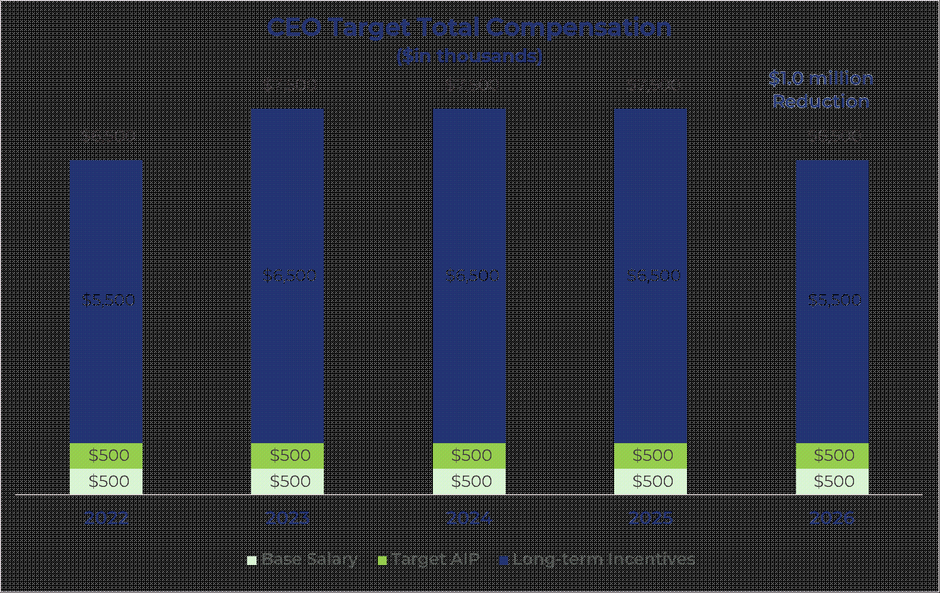

Historical CEO Pay-and-Performance Alignment
The vast majority of our CEO’s compensation is performance-based. Over the five most recently completed fiscal years, Mr. Morris’s cumulative realized compensation was approximately 44% of his cumulative target compensation during the same period. The Compensation Committee believes this demonstrates alignment between the CEO’s compensation and stockholder experience and underscores the rigor of our incentive compensation program.

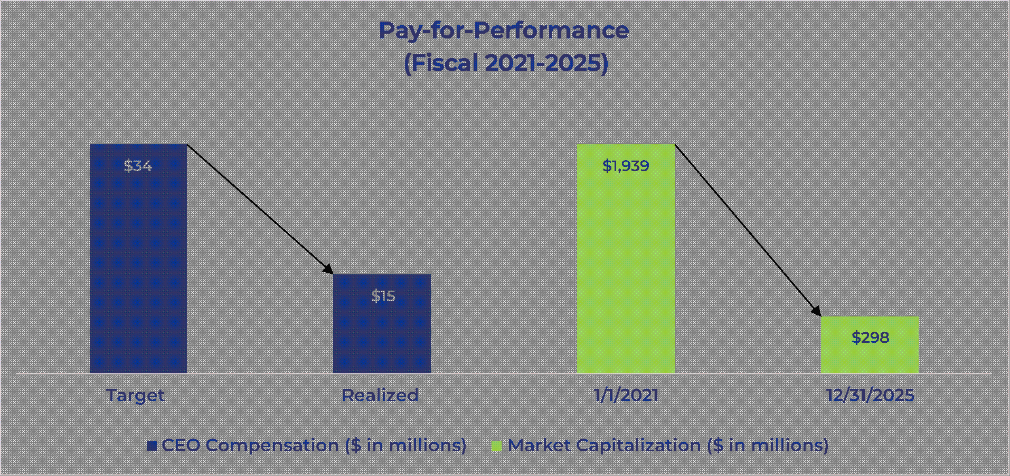
34

Table of Contents

The following assumptions and calculations were used for purposes of the chart above:
•
Cumulative target pay for 2021-2025 includes base salary during each year, target annual cash incentive for each year, and target long-term equity incentives awarded. Equity based awards are valued for this purpose at the target amount approved by the Compensation Committee.
•
Cumulative realizable pay for 2021-2025 includes base salary paid during each year, actual AIP pay received for each year, and the value of shares at the time of vesting.
2025 Pay Mix and Target Total Compensation
The Compensation Committee strives to align our compensation program with short- and long-term Company performance objectives and stockholder value. We believe that our current executive compensation program emphasizes performance-based pay and reflects best practices to ensure sound corporate governance. The vast majority of NEO compensation is variable, representing 93% of target compensation for our CEO and an average of 78% of target compensation for our other NEOs (excluding Mr. Sullivan). In addition, our pay mix is heavily weighted in equity, representing 86% of target compensation for our CEO and an average of 64% of target compensation for our other NEOs (excluding Mr. Sullivan), which we believe closely aligns the interests of the NEOs with long-term stockholder value creation. The following charts show the mix of total target compensation in 2025 for our CEO and the average of all other NEOs (excluding Mr. Sullivan).

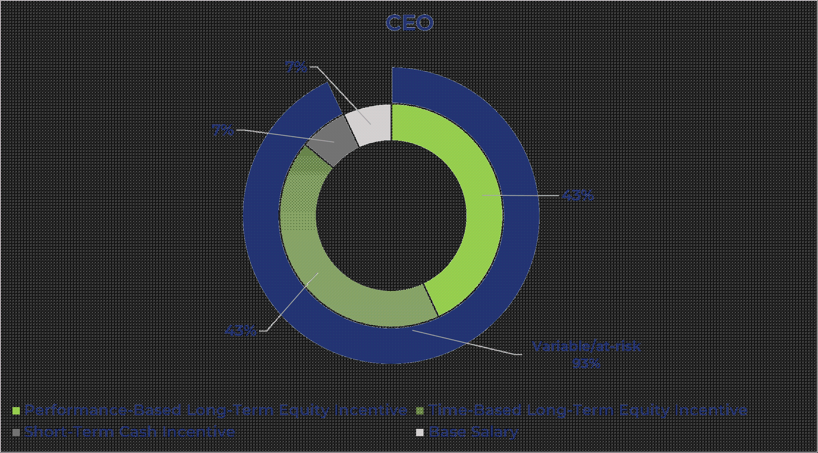

35

Table of Contents

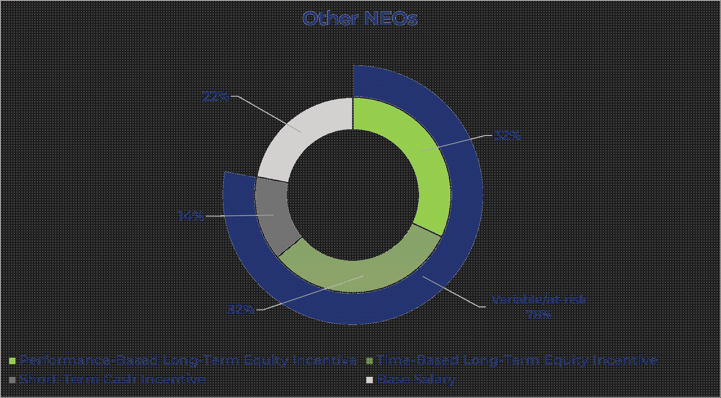

While aiming for a pay mix focused on variable and performance-based vehicles and designed to attract, retain and motivate our NEOs, and following a review of peer companies and executive performance, the Compensation Committee approved executive pay at the following target levels for 2025 (except with respect to Mr. Sullivan as noted below):

Name |  | Base  Salary  ($) |  |  | % of  Total |  |  | Target  Annual  Cash  Incentive  ($) |  |  | % of  Total |  |  | Target  Long-Term  Equity  Incentives  ($) |  |  | % of  Total |  |  | Total Target  Compensation
John Morris |  | 500,000 |  |  | 7% |  |  | 500,000 |  |  | 7% |  |  | 6,500,000 |  |  | 87% |  |  | 7,500,000
Robert S. Houser (1) |  | 400,000 |  |  | 23% |  |  | 240,000 |  |  | 14% |  |  | 1,100,000 |  |  | 63% |  |  | 1,740,000
Timothy J. Murphy |  | 410,000 |  |  | 17% |  |  | 307,500 |  |  | 12% |  |  | 1,730,000 |  |  | 71% |  |  | 2,447,500
Thomas E. Sullivan (2) |  | 232,793 |  |  | 41% |  |  | 69,848 |  |  | 12% |  |  | 260,000 |  |  | 46% |  |  | 562,641
David Guthrie |  | 410,000 |  |  | 22% |  |  | 307,500 |  |  | 16% |  |  | 1,179,000 |  |  | 62% |  |  | 1,896,500
Tyler B. Dempsey |  | 394,625 |  |  | 25% |  |  | 197,313 |  |  | 12% |  |  | 1,000,000 |  |  | 63% |  |  | 1,591,938
Shaler Alias |  | 354,881 |  |  | 23% |  |  | 177,440 |  |  | 12% |  |  | 1,005,179 |  |  | 65% |  |  | 1,537,500

(1)
Mr. Houser’s 2025 target annual cash incentive of $240,000 (60% of base salary) was approved for 2025, but such bonus would be prorated based on actual salary earned in 2025 based on his start date of September 2025. Mr. Houser’s target long-term incentive opportunity was reviewed and approved in connection with his hiring and is intended to be effective commencing in 2026. Mr. Houser also received a signing bonus, one-time cash bonus and one-time restricted stock award in connection with the start of his employment that are not reflected in the table above.
(2)
Mr. Sullivan served as Interim Chief Financial Officer for a portion of the fiscal year. Due to the interim and transitional nature of this role, the Compensation Committee determined not to adjust his previously-determined base salary and target incentives in connection with his appointment as Interim Chief Financial Officer. The base salary amount reflects his actual base salary paid in 2025 and his target annual cash incentive amount calculated in accordance with his employment agreement. In connection with his appointment as Interim Chief Financial Officer, Mr. Sullivan received a special one-time grant of $50,000 of time-based restricted stock, which was approved by the Compensation Committee and is not reflected in the table above.
36

Table of Contents

Greater detail regarding the compensation of our NEOs can be found within the 2025 Summary Compensation Table.
2025 Say-on-Pay Vote, Stockholder Engagement, and Consideration of Feedback
Our annual Say-on-Pay vote provides an important forum for our stockholders to share their perspectives on our executive compensation practices, where REPAY has historically received strong support. The approximately 73% support level on our 2025 Say-on-Pay vote fell short of our expectations and was inconsistent with our average investor support of approximately 98% on Say-on-Pay votes through 2024.
In response, REPAY undertook an enhanced stockholder outreach program in the second half of 2025 to address any concerns regarding the compensation program. As such, we reached out to stockholders owning 58% of our outstanding shares and met with all stockholders who accepted a meeting, accounting for 32% of our outstanding shares. As the independent Chair of our Compensation Committee, Mr. Garcia personally led the majority of these discussions, representing 27% of our outstanding shares.
Post-2025 Annual Meeting Engagement, in Numbers:

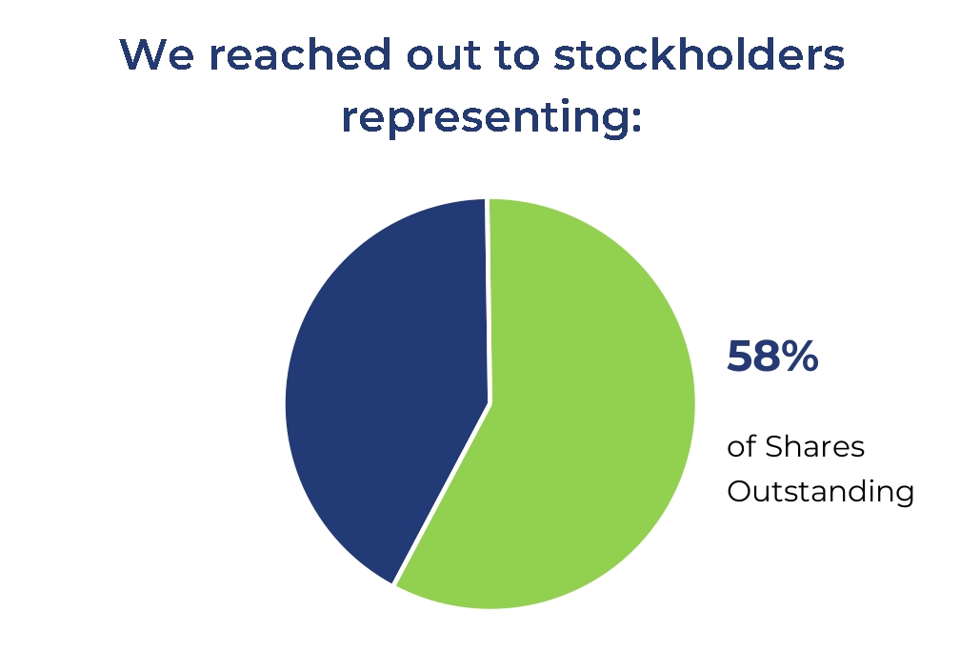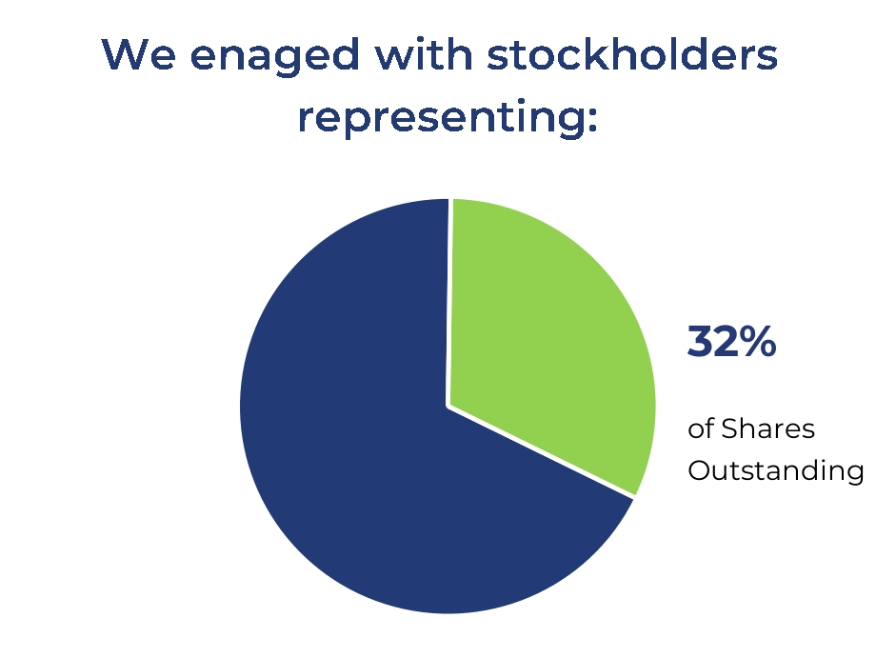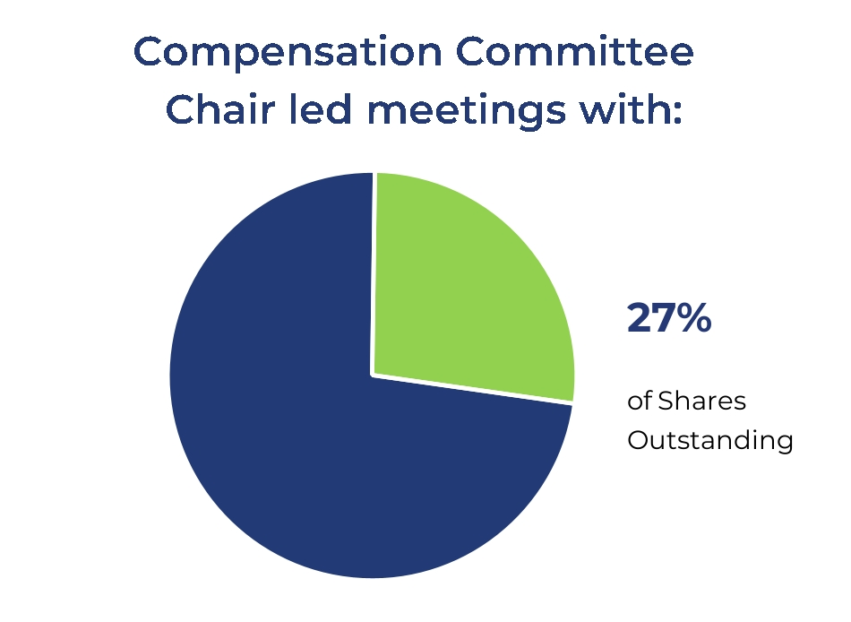

During these engagement sessions, stockholders shared a range of perspectives, and while no single theme or consistent concern emerged, the feedback generally reflected a desire for continued alignment between pay and performance, as well as enhanced clarity regarding the performance-based incentives of our compensation program. During these discussions, our stockholders were generally supportive of the structure and design of our core annual and long-term incentive plans, including the performance metrics, the period and measurement of performance, the emphasis on aligning executive and stockholder interests through the use of equity-based awards, and the balance of annual and long-term performance-based incentives to drive long-term stockholder value.
The Compensation Committee carefully considered this feedback, together with the Company’s pay-for-performance philosophy, in determining to (i) lower our CEO’s target long-term equity incentive award for 2026 by $1,000,000, representing a 15% decrease in such award from 2025, and (ii) provide greater transparency regarding our performance-based awards in this Proxy Statement.
In addition to our latest round of investor engagement and responsive actions, we have a track-record of demonstrating accountability to our stockholders through our compensation program decisions. These important decisions regarding our compensation program in recent years include, but are not limited to:
•
No increase to CEO target pay opportunity since 2023;
•
No increase to any NEO target pay opportunity between 2024 and 2025;
37

Table of Contents

•
Intentional efforts to “right-size” our compensation benchmarking peer group composition – with the two primary goals being to position REPAY in a size-appropriate universe of benchmarks, while also improving representation of payments/fintech companies that are relevant to REPAY; and
•
Enhanced proxy disclosure of the pay program, with a focus on incentive program measures and performance outcomes.

Objectives of the Compensation Program
Our executive compensation program encompasses the overarching ideals of the Company as a whole. We value performance driven metrics and an astute workforce, and compensation decisions are made in support of the philosophy to pay for performance. The Compensation Committee believes this is best effectuated by designing compensation programs and policies to achieve the following primary objectives:
•
attract, retain and motivate our highly-talented executive team;
•
align the objectives and interests of our executives with those of our stockholders in order to increase overall value and output within the Company; and
•
promote the achievement of key financial and strategic milestones.
Attract and Retain Talented Executive Team
We operate in a highly competitive industry for talented executives. The Compensation Committee has designed our compensation program to attract, retain and motivate an executive team capable of maximizing the Company’s performance in both the short- and long-term. With our compensation program and policies, we aim to provide our NEOs with a total compensation package that is competitive with comparable positions at other companies with which we compete for talent.
Align Interests of Named Executive Officers and Stockholders
The following compensation policies and practices are designed to align the interests of our NEOs and our stockholders:

 |  |  | What We Do |  |  |  |  |  |  |  |  |  |  |  | What We Don’t Do
 |  |  |  | Commitment to pay for performance |  |  |  |  | Engage an independent compensation consultant |  |  |  |  |  | No significant perquisites
 |  |  |  | Stock ownership guidelines |  |  |  |  | Fully independent compensation committee |  |  |  |  |  | No incentives that encourage excessive risk-taking
 |  |  |  | Anti-hedging/Anti-pledging policy |  |  |  |  | Capped annual and long-term incentive programs |  |  |  |  |  | No tax gross ups
 |  |  |  | Mix of short-term and long-term incentives and performance metrics |  |  |  |  | Double trigger change in control cash severance benefits and equity vesting |  |  |  |  |  | No guaranteed incentive payments
 |  |  |  | Annual risk assessments |  |  |  |  | Clawback policy
 |  |  |  | Primarily formulaic incentive design and transparent disclosure |  |  |  |  | Annual say-on-pay vote

38

Table of Contents

Material Elements of Our Compensation Programs
Our compensation philosophy is supported by the following material compensation elements, which the Compensation Committee uses in determining the compensation of our NEOs:

 | Compensation Element |  |  | How It’s Paid |  |  | Purpose
 | Base Salary |  |  | Cash (Fixed) |  |  | Provides a competitive fixed compensation relative to similar positions in the market and enables us to attract and retain highly skilled executive talent
 | Annual Cash Incentive Plan |  |  | Cash (Variable/at-risk) |  |  | Focuses executives on achieving annual financial and strategic goals that promote growth, profitability and returns, ultimately driving long-term stockholder value.
 | Long-Term Incentive Plan |  |  | Equity (Variable/at-risk) |  |  | Provides incentives for executives to reach long-term financial and strategic goals that drive stockholder value creation. Typically, our time-based awards vest over four years, and the performance period of our performance-based awards is three years.

Base Salary
Base salary generally provides market-competitive cash compensation for our executives for the services they render during the year and is a standard element of compensation necessary to attract and retain high-level executive talent. All NEO employment arrangements require an annual review of base salary by the Compensation Committee, and annual increases may be made by the Compensation Committee on a discretionary basis. In making base salary decisions, the Compensation Committee does not use a specific formula for evaluating the individual performance of each NEO. When reviewing base salaries as part of the total target compensation, the Compensation Committee considers, among other factors, our contractual obligations under each NEO’s employment agreement, their respective role and responsibilities, their experience and contributions to our financial and operational success, the competitiveness of each NEO’s pay opportunity based on market data, and the totality of the executive’s individual performance.
Annual Performance-Based Cash Incentive Awards
Annual performance-based cash incentive awards are awarded under the AIP for each NEO, other than Mr. Sullivan. These awards are designed to encourage the achievement of various pre-determined financial performance goals for the Company and personal and department performance goals tied to each of the NEO’s roles at the Company. The design of the AIP provides that each NEO’s cash incentive opportunity will be expressed as a percentage of his base salary and earned based on performance results as compared to pre-established threshold, target and maximum goals. NEOs participate in the AIP at individual target levels set forth in their respective employment agreements, which currently range from 50% to 100% of base salary. The AIP has a maximum funding at 200% of the target level for over performance and 0% funding of the target level for performance below threshold performance. Mr. Sullivan participated in the Company's annual cash bonus plan generally available to non-executive employees as described below.
Long-term Incentives: Performance-Based and Service-Based Equity Awards
Equity awards are a significant component of NEO compensation. Under the terms of the Second Amended and Restated Omnibus Incentive Plan, effective April 19, 2024 (the “Second Amended and Restated Plan”), the Compensation Committee has authority to
39

Table of Contents

grant equity awards to NEOs, which it has done each year since the Business Combination. These awards are intended to recognize employee and director contributions, encourage continued commitment to the Company’s long-term success, and support the attraction, retention, and motivation of individuals critical to the Company’s sustained growth and financial performance by providing an opportunity to acquire or increase an ownership interest in the Company.
In determining long-term equity incentives as part of target compensation, the Compensation Committee considers the nature of each NEO’s responsibilities, current and potential contributions to the Company’s success, and other factors it deems relevant. The Compensation Committee also believes that aligning NEO financial interests with long-term Company performance discourages excessive risk-taking and supports sustainable stockholder value creation.
Annual equity awards are typically approved at the Compensation Committee’s regularly scheduled first-quarter meeting, timed to align with annual performance evaluations and the Board’s review of year-end financial results. Meeting dates are generally established approximately one year in advance, and the grant date historically has been the first day of the open window period, pursuant to the Company’s insider trading policy, following Committee approval. Additional information regarding 2025 equity awards is provided below under “Named Executive Officers’ Compensation in 2025 – Annual Long-term Equity Incentives.” The Compensation Committee may also grant equity awards from time to time to recognize performance, support retention, or provide inducement value in accordance with the Award Grant Policy.

Process for Determining Named Executive Officers’ Compensation
Role of Compensation Committee
The Compensation Committee is comprised of independent, non-employee members of the Board and has the primary authority to determine our compensation philosophy and establish the compensation of our NEOs. In establishing our NEOs’ compensation, the Compensation Committee uses its subjective evaluation of the executives’ performance and responsibilities, our overall performance and the CEO’s recommendations with respect to the other NEOs. The Compensation Committee’s specific authority and responsibilities are set forth in its charter, a copy of which is available on the “Investors” page of our website, www.repay.com under the “Governance” tab.
The Compensation Committee has also engaged an independent compensation consultant to advise the Compensation Committee regarding the status of our NEOs’ compensation in relation to comparable companies. The Compensation Committee works very closely with its independent compensation consultant and management to evaluate the effectiveness of our executive compensation program throughout the year.
Role of Management
Management plays a significant role in the process of establishing executive compensation. The most significant aspects of management’s role are:
•
CEO evaluation of employee performance (other than for the CEO);
•
preparing information for Compensation Committee meetings;
•
recommending business performance targets and objectives;
•
providing background information regarding our strategic objectives; and
•
recommending salary levels and equity awards.
40

Table of Contents

From time to time, the Compensation Committee may invite any director, member of management and such other persons as it deems appropriate to its meetings in order to carry out its responsibilities. Typically, our CEO reviews the performance of senior management and makes recommendations on compensation levels in accordance with our Award Grant Policy, and our Executive Vice President, Human Resources provides general support to the Compensation Committee, including providing details with respect to the operation of our various compensation and benefit plans. Our General Counsel advises the Compensation Committee on legal matters. The CEO and Executive Vice President, Human Resources present to the Compensation Committee the proposed individual goals for each of the NEOs and an analysis of the achievement of the goals approved by the Compensation Committee. In addition, these officers answer questions posed by the Compensation Committee. Also, the Board has delegated authority to our CEO to grant equity awards to employees other than executive officers, subject to certain parameters set forth in our Award Grant Policy.
The CEO recommends to the Compensation Committee annual base salaries, annual performance-based cash incentive awards and long-term or performance equity grants for the NEOs (other than the CEO). The Compensation Committee then evaluates each NEO, sets performance criteria for annual performance-based cash incentive awards, and makes long-term equity grants, if any. Although the Compensation Committee considers the CEO’s recommendations, the final decisions regarding base salary, annual incentive awards and equity awards of the NEOs are within the sole discretion of the Compensation Committee.
Role of the Independent Compensation Consultant
The Compensation Committee has the authority to retain independent compensation consultants to provide counsel and advice. For 2025, the Compensation Committee retained Frederic W. Cook & Co., Inc. (“FW Cook”) as its independent advisor on executive and non-employee director compensation matters. FW Cook reports directly to the Compensation Committee and does not provide any other services to the Company. The Compensation Committee assessed the independence of FW Cook in 2025 and whether any work provided by FW Cook raises any conflict of interest, taking into consideration the independence factors set forth in applicable SEC and Nasdaq rules, and determined that FW Cook was independent.
As the Compensation Committee’s independent compensation consultant, FW Cook generally reviews and evaluates our executive compensation programs. FW Cook considers the objectives of our compensation programs and compares them to peer group companies (as discussed below) and best practices and consults the Compensation Committee on competitive compensation practices and trends. The Compensation Committee pre-approves any services to be provided by FW Cook. FW Cook assisted the Compensation Committee in establishing our compensation philosophy, determining our peer group and determining appropriate levels of compensation for our NEOs in 2025.
Market Survey Analysis
The Compensation Committee annually reviews peer group compensation benchmarking and third-party market surveys to ensure executive compensation is competitive against companies that we compete with for business and executive talent. We compete with a variety of payment processing companies, both larger and smaller on a revenue and market capitalization basis, as well as software and services companies in the broader payments ecosystem.
41

Table of Contents

Peer group refinement has been an area of particular focus of the Compensation Committee in recent years, informed in part by stockholder feedback. Over the past three years, the Compensation Committee has actively revised peer group composition to remove larger companies that had outgrown the peer group or were no longer appropriate for pay benchmarking based on market consolidation or other business transaction, and to replace them with more size-appropriate peers that improve the representation of payments and financial technology companies.
With FW Cook’s assistance, the Compensation Committee updated the Company’s peer group to ensure that the Company’s revenues were within +/-10% of the peer group median. The peer companies referred to for evaluation of our 2025 NEO compensation were as follows:

ACI Worldwide, Inc.  Agilysys, Inc.  AvidXchange Holdings, Inc.  BigCommerce Holdings, Inc. (n/k/a Commerce.com, Inc.)  BILL Holdings, Inc.  Cass Information Systems, Inc. |  | Cantaloupe, Inc.  EVERTEC, Inc.  Flywire Corporation  International Money Express, Inc.  Mitek Systems, Inc.  Model N, Inc. |  | Olo Inc.  Q2 Holdings, Inc.  Paymentus Holdings Inc.  Synchronoss Technologies, Inc.  Verra Mobility Corporation

In comparison to the peer group used to benchmark 2024 compensation, the Compensation Committee removed Nuvei Corporation in connection with its take-private transaction and added Paymentus Holdings, Inc., which is a direct competitor in the Consumer Payments segment.
The Compensation Committee reviewed compensation information from this peer group by comparable executive position and level to better understand the market for other participants for all aspects of compensation. In a review of the applicable data, the Compensation Committee sought to ensure that the overall compensation to our NEOs was competitive with industry standards and within a competitive range around median compensation levels at other companies of similar characteristics based on the executive’s position, level and job performance. The Compensation Committee took this evaluation into account in determining all elements of NEO compensation for 2025. The Compensation Committee annually evaluates the list of peer companies and will continue to make appropriate adjustments.
For 2026, the Compensation Committee further refined the peer group based on discussions with stockholders and in consideration of key size indicators to ensure size remained competitive with peers. In connection with this update, the Compensation Committee removed companies that had outgrown the peer group including ACI Worldwide, Inc., BILL Holdings, Inc., Verra Mobility Corporation and Q2 Holdings, Inc., and added Payoneer Global Inc., Marqeta, Inc., PROS Holdings, Inc. and Upland Software, Inc. These changes further improved our positioning relative to the peer group (within 4% of the peer group median revenue).

Named Executive Officers’ Compensation in 2025
Base Salary
Base salary represents annual fixed compensation and provides our NEOs with a level of compensation consistent with their experience, responsibilities and contributions in relation to comparable positions in the marketplace. The Compensation Committee met in February of 2025 to determine the base salaries for our NEOs (other than Mr. Houser and
42

Table of Contents

Mr. Sullivan) for 2025 and determined that base salaries should remain at the same levels as set in 2024 as set forth in the table below. Mr. Houser was appointed as Chief Financial Officer, effective September 8, 2025, and his compensation was approved by the Compensation Committee in August 2025. Due to the interim and transitional nature of Mr. Sullivan’s role as Interim Chief Financial Officer, his base salary continued to be based on his prior position as determined by the then CFO in his annual review as the Compensation Committee determined not to adjust the salary in connection with his appointment as Interim Chief Financial Officer.
Base salaries for our NEOs at the end of fiscal 2025, compared to their base salaries in effect at the end of fiscal 2024, are set forth below:

Name |  | 2025 Base  Salary ($) |  |  |  |  |  | 2024 Base  Salary ($) |  |  |  |  |  | % Change
John Morris |  |  |  | 500,000 |  |  |  |  |  | 500,000 |  |  |  |  | 0.0%
Robert S. Houser |  |  |  | 400,000 |  |  |  |  |  | — |  |  |  |  | N/A
Timothy J. Murphy |  |  |  | 410,000 |  |  |  |  |  | 410,000 |  |  |  |  | 0.0%
Thomas E. Sullivan |  |  |  | 232,793 |  |  |  |  | N/A |  |  |  |  |  | N/A
David Guthrie |  |  |  | 410,000 |  |  |  |  |  | 410,000 |  |  |  |  | 0.0%
Tyler B. Dempsey |  |  |  | 394,625 |  |  |  |  |  | 394,625 |  |  |  |  | 0.0%
Shaler Alias |  |  |  | 354,881 |  |  |  |  |  | 354,881 |  |  |  |  | 0.0%

Annual Performance-Based Cash Incentives
For 2025, our NEOs were entitled under their employment agreements to participate in an annual cash bonus plan with the following targets, expressed as a percentage of base salary: Mr. Morris, 100%; Mr. Houser, 60%; Mr. Murphy, 75%; Mr. Sullivan, 30%; Mr. Guthrie, 75%; Mr. Dempsey, 50%; and Mr. Alias, 50%. These targets are consistent with the target levels for those individuals in 2024 employed at that time.
AIP for NEOs (other than Mr. Sullivan)
The Compensation Committee establishes AIP targets during the first quarter of the fiscal year. The Compensation Committee’s philosophy is that the AIP target performance goals should match the Company’s internal operating plan approved by the Board. Individual performance results are also factored into the AIP opportunity. For fiscal year 2025, the Compensation Committee established the performance goals for NEOs under the AIP, which are summarized as follows:

Performance Objective: |  | Adjusted EBITDA |  |  |  | RCS Business  Unit Gross Profit |  |  |  | Individual  Performance
Weighting among performance objectives (except for Mr. Alias) |  |  | 75% |  |  |  | 0% |  |  |  | 25%
Weighting among performance objectives (for Mr. Alias) |  |  | 35% |  |  |  | 40% |  |  |  | 25%
Threshold |  |  | $124.3 million |  |  |  | $11.8 million |  |  |  | 50%
Target |  |  | $142.9 million |  |  |  | $13.6 million |  |  |  | 100%
Maximum |  |  | $157.1 million |  |  |  | $15.0 million |  |  |  | 200%

43

Table of Contents

If actual performance of a financial metric does not meet the threshold, no award will be earned for that financial goal. If the actual performance of a financial metric reaches the threshold, the award earned for that financial goal will be 50% of the target. The award earned for results between the threshold and the target and between the target and the maximum of 200% of the target is calculated using straight-line interpolation. The maximum incentive award for any NEO is 200% of his target bonus. The target performance goals under the 2025 AIP were set at an aggressive level above actual 2024 results that would require the Company to achieve the performance expected under its demanding operating plan. Therefore, the rigorous targets were not all met.
For 2025, Adjusted EBITDA was $128.6 million, which resulted in a payout of 61% of the target for that objective. In 2025, the Repay Clearing and Settlement (“RCS”) Business Unit Gross Profit was $13.7 million, which resulted in a payout of 104% of the target for that objective for Mr. Alias.
For purposes of determining the level of achievement in 2025 of each NEO for the portion of the AIP attributable to individual goals, the Compensation Committee reviewed each NEO’s level of achievement of specific objectives that were established in the first quarter of 2025. A summary of the categories and weighting of objectives for each NEO, as well as the Compensation Committee’s determination of the level of achievement, is set forth below. For Mr. Houser, the Compensation did not set specific weighted objectives, but rather compared Mr. Houser’s performance against a 30-60-90-120 day plan set by the Compensation Committee at the time of his hiring. Mr. Murphy was not eligible to receive an annual cash incentive bonus under the 2025 AIP following his departure from the Company. Therefore, his individual performance for 2025 was not evaluated by the Compensation Committee.

44

Table of Contents

Name |  | Objective Category — Description |  | Weighting |  | Achievement
John Morris |  | Strategic Planning - Evaluate M&A and alternatives and finalize growth plan |  | 25% |  | 100%
 |  | Financial - Capital allocation strategy and debt refinancing |  | 15% |  | 100%
 |  | Investor Relations - Investor conferences and stockholder meetings |  | 10% |  | 100%
 |  | Consumer & Business Payments - Client meetings and pitches and oversight of strategy |  | 10% |  | 50%
 |  | People/Talent - Succession plan, support hiring |  | 10% |  | 100%
 |  | Board Relations - Individual board member meetings, succession planning |  | 10% |  | 100%
 |  | Technology & Data - Vendor negotiation, support migration, improve internal reporting, improve operational processes |  | 10% |  | 75%
 |  | Performance Metrics - Oversee performance goals and reviews for leadership |  | 10% |  | 65%
Robert S. Houser |  | 30-60-90-120 plan covering the following areas: |  | N/A |  | 100%
 |  | Treasury, Strategy, Financial Management, Investor Relations, Accounting, FP&A, Staffing and Board Responsibility
David Guthrie |  | Product & Engineering - Implementation of various product, platform and integration enhancements and upgrades |  | 20% |  | 95%
 |  | Budgets - Spending reductions and Capex analysis |  | 20% |  | 100%
 |  | Security - Audits and cybersecurity enhancement |  | 15% |  | 100%
 |  | Information Technology and Platform Infrastructure - Automation and migration |  | 10% |  | 95%
 |  | Technology Committee Improvements |  | 10% |  | 100%
 |  | Implement Performance Metrics |  | 10% |  | 100%
 |  | Quality - Improve uptimes |  | 5% |  | 100%
 |  | Data & Automation - Launch various automation initiatives |  | 5% |  | 100%
 |  | People - Enhance product support team |  | 5% |  | 100%
Tyler B. Dempsey |  | Legal/Compliance Department - Headcount management |  | 20% |  | 100%
 |  | Board/Committee - Corporate secretary duties, support and improve processes and activities of Board and Committees |  | 20% |  | 100%
 |  | Outside Legal Spend |  | 20% |  | 100%
 |  | Support Corporate Strategy Efforts |  | 15% |  | 100%
 |  | Intercompany Arrangements Framework Development |  | 10% |  | 100%
 |  | Implement Performance Metrics |  | 10% |  | 100%
 |  | Vendor Management |  | 10% |  | 100%
Shaler Alias |  | Front End Processing Provider Extension |  | 25% |  | 100%
 |  | RSC Financial Growth and Client Retention |  | 20% |  | 100%
 |  | RSC 2.0 Conversion |  | 20% |  | 100%
 |  | RSC Cost Savings |  | 12.5% |  | 100%
 |  | Facilities - Manage facilities strategy and increase operational savings |  | 12.5% |  | 100%
 |  | Implement Performance Metrics |  | 10% |  | 100%

For each NEO, the Compensation Committee determined the achievement of the individual performance weighted objectives as follows: Mr. Morris, 89.0%; Mr. Houser, 100.0%; Mr. Guthrie, 98.3%; Mr. Dempsey, 100.0%; and Mr. Alias, 99.9%. After considering the other 2025 accomplishments for each NEO, including Mr. Guthrie’s exceptional performance (particularly his leadership in advancing key technology product initiatives such as our digital wallet capabilities, improved instant funding solutions and self-service onboarding, which are critical to our service offerings), the Compensation Committee approved a payout for the portion of the AIP attributable to individual goals as follows: Mr.
45

Table of Contents

Morris, 89.0%; Mr. Houser, 100.0%; Mr. Guthrie, 163.3%; Mr. Dempsey, 100.0%; and Mr. Alias, 99.9%.
The target and actual annual performance-based cash incentive awards for each NEO under the 2025 AIP are detailed below (with actual awards reflecting a 61% payout on the Adjusted EBITDA metric):

Name |  | Target Annual  Cash Incentive  Awards ($)* |  |  |  |  | Total  Payout % |  |  |  |  | Actual 2025 AIP  Cash Incentive  Awards ($)
John Morris |  |  | 500,000 |  |  |  |  | 68.0 | % |  |  |  | 340,000
Robert S. Houser (1) |  |  | 75,455 |  |  |  |  | 70.7 | % |  |  |  | 53,384
Timothy J. Murphy (2) |  |  | 307,500 |  |  |  |  | — |  |  |  |  | —
David Guthrie |  |  | 307,500 |  |  |  |  | 86.6 | % |  |  |  | 266,218
Tyler B. Dempsey |  |  | 197,313 |  |  |  |  | 70.8 | % |  |  |  | 139,599
Shaler Alias |  |  | 177,441 |  |  |  |  | 87.9 | % |  |  |  | 156,015
* Based on salary received in 2025.
(1)
Mr. Houser’s employment with the Company began on September 8, 2025, and as a result, his annual cash incentive eligibility under the 2025 AIP is prorated based on actual salary earned.
(2)
Mr. Murphy resigned as Chief Financial Officer, effective May 15, 2025, and as a result, he was not eligible to receive an annual cash incentive award under the 2025 AIP.
In addition to his participation in the AIP, Mr. Houser received a one-time cash signing bonus of $150,000 in 2025 in consideration of expected out-of-pocket commuting and temporary housing expenses and an additional one-time cash bonus of $100,000 in 2026 in consideration of bonus compensation forfeited from his prior employer, each in accordance with the terms of his employment agreement. If, within 24 months after the start of his employment, Mr. Houser resigns other than for “good reason” (as defined in the employment agreement) or his employment is terminated by the Company for “cause” (as defined in the employment agreement), then Mr. Houser will be required to repay a pro rata portion of these one-time cash bonuses.
Annual Bonus Program for Mr. Sullivan
Mr. Sullivan is eligible to receive an annual bonus pursuant to the terms of his employment agreement and participated in the Company’s annual bonus program applicable to non-executive employees. For fiscal year 2025, the Company established the relative weighting of the components of Mr. Sullivan’s bonus, with 50% based on Company performance (measured by Adjusted EBITDA), 25% based on personal and departmental goals and 25% based on individual performance.
While Adjusted EBITDA served as the primary objective performance metric, the remaining components of Mr. Sullivan’s bonus were determined based on management’s qualitative assessment of his performance and contributions during the year. In addition, due to the transition in the Interim Chief Financial Officer role during 2025, his performance was evaluated holistically based on his responsibilities and contributions over the course of the year.
Consistent with the approach applied to executive officers, the payout for the Adjusted EBITDA component was aligned with overall Company performance. For 2025, Adjusted EBITDA was $128.6 million, which resulted in a payout of approximately 61% of target for this component.
With respect to the remaining 50% of the bonus opportunity, management evaluated Mr. Sullivan’s performance based on his execution of key responsibilities, support of the
46

Table of Contents

Company’s financial and strategic initiatives, and his performance during the CFO transition period. Based on this assessment, payouts of 100% and 100% of target were approved for the personal and departmental goals and individual performance components, respectively.
Mr. Sullivan’s target bonus opportunity for 2025 was $69,848. Based on the performance described above, the total payout was approximately 80.5% of target, resulting in an annual cash bonus award of $56,227.
Annual Long-Term Equity Incentives
During 2025, we granted both time-based restricted stock awards and performance-based restricted stock unit awards to all NEOs (except for Mr. Sullivan and Mr. Houser) under the Second Amended and Restated Plan (or its predecessor). For all other NEOs, the Compensation Committee determined to make 50% of the annual equity award in time-based restricted stock and 50% in performance-based restricted stock units. In developing this mix of annual equity awards, the Compensation Committee balanced the objectives relating to achieving milestones and aligning interests with stockholders provided by the performance-based awards and the objectives relating to retention and share ownership provided by the time-based awards. Each of the time-based awards generally vests in equal annual installments over a four-year period on the anniversary of the grant date. The performance-based awards have a performance cycle over a three-year performance period beginning in the year of grant. While the performance-based awards cliff vest as of the end of the performance period (subject to Company performance), actual share distribution is subject to a short administration period following the end of the performance period to allow for Compensation Committee approval of achievement of the performance targets.
For the performance-based awards granted in 2025, the Compensation Committee granted 50% of the awards tied to each of two different performance metrics: an Adjusted EBITDA performance measure and a relative TSR performance measure. The Adjusted EBITDA performance measure is designed to tie a portion of our NEO’s executive compensation to a key internal operational performance metric that measures management’s ability to drive profitable growth. The Compensation Committee believes Adjusted EBITDA is a key indicator of value creation. The TSR performance measure is designed to further align the NEO’s interests with those of our stockholders.
The Compensation Committee considered several potential financial metrics and noted that Adjusted EBITDA is also used as a performance objective under the short-term AIP. This was also a topic discussed during our investor outreach, during which investors expressed a range of views. A minority of stockholders indicated that, as a matter of their internal policies or voting frameworks, they generally prefer or require the use of different metrics across short-term and long-term incentive programs, while others strongly supported the continued use of Adjusted EBITDA given its consistent role as a key financial measure used by the Company both internally and in external communications. After careful consideration of these perspectives and other factors, the Compensation Committee concluded Adjusted EBITDA growth is the most appropriate internal financial metric for this purpose because it incentivizes our executive management team to both drive revenue growth and to carefully manage costs over the long-term, complementing the short-term nature of the AIP.
For the Adjusted EBITDA PSUs, the Compensation Committee established threshold, target and maximum Adjusted EBITDA growth rate goals in February 2025 for each of fiscal year 2025, fiscal year 2026 and fiscal year 2027. These pre-established growth rate goals will be applied to the prior year’s actual Adjusted EBITDA results. The target growth
47

Table of Contents

rate goal for fiscal year 2025 aligns with the Company’s internal operating plan approved by the Board.
For fiscal years 2026 and 2027, the target growth rate goals are based on a medium-term growth framework reviewed with the Board that reflects an expected acceleration in performance over the period. This framework incorporates management’s view of normalized operating trends, including the impact of variability associated with the political media cycle affecting the Business Payments unit, as well as anticipated benefits from go-to-market and other growth investments. The Compensation Committee considered this framework in establishing forward-looking targets that are intended to be rigorous while supporting sustained long-term growth. We disclose the TSR goals, but not the financial goals, at the time of grant as the financial information is commercially sensitive and is not otherwise publicly disclosed. Based on feedback from our stockholders, we intend to disclose the financial goals (including threshold, target, and maximum) at the time of vesting, which is more consistent with competitive market practice and will better allow stockholders to assess the alignment between our pay and our performance.
The average of each of the three years’ annual achievement of goals (which may range from 0% to 200%) will determine the percentage of the Adjusted EBITDA PSUs that are earned. Additional information with respect to the varying levels of performance and corresponding payout percentages is as follows:

Repay Adjusted EBITDA Year-over-Year Growth (all expressed as percentages) |  | Percent of Target  Award Earned
Growth Rate equivalent to 110% of Adjusted EBITDA implied by Target Growth Rate |  | 200%
Target Growth Rate |  | 100%
Growth Rate equivalent to 90% of Adjusted EBITDA implied by Target Growth Rate |  | 50%
Growth Rate less than 90% of Adjusted EBITDA implied by Target Growth Rate |  | 0%
For the TSR PSUs, TSR is defined as stock price appreciation assuming any dividends are reinvested on ex-dividend date. To mitigate against unusual volatility, the actual beginning and ending price for the performance period will reflect a 20-trading day average. The TSR performance will be measured against the Russell 2000 over the three-year performance period. This benchmark provides for a robust comparator group, which mitigates against anomalies due to changes in the composition of the peer group over the performance period. TSR will be measured separately for Repay and each company in the comparator group. The percent of target award earned is based on the percentile rank of Repay’s TSR relative to the TSR of the members of the comparator group. The performance and percent of award earned is as follows:

Repay TSR Performance |  | Percent of Target  Award Earned
75th percentile or higher |  | 200%
50th percentile |  | 100%
25th percentile |  | 50%
Below 25th percentile |  | 0%

The Compensation Committee evaluated potential changes to the terms of the TSR PSUs for 2025, including the rigor of the TSR performance goals and the possibility of a cap in the event of negative absolute TSR over the performance period. Discussions with our investors suggest broad support for the design of our existing TSR PSUs, which have
48

Table of Contents

resulted in zero payouts in three of the last four years in periods of relative underperformance. In addition, the Compensation Committee, with FW Cook’s assistance, concluded that the current design of the TSR PSUs remains consistent with the prevailing practices among peer companies with whom Repay competes for executive talent. The Compensation Committee will continue to monitor evolving market trends and feedback from investors and may consider changes to the TSR PSUs terms in the future. In addition, the Compensation Committee has also committed to fully disclose the rationale for any relative TSR payouts above target for periods of negative absolute TSR (if applicable).
For each Adjusted EBITDA PSU and TSR PSU, the award earned for results between any of 50%, 100% and 200% levels will be calculated using straight-line interpolation. In each case, the achievement of the performance goals for the performance-based equity awards granted in 2025 will be determined in early 2028.
In determining the size of the dollar value of annual equity awards granted, the Compensation Committee considered a variety of factors, including the desired equity mix and target total compensation. The actual number of equity awards granted is calculated by dividing the dollar value of the award by the closing price of our stock on the grant date. The dollar value of the awards granted in 2025 were generally consistent with those granted in 2024. In 2025, the grant date for the time-based restricted stock awards and the performance-based restricted stock unit awards was March 5, 2025. The annual grants of equity incentives were awarded to our NEOs (other than Mr. Houser and Mr. Sullivan) in 2025 as provided below.

Name |  | Time-Based  Restricted Stock |  |  |  |  | Performance-  Based  Restricted  Stock Units  (EBITDA) |  |  |  |  | Performance-  Based  Restricted  Stock Units  (TSR)
John Morris |  |  | 520,000 |  |  |  |  | 260,000 |  |  |  |  | 260,000
Timothy J. Murphy |  |  | 138,400 |  |  |  |  | 69,200 |  |  |  |  | 69,200
David Guthrie |  |  | 94,320 |  |  |  |  | 47,160 |  |  |  |  | 47,160
Tyler B. Dempsey |  |  | 80,000 |  |  |  |  | 40,000 |  |  |  |  | 40,000
Shaler Alias |  |  | 80,414 |  |  |  |  | 40,207 |  |  |  |  | 40,207

In accordance with his employment agreement, Mr. Houser received a one-time new-hire restricted stock award of 118,243 shares, which was provided in consideration of equity compensation forfeited from his prior employer. This award vests in four equal annual installments commencing September 8, 2026. The restricted stock was granted pursuant to an inducement award agreement outside of our Second Amended and Restated Plan as a material inducement to Mr. Houser’s acceptance of employment in accordance with NASDAQ Listing Rule 5635(c)(4). The Compensation Committee determined the size and structure of Mr. Houser’s one-time new hire awards, including the decision not to include performance-based vesting conditions, based on a review of the compensation opportunities forfeited at his prior employer. The four-year vesting schedule for these awards is longer than the vesting requirements applicable to his prior employer’s awards.
Based on his position at the time of the annual equity grants, Mr. Sullivan was eligible to receive time-based restricted stock, but not performance shares and received a grant of 41,600 shares of restricted stock that vests in four equal annual installments commencing March 5, 2026. In addition, the Compensation Committee approved a special one-time award of $50,000 of time-based restricted stock to Mr. Sullivan, with a one-year vesting schedule, in accordance with, and subject to, the Award Grant Policy and
49

Table of Contents

the Second Amended and Restated Plan. The Compensation Committee approved the one-time special award to Mr. Sullivan in connection with his leadership during the unexpected transition in the Chief Financial Officer role. Mr. Sullivan assumed substantially expanded responsibilities on short notice and played a critical role in maintaining the integrity and continuity of the Company’s financial operations and disclosures. The Compensation Committee determined not to apply additional performance conditions, as the award was intended to recognize the scope, urgency, and successful execution of these incremental responsibilities, and was primarily retention-motivated. The Compensation Committee views this as a targeted, non-recurring action taken in response to a specific business need.
Forfeiture of Fiscal 2023 Performance-Based Equity Awards
Certain of our NEOs were granted performance-based restricted stock units (the “2023 PSUs”) on March 19, 2023. The 2023 PSUs had a three-year performance period ending on December 31, 2025. Vesting of the 2023 PSUs was subject to attainment of performance goals based upon relative TSR relative to the Russell 2000 Index. The maximum payout of 200% of target is achieved if TSR performance is at or above the 75th percentile. The target performance goal set for these awards was a relative TSR performance at the 50th percentile, and the threshold performance goal was a relative TSR performance at or above the 25th percentile. If the relative TSR performance was below the 25th percentile, the award would be forfeited.
The relative TSR Performance as of December 31, 2025 was as follows:

Performance Period |  | 1/1/2023 – 12/31/2025
Performance Period Elapsed |  |  | 100 | %
Repay TSR |  |  | (54.97 | )%
Repay Rank |  |  | 1,300
Peer Count |  |  | 1,638
Repay Percentile |  |  | 21 | %
Current Payout |  |  | 0 | %

The relative TSR percentile rank for the performance period was at the 21st percentile. Therefore, the 2023 PSUs were forfeited for each applicable NEO. This is the third instance in the past four years in which our TSR PSUs were forfeited due to performance falling below threshold levels, which reinforces the pay-for-performance alignment in our plan.

Other Important Compensation Policies Affecting the Named Executive Officers
Stock Ownership Guidelines
In 2020, the Compensation Committee adopted minimum ownership requirements for Company stock for the executive officers to align executive interests with stockholders. In 2025, the guidelines were updated to provide great clarity and administrative detail. Under the guidelines, the CEO is required to maintain ownership of Company stock with a value equal to five times his annual base salary. The other executive officers must own equity equal to three times their base salary.
In 2019, the Compensation Committee adopted stock ownership guidelines for our non-employee directors. These guidelines require each director to own equity equal to five times the annual cash retainer within five years of appointment to the Board.
50

Table of Contents

The following types of equity count towards compliance: beneficially owned shares (including shares or LLC units exchangeable for shares held by family members, trusts or similar indirect holdings), shares held in a 401(k) plan, unvested restricted stock or restricted stock units. Unearned performance shares and unexercised stock options do not count towards compliance with the guidelines.
Compliance with these guidelines will be reviewed annually by the Compensation Committee and the ownership thresholds must be achieved within five years of application of the policy. As of the date of the most recent annual review, each of our executive officers and directors was in compliance (or deemed compliance) with these stock ownership guidelines.
Clawback Policy
On August 2, 2023, we adopted the Repay Holdings Corporation Clawback Policy (the “Clawback Policy”), effective as of October 2, 2023, ensuring compliance with all Dodd-Frank regulatory requirements. Among other things, the Clawback Policy generally requires reimbursement or forfeiture of any excess incentive compensation received by an executive during the three fiscal years immediately preceding any accounting restatement. The amount to be recovered will approximate the amount by which the executive’s incentive compensation for the relevant period exceeded amounts that would have been earned based on the restated financial results.
While the Clawback Policy applies to incentive compensation earned by or awarded to executives on or after October 2, 2023, the Second Amended and Restated Plan also includes a clawback provision, pursuant to which we may recover the unearned portion of cash-based or equity-based compensation granted under the Second Amended and Restated Plan in the event our financial statements are restated as a result of material noncompliance with financial reporting requirements. The look-back for this clawback covers any of the prior three fiscal years. This clawback provision applies to any officer of the Company in a position of executive vice president or above, which includes all of the NEOs.
Anti-Hedging and Anti-Pledging Policy
The Board believes that it is undesirable for our directors, officers and employees to engage in hedging or speculative transactions that may put the personal gain of the insider in conflict with the best interests of the Company and our securityholders or otherwise give the appearance of impropriety. Therefore, we adopted an insider trading policy, which generally prohibits our directors, officers, and employees, whether or not in possession of material non-public information from (i) trading in options, warrants, puts and calls or similar instruments on our securities, and (ii) selling our securities “short” (i.e., selling stock that is not owned and borrowing the shares to make delivery).
In addition, our insider trading policy discourages margin accounts and pledges. The policy generally prohibits our directors, officers, and employees, whether or not in possession of material non-public information, from purchasing our securities on margin, borrowing against any account in which our securities are held or pledging our securities as collateral for a loan, without first obtaining pre-clearance.
Under the insider trading policy, our NEOs may only trade our securities during certain designated periods, as set out in our insider trading policy, and must obtain pre-clearance and approval prior to any transaction. All NEOs and directors are in compliance with this policy.
51

Table of Contents

Perquisites
We do not provide any material perquisites to our NEOs. Our NEOs are entitled to participate in our health, welfare and vacation benefits to the same degree that our other employees are entitled to participate.
Employment Agreements
We have entered into employment agreements with our executive officers, as described below. Each of Messrs. Morris, Murphy and Alias entered into their employment agreements with the Company in connection with the Business Combination. For Messrs. Dempsey, Guthrie and Houser, each of their employment agreements was entered into at the commencement of such individual’s employment. Mr. Sullivan entered into his employment agreement in connection with his promotion to Chief Accounting Officer in 2021.
Employment Agreement with Mr. Morris
On January 21, 2019, we entered into a three-year employment agreement with Mr. Morris, which sets forth the terms and conditions of his service as CEO. On March 1, 2021, the Company and Mr. Morris entered into the First Amendment to his employment agreement to expand the scope of the non-compete provision to better align with the current description of our business. On March 1, 2022, the Company and Mr. Morris entered into the Second Amendment to his employment agreement to increase his individual target level for his annual performance-based cash bonus. Mr. Morris’ employment agreement currently provides for:
•
a base salary of at least $355,000 per year (and which is currently $500,000 per year);
•
an annual performance-based cash bonus with a target amount of 100% of his base salary based on the achievement of certain performance objectives established by the Compensation Committee;
•
the opportunity to participate in our employee benefit plans; and
•
automatic renewals for successive one-year periods unless either party provides written notice at least 90 days prior to the end of the applicable term.
Employment Agreement with Mr. Houser
On August 7, 2025, we entered into an employment agreement with Mr. Houser which sets forth the terms and conditions of his service as Chief Financial Officer, which provides for:
•
a base salary of at least $400,000 per year;
•
an annual performance-based cash bonus with a target amount of 60% of his base salary based on the achievement of certain performance objectives established by the Compensation Committee;
•
the opportunity to participate in our employee benefit plans; and
•
one-time cash signing bonus of $150,000 within 30 days after September 8, 2025 and an additional one-time cash bonus of $100,000 by no later than March 15, 2026.
52

Table of Contents

Employment Agreement with Mr. Murphy
On January 21, 2019, we entered into a three-year employment agreement with Mr. Murphy, which sets forth the terms and conditions of his service as Chief Financial Officer. On March 1, 2021, Mr. Murphy’s employment agreement was amended to expand the scope of the non-compete provision to better align with the current description of our business and provided for:
•
a base salary of at least $275,000 per year(and which is currently $410,000 per year);
•
an annual performance-based cash bonus with a target amount of 75% of his base salary based on the achievement of certain performance objectives established by the Compensation Committee;
•
the opportunity to participate in our employee benefit plans; and
•
automatic renewals for successive one-year periods unless either party provides written notice at least 90 days prior to the end of the applicable term.
Mr. Murphy resigned as Chief Financial Officer, effective May 15, 2025. As a result of his resignation, Mr. Murphy was not eligible to receive a bonus under the AIP and forfeited all of his outstanding equity awards.
Employment Agreement with Mr. Guthrie
On January 20, 2022, we entered into an employment agreement with Mr. Guthrie, which sets forth the terms and conditions of his service as Chief Technology Officer. On March 20, 2023, Mr. Guthrie’s employment agreement was amended to increase his individual target level for his annual performance-based cash bonus and currently provides for:
•
a base salary of at least $350,000 per year (and which is currently $410,000 per year);
•
an annual performance-based cash bonus with a target amount of 75% of his base salary based on the achievement of certain performance objectives established by the Compensation Committee; and
•
the opportunity to participate in our employee benefit plans.
Employment Agreement with Mr. Dempsey
On September 1, 2019, we entered into a three-year employment agreement with Mr. Dempsey, which sets forth the terms and conditions of his service as General Counsel. On March 1, 2021, Mr. Dempsey’s employment agreement was amended to expand the scope of the non-compete provision to better align with the current description of our business and currently provides for:
•
a base salary of at least $350,000 per year (and which is currently $394,625 per year);
•
an annual performance-based cash bonus with a target amount of 50% of his base salary based on the achievement of certain performance objectives established by the Compensation Committee;
•
the opportunity to participate in our employee benefit plans; and
•
automatic renewals for successive one-year periods unless either party provides written notice at least 90 days prior to the end of the applicable term.
53

Table of Contents

Employment Agreement with Mr. Alias
On January 21, 2019, we entered into a three-year employment agreement with Mr. Alias, which sets forth the terms and conditions of his service as President. On March 1, 2021, Mr. Alias’ employment agreement was amended to expand the scope of the non-compete provision to better align with the current description of our business and provided for:
•
a base salary of at least $305,000 per year;
•
an annual performance-based cash bonus with a target amount of 50% of his base salary based on the achievement of certain performance objectives established by the Compensation Committee;
•
the opportunity to participate in our employee benefit plans; and
•
automatic renewals for successive one-year periods unless either party provides written notice at least 90 days prior to the end of the applicable term.
Mr. Alias’s employment as the Company’s President terminated on February 27, 2026 in connection with a restructuring of the Company’s RCS business unit leadership. Although the timing of his departure was mutually agreed, the circumstances constituted a termination without “Cause” (or alternatively would have provided Mr. Alias with “Good Reason”) under his executive employment agreement. Mr. Alias also resigned from the Company’s board of directors on the same date as required under the terms of the Founders’ Stockholder Agreement. In connection with his departure, Mr. Alias is entitled to receive severance benefits under his executive employment agreement based on a termination without “Cause” as described below under “Potential Payments Upon Termination or Change-In-Control.” All such severance obligations were contractually obligated under the terms of his executive employment agreement. Mr. Alias executed a general release of claims in connection with his termination. His right to receive severance payments is conditioned on his continued compliance with the restrictive covenant obligations set forth in his executive employment agreement.
Employment Agreement with Mr. Sullivan
On September 16, 2021, we entered into an employment agreement with Mr. Sullivan, which sets forth the terms and conditions of his service as Chief Accounting Officer, which provides for:
•
a base salary of at least $210,000 per year;
•
an annual performance-based cash bonus with a target amount of 30% of his base salary based on the achievement of certain performance objectives established by the Company; and
•
the opportunity to participate in our employee benefit plans.
Termination Benefits under the Employment Agreements
Each of the NEO’s employment agreements also provide for severance benefits upon a termination of employment and certain restrictive covenants, including non-competition and non-solicitation covenants as described below.
Post-Termination Restrictions and Compensation
This section describes the post-employment benefits that each of our NEOs would be entitled to receive along with the restrictions each NEO would face in connection with various termination of employment and change-in-control scenarios. The Compensation
54

Table of Contents

Committee believes that our NEOs should be provided with reasonable severance benefits in the event a NEO is terminated under certain circumstances. Severance benefits for NEOs reflect the fact that the NEO may not be able to find reasonably comparable employment within a reasonable period of time following a termination. In addition, the Compensation Committee believes that certain post-termination benefits such as change in control payments will allow the NEOs to focus their time on potential transactions that may be beneficial to the Company, rather than have concern for their own employment prospects following a change in control.
Severance and Change in Control Benefits
Pursuant to the terms of the employment agreements for each of our NEOs, in the event of a termination of the executive’s employment by us without “Cause” (as defined in the agreements), by the executive for “Good Reason,” (as defined in the agreements), or a non-renewal by us, the executive is entitled to receive the following payments and benefits:
•
an amount equal to the sum of base salary and target annual bonus, payable in installments over the Severance Period (as defined below);
•
immediate vesting of all time-based equity awards that would have vested through the Severance Period;
•
all performance-based equity awards that remain outstanding and eligible to vest based on achievement of performance objectives through the Severance Period; and
•
outstanding stock options remain outstanding until the earlier of (i) the expiration of the Severance Period and (ii) the original expiration of the stock option.
The severance period is 18 months (or 12 months in the case of Mr. Sullivan); provided that in the event such termination is on or within 24 months following a change in control or prior to and in anticipation of a change in control, the severance period is 30 months (or 18 months in the case of Mr. Sullivan) (such applicable period, the “Severance Period”). Such severance payments and benefits are subject to execution and non-revocation of a release of claims.
Pursuant to the terms of each NEOs employment agreements, in the event of a termination due to death or incapacity, our NEOs are entitled to the annual bonus that would have been paid had the executive remained employed until the end of the applicable bonus period.
In the event of any termination of employment, each of our NEOs are entitled to a lump sum equal to (i) any earned but unpaid base salary, (ii) any earned but unpaid annual bonus, (iii) any unreimbursed business expenses and (iv) vested and accrued employee benefits, if any, to which the executive is entitled under employee benefit plans (“Accrued Rights”).
Equity Award Treatment
The treatment of equity awards in the event of a termination of employment or change in control is governed by the employment agreements, the Second Amended and Restated Plan and the equity award agreements.
Upon a voluntary resignation for any reason other than good reason or termination for cause, an NEO would only be entitled to his respective Accrued Rights. Upon a termination without cause or a voluntary termination for good reason prior to a change in control, (i)
55

Table of Contents

all unvested restricted stock that would have vested through the Severance Period will vest, (ii) unvested performance share units will be vested on a pro rata basis with respect to the employment requirement (with the pro rata period including the Severance Period), and the payout of the prorated performance share units will remain subject to actual performance at the end of the performance period, and (iii) all unvested performance-based stock options with respect to which the employment requirement has not been satisfied will be vested on a pro rata basis with respect to the employment requirement (with the pro rata period including the Severance Period), and the payout of those prorated performance-based stock options, plus the performance-based stock options with respect to which the employment requirement had been satisfied previously, will continue to be eligible to vest subject to the performance requirements until the earlier of March 18, 2028 or the end of the Severance Period.
Upon death or disability prior to a change in control, (i) all unvested restricted stock will fully accelerate, (ii) unvested performance share units will be vested on a pro rata basis with respect to the employment requirement, and the payout of the prorated performance share units will remain subject to actual performance at the end of the performance period, and (iii) unvested performance-based stock options with respect to which the employment requirement has not been satisfied will be vested on a pro rata basis with respect to the employment requirement, and the payout of those prorated performance-based stock options, plus the performance-based stock options with respect to which the employment requirement had been satisfied previously, will continue to be eligible to vest subject to the performance requirements until March 18, 2028.
In the event of a change of control, unvested restricted stock will become fully vested if the successor to the Company does not assume or provide a substitute for the unvested shares under the awards and the holder remains employed as of such date. If the successor to the Company does assume or provide a substitute for the unvested restricted stock, the assumed or substitute award will remain outstanding subject to the same vesting requirements after the change in control for each holder who remains employed after the change in control. In the event of a change of control, if the successor to the Company does not assume or provide a substitute for the unvested TSR-based performance share units, the unvested TSR-based performance share units will vest as of the change in control based on actual performance up to the date of the change in control if the holder remains employed as of such date. If the successor to the Company does assume or provide a substitute for the unvested TSR-based performance share units, the unvested TSR-based performance share units will remain outstanding and subject to employment-based vesting with respect to the number of shares earned as of the date of the change in control determined based on actual performance up to the date of the change in control for holders who remain employed as of the date of the change in control. Unvested TSR-based performance share units that were granted to holders who terminated employment prior to the change in control and that remain outstanding as of the change in control also will vest as of the change in control based on actual performance up to the date of the change in control. In the event of a change of control, if the successor to the Company does not assume or provide a substitute for the unvested Adjusted EBITDA-based performance share units, the unvested Adjusted EBITDA-based performance share units will vest as of the change in control based on the original target level if the holder remains employed as of the date of the change in control. If the successor to the Company does assume or provide a substitute for the unvested Adjusted EBITDA-based performance share units, the unvested Adjusted EBITDA-based performance share units will remain outstanding and subject to employment-based vesting with respect to the original number of target shares for holders who remain employed as of the date of the change in control. Unvested Adjusted EBITDA-based performance share units that were granted to holders who terminated employment prior to the change in control and that remain outstanding as of
56

Table of Contents

the change in control also will vest as of the change in control based on the original target level. In the event of a change of control, if the successor to the Company does not assume or provide a substitute for the unvested performance-based options, the unvested performance-based stock options will vest in full as of the date of the change in control if the holder remains employed as of such date. If the successor to the Company does assume or provide a substitute for the unvested performance-based options, the unvested performance-based stock options will remain outstanding and subject to employment-based vesting with respect to all of such performance-based options for holders who remain employed as of the date of the change in control. Unvested performance-based options that were granted to holders who terminated employment prior to the change in control and that remain outstanding as of the change in control also will vest as of the change in control.
If the equity award remains outstanding after the change in control, all unvested restricted stock, unvested performance share units and unvested performance-based stock options will fully accelerate and vest after any adjustments described above in connection with the change in control upon a termination without cause or a voluntary termination for good reason or death or disability.
Non-Compete and Non-Solicitation Agreements
Each of our NEOs are prohibited, pursuant to their employment agreements, from soliciting our customers or vendors, or recruiting our employees for a period of 24 months following the separation date. In addition, each NEO has agreed to not, directly or indirectly, compete with Repay within the Restricted Territory, as defined in the NEO’s employment agreement, for a period of 24 months. Pursuant to the employment agreements, the NEOs are also prohibited from divulging or making use of any Confidential Information or Trade Secrets (as defined in the agreements) during the NEO’s employment and following cessation of employment with the Company for any reason.
Health and Insurance Plans
Pursuant to their employment agreements, our NEOs are entitled to participate in our health, welfare and vacation benefits to the same degree that our other employees are entitled to participate.
Retirement Benefits
We have established a qualified retirement plan under Section 401(k) of the Internal Revenue Code. The plan covers all employees, including our NEOs. The purpose of this plan is to provide all employees with a tax-advantaged savings opportunity for retirement. Eligible compensation under this plan is capped at Internal Revenue Code annual limits. The plan provides for matching contributions of 50% of participant deferrals, with a maximum annual employer contribution of 3% of a participant’s regular base pay. The matching contribution formula is applied on a payroll to payroll basis.
Indemnification Agreements
We have entered into indemnification agreements with each of our directors and executive officers to provide contractual indemnification in addition to the indemnification provided in our Certificate of Incorporation. Each indemnification agreement provides for indemnification and advancements by the Company of certain expenses and costs relating to claims, suits or proceedings arising from his service to the
57

Table of Contents

Company or, at our request, service to other entities, as officers or directors to the maximum extent permitted by applicable law.
Additional Compensation Matters
Risk Assessment of Compensation Policies and Practices
The Compensation Committee and management work together to perform a risk assessment of our executive compensation programs on at least an annual basis to determine whether any risks arising from such programs and policies are reasonably likely to have a material adverse effect on the Company. The Compensation Committee discusses this assessment with management and the ways in which risk is effectively managed or mitigated as it relates to our compensation programs and policies.
During 2025, we assessed the risks associated with our compensation programs for all employees and have concluded that our compensation policies and practices do not create risks that are reasonably likely to have a material adverse effect on the Company. Because our compensation programs put a heavy emphasis on performance-based incentives, we strive to ensure that such incentives do not result in actions that may conflict with the long-term best interests of the Company and our stockholders. The Compensation Committee believes that our compensation programs do not encourage excessive risk taking but instead encourage behaviors that support sustainable value creation for the Company and our stockholders. We believe that our compensation program reflects an appropriate mix of compensation elements and balances current and long-term performance objectives, cash and equity compensation, and risks and rewards.
Impact of Accounting and Tax Treatment of Compensation
The Compensation Committee regularly considers the various tax and accounting implications when designing our executive compensation programs. When determining the amount of long-term incentives and equity grants to certain executives and employees, the compensation committee considers and reviews the compensation costs associated with such grants.
Section 162(m) of the Internal Revenue Code generally limits the deductibility of compensation paid to certain executive officers in excess of $1 million during any taxable year. While considering tax deductibility as only one of several considerations in determining compensation, the Compensation Committee believes that the tax deduction limitation should not compromise its ability to structure compensation programs that provide benefits to the Company that outweigh the potential benefit of a tax deduction and, therefore, may approve compensation that is not deductible for tax purposes. We intend to design our executive compensation arrangements to be consistent with the interests of our stockholders. We believe that it is important to preserve flexibility in administering compensation programs to promote various corporate goals. Accordingly, we have not adopted a policy that all compensation must qualify as deductible under Section 162(m) of the Internal Revenue Code, therefore, some amounts paid under our compensation programs may not be deductible as the result of Section 162(m).
58

Table of Contents

EXECUTIVE COMPENSATION

Summary Executive Compensation Table
The following table sets forth information concerning the annual and long-term compensation awarded to, earned by, or paid to our NEOs for all services rendered in all capacities to the Company, or any of our subsidiaries, for the last three completed fiscal years (except that, for Messrs. Houser, Sullivan and Alias, disclosure is provided for only the most recently completed fiscal year, which was the only applicable fiscal year for which each was an NEO).

Name and principal position |  | Year |  | Salary  ($) (1) |  |  |  |  | Bonus  ($) |  |  |  |  | Stock  awards  ($) (2) |  |  |  |  | Option  awards  ($)(3) |  |  |  |  | Non-equity  incentive plan  compensation  ($) (4) |  |  |  |  | All other  compensation  ($) (5) |  |  |  |  | Total  ($)
John Morris |  | 2025 |  |  | 500,000 |  |  |  |  | — |  |  |  |  | 7,293,000 |  |  |  | — |  |  |  |  |  | 340,000 |  |  |  |  | 10,500 |  |  |  |  | 8,143,500
Chief Executive Officer |  | 2024 |  |  | 500,000 |  |  |  |  | — |  |  |  |  | 7,615,714 |  |  |  | — |  |  |  |  |  | 488,750 |  |  |  |  | 10,350 |  |  |  |  | 8,614,814
 |  | 2023 |  |  | 500,000 |  |  |  |  | — |  |  |  |  | 7,952,685 |  |  |  | — |  |  |  |  |  | 457,875 |  |  |  |  | 12,020 |  |  |  |  | 8,922,581
Robert S. Houser |  | 2025 |  |  | 125,758 |  |  |  |  | 150,000 |  |  |  |  | 699,999 |  |  |  |  | — |  |  |  |  | 53,384 |  |  |  |  | — |  |  |  |  | 1,029,140
Chief Financial Officer
[since September 8, 2025]
Timothy J. Murphy |  | 2025 |  |  | 153,750 |  |  |  |  | — |  |  |  |  | 1,941,060 |  |  |  |  | — |  |  |  |  | — |  |  |  |  | 3,075 |  |  |  |  | 2,097,885
Former Chief Financial Officer |  | 2024 |  |  | 408,333 |  |  |  |  | — |  |  |  |  | 2,026,951 |  |  |  |  | — |  |  |  |  | 295,531 |  |  |  |  | 8,500 |  |  |  |  | 2,739,315
[through May 15, 2025] |  | 2023 |  |  | 397,500 |  |  |  |  | — |  |  |  |  | 1,940,451 |  |  |  |  | 749,997 |  |  |  |  | 273,902 |  |  |  |  | 11,233 |  |  |  |  | 3,373,083
Thomas E. Sullivan |  | 2025 |  |  | 232,793 |  |  |  |  | — |  |  |  |  | 309,998 |  |  |  |  | — |  |  |  |  | 56,228 |  |  |  |  | — |  |  |  |  | 599,019
Chief Accounting Officer
and Former Interim Chief Financial Officer [from May 15, 2025 to September 8, 2025]
David Guthrie |  | 2025 |  |  | 410,000 |  |  |  |  | — |  |  |  |  | 1,322,838 |  |  |  | — |  |  |  |  |  | 266,218 |  |  |  |  | 3,929 |  |  |  |  | 2,002,985
Chief Technology Officer |  | 2024 |  |  | 408,333 |  |  |  |  | — |  |  |  |  | 1,381,369 |  |  |  | — |  |  |  |  |  | 299,359 |  |  |  |  | 4,075 |  |  |  |  | 2,093,137
 |  | 2023 |  |  | 391,667 |  |  |  |  | — |  |  |  |  | 1,345,836 |  |  |  |  | 749,997 |  |  |  |  | 258,229 |  |  |  |  | 9,119 |  |  |  |  | 2,754,847
Tyler Dempsey |  | 2025 |  |  | 394,625 |  |  |  |  | — |  |  |  |  | 1,122,000 |  |  |  |  | — |  |  |  |  | 139,599 |  |  |  |  | 10,500 |  |  |  |  | 1,666,724
General Counsel |  | 2024 |  |  | 393,021 |  |  |  |  | — |  |  |  |  | 1,171,644 |  |  |  |  | — |  |  |  |  | 192,089 |  |  |  |  | 10,350 |  |  |  |  | 1,767,104
 |  | 2023 |  |  | 383,250 |  |  |  |  | — |  |  |  |  | 1,162,311 |  |  |  |  | 499,994 |  |  |  |  | 176,774 |  |  |  |  | 13,200 |  |  |  |  | 2,235,530
Shaler Alias |  | 2025 |  |  | 354,881 |  |  |  |  | — |  |  |  |  | 1,127,806 |  |  |  | — |  |  |  |  |  | 156,015 |  |  |  |  | 4,880 |  |  |  |  | 1,643,582
Former President
[through February 28, 2026]

(1)
Amounts reflect annual base salary paid for the fiscal year.
(2)
Stock awards were in the form of time-based restricted stock and performance-based restricted stock units. Amounts shown above are the aggregate grant date fair value of awards computed in accordance with FASB ASC Topic 718. The grant date fair value of TSR-based performance-based restricted stock units is estimated using the Monte Carlo simulation. For a discussion of the assumptions made in such valuation, see Note 2 to our audited financial statements for the fiscal year ended December 31, 2025, included in our 2025 Form 10-K. Assuming achievement of the highest level of performance under the performance-based restricted stock unit awards (200% of the target), the value of the 2025 time-based restricted stock and performance-based vested restricted unit awards, based on the closing price of our Class A common stock on the applicable grant dates, would be as follows: Mr. Morris, $9,750,000; Mr. Murphy, $2,595,000; Mr. Guthrie, $1,768,500; Mr. Alias, $1,507,763; and Mr. Dempsey, $1,500,000. Messrs. Houser and Sullivan did receive performance-based equity awards in 2025.
(3)
Option awards in 2023 were in the form of performance-based stock options. Amounts shown above are the aggregate grant date fair value of awards computed in accordance with FASB ASC Topic 718. For a discussion of the assumptions made in such valuation, see Note 2 to our audited financial statements for the fiscal year ended December 31, 2025, included in our 2025 Form 10-K.
(4)
Represents annual performance-based cash incentives.
(5)
Amounts reflect matching contributions made by the Company to NEO’s 401(k) plan account.
59

Table of Contents

Grants of Plan-Based Awards Table
The following table sets forth information regarding grants of annual incentive awards to the NEOs during the fiscal year ended December 31, 2025. The non-equity awards were made under program terms and performance objectives approved by the Compensation Committee for annual cash bonuses for the NEO under each of their respective employment agreements (except as noted below for Mr. Sullivan). The equity awards were made under the Second Amended and Restated Plan (except as noted below for Mr. Houser).

 |  | Estimated Future Payouts Under  Non-Equity Incentive Plan Award (2) |  |  |  |  |  |  |  |  | Estimated Future Payouts Under  Equity Incentive Plan Award (3) |  |  |  |  |  |  |  |  | All Other  Stock |  |  | All Other  Option |  |  |  |  |  | Grant
Name (1) | Grant  Date | Threshold  ($) |  |  | Target  ($) |  |  | Maximum  ($) |  |  | Threshold  (#) |  |  | Target  (#) |  |  | Maximum  (#) |  |  | Awards:  Number  of Shares  of Stock  or Units  (#) (4) |  |  | Awards:  Number of  Securities  Underlying  Options  (#) |  |  | Exercise  Price of  Options  Awards  ($/sh) |  |  | Date Fair  Value of  Stock and  Option  Awards  ($) (5)
John Morris
AIP | 3/5/2025 |  | 250,000 |  |  | 500,000 |  |  | 1,000,000
RSA | 3/5/2025 |  |  |  |  |  |  |  |  |  |  |  |  |  |  |  |  |  |  |  | 520,000 |  |  |  |  |  |  |  |  | 3,250,000
PSU - EBITDA | 3/5/2025 |  |  |  |  |  |  |  |  |  |  | 130,000 |  |  | 260,000 |  |  | 520,000 |  |  |  |  |  |  |  |  |  |  |  | 1,625,000
PSU - TSR | 3/5/2025 |  |  |  |  |  |  |  |  |  |  | 130,000 |  |  | 260,000 |  |  | 520,000 |  |  |  |  |  |  |  |  |  |  |  | 2,418,000
Robert S. Houser
AIP | 9/8/2025 |  | 31,439 |  |  | 62,879 |  |  | 125,758
RSA | 9/8/2025 |  |  |  |  |  |  |  |  |  |  |  |  |  |  |  |  |  |  |  | 118,243 |  |  |  |  |  |  |  |  | 699,999
Timothy J. Murphy
AIP | 3/5/2025 |  | 153,750 |  |  | 307,500 |  |  | 615,000
RSA | 3/5/2025 |  |  |  |  |  |  |  |  |  |  |  |  |  |  |  |  |  |  |  | 138,400 |  |  |  |  |  |  |  |  | 865,000
PSU - EBITDA | 3/5/2025 |  |  |  |  |  |  |  |  |  |  | 34,600 |  |  | 69,200 |  |  | 138,400 |  |  |  |  |  |  |  |  |  |  |  | 432,500
PSU - TSR | 3/5/2025 |  |  |  |  |  |  |  |  |  |  | 34,600 |  |  | 69,200 |  |  | 138,400 |  |  |  |  |  |  |  |  |  |  |  | 643,560
Thomas E. Sullivan
AIP | 3/5/2025 |  |  |  |  | 70,179
RSA | 3/5/2025 |  |  |  |  |  |  |  |  |  |  |  |  |  |  |  |  |  |  |  | 41,600 |  |  |  |  |  |  |  |  | 260,000
RSA | 5/7/2025 |  |  |  |  |  |  |  |  |  |  |  |  |  |  |  |  |  |  |  | 13,192 |  |  |  |  |  |  |  |  | 49,998
David Guthrie
AIP | 3/5/2025 |  | 153,750 |  |  | 307,500 |  |  | 615,000
RSA | 3/5/2025 |  |  |  |  |  |  |  |  |  |  |  |  |  |  |  |  |  |  |  | 94,320 |  |  |  |  |  |  |  |  | 589,500
PSU - EBITDA | 3/5/2025 |  |  |  |  |  |  |  |  |  |  | 23,580 |  |  | 47,160 |  |  | 94,320 |  |  |  |  |  |  |  |  |  |  |  | 294,750
PSU - TSR | 3/5/2025 |  |  |  |  |  |  |  |  |  |  | 23,580 |  |  | 47,160 |  |  | 94,320 |  |  |  |  |  |  |  |  |  |  |  | 438,588
Tyler Dempsey
AIP | 3/5/2025 |  | 98,656 |  |  | 197,313 |  |  | 394,625
RSA | 3/5/2025 |  |  |  |  |  |  |  |  |  |  |  |  |  |  |  |  |  |  |  | 80,000 |  |  |  |  |  |  |  |  | 500,000
PSU - EBITDA | 3/5/2025 |  |  |  |  |  |  |  |  |  |  | 20,000 |  |  | 40,000 |  |  | 80,000 |  |  |  |  |  |  |  |  |  |  |  | 250,000
PSU - TSR | 3/5/2025 |  |  |  |  |  |  |  |  |  |  | 20,000 |  |  | 40,000 |  |  | 80,000 |  |  |  |  |  |  |  |  |  |  |  | 372,000
Shaler Alias
AIP | 3/5/2025 |  | 88,720 |  |  | 177,441 |  |  | 354,881
RSA | 3/5/2025 |  |  |  |  |  |  |  |  |  |  |  |  |  |  |  |  |  |  |  | 80,414 |  |  |  |  |  |  |  |  | 502,588
PSU - EBITDA | 3/5/2025 |  |  |  |  |  |  |  |  |  |  | 20,104 |  |  | 40,207 |  |  | 80,414 |  |  |  |  |  |  |  |  |  |  |  | 251,294
PSU - TSR | 3/5/2025 |  |  |  |  |  |  |  |  |  |  | 20,104 |  |  | 40,207 |  |  | 80,414 |  |  |  |  |  |  |  |  |  |  |  | 373,925

(1)
“AIP” refers to performance-based cash incentive awards under the 2025 AIP. “PSU” refers to performance-based restricted stock units awarded under the Second Amended and Restated Plan. “RSA” refers to time-based restricted stock awarded under the Second Amended and Restated Plan, except that the equity award granted to Robert Houser was approved by the Compensation Committee as a stand-alone inducement grant in accordance with applicable Nasdaq rules and was made outside of the Second Amended and Restated Plan.
60

Table of Contents

(2)
The amounts shown reflect the threshold, target and maximum annual cash incentive opportunities under our 2025 AIP approved by the Compensation Committee, except Mr. Sullivan, as discussed in “Compensation Discussion and Analysis” above.
(3)
Represents grants of PSUs to each NEO during 2025. The TSR-based PSUs are earned, if at all, based on our TSR performance after a three-year performance period relative to the TSR over the same performance period for the companies in the Russell 2000 Index. The Adjusted EBITDA-based PSUs are earned, if at all, based on Adjusted EBITDA for each of the three years of the performance period. Additional information regarding the terms of the PSUs is set forth in the “Compensation Discussion and Analysis” above.
(4)
RSAs represent grants of RSAs to each NEO during 2025. These RSAs will generally vest in equal annual installments over a four-year period, except that the RSA grant to Thomas Sullivan on May 7, 2025 vests in full on the first anniversary of the grant date. Additional information regarding the terms of the RSAs is set forth in the “Compensation Discussion and Analysis” above.
(5)
Amounts shown are the grant date fair value of each award computed in accordance with FASB ASC Topic 718. For a discussion of the assumptions made in such valuation, see Note 2 to our audited financial statements for the fiscal year ended December 31, 2025, included in our 2025 Form 10-K.

Narrative Disclosure to Summary Executive Compensation Table and Grants of Plan-Based Awards Table
For additional information concerning our executive compensation policies, see “Compensation Discussion and Analysis” above.

Outstanding Equity Awards at Fiscal Year-End
The following table sets forth information concerning unexercised options; stock that has not vested; and equity incentive awards for each NEO outstanding as of the end of our last completed fiscal year.

61

Table of Contents

 |  | Option Awards |  |  |  |  |  |  |  |  |  |  |  |  |  |  |  | Stock Awards
Name | Grant  Date | Number of  securities  underlying  unexercised  options  (#)  exercisable (1) |  |  | Number of  securities  underlying  unexercised  options  (#)  unexercisable (1) |  |  | Equity  incentive  plan  awards:  number of  securities  underlying  unexercised  unearned  options  (#) (1) |  |  | Option  exercise  price  ($) |  |  | Option  expiration  date |  |  |  | Number  of shares  or units  of stock  that have  not vested  (#) (2) |  |  | Market  value of  shares or  units of  stock that  have not  vested  ($) (3) |  |  | Equity  incentive  plan awards:  Number of  unearned  shares, units  or other  rights that  have not  vested  (#) |  |  | Equity  incentive  plan awards:  Market or  payout  value of  unearned  shares,  units or other  rights  that have  not vested  ($) (3)
John | 2/23/2022 |  |  |  |  |  |  |  |  |  |  |  |  |  |  |  |  |  | 41,094 |  |  | 149,993
Morris | 3/19/2023 |  |  |  |  |  |  |  |  |  |  |  |  |  |  |  |  |  | 265,090 |  |  | 967,579 |  |  | 265,090 | (4) |  | 967,577
 | 2/19/2024 |  |  |  |  |  |  |  |  |  |  |  |  |  |  |  |  |  | 306,219 |  |  | 1,117,699
 | 5/30/2024 - EBITDA |  |  |  |  |  |  |  |  |  |  |  |  |  |  |  |  |  |  |  |  |  |  |  | 83,763 | (5) |  | 305,733
 | 5/30/2024 - TSR |  |  |  |  |  |  |  |  |  |  |  |  |  |  |  |  |  |  |  |  |  |  |  | 83,763 | (5) |  | 305,735
 | 3/5/2025 |  |  |  |  |  |  |  |  |  |  |  |  |  |  |  |  |  | 520,000 |  |  | 1,898,000
 | 3/5/2025 - EBITDA |  |  |  |  |  |  |  |  |  |  |  |  |  |  |  |  |  |  |  |  |  |  |  | 260,000 | (6) |  | 949,000
 | 3/5/2025 - TSR |  |  |  |  |  |  |  |  |  |  |  |  |  |  |  |  |  |  |  |  |  |  |  | 130,000 | (6) |  | 474,500
Robert S. | 9/8/2025 |  |  |  |  |  |  |  |  |  |  |  |  |  |  |  |  |  | 118,243 |  |  | 431,587
Houser
Timothy J. | 3/19/2023 |  |  |  |  |  |  |  |  |  |  | — |  |  | —
Murphy
Thomas E. | 2/23/2022 |  |  |  |  |  |  |  |  |  |  |  |  |  |  |  |  |  | 3,885 |  |  | 14,180
Sullivan | 3/19/2023 |  |  |  |  |  |  |  |  |  |  |  |  |  |  |  |  |  | 31,811 |  |  | 116,110
 | 2/19/2024 |  |  |  |  |  |  |  |  |  |  |  |  |  |  |  |  |  | 24,498 |  |  | 89,418
 | 3/5/2025 |  |  |  |  |  |  |  |  |  |  |  |  |  |  |  |  |  | 41,600 |  |  | 151,840
 | 5/7/2025 |  |  |  |  |  |  |  |  |  |  |  |  |  |  |  |  |  | 13,192 |  |  | 48,151
David | 2/23/2022 |  |  |  |  |  |  |  |  |  |  |  |  |  |  |  |  |  | 6,054 |  |  | 22,097
Guthrie | 3/19/2023 |  | 88,339 |  |  |  |  |  | 198,868 |  |  | 6.13 |  |  | 3/18/2030 |  |  |  | 44,862 |  |  | 163,746 |  |  | 44,861 | (4) |  | 163,743
 | 2/19/2024 |  |  |  |  |  |  |  |  |  |  |  |  |  |  |  |  |  | 55,543 |  |  | 202,732
 | 5/30/2024 - EBITDA |  |  |  |  |  |  |  |  |  |  |  |  |  |  |  |  |  |  |  |  |  |  |  | 15,193 | (5) |  | 55,454
 | 5/30/2024 - TSR |  |  |  |  |  |  |  |  |  |  |  |  |  |  |  |  |  |  |  |  |  |  |  | 15,194 | (5) |  | 55,456
 | 3/5/2025 |  |  |  |  |  |  |  |  |  |  |  |  |  |  |  |  |  | 94,320 |  |  | 344,268
 | 3/5/2025 - EBITDA |  |  |  |  |  |  |  |  |  |  |  |  |  |  |  |  |  |  |  |  |  |  |  | 47,160 | (6) |  | 172,134
 | 3/5/2025 - TSR |  |  |  |  |  |  |  |  |  |  |  |  |  |  |  |  |  |  |  |  |  |  |  | 23,580 | (6) |  | 86,067
Tyler | 2/23/2022 |  |  |  |  |  |  |  |  |  |  |  |  |  |  |  |  |  | 6,426 |  |  | 23,455
Dempsey | 3/19/2023 |  | 58,892 |  |  |  |  |  | 132,578 |  |  | 6.13 |  |  | 3/18/2030 |  |  |  | 38,744 |  |  | 141,416 |  |  | 38,744 | (4) |  | 141,414
 | 2/19/2024 |  |  |  |  |  |  |  |  |  |  |  |  |  |  |  |  |  | 47,111 |  |  | 171,955
 | 5/30/2024 - EBITDA |  |  |  |  |  |  |  |  |  |  |  |  |  |  |  |  |  |  |  |  |  |  |  | 12,887 | (5) |  | 47,036
 | 5/30/2024 - TSR |  |  |  |  |  |  |  |  |  |  |  |  |  |  |  |  |  |  |  |  |  |  |  | 12,887 | (5) |  | 47,036
 | 3/5/2025 |  |  |  |  |  |  |  |  |  |  |  |  |  |  |  |  |  | 80,000 |  |  | 292,000
 | 3/5/2025 - EBITDA |  |  |  |  |  |  |  |  |  |  |  |  |  |  |  |  |  |  |  |  |  |  |  | 40,000 | (6) |  | 146,000
 | 3/5/2025 - TSR |  |  |  |  |  |  |  |  |  |  |  |  |  |  |  |  |  |  |  |  |  |  |  | 20,000 | (6) |  | 73,000
Shaler | 2/23/2022 |  |  |  |  |  |  |  |  |  |  |  |  |  |  |  |  |  | 6,941 |  |  | 25,335
Alias | 4/13/2022 |  |  |  |  |  |  |  |  |  |  |  |  |  |  |  |  |  | 299 |  |  | 1,091
 | 3/19/2023 |  |  |  |  |  |  |  |  |  |  |  |  |  |  |  |  |  | 39,995 |  |  | 145,982 |  |  | 39,994 | (4) |  | 145,978
 | 2/19/2024 |  |  |  |  |  |  |  |  |  |  |  |  |  |  |  |  |  | 47,355 |  |  | 172,846
 | 5/30/2024 - EBITDA |  |  |  |  |  |  |  |  |  |  |  |  |  |  |  |  |  |  |  |  |  |  |  | 12,953 | (5) |  | 47,278
 | 5/30/2024 - TSR |  |  |  |  |  |  |  |  |  |  |  |  |  |  |  |  |  |  |  |  |  |  |  | 12,954 | (5) |  | 47,280
 | 3/5/2025 |  |  |  |  |  |  |  |  |  |  |  |  |  |  |  |  |  | 80,414 |  |  | 293,511
 | 3/5/2025 - EBITDA |  |  |  |  |  |  |  |  |  |  |  |  |  |  |  |  |  |  |  |  |  |  |  | 40,207 | (6) |  | 146,756
 | 3/5/2025 - TSR |  |  |  |  |  |  |  |  |  |  |  |  |  |  |  |  |  |  |  |  |  |  |  | 20,104 | (6) |  | 73,378

(1)
These represent performance-based stock options granted in 2023. The terms of the performance-based stock options provide that they vest and become exercisable in three separate tranches as follows: (a) 31% shall vest and become exercisable on the later of (i) March 19, 2024 and (ii) the date on which the closing price
62

Table of Contents

per share of Class A common stock has equaled or exceeded $10.00 for any consecutive 20 day trading period ending on or prior to March 18, 2028; (b) 32% shall vest and become exercisable on the later of (i) March 19, 2025 and (ii) the date on which the closing price per share of Class A common stock has equaled or exceeded $14.50 for any consecutive 20 day trading period ending on or prior to March 18, 2028; and (c) 37% shall vest and become exercisable on the later of (i) March 19, 2026 and (ii) the date on which the closing price per share of Class A common stock has equaled or exceeded $19.54 for any consecutive 20 day trading period ending on or prior to March 18, 2028. The first tranche of the performance-based stock options vested on April 9, 2024.
(2)
These represent time-based RSAs of our Class A common Stock. The RSAs vest in equal annual installments over a four-year period on the anniversary of the grant date, except that Mr. Sullivan received a special one-time grant that vests in full on the first anniversary of the grant date. Additional information regarding the terms of the RSAs is set forth in the “Compensation Discussion and Analysis” above.
(3)
Based on the closing price of our Class A common stock ($3.65) on December 31, 2025.
(4)
These represent PSUs granted in 2023. The PSUs are earned, if at all, based on our TSR performance after a three-year performance period ending December 31, 2025 relative to the TSR over the same performance period for the companies in the Russell 2000 Index. Additional information regarding the terms of the PSUs is set forth in the “Compensation Discussion and Analysis” above. The number of 2023 PSUs in this table is based on assumed achievement at the “threshold” level payout of 50%. However, on February 10, 2026, the Compensation Committee determined that the TSR performance thresholds were not met and all 2023 PSUs were forfeited.
(5)
These represent PSUs granted in 2024. The Adjusted EBITDA-based PSUs are earned, if at all, based on Adjusted EBITDA for each of the three years during the performance period ending December 31, 2026. The TSR-based PSUs are earned, if at all, based on our TSR performance after a three-year performance period ending December 31, 2026 relative to the TSR over the same performance period for the companies in the Russell 2000 Index. Additional information regarding the terms of the PSUs is set forth in the “Compensation Discussion and Analysis” above. The number of 2024 PSUs in this table is based on assumed achievement at the “threshold” level payout of 50%.
(6)
These represent PSUs granted in 2025. The Adjusted EBITDA-based PSUs are earned, if at all, based on Adjusted EBITDA for each of the three years during the performance period ending December 31, 2027. The TSR-based PSUs are earned, if at all, based on our TSR performance after a three-year performance period ending December 31, 2027 relative to the TSR over the same performance period for the companies in the Russell 2000 Index. Additional information regarding the terms of the PSUs is set forth in the “Compensation Discussion and Analysis” above. The number of 2025 Adjusted EBITDA-based PSUs in this table is based on assumed achievement at the “target” level payout of 100%, and the number of 2025 TSR-based PSUs in this table is based on assumed achievement at the “threshold” level of 50%.

Option Exercises and Stock Vested Table
The following table sets forth information concerning the exercise of all stock options and vesting of all stock awards on an aggregated basis for each NEO during the fiscal year ended December 31, 2025.

 |  | Stock Awards
Name | Number of Shares Acquired  on Vesting  (#) |  |  |  |  |  | Value Realized  on Vesting  ($) (1)
John Morris |  |  | 395,578 |  |  |  |  |  | 2,694,758
Robert S. Houser |  |  | — |  |  |  |  |  | —
Timothy J. Murphy |  |  | 107,130 |  |  |  |  |  | 734,505
Thomas E. Sullivan |  |  | 30,418 |  |  |  |  |  | 199,845
David Guthrie |  |  | 60,825 |  |  |  |  |  | 411,896
Tyler Dempsey |  |  | 60,802 |  |  |  |  |  | 415,567
Shaler Alias |  |  | 64,506 |  |  |  |  |  | 441,434

(1)
Represents the number of shares of time-based restricted stock awards vested multiplied by the closing price of our Class A common stock on the vesting date.
63

Table of Contents

Potential Payments Upon Termination or Change-In-Control
Pursuant to the terms of the employment agreements for each NEO, in the event of a termination of the executive’s employment by us without “Cause” (as defined in the agreements), by the executive for “Good Reason,” (as defined in the agreements), or a non-renewal by us, the executive is entitled to receive the following payments and benefits:
•
An amount equal to the sum of base salary and target annual bonus for each fiscal year during the Severance Period (as defined below), payable in installments;
•
Immediate vesting of all time-based equity awards that would have vested through the Severance Period;
•
All performance-based equity awards remain outstanding and eligible to vest based on achievement of performance objectives through the Severance Period; and
•
Outstanding stock options remain outstanding until the earlier of (i) the expiration of the Severance Period and (ii) the original expiration of the stock option.
Pursuant to the terms of the Performance-Based Non-Qualified Stock Option Award Agreements, for each NEO, in the event of a termination of the executive’s employment by us without “Cause” (as defined in the agreements), by the executive for “Good Reason,” (as defined in the agreements), the Stock Options outstanding (i) shall become vested with respect to the service-based vesting requirements applicable to the Stock Options, if not satisfied previously, notwithstanding the termination of the NEO’s employment with the Company, with respect to those Stock Options that would have satisfied the service-based vesting requirements applicable to the Stock Options had the NEO remained employed with the Company through the Severance Period and the NEO, and (ii) such Stock Options, plus any of the NEO’s Stock Options with respect to which the service-based vesting requirements applicable to the Stock Options were satisfied previously, shall remain outstanding and eligible to become vested and exercisable on satisfaction of the performance-based vesting requirements applicable to such Stock Options prior to the earlier of the end of the Performance Period and the Severance Period on the same basis that such Stock Options would have become vested and exercisable had the NEOs employment with the Company not terminated prior to the earlier of the end of the Performance Period and the Severance Period.
The severance period is 18 months (or 12 months in the case of Mr. Sullivan); provided that in the event such termination is on or within 24 months following a change in control or prior to and in anticipation of a change in control, the severance period is 30 months (or 18 months in the case of Mr. Sullivan) (such applicable period, the “Severance Period”). Such severance payments and benefits are subject to execution and non-revocation of a release of claims.
Pursuant to the terms of the employment agreements, in the event of a termination due to death or incapacity, each NEO is entitled to the annual bonus that would have been paid had the executive remained employed until the end of the applicable bonus period.
In the event of any termination of employment, each NEO is entitled to a lump sum equal to (i) any earned but unpaid base salary, (ii) any earned but unpaid annual bonus, (iii) any unreimbursed business expenses and (iv) vested and accrued employee benefits, if any, to which the executive is entitled under employee benefit plans.
For additional information concerning our executive compensation, see “Compensation Discussion and Analysis” above.
64

Table of Contents

The following table shows the value to the NEOs of hypothetical benefits and payments provided upon termination as of December 31, 2025 under the Company’s policies and programs. The value of the acceleration of time-based equity awards and performance-based equity awards are calculated based on the $3.65 closing price of our Class A common stock on December 31, 2025. Mr. Murphy resigned from the Company in May 2025 and was not employed on December 31, 2025; accordingly, no termination-related amounts have been calculated or presented for him.

Name | Payment and/or Benefit |  | Termination  for Cause  ($) |  |  |  |  | Voluntary  Termination  ($) |  |  |  |  | Termination  Without  Cause or for  Good  Reason or  Non-  Renewal  ($) |  |  |  |  | Termination  Without  Cause or for  Good  Reason or  Non-  Renewal  Upon  Change in  Control  ($) (1) |  |  |  |  | Incapacity |  |  |  |  | Death
John | Base Salary |  |  |  | — |  |  |  |  | — |  |  |  |  | 750,000 |  |  |  |  | 1,250,000 |  |  |  |  | — |  |  |  |  | —
Morris | Annual Bonus (2) |  |  |  | 340,000 |  |  |  |  | 340,000 |  |  |  |  | 1,090,000 |  |  |  |  | 1,590,000 |  |  |  |  | 340,000 |  |  |  |  | 340,000
 | Acceleration of Time-Based Equity Awards |  |  |  | — |  |  |  |  | — |  |  |  |  | 2,811,705 |  |  |  |  | 4,133,271 |  |  |  |  | 4,133,271 |  |  |  |  | 4,133,271
 | Acceleration of Performance-Based Equity Awards ﻿(3) |  |  |  | — |  |  |  |  | — |  |  |  |  | 1,400,854 |  |  |  |  | 1,560,466 |  |  |  |  | 723,399 |  |  |  |  | 723,399
 | Acceleration of Performance-Based Stock Option Awards |  |  |  | — |  |  |  |  | — |  |  |  |  | — |  |  |  |  | — |  |  |  |  | — |  |  |  |  | —
Robert S. | Base Salary |  |  |  | — |  |  |  |  | — |  |  |  |  | 600,000 |  |  |  |  | 1,000,000 |  |  |  |  | — |  |  |  |  | —
Houser | Annual Bonus (2) |  |  |  | 53,384 |  |  |  |  | 53,384 |  |  |  |  | 353,384 |  |  |  |  | 553,384 |  |  |  |  | 53,384 |  |  |  |  | 53,384
 | Acceleration of Time-Based Equity Awards |  |  |  | — |  |  |  |  | — |  |  |  |  | 107,894 |  |  |  |  | 431,587 |  |  |  |  | 431,587 |  |  |  |  | 431,587
 | Acceleration of Performance-Based Equity Awards﻿ (3) |  |  |  | — |  |  |  |  | — |  |  |  |  | — |  |  |  |  | — |  |  |  |  | — |  |  |  |  | —
 | Acceleration of Performance-Based Stock Option Awards |  |  |  | — |  |  |  |  | — |  |  |  |  | — |  |  |  |  | — |  |  |  |  | — |  |  |  |  | —
Timothy J. | Base Salary |  |  |  | — |  |  |  |  | — |  |  |  |  | — |  |  |  |  | — |  |  |  |  | — |  |  |  |  | —
Murphy | Annual Bonus (2) |  |  |  | — |  |  |  |  | — |  |  |  |  | — |  |  |  |  | — |  |  |  |  | — |  |  |  |  | —
 | Acceleration of Time-Based Equity Awards |  |  |  | — |  |  |  |  | — |  |  |  |  | — |  |  |  |  | — |  |  |  |  | — |  |  |  |  | —
 | Acceleration of Performance-Based Equity Awards ﻿(3) |  |  |  | — |  |  |  |  | — |  |  |  |  | — |  |  |  |  | — |  |  |  |  | — |  |  |  |  | —
 | Acceleration of Performance-Based Stock Option Awards |  |  |  | — |  |  |  |  | — |  |  |  |  | — |  |  |  |  | — |  |  |  |  | — |  |  |  |  | —
Thomas E. | Base Salary |  |  |  | — |  |  |  |  | — |  |  |  |  | 233,928 |  |  |  |  | 350,893 |  |  |  |  | — |  |  |  |  | —
Sullivan | Annual Bonus (2) |  |  |  | 56,228 |  |  |  |  | 56,228 |  |  |  |  | 126,407 |  |  |  |  | 161,496 |  |  |  |  | 56,228 |  |  |  |  | 56,228
 | Acceleration of Time-Based Equity Awards |  |  |  | — |  |  |  |  | — |  |  |  |  | 188,150 |  |  |  |  | 313,973 |  |  |  |  | 419,699 |  |  |  |  | 419,699
 | Acceleration of Performance-Based Equity Awards ﻿(3) |  |  |  | — |  |  |  |  | — |  |  |  |  | — |  |  |  |  | — |  |  |  |  | — |  |  |  |  | —
 | Acceleration of Performance-Based Stock Option Awards |  |  |  | — |  |  |  |  | — |  |  |  |  | — |  |  |  |  | — |  |  |  |  | — |  |  |  |  | —
David | Base Salary |  |  |  | — |  |  |  |  | — |  |  |  |  | 615,000 |  |  |  |  | 1,025,000 |  |  |  |  | — |  |  |  |  | —
Guthrie | Annual Bonus (2) |  |  |  | 266,218 |  |  |  |  | 266,218 |  |  |  |  | 727,468 |  |  |  |  | 1,034,968 |  |  |  |  | 266,218 |  |  |  |  | 266,218
 | Acceleration of Time-Based Restricted Stock Awards |  |  |  | — |  |  |  |  | — |  |  |  |  | 493,130 |  |  |  |  | 732,843 |  |  |  |  | 732,843 |  |  |  |  | 732,843
 | Acceleration of Performance- Based Restricted Stock Unit Awards﻿ (3) |  |  |  | — |  |  |  |  | — |  |  |  |  | 254,092 |  |  |  |  | 283,043 |  |  |  |  | 131,212 |  |  |  |  | 131,212
 | Acceleration of Performance-Based Stock Option Awards |  |  |  | — |  |  |  |  | — |  |  |  |  | — |  |  |  |  | — |  |  |  |  | — |  |  |  |  | —
Tyler | Base Salary |  |  |  | — |  |  |  |  | — |  |  |  |  | 591,938 |  |  |  |  | 986,563 |  |  |  |  | — |  |  |  |  | —
Dempsey | Annual Bonus (2) |  |  |  | 139,599 |  |  |  |  | 139,599 |  |  |  |  | 435,568 |  |  |  |  | 632,880 |  |  |  |  | 172,281 |  |  |  |  | 139,599
 | Acceleration of Time-Based Equity Awards |  |  |  | — |  |  |  |  | — |  |  |  |  | 425,506 |  |  |  |  | 628,826 |  |  |  |  | 628,826 |  |  |  |  | 628,826
 | Acceleration of Performance-Based Equity Awards ﻿(3) |  |  |  | — |  |  |  |  | — |  |  |  |  | 215,516 |  |  |  |  | 240,071 |  |  |  |  | 111,292 |  |  |  |  | 111,292
 | Acceleration of Performance-Based Stock Option Awards |  |  |  | — |  |  |  |  | — |  |  |  |  | — |  |  |  |  | — |  |  |  |  | — |  |  |  |  | —
Shaler | Base Salary |  |  |  | — |  |  |  |  | — |  |  |  |  | 532,322 |  |  |  |  | 887,203 |  |  |  |  | — |  |  |  |  | —
Alias (4) | Annual Bonus (2) |  |  |  | 156,015 |  |  |  |  | 156,015 |  |  |  |  | 422,176 |  |  |  |  | 599,616 |  |  |  |  | 156,015 |  |  |  |  | 156,015
 | Acceleration of Time-Based Equity Awards |  |  |  | — |  |  |  |  | — |  |  |  |  | 434,390 |  |  |  |  | 638,765 |  |  |  |  | 638,765 |  |  |  |  | 638,765
 | Acceleration of Performance-Based Equity Awards ﻿(3) |  |  |  | — |  |  |  |  | — |  |  |  |  | 216,630 |  |  |  |  | 241,312 |  |  |  |  | 111,867 |  |  |  |  | 111,867
 | Acceleration of Performance-Based Stock Option Awards |  |  |  | — |  |  |  |  | — |  |  |  |  | — |  |  |  |  | — |  |  |  |  | — |  |  |  |  | —

(1)
Assumes a change in control occurred on December 31, 2025, immediately followed by the executive’s termination.
65

Table of Contents

(2)
Amount includes 2025 AIP bonus because, under executive employment agreements, such bonus is deemed earned if the executive is employed on December 31, 2025.
(3)
Assumes TSR performance thresholds from third party calculation of actual performance through December 31, 2025.
(4)
Upon his termination on February 27, 2026, Mr. Alias became eligible to receive the following severance benefits pursuant to his executive employment agreement: payment of his base salary and AIP target bonus amount over an 18-month period (the “Separation Period”), totaling $954,498; immediate vesting of his time-based equity awards that would have vested during the Separation Period; and his outstanding performance equity awards will remain outstanding and be eligible to vest based on achievement of performance objectives during the Separation Period.

Pay Ratio Disclosure
Pursuant to Item 402(u) of Regulation S-K promulgated under the Exchange Act, we are required to disclose the median annual total compensation of all the Company’s employees, the total compensation of our CEO and the ratio of those two amounts. The pay ratio set forth below is a reasonable estimate and has been calculated in a manner consistent with SEC rules and based on the methodology described below. The SEC rules for identifying median employees allow companies to use a variety of methodologies. As a result, the pay ratio reported by others may not be comparable to our reported pay ratio. For the year ended December 31, 2025:
•
the total compensation for our median employee was $114,434;
•
the annual total compensation of Mr. Morris was $8,143,500; and
•
based on the information above, the ratio of the annual total compensation of our CEO to the median of the annual total compensation of all employees is 71 to 1.
The methodology that we used and the material assumptions, adjustments and estimates that we used to identify the median and determine annual total compensation were as follows:
Employee population. As of December 31, 2025, the date we selected to identify our median employee, our employee population consisted of approximately 487 individuals, which reflects our employee population for purposes of determining the pay ratio described above.
Identification of Median. To identify the median of the annual total compensation of all of our employees, we reviewed the total cash compensation of all applicable employees for the twelve-month period ending on December 31, 2025 (the “reported compensation”). In making this calculation, we did not annualize the reported compensation of any of our employees who were hired during the period, nor did we make any cost of living adjustments to the reported compensation in identifying the median employee. Using this methodology, we determined that our median employee was a full-time, salaried employee located in the U.S.

Pay Versus Performance
As required by Item 402(v) of Regulation S-K, we are providing the following information about the relationship between executive compensation actually paid (“CAP”) and certain financial performance of the Company. In determining CAP to the named executive officers, the Company is required to make various adjustments to the amounts that have been previously reported in the Summary Compensation Table (“SCT”) for the fiscal years presented, as the SEC’s valuation methods for this section differ from those required in the Summary Compensation Table. For further information concerning the Company’s variable pay-for-performance philosophy and how the Company’s aligns
66

Table of Contents

executive compensation with the Company’s performance, refer to “Executive Compensation — Compensation Discussion and Analysis.”

Most Important Performance Measures
The three items listed below represent the most important metrics we used to determine CAP for FY2025 as further described in our Compensation Discussion and Analysis (CD&A).
Most Important Performance Measures

Adjusted EBITDA
Normalized Organic Gross Profit Growth
Total Stockholder Return

 |  | Summary  Compensation |  |  |  |  | Compensation  Actually |  |  |  |  | Average  Summary  Compensation  Table Total |  |  |  |  | Average  Compensation  Actually Paid |  |  |  |  | Value of Initial  Fixed $100  Investment Based On: |  |  |  |  |  |  |  |  |  |  |  |  |  |  | Adjusted
Year  (a) |  | Table Total to  CEO  (b) |  |  |  |  | Paid to  CEO (1)  (c) |  |  |  |  | for Non-CEO  NEOs (2)  (d) |  |  |  |  | to Non-CEO  NEOs (2)  (e) |  |  |  |  | Company  TSR (3)  (f) |  |  |  |  | Peer Group  TSR (4)  (g) |  |  |  |  | Net Income  (in thousands) (5)  (h) |  |  |  |  | EBITDA  (in thousands) (6)  (i)
2025 |  | $ | 8,143,500 |  |  |  | $ | (2,039,267 | ) |  |  | $ | 1,506,556 |  |  |  | $ | (4,298,210 | ) |  |  | $ | 24.91 |  |  |  | $ | 352.79 |  |  |  | $ | (271,088 | ) |  |  | $ | 128,589
2024 |  | $ | 8,614,814 |  |  |  | $ | 4,660,812 |  |  |  | $ | 2,129,403 |  |  |  | $ | 1,255,053 |  |  |  | $ | 52.08 |  |  |  | $ | 286.10 |  |  |  | $ | (10,345 | ) |  |  | $ | 140,810
2023 |  | $ | 8,922,581 |  |  |  | $ | 10,501,439 |  |  |  | $ | 2,688,086 |  |  |  | $ | 4,041,336 |  |  |  | $ | 58.29 |  |  |  | $ | 210.85 |  |  |  | $ | (117,420 | ) |  |  | $ | 126,806
2022 |  | $ | 6,101,031 |  |  |  | $ | (1,912,798 | ) |  |  | $ | 1,432,824 |  |  |  | $ | (866,781 | ) |  |  | $ | 54.95 |  |  |  | $ | 134.82 |  |  |  | $ | 8,741 |  |  |  | $ | 124,519
2021 |  | $ | 5,426,105 |  |  |  | $ | 1,231,283 |  |  |  | $ | 1,693,926 |  |  |  | $ | 467,057 |  |  |  | $ | 124.71 |  |  |  | $ | 189.64 |  |  |  | $ | (56,037 | ) |  |  | $ | 93,120

(1)
The dollar amounts reported in column (c) represent the amount of CAP to our Chief Executive Officer (“CEO”), John A. Morris, as computed in accordance with Item 402(v) of Regulation S-K. The dollar amounts do not reflect the actual amount of compensation earned by or paid to Mr. Morris during the applicable year. To calculate CAP to Mr. Morris, for each of the years shown, the following amounts were deducted from and added to SCT total compensation.

Year |  | SCT Total |  |  |  |  | Deductions  from  SCT Total  (i) |  |  |  |  | Additions  to  SCT Total  (ii) |  |  |  |  | CAP
2025 |  | $ | 8,143,500 |  |  |  | $ | (7,293,000 | ) |  |  | $ | (2,889,767 | ) |  |  | $ | (2,039,267 | )
2024 |  | $ | 8,614,814 |  |  |  | $ | (7,615,714 | ) |  |  | $ | 3,661,711 |  |  |  | $ | 4,660,812
2023 |  | $ | 8,922,581 |  |  |  | $ | (7,952,685 | ) |  |  | $ | 9,531,543 |  |  |  | $ | 10,501,439
2022 |  | $ | 6,101,031 |  |  |  | $ | (5,499,988 | ) |  |  | $ | (2,513,842 | ) |  |  | $ | (1,912,798 | )
2021 |  | $ | 5,426,105 |  |  |  | $ | (4,749,989 | ) |  |  | $ | 555,167 |  |  |  | $ | 1,231,283

(i)
Represents the grant date fair value of equity-based awards granted each year, as shown in the Share Awards column of the Summary Compensation Table.
(ii)
Reflects the value of equity calculated in accordance with the SEC methodology for determining CAP for each year shown. The equity component of CAP is further detailed in the supplemental table below.
67

Table of Contents

CEO Equity Component of CAP

Year |  | Fair Value of  Equity Awards  Granted in the  Year and  Outstanding and  Unvested as of  Year End |  |  |  |  |  | Year over Year  Change in Fair  Value of Equity  Awards Granted  in Prior Years  and Outstanding  and Unvested as  of Year End |  |  |  |  |  | Fair Value as of  Vesting Date of  Equity Awards  Granted and  Vested in the  Year |  |  |  |  |  | Year over Year  Change in Fair  Value of Equity  Awards Granted  in Prior Years  that Vested in  the Year |  |  |  |  |  | Fair Value at the  End of the Prior  Year of Equity  Awards that  were Forfeited  in the Year |  |  |  |  |  | Value of  Dividends or  other Earnings  Paid on Equity  Awards not  Otherwise  Reflected in Fair  Value or Total  Compensation |  |  |  |  |  | Total  Equity  Award  Adjustments
2025 |  |  | $ | 3,515,200 |  |  |  |  | $ | (1,218,612 | ) |  |  |  | $ | — |  |  |  |  | $ | (5,186,355 | ) |  |  |  | $ | — |  |  |  |  | $ | — |  |  |  |  | $ | (2,889,767 | )
2024 |  |  | $ | 6,179,303 |  |  |  |  | $ | (2,538,597 | ) |  |  |  | $ | — |  |  |  |  | $ | 21,005 |  |  |  |  | $ | — |  |  |  |  | $ | — |  |  |  |  | $ | 3,661,711
2023 |  |  | $ | 11,510,186 |  |  |  |  | $ | (1,057,920 | ) |  |  |  | $ | — |  |  |  |  | $ | (14,004 | ) |  |  |  | $ | 906,720 |  |  |  |  | $ | — |  |  |  |  | $ | 9,531,543
2022 |  |  | $ | 2,646,438 |  |  |  |  | $ | (4,334,653 | ) |  |  |  | $ | — |  |  |  |  | $ | (825,626 | ) |  |  |  | $ | — |  |  |  |  | $ | — |  |  |  |  | $ | (2,513,842 | )
2021 |  |  | $ | 3,903,559 |  |  |  |  | $ | (2,884,097 | ) |  |  |  | $ | — |  |  |  |  | $ | (464,295 | ) |  |  |  | $ | — |  |  |  |  | $ | — |  |  |  |  | $ | 555,167

(2)
The dollar amounts reported in column (e) represent the average amount of CAP to the non-CEO named executive officers (“Non-CEO NEOs”) as a group, as computed in accordance with Item 402(v) of Regulation S-K. The dollar amounts do not reflect the actual average amount of compensation earned by or paid to the Non-CEO NEOs during the applicable year. The Non-CEO NEOs reflected in columns (d) and (e) consist of the following individuals for each of the years shown: (i) Shaler Alias, Timothy J. Murphy, Tyler B. Dempsey and Jacob H. Moore for 2021; (ii) Shaler Alias, Timothy J. Murphy, Tyler B. Dempsey, David Guthrie and Michael F. Jackson for 2022; (iii) Timothy J. Murphy, Tyler B. Dempsey, David Guthrie and Jacob H. Moore for 2023 and 2024; (iv)Robert S. Houser, Timothy J. Murphy, Thomas E. Sullivan, David Guthrie, Tyler Dempsey and Shaler Alias for 2025. To calculate CAP to our Non-CEO NEOs for each of the years shown, the following amounts were deducted from and added to SCT total compensation.

Average Non-CEO NEOs SCT Total to CAP Reconciliation:

Year |  | SCT Total |  |  |  |  | Deductions  from  SCT Total  (i) |  |  |  |  | Additions  to  SCT Total  (ii) |  |  |  |  | CAP
2025 |  | $ | 1,506,556 |  |  |  | $ | (1,087,283 | ) |  |  | $ | (4,717,483 | ) |  |  | $ | (4,298,210 | )
2024 |  | $ | 2,129,403 |  |  |  | $ | (1,467,194 | ) |  |  | $ | 592,844 |  |  |  | $ | 1,255,053
2023 |  | $ | 2,688,086 |  |  |  | $ | (1,418,022 | ) |  |  | $ | 2,771,272 |  |  |  | $ | 4,041,336
2022 |  | $ | 1,432,824 |  |  |  | $ | (1,034,808 | ) |  |  | $ | (1,264,797 | ) |  |  | $ | (866,781 | )
2021 |  | $ | 1,693,926 |  |  |  | $ | (954,815 | ) |  |  | $ | (272,054 | ) |  |  | $ | 467,057

(i)
Represents the grant date fair value of equity-based awards granted each year, as shown in the Share Awards column of the Summary Compensation Table.
(ii)
Reflects the value of equity calculated in accordance with the SEC methodology for determining CAP for each year shown. The equity component of CAP is further detailed in the supplemental table below.
68

Table of Contents

Average Non-CEO NEOs Equity Component of CAP:

Year |  | Fair Value of  Equity Awards  Granted in the  Year and  Outstanding and  Unvested as of  Year End |  |  |  |  |  | Year over Year  Change in Fair  Value of Equity  Awards Granted  in Prior Years  and Outstanding  and Unvested as  of Year End |  |  |  |  |  | Fair Value as of  Vesting Date of  Equity Awards  Granted and  Vested in the  Year |  |  |  |  |  | Year over Year  Change in Fair  Value of Equity  Awards Granted  in Prior Years  that Vested in  the Year |  |  |  |  |  | Fair Value at the  End of the Prior  Year of Equity  Awards that  were Forfeited  in the Year |  |  |  |  |  | Value of  Dividends or  other Earnings  Paid on Equity  Awards not  Otherwise  Reflected in Fair  Value or Total  Compensation |  |  |  |  |  | Total  Equity  Award  Adjustments
2025 |  |  | $ | 392,263 |  |  |  |  | $ | (843,403 | ) |  |  |  | $ | — |  |  |  |  | $ | (504,257 | ) |  |  |  | $ | (3,762,086 | ) |  |  |  | $ | — |  |  |  |  | $ | (4,717,483 | )
2024 |  |  | $ | 1,190,464 |  |  |  |  | $ | (672,331 | ) |  |  |  | $ | — |  |  |  |  | $ | 74,712 |  |  |  |  | $ | — |  |  |  |  | $ | — |  |  |  |  | $ | 592,844
2023 |  |  | $ | 3,083,899 |  |  |  |  | $ | (166,538 | ) |  |  |  | $ | — |  |  |  |  | $ | (3,906 | ) |  |  |  | $ | (142,183 | ) |  |  |  | $ | — |  |  |  |  | $ | 2,771,272
2022 |  |  | $ | 443,280 |  |  |  |  | $ | (977,999 | ) |  |  |  | $ | 118,182 |  |  |  |  | $ | (401,234 | ) |  |  |  | $ | (447,026 | ) |  |  |  | $ | — |  |  |  |  | $ | (1,264,797 | )
2021 |  |  | $ | 784,670 |  |  |  |  | $ | (881,485 | ) |  |  |  | $ | — |  |  |  |  | $ | (175,239 | ) |  |  |  | $ | — |  |  |  |  | $ | — |  |  |  |  | $ | (272,054 | )

(3)
Cumulative TSR is calculated by dividing the sum of the cumulative amount of dividends for the measurement period, assuming reinvestment of all dividends, if any, and the difference between the Company’s share price at the end and the beginning of the measurement period by the Company’s share price at the beginning of the measurement period.
(4)
Represents the weighted peer group TSR, weighted according to the respective companies’ stock market capitalization at the beginning of each period for which a return is indicated. The peer group used for this purpose is the constituent members of the Standard and Poor’s (“S&P”) 500 Index and S&P Information Technology Index.
(5)
The dollar amounts reported represent the amount of net income reflected in the Company’s audited financial statements for the applicable year.
(6)
Adjusted EBITDA is a non-GAAP financial measure that represents net income prior to interest expense, tax expense, depreciation and amortization, as adjusted to add back certain charges deemed to not be part of normal operating expenses, non-cash charges and/or non-recurring charges, such as loss on extinguishment of debt, loss on termination of interest rate hedge, non-cash change in fair value of contingent consideration, non-cash change in fair value of assets and liabilities, share-based compensation charges, transaction expenses, restructuring and other strategic initiative costs and other non-recurring charges. Please refer to p. 46 of our Annual Report on Form 10-K for reconciliations to the closest GAAP measure.
69

Table of Contents

Additional Information
Compensation Actually Paid versus Cumulative TSR
The following graph illustrates the relationship between the Company’s cumulative TSR and CAP. As described in more detail in the section “Executive Compensation — Compensation Discussion and Analysis” the Company targets that a significant amount of the value of total annual compensation awarded to the NEOs would be comprised of equity awards.

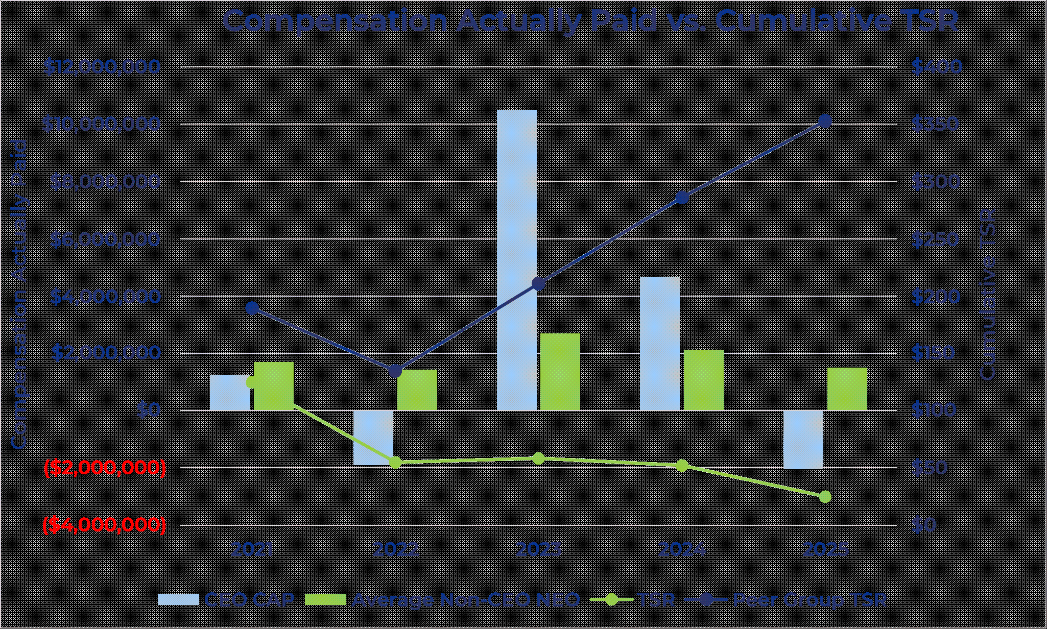

70

Table of Contents

Compensation Actually Paid versus Net Income
The following graph illustrates the relationship between net income and CAP. The Company does not use net income as a performance measure in its overall executive compensation program.

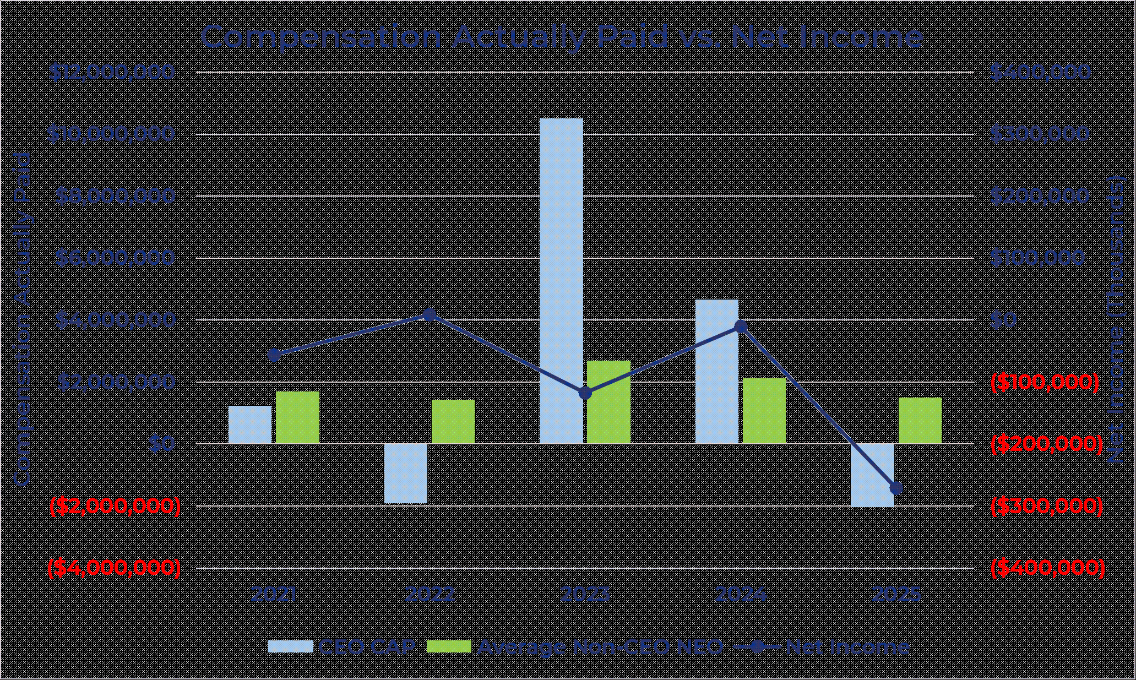

71

Table of Contents

Compensation Actually Paid and Adjusted EBITDA
The following graph demonstrates the amount of compensation actually paid to Mr. Morris and the average amount of compensation actually paid to the Company’s NEOs as a group (excluding Mr. Morris) as compared with the Company’s Adjusted EBITDA over the four years presented in the table. While the Company uses numerous financial and non-financial performance measures for the purpose of evaluating performance for the Company’s compensation programs, the Company has determined that Adjusted EBITDA is the financial performance measure that, in the Company’s assessment, represents the most important performance measure (that is not otherwise required to be disclosed in the table) used by the Company to link compensation actually paid to the company’s NEOs, for the most recently completed fiscal year, to Company performance. The Company utilizes Adjusted EBITDA when setting goals for annual performance-based cash incentives under each NEO’s employment agreement and long-term equity incentives.

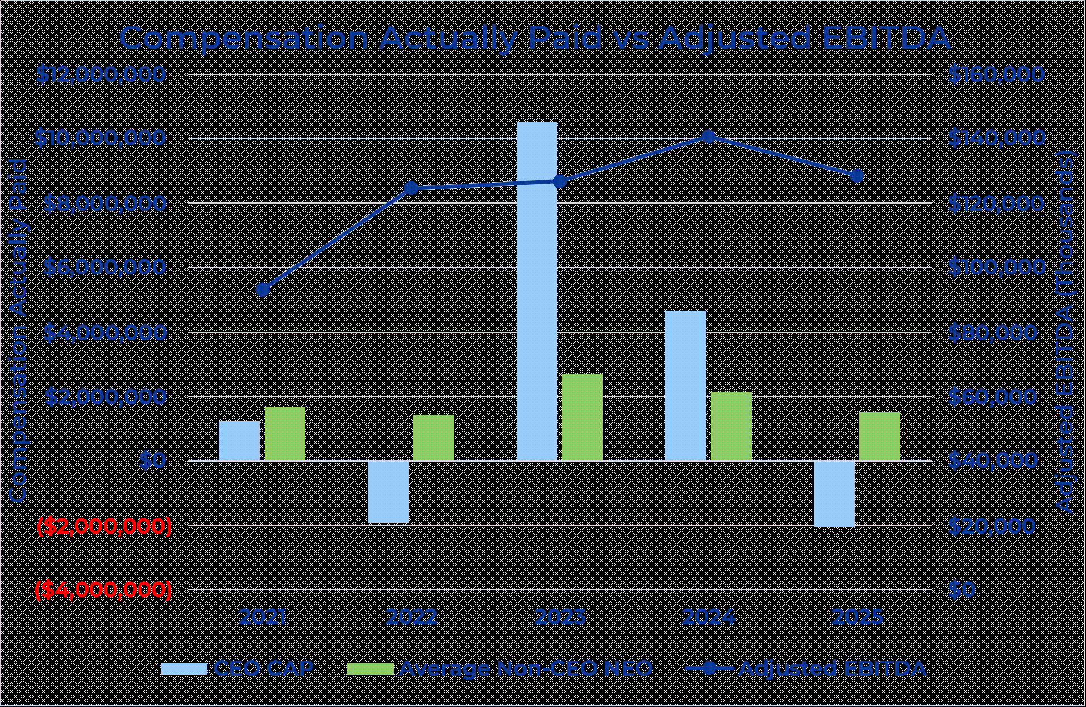

72

Table of Contents

DIRECTOR COMPENSATION

2025 Director Compensation Table
The following table sets forth information concerning the annual and long-term compensation awarded to, earned by, or paid to each non-employee director for all services rendered in all capacities to our company, or any of its subsidiaries, for the last fiscal year.

Name(1) |  | Fees Earned or  Paid in Cash  ($) (2) |  |  |  |  |  | Stock Awards  ($) (3) (4) |  |  |  |  |  | Total  ($)
Peter J. Kight |  |  |  | 70,417 |  |  |  |  |  | 250,000 |  |  |  |  |  | 320,417
Paul R. Garcia |  |  |  | 59,611 |  |  |  |  |  | 170,000 |  |  |  |  |  | 229,611
Maryann Goebel |  |  |  | 50,000 |  |  |  |  |  | 170,000 |  |  |  |  |  | 220,000
Robert Hartheimer |  |  |  | 56,803 |  |  |  |  |  | 170,000 |  |  |  |  |  | 226,803
William Jacobs |  |  |  | 127,000 |  |  |  |  |  | — |  |  |  |  |  | 127,000
Emnet Rios |  |  |  | 54,708 |  |  |  |  |  | 170,000 |  |  |  |  |  | 224,708
Richard E. Thornburgh |  |  |  | 52,126 |  |  |  |  |  | 170,000 |  |  |  |  |  | 222,126

(1)
Each of John Morris’ and Shaler Alias’ compensation is disclosed under “Executive Compensation.” Shaler Alias resigned from the Board, effective February 27, 2026. William Jacobs retired from the Board and did not stand for re-election in 2025. Robert Hartheimer resigned from the Board, effective October 28, 2025.
(2)
Amount includes a one-time cash payment of $100,000 to William Jacobs in connection with his retirement from the Board and in recognition of previous service.
(3)
Amounts shown are the grant date fair value of each award computed in accordance with FASB ASC Topic 718. The aggregate dollar value of the restricted stock units is based on $5.00 per share of Class A common stock on June 12, 2025.
(4)
The aggregate number of stock awards outstanding for each continuing director (other than Mr. Kight and Ms. Rios) as of December 31, 2025 is 114,856. The aggregate number of stock awards outstanding for Mr. Kight as of December 31, 2025 is 156,175. The aggregate number of stock awards outstanding for Ms. Rios as of December 31, 2025 is 97,103.

Narrative Disclosure to Director Compensation Table
Under our non-employee director compensation policy, we compensate our non-employee directors with a combination of cash and equity in the form of restricted stock units. In addition, we reimburse directors for their reasonable out-of-pocket expenses incurred in connection with attending Board and committee meetings.
Annual Cash Retainer
Under the non-employee director compensation policy, non-employee directors are entitled to an annual cash retainer of $40,000, which is paid quarterly in arrears on October 1, January 1, April 1 and July 1 of each year. The value of the annual cash retainer is unchanged since 2022. The non-executive chairman is entitled to an additional cash retainer of $20,000 which is paid quarterly in arrears on October 1, January 1, April 1 and July 1 of each year.
73

Table of Contents

Annual Equity Award
An annual equity award is awarded to incumbent directors at each stockholders’ meeting in the form of restricted stock units, calculated based on the closing price on the grant date (or the most recent trading day if such date is not a trading day) and rounded down to the nearest whole unit. Restricted stock units vest on the earlier of (1) the first anniversary of the date of grant and (2) the next regularly scheduled annual meeting of stockholders that is at least 50 weeks after the date of grant. Vesting also accelerates upon a change of control or termination from service as a result of the director’s death or disability. Vested restricted stock units are settled on the earlier of (x) the date the director undergoes a “separation from service” as defined in Section 409A of the Internal Revenue Code and (y) a change of control. For fiscal 2025, each continuing director received an award of approximately $170,000 in restricted stock units. The target value of the annual equity award has remained $170,000 since 2022. The non-executive chairman received an award of approximately $250,000, which is reflective of his leadership role and responsibilities.
Committee and Committee Chair Fees
The non-employee director compensation policy also provides that non-employee directors serving as an Audit Committee member will receive an additional $7,500 cash payment annually. Directors serving as committee members of another committee (other than the Audit Committee) will receive an additional $5,000 cash payment annually. Such payments are made quarterly in arrears on October 1, January 1, April 1 and July 1 of each year.
Directors serving as committee chairpersons will receive additional cash compensation. The non-employee director compensation policy entitles the Audit Committee chairperson to $20,000, the Compensation Committee chairperson to $15,000 and all other committee chairpersons (other than audit and compensation) to $10,000 (in each case, on an annual basis). Such payments are made quarterly in arrears on October 1, January 1, April 1 and July 1 of each year.
74

Table of Contents

COMPENSATION COMMITTEE INTERLOCKS AND INSIDER PARTICIPATION
The members of our Compensation Committee are currently Paul R. Garcia and Richard E. Thornburgh.
None of our executive officers currently serve, and in the past year has not served, (i) as a member of the compensation committee or the board of directors of another entity, one of whose executive officers served on our Compensation Committee, (ii) as a director of another entity, one of whose executive officers served on our Compensation Committee, or (iii) as a member of the compensation committee of another entity, one of whose officers served on our Board.
75

Table of Contents

COMPENSATION COMMITTEE REPORT
The Compensation Committee has reviewed and discussed the Compensation Discussion and Analysis contained in this Proxy Statement with management. Based upon such review, the related discussions and such other matters deemed relevant and appropriate to the Compensation Committee, the Compensation Committee has recommended to the Board that the Compensation Discussion and Analysis be included in the Proxy Statement for the 2026 Annual Meeting of Stockholders.
Submitted by the Compensation Committee:
Paul R. Garcia, Chairperson
Richard E. Thornburgh
The Compensation Committee report does not constitute soliciting material and shall not be deemed to be filed or incorporated by reference into any other filing under the Securities Act of 1933, or the Securities Exchange Act of 1934, except to the extent that the Company specifically incorporates the Compensation Committee report by reference therein.
76

Table of Contents

SECURITY OWNERSHIP OF CERTAIN BENEFICIAL OWNERS AND MANAGEMENT

Beneficial Ownership Table
The following table sets forth certain information regarding the beneficial ownership of our Class A common stock, our Class V common stock and the limited liability company interests of Hawk Parent (the “Post-Merger Repay Units”) as of [●], the record date for the Annual Meeting.
In connection with the Business Combination, equityholders of Hawk Parent received as consideration for their existing limited liability company interests of Hawk Parent an amount of cash and a number of Post-Merger Repay Units. In connection with the issuance of such Post-Merger Repay Units, we issued to Hawk Parent, as the surviving company following the Merger, 100 shares of Class V common stock of the Company, and Hawk Parent distributed one share of Class V common stock to each holder of Post-Merger Repay Units. Limited liability company interests of Hawk Parent held by the Company or any of its subsidiaries are not reflected as Post-Merger Repay Units for any purposes in these tables.
The information is provided with respect to (1) each person who is known by us to own beneficially more than 5% of the outstanding shares of our Class A common stock, (2) each of our directors, (3) each of our NEOs and (4) all of our directors and executive officers, as a group.
Beneficial ownership is determined in accordance with the rules of the SEC, which generally deem a person to beneficially own any shares of our Class A common stock the person has or shares voting or dispositive power over and any additional shares obtainable within 60 days through the exercise of options, warrants or other purchase rights. Unless otherwise indicated, each person possesses sole voting and investment power with respect to the shares identified as beneficially owned. Percentage of beneficial ownership is based on 89,683,117 shares of our Class A Common Stock and 5,285,883 Post-Merger Repay Units outstanding on [●], the record date for the Annual Meeting
Unless otherwise indicated, we believe that all persons named in the table have sole voting and investment power with respect to all shares beneficially owned by them. No director or executive officer has pledged any of the shares or units disclosed below. Unless otherwise noted, the business address of each of the following entities or individuals is 3060 Peachtree Road NW, Suite 1100, Atlanta, Georgia 30305.
77

Table of Contents

Beneficial Ownership of Repay Holdings Corporation
Name |  | Class A  common  stock (1) |  |  |  |  |  | % of  Class (2) |  |  |  |  |  | Company  Voting  Power % (3) (4)
Directors and Named Executive Officers:
John Morris (5) |  |  |  | 7,246,086 |  |  |  |  |  | 7.8 | % |  |  |  |  | 7.6 | %
Shaler Alias (6) |  |  |  | 1,608,342 |  |  |  |  |  | 1.8 | % |  |  |  |  | 1.7 | %
Robert S. Houser (7) |  |  |  | 311,904 |  |  |  |  | * |  |  |  |  |  | *
Timothy J. Murphy (8) |  |  |  | 338,282 |  |  |  |  | * |  |  |  |  |  | *
Tyler B. Dempsey (9) |  |  |  | 550,143 |  |  |  |  | * |  |  |  |  |  | *
David Guthrie (10) |  |  |  | 545,524 |  |  |  |  | * |  |  |  |  |  | *
Thomas Sullivan (11) |  |  |  | 248,561 |  |  |  |  | * |  |  |  |  |  | *
Paul R. Garcia (12) |  |  |  | 180,656 |  |  |  |  | * |  |  |  |  |  | *
Maryann Goebel (12) |  |  |  | 114,856 |  |  |  |  | * |  |  |  |  |  | *
Peter J. Kight (12) |  |  |  | 1,670,070 |  |  |  |  |  | 1.9 | % |  |  |  |  | 1.8 | %
Emnet Rios (12) |  |  |  | 97,103 |  |  |  |  | * |  |  |  |  |  | *
Richard E. Thornburgh (12) (13) |  |  |  | 232,721 |  |  |  |  | * |  |  |  |  |  | *
All Directors and Executive Officers as a Group (13 persons) (12) |  |  |  | 12,880,760 |  |  |  |  |  | 13.6 | % |  |  |  |  | 14.1 | %
5% Stockholders
Forager Fund, L.P. (14) |  |  |  | 11,106,648 |  |  |  |  |  | 12.4 | % |  |  |  |  | 11.7 | %
Beckham Aggregator, L.P. (15) |  |  |  | 8,907,540 |  |  |  |  |  | 9.9 | % |  |  |  |  | 9.4 | %
Veradace Partners L.P. (16) |  |  |  | 7,355,504 |  |  |  |  |  | 8.2 | % |  |  |  |  | 7.7 | %
Private Management Group, Inc. (17) |  |  |  | 5,412,492 |  |  |  |  |  | 6.0 | % |  |  |  |  | 5.7 | %
BlackRock, Inc. (18) |  |  |  | 5,272,940 |  |  |  |  |  | 5.9 | % |  |  |  |  | 5.6 | %

* less than one percent.
(1)
Interests shown consist of Class A common stock and the Class A common stock exchangeable for Post-Merger Repay Units pursuant to the Exchange Agreement (described under section entitled “Related Party Transactions” below). Subject to the terms of the Exchange Agreement and the Hawk Parent Limited Liability Company Agreement, each holder of a Post-Merger Repay Unit, subject to certain limitations, has the right to cause Hawk Parent to acquire all or a portion of its Post-Merger Repay Units for shares of our Class A common stock at an initial exchange ratio of one share of Class A common stock for each Post-Merger Repay Unit exchanged (subject to adjustments for any subdivisions or combination of the Post-Merger Repay Units that is not accompanied by an identical subdivision or combination of our Class A common stock or, by any such subdivision or combination of our Class A common stock that is not accompanied by an identical subdivision or combination of the Post-Merger Repay Unit). In connection with such exchange, the corresponding number of shares of Post-Merger Repay Units will be cancelled. The Company has the option to deliver cash in lieu of shares of Class A common stock upon exercise by such holder of its exchange right. However, beneficial ownership is reflected here to include beneficial ownership of shares of our Class A common stock for which such Post-Merger Repay Units may be exchanged. The “Beneficial Ownership of Hawk Parent, LLC” table below reflects the number of Post-Merger Repay Units held by each of the persons in the table above. For clarity, each such number of Post-Merger Repay Units is already included in the Class A common stock column in the table above as described.
78

Table of Contents

Beneficial Ownership of Hawk Parent, LLC
(included in Beneficial Ownership of Repay Holdings Corporation table above)

Name |  | Class V  common  stock / Post-  Merger  Repay  Units (3) |  |  |  |  |  | % of  ownership  of Hawk  Parent,  LLC
Directors and Named Executive Officers:
John Morris |  |  |  | 3,658,529 |  |  |  |  |  | 69.2 | %
Shaler Alias |  |  |  | 878,072 |  |  |  |  |  | 16.6 | %
Timothy Murphy |  |  |  | — |  |  |  |  |  | —
Robert S. Houser |  |  |  | — |  |  |  |  |  | —
Tyler B. Dempsey |  |  |  | — |  |  |  |  |  | —
David Guthrie |  |  |  | — |  |  |  |  |  | —
Jacob H. Moore |  |  |  | — |  |  |  |  |  | —
Paul R. Garcia |  |  |  | — |  |  |  |  |  | —
Maryann Goebel |  |  |  | — |  |  |  |  |  | —
Peter J. Kight |  |  |  | — |  |  |  |  |  | —
Emnet Rios |  |  |  | — |  |  |  |  |  | —
Richard E. Thornburgh |  |  |  | — |  |  |  |  |  | —
All Directors and Executive Officers as a Group (13 persons) |  |  |  | 4,536,601 |  |  |  |  |  | 85.8 | %

(2)
To calculate a stockholder’s percentage of beneficial ownership of Class A common stock, we must include in the numerator and denominator those shares of Class A common stock obtainable within 60 days through the exercise of options, warrants or other purchase rights (including the shares underlying Post-Merger Repay Units that such stockholder is considered to beneficially own). Shares of Class A common stock obtainable within 60 days through the exercise of options, warrants or other purchase rights held by other stockholders, however, are disregarded in this calculation. Therefore, the denominator used in calculating beneficial ownership of Class A common stock of each of the stockholders may be different.
(3)
Each holder of Post-Merger Repay Units also holds one share of our Class V common stock and is entitled to a number of votes that is equal to the product of (i) the total number of Post-Merger Repay Units held by such holder multiplied by (ii) the exchange ratio between the Post-Merger Repay Units and Class A common stock, which will initially be one-for-one. Subject to the terms of the Exchange Agreement, the Post-Merger Repay Units are initially exchangeable for shares of Class A common stock.
(4)
Represents percentage of voting power of our Class A common stock and Class V common stock voting together as a single class.
(5)
Represents securities held of record by (i) John Morris, individually, (ii) The Morris Dynasty Trust dated April 30, 2024 (the “Morris Family Trust’), (iii) The John A. Morris Irrevocable Trust #1 (the “Irrevocable Trust”), (iv) the 2018 JAM Family Charitable Trust dated March 1, 2018 (the “JAM Family Charitable Trust”), (v) JOSEH Holdings, LLC and (vi) JAM Family Investments, Inc. (together with the Morris Family Trust, the Irrevocable Trust, the JAM Family Charitable Trust and JOSEH Holdings, LLC, the “Morris Entities”). John Morris’ spouse is the trustee of the Morris Family Trust and Mr. Morris’ spouse and descendants are the beneficiaries of the Morris Family Trust. John Morris’ spouse is also the trustee of the Irrevocable Trust and Mr. Morris, Mr. Morris’ spouse and descendants are the beneficiaries of the Irrevocable Trust. John Morris is the sole trustee of the JAM Family Charitable Trust. John Morris owns all of the voting ownership interests of JOSEH Holdings, LLC and serves as the sole member of its board of managers. John Morris (through a revocable trust of which he is the sole trustee) owns all of the voting shares of JAM Family Investments, Inc. and is the sole member of its board of directors. The number of shares of Class A common stock beneficially owned by Mr. Morris includes (a) 1,028,385 shares of Class A common stock held directly by the Morris Family Trust, (b) 86,761 shares of Class A common stock held directly by the Irrevocable Trust, (c) 338,444 Post-Merger Repay Units held directly by the JAM Family Trust, (d) 3,239,397 Post-Merger Repay Units and/or shares of Class A common stock held directly by JOSEH Holdings, LLC, (e) 15,000 shares of Class A common stock held directly by JAM Family
79

Table of Contents

Investments, Inc., and (f) 1,695,000 shares of restricted Class A common stock that remain subject to time-based vesting (for which Mr. Morris has sole voting power but no investment power). Mr. Morris is an officer and director of the Company.
(6)
Represents securities held of record by (i) Shaler Alias, individually, and (ii) Alias Holdings, LLC (“Alias Holdings”). Shaler Alias owns all of the voting ownership interests of Alias Holdings. He also serves as the sole member of its board of managers. The number of shares of Class A common stock beneficially owned by Mr. Alias includes 732,987 Post-Merger Repay Units and/or shares of Class A common stock held directly by Alias Holdings. Mr. Alias separated from the Company effective February 27, 2026. The information set forth herein is based on the Company’s records and publicly available filings.
(7)
All of the shares of Class A common stock beneficially owned by Robert S. Houser represent shares of restricted Class A common stock that remain subject to time-based vesting (for which Mr. Houser has sole voting power but no investment power). Mr. Houser is an officer of the Company.
(8)
Represents securities held of record by (i) Timothy Murphy, individually, and (ii) The TKM Charitable Remainder Unitrust (“TKM CRUT”). Mr. Murphy is the sole trustee of TKM CRUT. The number of shares of Class A common stock beneficially owned by Mr. Murphy includes 52,000 shares of Class A common stock held directly by TKM CRUT. Mr. Murphy was an officer of the Company through May 15, 2025. The information set forth herein is based on the Company’s records and publicly available filings.
(9)
The number of shares of Class A common stock beneficially owned by Tyler B. Dempsey includes (a) 58,892 shares of Class A common stock underlying options that are currently exercisable and (b) 286,836 shares of restricted Class A common stock that remain subject to time-based vesting (for which Mr. Dempsey has sole voting power but no investment power). Mr. Dempsey is an officer of the Company.
(10)
The number of shares of Class A common stock beneficially owned by David Guthrie includes (a) 88,339 shares of Class A common stock underlying options that are currently exercisable and (b) 337,770 shares of restricted Class A common stock that remain subject to time-based vesting (for which Mr. Guthrie has sole voting power but no investment power). Mr. Guthrie is an officer of the Company.
(11)
The number of shares of Class A common stock beneficially owned by Thomas Sullivan includes 168,179 shares of restricted Class A common stock that remain subject to time-based vesting (for which Mr. Sullivan has sole voting power but no investment power). Mr. Sullivan served as Interim Chief Financial Officer of the Company.
(12)
For each non-employee director (other than Mr. Kight and Ms. Rios), includes 114,856 shares issuable under restricted stock units that are vested or scheduled to vest on [●], 2026. For Mr. Kight, includes 156,175 shares issuable under restricted stock units that are vested or scheduled to vest on [●]. For Ms. Rios, includes 97,103 shares issuable under restricted stock units that are vested or scheduled to vest on [●].
(13)
Includes 101,265 shares of Class A common stock held by Thornburgh Family Foundation (for which Mr. Thornburgh has shared voting power and shared investment power).
(14)
Based solely on information contained in the Schedule 13D/A filed with the SEC on April 13, 2026 by Forager Fund, L.P. (“Forager Fund”), Forager Capital Management, LLC (“Forager GP”), Edward Kissel and Robert MacArthur, pursuant to which each of Forager Fund and Forager GP reports sole voting power and sole dispositive power over all of the reported shares, and each of Messrs. Kissel and MacArthur reports shared voting power and shared dispositive power over all of the reported shares. Forager GP is the sole general partner of Forager Fund and may be deemed to beneficially own the securities owned by Forager Fund. Each of Messrs. Kissel and MacArthur is a principal of Forager GP and has shared authority to vote (or direct the vote of), and to dispose (or direct the disposal) of, the shares on behalf of Forager GP. The principal business address for Forager Fund, Forager GP and Messrs. Kissel and MacArthur is 2025 3rd Avenue North, Suite 350, Birmingham, AL 35203.
(15)
Based solely on information contained in the Schedule 13D filed with the SEC on February 20, 2024 by BT Parent GP, LLC “BT Parent GP”) and Beckham Aggregator, L.P (“Beckham Aggregator”), who each report shared voting power and shared dispositive power over all of the shares. BT Parent GP is the general partner of Beckham Aggregator. The principal business address for each entity identified in this paragraph is c/o Parthenon Capital Partners, Four Embarcadero Center, Suite 3610, San Francisco, CA 94111.
(16)
Based solely on information contained in the Schedule 13D filed with the SEC on April 15, 2026 by Veradace Capital Management LLC (“Veradace Capital”), Veradace, Alexander Vezendan and John Conlin, who each report shared voting power and shared dispositive power over all of the reported shares. The shares beneficially owned consist of 7,245,104 shares of Class A common stock and options to purchase 110,400 shares of Class A common stock. Veradace is the record and direct beneficial owner of the reported securities. Veradace Capital is the investment advisor to Veradace Fund and may be deemed to beneficially own the securities owned by Veradace. Messrs. Vezendan and Conlin are the principals of, and may be deemed to beneficially own securities owned by, Veradace Capital. The principal business address for Veradace Capital, Veradace, and Messrs. Vezendan and Conlin is 3889 Maple Avenue, Suite 220, Dallas, TX 75219.
(17)
Based solely on information contained in the Schedule 13G/A filed with the SEC on February 10, 2026 by Private Management Group Inc., who reports sole voting power and sole dispositive power over all of the reported shares. The principal business address for Private Management Group Inc. is 15635 Alton Parkway, Suite 400, Irvine, CA 92618.
80

Table of Contents

(18)
Based solely on information contained in the Schedule 13G/A filed with the SEC on January 21, 2026 by BlackRock, Inc., who reports sole voting power over 5,201,134 of the shares and sole dispositive power over all of the reported shares. The principal business address for BlackRock, Inc. is 50 Hudson Yards, New York, NY 10001.

Changes in Control
There are no arrangements, known to Repay, including any pledge by any person of securities of Repay or any of its parents, the operation of which may at a subsequent date result in a change in control of Repay.
81

Table of Contents

DELINQUENT SECTION 16(a) REPORTS
Section 16(a) of the Exchange Act requires our executive officers, directors and persons who beneficially own more than 10% of a registered class of our equity securities to file with the SEC initial reports of ownership and reports of changes in ownership of our ordinary shares and other equity securities. These executive officers, directors, and greater than 10% beneficial owners are required by SEC regulation to furnish us with copies of all Section 16(a) forms filed by such reporting persons. Based solely on our review of such forms furnished to us and written representations from certain reporting persons, we believe that all filing requirements applicable to our executive officers, directors and greater than 10% beneficial owners were filed in a timely manner during the year ended December 31, 2025.
82

Table of Contents

RELATED PARTY TRANSACTIONS

Transactions with Related Persons
Post-Business Combination Arrangements
Exchange Agreement
In connection with the Closing, we entered into the Exchange Agreement with holders (the “Repay Unitholders”) of the Post-Merger Repay Units, including John Morris, Shaler Alias, William Jacobs, Tim Murphy and Jacob Moore, which provides the Repay Unitholders with the right to elect to exchange such Post-Merger Repay Units into shares of Class A common stock (as described below). The Exchange Agreement provides that Repay Unitholders are able to exchange all or any portion of their Post-Merger Repay Units for shares of Class A common stock by delivering a written notice to both Hawk Parent and us and surrendering such Post-Merger Repay Units to us, subject to certain limitations. The initial exchange ratio is one Post-Merger Repay Unit for one share of Class A common stock. The exchange ratio will be adjusted for any subdivision (split, unit distribution, reclassification, reorganization, recapitalization or otherwise) or combination (by reverse unit split, reclassification, reorganization, recapitalization or otherwise) of the Post-Merger Repay Units that is not accompanied by an identical subdivision or combination of the Class A common stock or, by any such subdivision or combination of the Class A common stock that is not accompanied by an identical subdivision or combination of the Post-Merger Repay Units. If the Class A common stock is converted or changed into another security, securities or other property, on any subsequent exchange an exchanging Repay Unitholder will be entitled to receive such security, securities or other property. The exchange ratio will also adjust in certain circumstances when we acquire Post-Merger Repay Units other than through an exchange for our shares of Class A common stock.
Hawk Parent and each Repay Unitholder will bear its own expense regarding any exchange, except that Hawk Parent will be responsible for transfer tax, stamp taxes and similar duties (unless the applicable holder has requested that the Company issue the shares of Class A common stock in the name of another holder).
Tax Receivable Agreement
In connection with the Closing, we entered into the Tax Receivable Agreement with the Repay Unitholders.
As described above, Repay Unitholders may, subject to certain conditions, exchange their Post-Merger Repay Units for our shares of Class A common stock on a one-for-one basis, subject to the terms of the Exchange Agreement, including in certain cases adjustments as set forth therein. Hawk Parent currently has and will have in effect an election under Section 754 of the Internal Revenue Code for each taxable year in which an exchange of Post-Merger Repay Units for shares of Class A common stock occurs, which is expected to result in increases to the tax basis of the assets of Hawk Parent at the time of an exchange of Post-Merger Repay Units. These increases in tax basis may reduce the amount of tax that we would otherwise be required to pay in the future. These increases in tax basis may also decrease gains (or increase losses) on future dispositions of certain capital assets to the extent tax basis is allocated to those capital assets.
The Tax Receivable Agreement provides for the payment by us to exchanging Repay Unitholders of 100% of the tax benefits, if any, that we realize (or in certain cases are deemed to realize) as a result of these increases in tax basis and certain other tax attributes of Hawk Parent and tax benefits related to entering into the Tax Receivable Agreement,
83

Table of Contents

including tax benefits attributable to payments under the Tax Receivable Agreement. This payment obligation is an obligation of the Company and not of Hawk Parent. For purposes of the Tax Receivable Agreement, the cash tax savings in income tax will be computed by comparing the actual income tax liability of the Company (calculated with certain assumptions) to the amount of such taxes that the Company would have been required to pay had there been no increase (or decrease) to the tax basis of the assets of Hawk Parent as a result of the exchanges and had the Company not entered into the Tax Receivable Agreement. Such increase or decrease will be calculated under the Tax Receivable Agreement without regard to any transfers of Post-Merger Repay Units or distributions with respect to Post-Merger Repay Units before the exchange under the Exchange Agreement.
The term of the Tax Receivable Agreement will continue until all such tax benefits have been utilized or expired unless the Company exercises its right to terminate the Tax Receivable Agreement for an amount representing the present value of anticipated future tax benefits of the Tax Receivable Agreement. In addition, if there is a Change of Control, as such term is defined in the Tax Receivable Agreement, then with respect to any exchange of Post-Merger Repay Units for our shares of Class A common stock occurring prior to such Change of Control, the Company’s obligations under the Tax Receivable Agreement will be accelerated as if the Company exercised its right to terminate the Tax Receivable Agreement as of the date of the Change of Control.
We expect that, as a result of the size of the increases in the tax basis of the tangible and intangible assets of Hawk Parent, the payments that we may make under the Tax Receivable Agreement will be substantial. There may be a material negative effect on our liquidity if, as a result of timing discrepancies or otherwise, the payments under the Tax Receivable Agreement exceed the actual cash tax savings that we realize in respect of the tax attributes subject to the Tax Receivable Agreement and/or distributions to the Company by Hawk Parent are not sufficient to permit the Company to make payments under the Tax Receivable Agreement after it has paid taxes. Late payments under the Tax Receivable Agreement generally will accrue interest at an uncapped rate equal to Term SOFR plus 571.513 basis points. The payments under the Tax Receivable Agreement are not conditioned upon continued ownership of us by Repay Unitholders. The rights of each party under the Tax Receivable Agreement other than the Company are assignable.
In respect of tax returns filed during the year ended December 31, 2025, we made payments under the Tax Receivable Agreement exceeding $120,000 to the following related parties: approximately $635,782 to John Morris (including certain affiliated entities), approximately $1,033,101 to Shaler Alias (including certain affiliated entities) and approximately $260,833 to Tim Murphy (including certain affiliated entities).
Founders’ Stockholders Agreement
In connection with the Closing, the Company entered into a Stockholders Agreement with Mr. Alias and Mr. Morris (together, the “Repay Founders”) (the “Founders’ Stockholders Agreement”).
Under the Founders’ Stockholders Agreement, Mr. Morris and Mr. Alias were designated to serve on our Board. The Founders’ Stockholders Agreement provides that (i) if Mr. Morris ceases to serve as CEO of the Company, he will immediately resign as a director and will no longer be entitled to be designated to our Board, and (ii) if Mr. Alias ceases to serve as President of the Company, he will immediately resign as a director and no longer be entitled to be designated to our Board. Following Mr. Alias’ resignation from the Board on February 27, 2026, Mr. Morris (as the beneficial holder of a majority of the shares of Class A common stock beneficially owned by the Repay Founders) is entitled to
84

Table of Contents

designate one designee for nomination to our Board as an independent director (the “Independent Founder Designee” and together with Mr. Morris if serving as a designee under the foregoing provisions, the “Founder Designees”).
Each Founder Designee must be eligible to serve as a director, and the Independent Founder Designee must be independent, in each case under applicable Nasdaq rules (or any other market upon which shares of Class A common stock are then traded). Mr. Morris may only be removed upon termination of service as described above, and the Independent Founder Designee may only be removed with the consent of the Repay Founders. In the event of any vacancy with respect to the seat of the Independent Founder Designee, we will use our best efforts to fill such vacancy with such person as designed by the Repay Founders. We also agree to use our best efforts to cause the Founder Designees to be elected to our Board. Additionally, any change in the size of our Board requires the consent of the Repay Founders. Mr. Morris will not be entitled to compensation (other than as an officer of the Company and expense reimbursements), but the Independent Founder Designee will be entitled to receive compensation consistent with the compensation received by other non-employee directors, including any fees and equity awards. Each Founder Designee will be entitled to the same rights and privileges applicable to all other members of Board, including indemnification and exculpation rights and director and officer insurance.
Repay Unitholders Registration Rights Agreement
In connection with the Closing, we entered into the Repay Unitholders Registration Rights Agreement with Corsair Capital LLC (“Corsair”) and the other Repay Unitholders. Under the Repay Unitholders Registration Rights Agreement, the Repay Unitholders are entitled to registration rights that obligate the Company to register for resale under the Securities Act all or any portion of the shares of Class A common stock issuable upon exchange for Post-Merger Repay Units pursuant to the Exchange Agreement so long as such shares are not then restricted under any applicable support agreement or escrow agreement.
Under the Repay Unitholders Registration Rights Agreement, we have agreed to indemnify the Repay Unitholders and each underwriter and each of their respective controlling persons against any losses or damages resulting from any untrue statement or omission of a material fact in any registration statement or prospectus pursuant to which they sell shares, unless such liability arises from their misstatement or omission, and Repay Unitholders have agreed to indemnify the Company and our officers and directors and controlling persons against all losses caused by their misstatements or omissions in those documents.
Amended Operating Agreement
Concurrently with the completion of the Business Combination, the existing amended and restated limited liability company agreement of Hawk Parent was amended and restated in its entirety to become the Amended Operating Agreement. Pursuant to the Amended and Restated Operating Agreement, the Post-Merger Repay Units are entitled to share in the profits and losses of Hawk Parent and to receive distributions as and if declared by the managing member of Hawk Parent and will have no voting rights. The Company, as managing member of Hawk Parent may, in its sole discretion, authorize distributions to the Hawk Parent members. All such distributions will be made pro rata in accordance with each member’s interest in Hawk Parent.
The Amended Operating Agreement also provides for cash distributions, which we refer to as “tax distributions,” to the holders of Post-Merger Repay Units if the Company, as
85

Table of Contents

the sole managing member of Hawk Parent, reasonably determines that a holder, by reason of holding Post-Merger Repay Units, incurs an income tax liability. Generally, these tax distributions will be computed based on the Company’s estimate of the net taxable income of Hawk Parent multiplied by an assumed tax rate equal to the highest effective marginal combined United States federal, state and local income tax rate prescribed for an individual or corporate resident in New York, New York (taking into account the non-deductibility of certain expenses and the character of the Company’s income).
Upon the liquidation or winding up of Hawk Parent, all net proceeds thereof will be distributed one hundred percent (100%) to the holders of Post-Merger Repay Units, pro rata based on their percentage interests.
Indemnification of Directors and Officers
Our Bylaws provide that we will indemnify our directors and officers to the fullest extent permitted by the Delaware General Corporate Law (“DGCL”). In addition, our Certificate of Incorporation provides that our directors will not be liable for monetary damages for breach of fiduciary duty to the fullest extent permitted by the DGCL.
In addition, we have entered into indemnification agreements with each of our executive officers and directors. The indemnification agreements provide the executive officers and directors with contractual rights to indemnification, expense advancement, and reimbursement to the fullest extent permitted under the DGCL.
There is no pending litigation or proceeding naming any of our directors or officers to which indemnification is being sought, and we are not aware of any pending or threatened litigation that may result in claims for indemnification by any director or officer.

Review, Approval or Ratification of Transactions with Related Persons
Under Nasdaq Marketplace Rules, our Audit Committee (or another independent body of our Board) is required to conduct an appropriate review of all related party transactions for potential conflict of interest situations on an ongoing basis. In accordance with our Nominating and Corporate Governance Committee’s charter, the Nominating and Corporate Governance Committee must review and oversee all related party transactions. For these purposes, a “related party transaction” refers to all transactions for which review or oversight is required by applicable law or Nasdaq rules or that are required to be disclosed in the notes to Repay’s financial statements or in Repay’s SEC filings.
We have adopted a formal written policy providing that our officers, directors, nominees for election as directors, beneficial owners of more than 5% of any class of our capital stock, any member of the immediate family of any of the foregoing persons and any firm, corporation or other entity in which any of the foregoing persons is employed or is a general partner or principal or in a similar position or in which such person has a 5% or greater beneficial ownership interest, are not permitted to enter into a related party transaction with the Company without the approval of the Nominating and Corporate Governance Committee, subject to certain exceptions.

86

Table of Contents

AUDITOR FEES
The Audit Committee selected Grant Thornton LLP (“Grant Thornton”) to serve as our independent registered accounting firm for the fiscal year ending December 31, 2026. We first engaged Grant Thornton in 2018, and it has served as our principal accounting firm since that date. The following table shows the fees for professional services rendered by Grant Thornton for the audit of our annual financial statements for the years ended December 31, 2025 and December 31, 2024, and fees billed for other services rendered by Grant Thornton during those periods.

 |  | 2025 |  |  |  |  |  | 2024
Audit Fees (1) |  |  | $ | 1,804,433 |  |  |  |  | $ | 2,000,078
Audit-Related Fees (2) |  |  |  | — |  |  |  |  |  | —
Tax Fees (3) |  |  |  | — |  |  |  |  |  | —
All Other Fees (4) |  |  |  | — |  |  |  |  |  | —
Total |  |  | $ | 1,804,433 |  |  |  |  | $ | 2,000,078

(1)
Audit Fees. Audit Fees consist of fees for professional services rendered for the audits of our annual consolidated financial statements, reviews of unaudited condensed consolidated quarterly financial statements, and consent procedures required in connection with our Form S-3 Registration Statements and Form S-8 Registration Statements.
(2)
Audit-Related Fees. Audit-Related Fees consist of fees for professional services that are reasonably related to the performance of the audit or review of the Company’s financial statements and are not reported under “Audit Fees.”
(3)
Tax Fees. Tax Fees consist of fees for professional services rendered with respect to federal and state tax compliance and tax advice. This can include preparation of tax returns, claims for refunds, payment planning, and tax law interpretation.
(4)
All Other Fees. All Other Fees consist of fees for professional services or costs not otherwise reported in Audit Fees, Audit-Related Fees or Tax Fees.
All audit-related services, tax services and other non-audit services were pre-approved by the Audit Committee, which concluded that the provision of such services by Grant Thornton was compatible with the maintenance of that firm’s independence in the conduct of its auditing functions. The Audit Committee’s outside auditor independence policy provides for pre-approval of audit and audit-related services specifically described by the committee on an annual basis and, in addition, individual engagements anticipated to exceed pre-established thresholds must be separately approved.
87

Table of Contents

PROPOSAL TWO:

ADVISORY VOTE ON EXECUTIVE COMPENSATION
As required by Section 14A of the Exchange Act, we are providing our stockholders with the opportunity at the Annual Meeting to vote on a non-binding advisory resolution, commonly known as a “say-on-pay” proposal, approving the compensation of our NEOs. This vote is not intended to address any specific item of compensation or the compensation of any specific NEO, but rather the overall compensation of our NEOs and the philosophy, policies and practices described in this Proxy Statement. A discussion of these items is found in the Compensation Discussion and Analysis section of this Proxy Statement.
Our executive compensation programs are designed to achieve three primary objectives: (i) attract, retain and motivate a highly-talented executive team; (ii) align the objectives and interests of our executives with those of our stockholders in order to increase overall value and output within the Company; and (iii) promote the achievement of key financial and strategic milestones. The Compensation Committee strives to align our compensation program with short- and long-term Company performance objectives and stockholder value. We believe that our current executive compensation program emphasizes performance-based pay and reflects best practices to ensure sound corporate governance.
Because your vote is advisory, it will not be binding upon the Company, the Compensation Committee or the Board. However, the Compensation Committee and the Board value the opinions of our stockholders and will take the outcome of the vote into account when determining the future compensation of the Company’s NEOs.
At our 2022 Annual Meeting, our stockholders voted to hold a stockholder advisory vote to approve the compensation of the Company’s named executive officers annually. Accordingly, we presently hold say-on-pay votes every year.

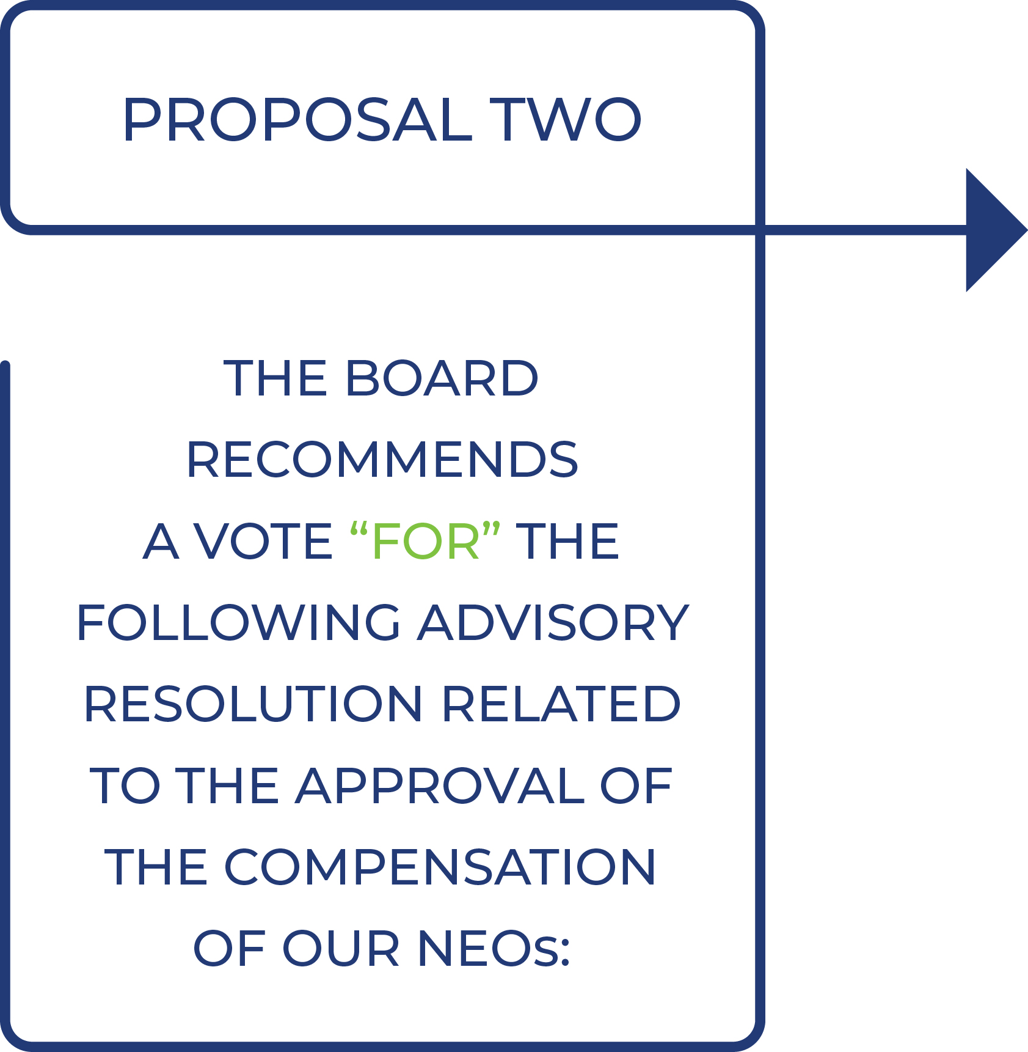

“RESOLVED, that the compensation paid to the Company’s named executive officers, as disclosed in the Proxy Statement for our 2026 Annual Meeting of Stockholders pursuant to the compensation disclosure rules of the Securities and Exchange Commission, including the Compensation Discussion and Analysis, named executive officer compensation tables and related narrative discussion, is hereby APPROVED.”

88

Table of Contents

PROPOSAL THREE:

APPROVAL OF THE AMENDMENT AND RESTATEMENT OF

THE COMPANY’S OMNIBUS INCENTIVE PLAN
We are asking our stockholders to approve an amendment and restatement of the Repay Holdings Corporation Second Amended and Restated Omnibus Incentive Plan (the “Third Amended and Restated Plan”). The Third Amended and Restated Plan amends and restates our stockholder-approved Repay Holdings Corporation Second Amended and Restated Omnibus Incentive Plan (as previously amended, the “Current Plan”). The adoption of the Third Amended and Restated Plan is subject to stockholder approval and the Third Amended and Restated Plan will not become effective if such approval is not received.
The Third Amended and Restated Plan would implement the following material amendments to the Current Plan:
•
increase the number of shares that may be issued pursuant to awards by 2,500,000 shares, in order to enable us to continue to offer eligible employees, directors, consultants and other advisors stock-based incentive awards under the plan, which we believe will enable us to attract, retain and reward these individuals and strengthen the mutuality of interests between them and our stockholders;
•
extend the expiration date from April 19, 2034 to April 29, 2036; and
•
make such other updates as described further below and in the draft of the plan attached to this proxy statement as Annex A.
Our Board believes that approval of the Third Amended and Restated Plan will serve the interests of our Company and our stockholders by providing for an additional amount of shares reserved for issuance under the Third Amended and Restated Plan, so that we can continue to grant awards to promote our long-term success; successfully attract and retain the best possible candidates for positions of substantial responsibility within the Company; align employee and non-employee award recipient interests with stockholder interests; and provide incentives to the recipients to promote the success of the Company.
Background of the Proposal
If our stockholders approve the Third Amended and Restated Plan, the Third Amended and Restated Plan will replace the Current Plan, and no further awards will be granted under the Current Plan on or after the date our stockholders approve the Third Amended and Restated Plan. The terms and conditions of awards granted previously under the Current Plan will not be affected by the adoption or approval of the Third Amended and Restated Plan, and the Current Plan will remain effective with respect to awards granted under the Current Plan prior to stockholders’ approval of the Third Amended and Restated Plan. If our stockholders do not approve the Third Amended and Restated Plan, the Current Plan will remain in effect pursuant to its terms. Furthermore, if our stockholders do not approve this proposal, our ability to attract, reward and retain valuable employees will be restricted as we will not have a sufficient number of shares to make equity grants in the years to come.
In assessing the appropriate terms of the Third Amended and Restated Plan, the Compensation Committee considered, among other items, the existing terms of the Current Plan, our compensation philosophy and practices, as well as feedback from our stockholders and other stakeholders. The Board believes that awards tied to our Class A common stock and Company performance promote the long-term success of the
89

Table of Contents

Company and views the Third Amended and Restated Plan as an essential element of the Company’s overall compensation program.
Overhang and Potential Dilution Analysis
The following table provides certain information regarding outstanding awards under our Current Plan (or issued as inducement awards) as of April 1, 2026:

 | As of April 1, 2026
Shares of unvested Time-Based Restricted Stock Awards (RSAs) |  |  | 6,885,511 |  | (1)
Unvested Performance-Based Restricted Stock Units (PSUs) |  |  | 3,443,285
Unvested Restricted Stock Units (RSUs) |  |  | 186,000
Vested but Unreleased RSUs |  |  | 411,846
Unvested Performance-Based Stock Options (PSOs) |  |  | 596,600
Vested but Unexercised PSOs |  |  | 206,123
Weighted Average Remaining Term of PSOs |  | 3.96 years
Weighted Average Exercise Price of PSOs |  | $ | 6.13
Shares of Class A Common Stock Available for Awards |  |  | 3,931,980 |  | (2)
(1)
Includes 118,243 RSAs granted as an inducement award to Robert S. Houser on September 8, 2025.
(2)
Based on “target” payout level of outstanding unvested PSUs. Taking into account the maximum potential payout level of our outstanding unvested PSUs, then, as of April 1, 2026, only 488,695 shares of our Class A common stock would be available for awards under our Current Plan.

 | As of April 1, 2026
Total number of shares of Class A common stock outstanding |  |  | 82,798,766 |  | (1)
Total number of Post-Merger Repay Units outstanding |  |  | 5,285,883
(1)
Excludes shares of unvested RSAs.
We calculate that the total potential dilution resulting from issuing all shares authorized under our equity plans as of April 1, 2026 (including the 2,500,000 additional shares that would be available if stockholders approve the Third Amended and Restated Plan) would be approximately 16.6%. This dilution rate is calculated as follows:
(shares of Class A common stock available for grant + outstanding equity awards) ÷ (shares of Class A common stock available for grant + outstanding equity awards + shares of Class A common stock outstanding)
For purposes of this calculation, (i) outstanding unvested PSUs are reflected at the “target” payout level, (ii) outstanding equity awards include only unvested RSAs, unvested PSUs, unvested RSUs, and unvested PSOs and (iii) shares of Class A common stock outstanding include the number of shares of Class A common stock for which Post-Merger Repay Units outstanding may be exchanged, but exclude unvested RSAs.
Historical Burn Rate
We are committed to managing the use of our equity incentives prudently to balance the benefits equity compensation brings to our compensation programs against the
90

Table of Contents

dilution it causes our stockholders. As part of our analysis when considering the number of shares to be included in the Third Amended and Restated Plan, we considered our equity incentive plans’ “burn rate” for each of the three fiscal years ending December 31, 2025, as further detailed in the following table:

 | Fiscal Year 2025 |  |  |  |  | Fiscal Year 2024 |  |  |  |  | Fiscal Year 2023
PSOs Granted |  |  | — |  |  |  |  | — |  |  |  |  | 1,148,822
RSAs/RSUs Granted |  |  | 2,581,001 |  |  |  |  | 2,061,749 |  |  |  |  | 2,898,860
PSUs Vested/Earned (1) |  |  | — |  |  |  |  | 146,807 |  |  |  |  | —
Total Shares Underlying Awards (Excluding Unearned PSUs) |  |  | 2,581,001 |  |  |  |  | 2,208,556 |  |  |  |  | 4,047,682
Weighted Average Number of Shares of Class A Common Stock Outstanding (2) |  |  | 90,862,104 |  |  |  |  | 95,678,128 |  |  |  |  | 96,850,559
Burn Rate (3) |  |  | 2.8 | % |  |  |  | 2.3 | % |  |  |  | 4.2 | %
Three-Year Average Burn Rate |  |  |  |  |  |  |  | 3.1 | %
(1)
Reflects net shares of Class A common stock issued in respect of PSU awards with a performance period of 2022 – 2024. Other PSU awards for performance periods of 2021-2023 and 2023-2025 were forfeited in their entirety. PSU award activity is not otherwise included in the burn rate information above. Additional information regarding PSU grants is available in the Company’s Annual Reports on Form 10-K.
(2)
Includes the number of shares of Class A common stock for which Post-Merger Repay Units outstanding may be exchanged.
(3)
Calculated as (i) Total Shares Underlying Awards (Excluding Unearned PSUs), divided by (ii) Weighted Average Number of Shares of Class A Common Stock Outstanding.
History of Disciplined and Responsible Share Usage
In 2025, our share-based compensation expense was $18.3 million which is approximately 25% below our 2024 expense and 17% below our 2023 expense.

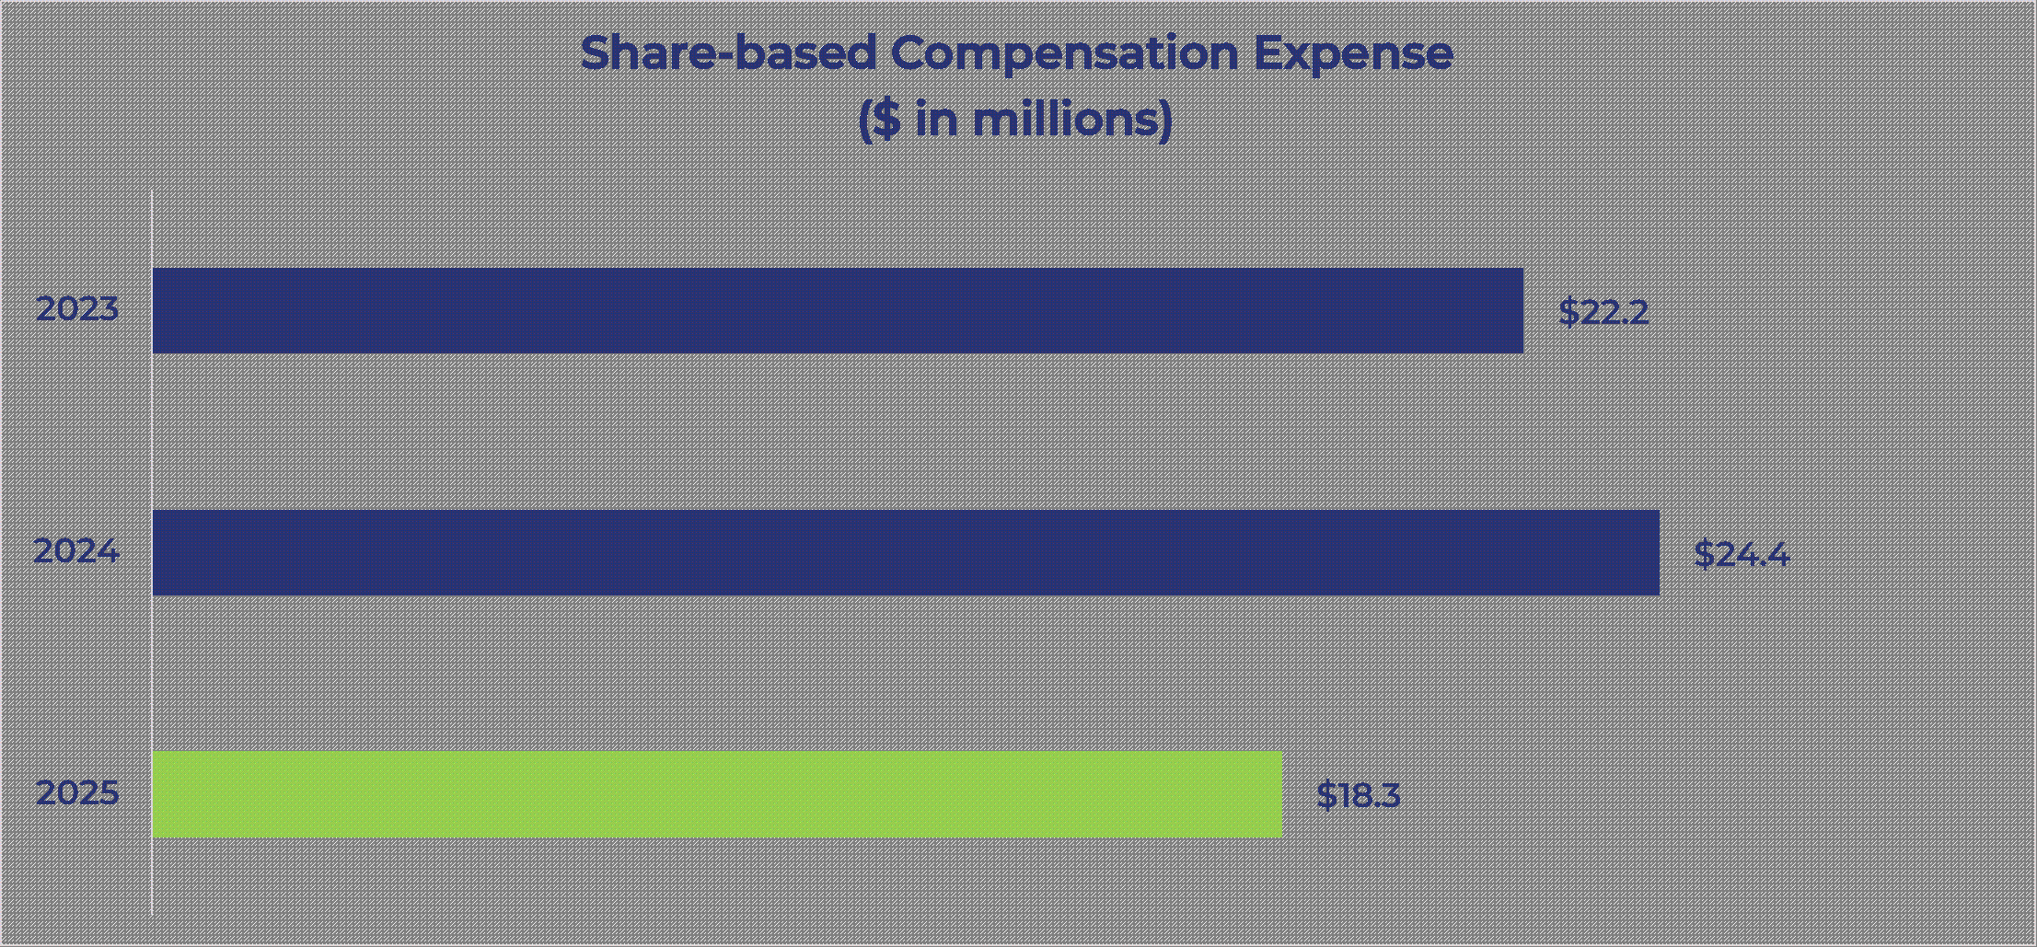
91

Table of Contents

Repay has a history of responsible share usage as evidenced by our equity practices relative to the companies in our current pay peer group:

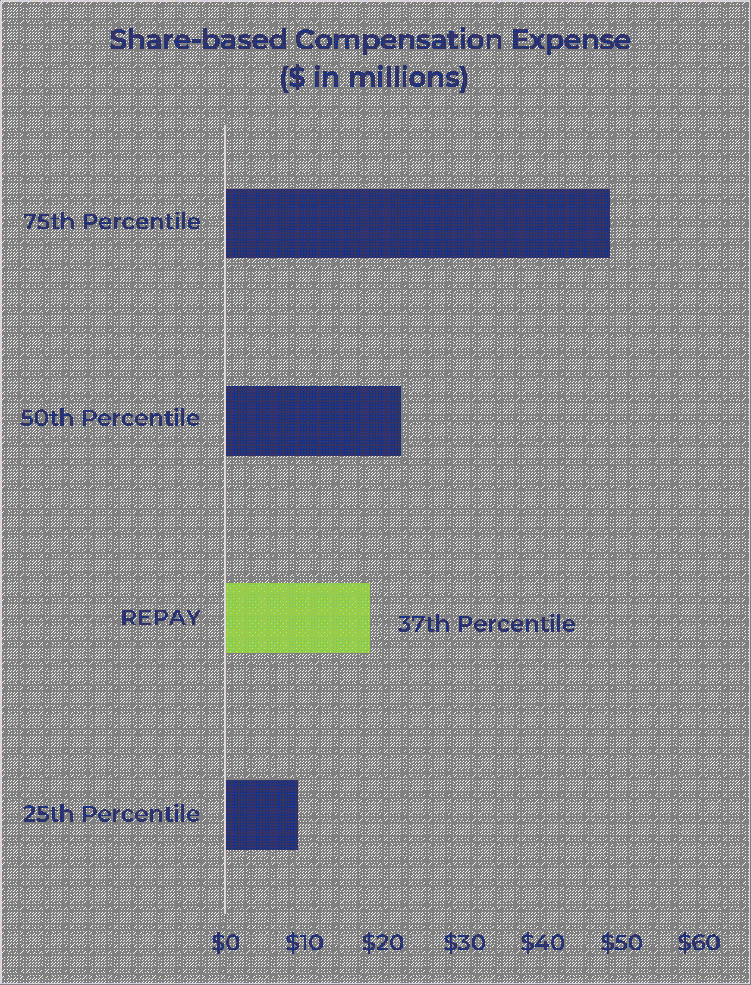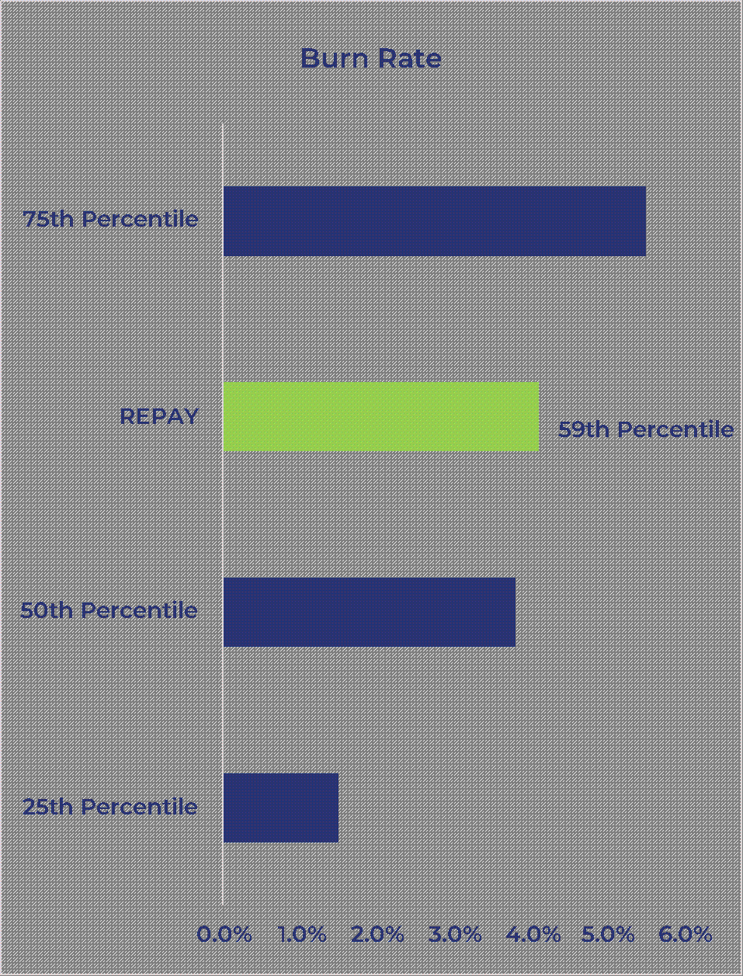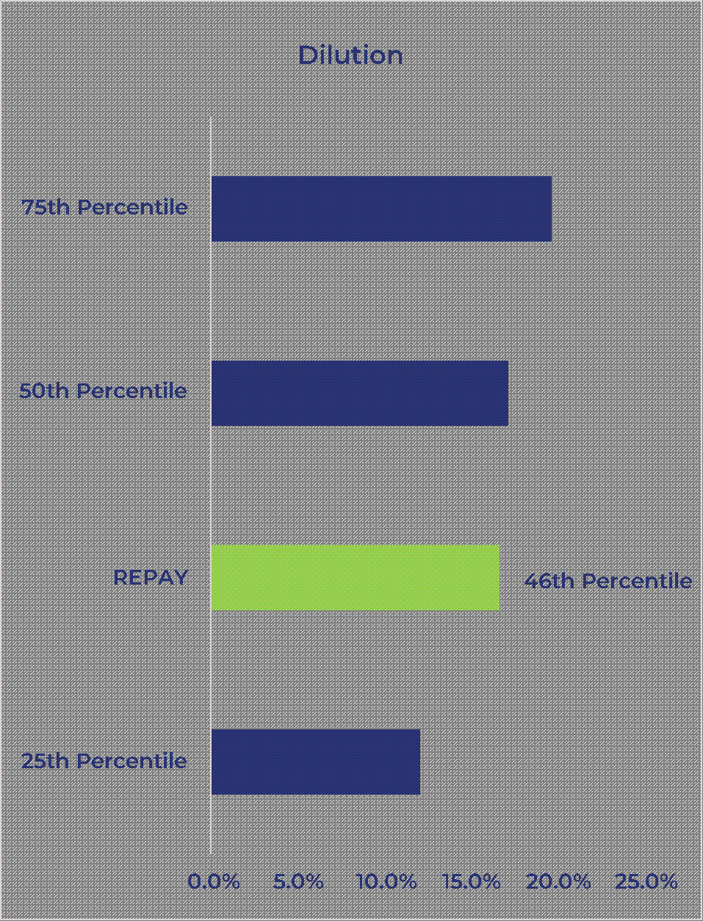
Source: Public SEC filings, analysis by FW Cook.
•
Share-based Compensation Expense: Our 2025 share-based compensation expense of $18.3 million is at the 37th percentile of our peer group (median $22.3 million).
•
Burn Rate: Our 2025 burn rate is 2.8% as defined above, which reflects the number of RSAs/RSUs granted and the number of PSUs vested, which we believe is more illustrative of our actual share usage. Over the past few years, the number of PSUs issued upon vesting has been materially lower than the number of shares granted as our PSUs are subject to challenging performance goals and are forfeited if our performance does not meet the threshold goal, as was the case for PSUs with three-year performance periods ending in 2022, 2023 and 2025.
If we include the number of PSUs granted in 2025, the burn rate is 4.1% which is at the 59th percentile of our peer group (54th percentile on a 3-year average basis). The peer group median was 3.5% in 2025. In the bar chart above, we illustrate how the 4.1% compares against peers because most peer companies do not disclose the number of PSUs that vest.
•
Dilution. Our estimated dilution including the 2.5 million requested shares results in a fully diluted overhang of 16.6% which ranks at the 46th percentile of our peer group (peer group median 17.2%).
Expected Duration
We expect that the shares available under the Third Amended and Restated Plan for future awards, if the Third Amended and Restated Plan is approved by our stockholders, will be sufficient for currently-anticipated awards for up to approximately one year. Expectations regarding future share usage could be impacted by a number of factors such as: (i) the future performance of our stock price; (ii) hiring and promotion activity at the executive level; (iii) the rate at which shares are returned to the Third Amended and Restated Plan’s reserve upon awards’ expiration, forfeiture or cash settlement without the issuance of the underlying shares; (iv) factors involved in acquiring other companies; and
92

Table of Contents

(v) other factors. While we believe that the assumptions used are reasonable, future share usage may differ from current expectations.
Summary of the Material Terms of the Third Amended and Restated Plan
The following summary is not a complete statement of the Third Amended and Restated Plan and is qualified in its entirety by reference to the complete text of the Third Amended and Restated Plan, a copy of which is attached hereto as Annex A.
General. The purposes of the Third Amended and Restated Plan are to recognize contributions made to the Company and its affiliates by its employees, directors, consultants and advisors, to provide such persons with additional incentives to devote themselves to the future success of the Company and to improve the ability of the Company to attract, retain and motivate individuals upon whom the Company’s sustained growth and financial success depend. These incentives are provided through the grant of stock options, stock appreciation rights, restricted stock, restricted stock units and dividend equivalent rights. Any of these awards may, but need not, be made as performance-based incentives.
Authorized Shares. The number of shares of Class A common stock available for awards under the Third Amended and Restated Plan shall be increased by 2,500,000 shares. The aggregate number of shares available for awards under the Third Amended and Restated Plan shall be reduced on a one-for-one basis by the number of shares issued under the Third Amended and Restated Plan and/or the Current Plan and increased by that number of shares subject to awards granted under the Third Amended and Restated Plan or the Current Plan which later become available in accordance with the provisions below. Up to a total of 24,726,728 of such shares may be granted as incentive stock options under the Third Amended and Restated Plan or the Current Plan. Upon settlement of a stock-settled stock appreciation right, the total number of shares available for issuance under the Third Amended and Restated Plan shall be reduced by the gross number of shares with respect to which the stock appreciation right is exercised.
If shares covered by an award are not purchased or are forfeited or expire, or otherwise terminate without delivery of any shares subject thereto, such as on a cash settlement of the award, then such shares will, to the extent of any such forfeiture, termination, cash-settlement or expiration, be available for future grant under the Third Amended and Restated Plan. If any shares subject to an option or stock-settled stock appreciation right are withheld for payment of the purchase, exercise or grant price or for payment of taxes, such withheld shares will be treated as granted and will not again be available for future grants. If any shares subject to a full-value award are withheld for payment of taxes, such withheld shares will again be available for future grants.
Adjustments to Shares Subject to the Third Amended and Restated Plan. In the event of a stock dividend, extraordinary cash dividend, rights offering to purchase Shares at a price that is substantially below Fair Market Value, stock split, recapitalization or other change in the number or class of issued or outstanding securities resulting from a subdivision or consolidation of the Company’s common stock and/or other outstanding equity securities or a recapitalization or other capital adjustment affecting the Company’s common stock, the administrator (as defined below) has the authority to make appropriate adjustments to the aggregate number of shares and class of shares as to which awards may be granted, the limitations as to grants to non-employee directors, the number of shares covered by each outstanding award and the option or grant price for each related outstanding option and stock appreciation right.
Administration. The Third Amended and Restated Plan will continue to be administered by the compensation committee of the Company Board (referred to as the
93

Table of Contents

“administrator”); provided that such committee consist of members of the Board, at least two, each of whom qualifies as a non-employee director under Rule 16b-3 of the Exchange Act and as an independent director under the rules of the stock exchange for so long as the Company is a publicly traded corporation. The Board may establish one or more committees to administer the Third Amended and Restated Plan with respect to separate classes of grantees (other than officers subject to Section 16 of the Exchange Act) and the Board will act as the administrator with respect to awards made to non-employee directors. Subject to the provisions of the Third Amended and Restated Plan, the administrator has the power to administer the Third Amended and Restated Plan, including but not limited to, the authority to (i) direct the Company to grant awards pursuant to the Third Amended and Restated Plan, (ii) determine the grantees to whom and the times at which awards will be granted, (iii) determine the price at which options or SARs are granted, (iv) determine the type of option or SAR to be awarded and the number of shares subject to such option of SAR, (v) determine the number of shares granted pursuant to each award, (vi) accelerate the exercisability or vesting of an award upon the occurrence of one or more events other than completion of a service period, including without limitation upon the grantee’s retirement, death, disability, termination of employment or service involuntarily for any reason other than for cause or voluntarily for good reason, a change in control, or, in the case of a director, a required resignation or removal from the Board in connection with a change in control, and (vii) approve the form and terms and conditions of the award documents and of each award (to the extent not inconsistent with the Third Amended and Restated Plan). The administrator’s interpretation and construction of any provisions of the Third Amended and Restated Plan or any award are final, binding and conclusive on all parties.
Eligibility. Awards may be granted to employees, directors, consultants and advisors of the Company and any parent or subsidiary corporation of the Company. Incentive stock options may be granted only to employees who, as of the time of grant, are employees of the Company or any parent or subsidiary corporation of the Company. As of the date of this Proxy Statement, approximately 5 non-employee directors, 5 executive officers and approximately 480 other employees of the Company and its subsidiaries would be eligible to be selected by the Compensation Committee to receive awards under the Third Amended and Restated Plan.
Stock Options. Stock options in the form of nonstatutory stock options or incentive stock options may be granted under the Third Amended and Restated Plan. The administrator determines the number of shares subject to each option. The administrator determines the exercise price of options granted under the Third Amended and Restated Plan; provided that the exercise price must at least be equal to the fair market value of the Company’s common stock on the date of grant. The term of a stock option may not exceed ten years. However, with respect to any participant who owns more than 10% of the voting power of all classes of the Company’s or any subsidiary’s outstanding stock, the term of an incentive stock option must not exceed five years and the exercise price of the incentive stock option must equal at least 110% of the fair market value of the Company’s common stock on the grant date. The grantee may pay the exercise price of an option (i) in cash, (ii) by certified check or (iii) by such method as the administrator approves, including payment through a broker. After the termination of service of a grantee other than due to death or disability, his or her option will remain exercisable for 90 days except as otherwise provided in the award agreement. After the termination of service of a grantee due to death or disability, the option will remain exercisable for 12 months unless otherwise provided in the award agreement. Upon a termination for cause, all options cease to be exercisable immediately on the date of termination and the grantee automatically forfeits all shares for which the Company has not yet delivered the share certificates. An option may not be exercised later than the expiration of its term. Subject to the provisions of the
94

Table of Contents

Third Amended and Restated Plan, the administrator determines the other terms of options.
Stock Appreciation Rights. Stock appreciation rights may be granted under the Third Amended and Restated Plan. Stock appreciation rights allow the recipient to receive the appreciation in the fair market value of the Company’s common stock between the exercise date and the date of grant. Stock appreciation rights may not have a term exceeding ten years (5 years for any SAR granted in tandem with an incentive stock option to any participant who owns more than 10% of the voting power of all classes of the Company’s or any subsidiary’s outstanding stock). Unless otherwise provided in an award agreement, in the event that a grantee’s services terminate for any reason other than due to death or disability, any stock appreciation right is forfeited and reacquired by the Company. In the event of a termination due to death or disability, all remaining restrictions with respect to stock appreciation rights immediately lapse unless otherwise provided in an award agreement. The grant price for a stock appreciation right may not be less than 100% of the fair market value per share on the date of grant (110% of the fair market value per share on the date of grant if the SAR is granted in tandem with an incentive stock option granted to any participant who owns more than 10% of the voting power of all classes of the Company’s or any subsidiary’s outstanding stock). Subject to the provisions of the Third Amended and Restated Plan, the administrator determines the other terms of stock appreciation rights, including when such rights become exercisable.
Restricted Stock Awards. Restricted stock may be granted under the Third Amended and Restated Plan. Restricted stock awards are grants of shares of the Company’s common stock that vest in accordance with terms and conditions established by the administrator. The administrator will determine the number of shares of restricted stock granted to any employee, director, consultant or advisor and, subject to the provisions of the Third Amended and Restated Plan, will determine the terms and conditions of such awards. The administrator may impose whatever conditions to vesting it determines to be appropriate (for example, the administrator may set restrictions based on the achievement of specific performance goals or continued service to the Company); provided, however, that the administrator, in its sole discretion, may accelerate the time at which any restrictions will lapse or be removed. Recipients of restricted stock awards generally will have voting rights with respect to such shares upon grant unless the administrator provides otherwise. Recipients of restricted stock awards are not entitled to receive any dividends with respect to such shares until the shares become vested. The administrator may provide that any dividends paid on restricted stock awards must be reinvested in shares of common stock, which is subject to the same vesting conditions applicable to the restricted stock awards. Unless otherwise provided in an award agreement, upon a termination of service for any reason other than due to death or disability any unvested restricted stock awards are forfeited, and upon a termination due to death or disability all restrictions with respect to any restricted stock awards immediately lapse.
Restricted Stock Units. Restricted stock units may be granted under the Third Amended and Restated Plan. Restricted stock units are bookkeeping entries representing the right to receive an amount equal to the fair market value of one share of the Company’s common stock. Subject to the provisions of the Third Amended and Restated Plan, the administrator determines the terms and conditions of restricted stock units, including the vesting criteria (which may include accomplishing specified performance criteria or continued service to the Company) and the form and timing of payment. Holders of restricted stock units do not have any rights as stockholders but the administrator may provide in an award agreement that such holders are entitled to receive cash payments equal to the per-share dividend paid on common stock which will be distributed upon
95

Table of Contents

vesting of the restricted stock unit. Restricted stock units are subject the same treatment upon terminations of service as restricted stock awards.
Dividend Equivalent Rights. Dividend equivalent rights may be granted under the Third Amended and Restated Plan. Dividend equivalent rights are entitlements to receive credits based on cash distributions that would have been paid on the shares of common stock subject to an equity-based award granted to an individual as though such shares had been issued to and held by the grantee. Dividend equivalent rights may not be granted in connection with stock options or stock appreciation rights. Subject to the terms of the Third Amended and Restated Plan, the administrator determines the terms and conditions of dividend equivalent rights. Except as otherwise provided in an award agreement, all dividend equivalent rights automatically terminate on the grantee’s termination of service for any reason.
Transferability of Awards. The Third Amended and Restated Plan allows for the transfer of awards (other than incentive stock options) for no consideration to the grantee’s immediate family or any trust or partnership in which all of the beneficiaries or partners or members, as applicable, are such grantee or his or her immediate family.
Grants to Non-Employee Directors. Grants made to non-employee directors may be in any form other than incentive stock options. The fair value of any awards granted to a non-employee director, including cash compensation paid or payable in respect of such director’s service, may not exceed $650,000 in the aggregate in any one calendar year.
Minimum Vesting Requirements. Awards granted under the Third Amended and Restated Plan shall vest no earlier than the first anniversary of the date the award is granted, and performance-based awards must have a performance period of at least one year; provided, however, that the administrator may grant awards without regard to the foregoing minimum vesting requirements with respect to (i) awards granted after the Company’s stockholders meeting scheduled for [●] in connection with awards that are assumed, converted or substituted pursuant to the Plan; (ii) shares delivered after the Company’s stockholders meeting scheduled for [●] in lieu of fully vested cash obligations; (iii) awards granted after the Company’s stockholders meeting scheduled for [●] to non-employee directors that vest on the earlier of the one-year anniversary of the date of grant of the award and the next annual meeting of the Company’s stockholders which is at least 50 weeks after the immediately preceding year’s annual meeting of the Company’s stockholders; and (iv) additional awards that may be granted after the Company’s stockholders meeting scheduled for [●] up to a maximum of five percent (5%) of the available shares authorized for issuance under the Plan (subject to adjustment as set forth in the Third Amended and Restated Plan). For the avoidance of doubt, the foregoing restriction does not apply to the administrator’s discretion to provide in the terms of the award or otherwise for accelerated exercisability or vesting of any award upon the occurrence of one or more events other than completion of a service or performance period, including without limitation the grantee’s retirement, death, disability, termination of employment or service involuntarily for any reason other than for cause or voluntarily for good reason, a change in control, or, in the case of a director, a required resignation from the Board in connection with a change in control.
Dividends on Performance-Based Awards. In the event we pay a cash dividend on our outstanding shares of Class A common stock, the administrator may provide that the holder of performance-based awards granted under the Third Amended and Restated Plan shall be entitled to receive a cash payment for each share of Class A common stock covered by such award equal to the per-share dividend paid. However, such cash dividend shall not be distributed to the holder of the award until such award becomes vested. The award document may also provide that such cash payment will be deem reinvested in
96

Table of Contents

additional performance-based awards at a price per unit equal to the fair market value of the Class A common stock on the date that such dividend is paid, provided such additional awards shall remain subject to the same restrictions applicable to the underlying award.
Parachute Limitations. To the extent that a grantee is a “disqualified individual” under Section 280G(c) of the Internal Revenue Code of 1986 (the “Code”), any award held by such grantee and any right to receive any payment or other benefit under the Third Amended and Restated Plan will not become exercisable or vested to the extent such exercise or vesting would cause any payment or benefit to such grantee to be subject to excise tax under Section 4999 of the Code; provided that such limitations are only applicable to the extent that the imposition of such limitation is beneficial to the grantee on a net after tax basis.
Change of Control. The Third Amended and Restated Plan provides that in the event of a change of control, as defined under the Third Amended and Restated Plan, except as otherwise provided in an award agreement, each outstanding award will be treated as described in the Third Amended and Restated Plan. Under the Third Amended and Restated Plan, awards assumed by an entity that is the surviving or successor entity following a change of control or are otherwise equitably converted or substituted in connection with a change of control shall have the same vesting schedule in effect following the change of control. If within one year following the change in control, the grantee’s employment or other service is terminated involuntarily without cause, voluntarily for good reason or, in the case of a director, as a result of a required resignation, then all of the grantee’s outstanding awards shall become fully exercisable and/or vested as the case may be as of the date of termination, with payout to such grantee within 60 days following the date of termination of employment or other service, provided that the payment date of any awards that are considered to be deferred compensation shall not be accelerated. For awards that are not assumed or equitably converted in connection with a change in control, the Third Amended and Restated Plan provides that such awards shall become immediately vested and exercisable, as the case may be, at or immediately prior to the consummation of the event that constitutes the change of control and all such vested awards shall be cancelled in exchange for a payout of the award (to the extent applicable under the terms of the award) to grantees within 60 days following the change of control, in an amount equal to the amount that the grantee would have received (net of the exercise or grant price with respect to any awards in the nature of options, stock appreciation rights or other purchase rights) and on the same terms (including without limitation any earn-out, escrow or other deferred consideration provisions) as if such vested awards were settled or distributed or such awards in the nature of vested options, stock appreciation rights or other purchase rights were exercised immediately prior to the consummation of the change in control. Performance-based awards that are assumed or converted in connection with a change of control shall be converted into a time-based award as of the change of control at target, and performance-based awards that are not assumed or converted in connection with a change of control shall become vested, and be paid and settled, at target and prorated based on the number of days in the specified performance period prior to and including the date of the change in control over the number of days in the specified performance period.
Amendment; Termination. The Board has the authority to amend the Third Amended and Restated Plan from time to time; provided that stockholder consent is require to: (i) increase the maximum number of shares as to which awards may be granted, except for adjustments in connection with certain events specified in the Third Amended and Restated Plan, (ii) materially expand the eligible participants or (iii) adopt any amendment constituting a change requiring stockholder approval under applicable laws or applicable listing requirements. Additionally, no amendment may materially adversely
97

Table of Contents

affect any outstanding award without consent of the impacted grantee. The Third Amended and Restated Plan automatically will terminate on April 29, 2036.
Repricing Prohibition. The Third Amended and Restated Plan provides that the Company may not, without stockholder approval, lower the exercise or grant price of an option or SAR after it is granted, cancel an option or SAR at any time when the exercise or grant price exceeds the fair market value of the Company’s Class A common stock or take any other action that would be treated as a repricing, other than in the case of a recapitalization of the Company’s Class A common stock.
Clawback Provision. The Third Amended and Restated Plan includes a clawback provision, pursuant to which we may recover the unearned portion of cash-based or equity-based compensation granted under the Third Amended and Restated Plan in the event our financial statements are restated as a result of material noncompliance with financial reporting requirements. The look-back for this clawback covers any of the prior three fiscal years. This clawback provision applies to any officer of the Company in a position of executive vice president or above, which includes all of the NEOs and is separate from and in addition to the Company’s recently adopted Clawback Policy, which also applies to any cash-based or equity-based compensation granted under the Third Amended and Restated Plan.
No “Evergreen” Provision. There is no “evergreen” feature pursuant to which the shares available for issuance under the Third Amended and Restated Plan can be automatically replenished.
Summary of U.S. Federal Income Tax Consequences of the Third Amended and Restated Plan
The following summary is intended only as a general guide to the material U.S. federal income tax consequences of participation in the Third Amended and Restated Plan. The summary is based on existing U.S. laws and regulations, and there can be no assurance that those laws and regulations will not change in the future. The summary does not purport to be complete and does not discuss the tax consequences upon a participant’s death, or the provisions of the income tax laws of any municipality, state or foreign country in which the participant may reside. As a result, tax consequences for any particular participant may vary based on individual circumstances.
Incentive Stock Options. An optionee recognizes no taxable income for regular income tax purposes as a result of the grant or exercise of an incentive stock option qualifying under Section 422 of the Code. Optionees who neither dispose of their shares within two years following the date the option was granted nor within one year following the exercise of the option normally will recognize a capital gain or loss equal to the difference, if any, between the sale price and the purchase price of the shares. If an optionee satisfies such holding periods upon a sale of the shares, the Company will not be entitled to any deduction for federal income tax purposes. If an optionee disposes of shares within two years after the date of grant or within one year after the date of exercise (a “disqualifying disposition”), the difference between the fair market value of the shares on the exercise date and the option exercise price (not to exceed the gain realized on the sale if the disposition is a transaction with respect to which a loss, if sustained, would be recognized) will be taxed as ordinary income at the time of disposition. Any gain in excess of that amount will be a capital gain. If a loss is recognized, there will be no ordinary income, and such loss will be a capital loss. Any ordinary income recognized by the optionee upon the disqualifying disposition of the shares generally should be deductible by the Company for federal income tax purposes, except to the extent such deduction is limited by applicable provisions of the Code.
98

Table of Contents

The difference between the option exercise price and the fair market value of the shares on the exercise date is treated as an adjustment in computing the optionee’s alternative minimum taxable income and may be subject to an alternative minimum tax which is paid if such tax exceeds the regular tax for the year. General rules may apply with respect to certain subsequent sales of the shares in a disqualifying disposition, certain basis adjustments for purposes of computing the alternative minimum taxable income on a subsequent sale of the shares and certain tax credits which may arise with respect to optionees subject to the alternative minimum tax.
Non-statutory Stock Options. Options not designated or qualifying as incentive stock options will be non-statutory stock options having no special U.S. tax status. An optionee generally recognizes no taxable income as the result of the grant of such an option. Upon exercise of a non-statutory stock option, the optionee normally recognizes ordinary income equal to the amount that the fair market value of the shares on such date exceeds the exercise price. If the optionee is an employee, such ordinary income generally is subject to withholding of income and employment taxes. Upon the sale of stock acquired by the exercise of a non-statutory stock option, any gain or loss, based on the difference between the sale price and the fair market value on the exercise date, will be taxed as capital gain or loss. No tax deduction is available to the Company with respect to the grant of a non-statutory stock option or the sale of the stock acquired pursuant to such grant.
Stock Appreciation Rights. In general, no taxable income is reportable when a stock appreciation right is granted to a participant. Upon exercise, the participant generally will recognize ordinary income in an amount equal to the fair market value of any shares of Company common stock received. Any additional gain or loss recognized upon any later disposition of the shares would be capital gain or loss.
Restricted Stock Awards. A participant acquiring restricted stock generally will recognize ordinary income equal to the fair market value of the shares on the vesting date. If the participant is an employee, such ordinary income generally is subject to withholding of income and employment taxes. The participant may elect, pursuant to Section 83(b) of the Code, to accelerate the ordinary income tax event to the date of acquisition by filing an election with the Internal Revenue Service no later than 30 days after the date the shares are acquired. Upon the sale of shares acquired pursuant to a restricted stock award, any gain or loss, based on the difference between the sale price and the fair market value on the date the ordinary income tax event occurs, will be taxed as capital gain or loss.
Restricted Stock Unit Awards. There are no immediate tax consequences of receiving an award of restricted stock units. A participant who is awarded restricted stock units generally will be required to recognize ordinary income in an amount equal to the fair market value of shares issued to such participant at the end of the applicable vesting period or, if later, the settlement date elected by the administrator or a participant. Any additional gain or loss recognized upon any later disposition of any shares received would be capital gain or loss.
Section 409A. Section 409A of the Code provides certain requirements for non-qualified deferred compensation arrangements with respect to an individual’s deferral and distribution elections and permissible distribution events.
If an award is subject to and fails to satisfy the requirements of Section 409A of the Code, the recipient of that award may recognize ordinary income on the amounts deferred under the award, to the extent vested, which may be prior to when the compensation is actually or constructively received. Also, if an award that is subject to Section 409A fails to comply with Section 409A’s provisions, Section 409A imposes an additional 20% federal income tax on compensation recognized as ordinary income, as well as certain premium
99

Table of Contents

interest on such deferred compensation. Certain states have enacted laws similar to Section 409A which impose additional taxes, interest and penalties on non-qualified deferred compensation arrangements. The Company will also have withholding and reporting requirements with respect to such amounts.
Tax Effect for the Company. The Company generally will be entitled to a tax deduction in connection with an award under the Third Amended and Restated Plan in an amount equal to the ordinary income realized by a participant and at the time the participant recognizes such income (for example, the exercise of a non-statutory stock option). General rules limit the deductibility of compensation paid to the Company’s chief executive officer and other “covered employees” as determined under Section 162(m) and applicable guidance.
THE FOREGOING IS ONLY A SUMMARY OF THE EFFECT OF THE U.S. FEDERAL INCOME TAXATION UPON PARTICIPANTS AND THE COMPANY UNDER THE THIRD AMENDED AND RESTATED PLAN. IT DOES NOT PURPORT TO BE COMPLETE AND DOES NOT DISCUSS THE TAX CONSEQUENCES OF A PARTICIPANT’S DEATH OR THE PROVISIONS OF THE INCOME TAX LAWS OF ANY MUNICIPALITY, STATE, OR FOREIGN COUNTRY IN WHICH THE PARTICIPANT MAY RESIDE.
New Plan Benefits
The Compensation Committee, in its sole discretion, determines the number and types of awards that will be granted under the Third Amended and Restated Plan. Accordingly, it is not possible to determine the future benefits that will be received by eligible participants if Proposal Three is approved by our stockholders.
Equity Compensation Plan Table
The following table provides information about the common stock that may be issued upon the exercise of options, warrants and rights under all of our existing equity compensation plans as of December 31, 2025:

Plan Category |  | (A) Number of  Securities to be  Issued Upon  Exercise of  Outstanding  Options, Warrants  and Rights |  |  |  |  |  | (B) Weighted  Average Exercise  Price of  Outstanding  Options,  Warrants and  Rights |  |  |  |  |  | (C) Number of  Securities  Remaining  Available for  Future Issuance  Under Equity  Compensation  Plans (Excluding  Securities  Reflected in  Column (a))
Equity Compensation Plans Approved by Stockholders (1) |  |  |  | 3,992,363 |  | (2) |  |  | $ | 6.13 |  | (3) |  |  |  | 8,753,051 |  | (4)
Equity Compensation Plans Not Approved by Stockholders |  |  |  | 118,243 |  | (5) |  |  |  | — |  |  |  |  |  | —
Total |  |  |  | 4,110,606 |  |  |  |  |  |  |  |  |  |  |  | 8,753,051
(1)
Reflects the following equity compensation plans: (A) the Incentive Plan and (B) the Repay Holdings Corporation 2021 Employee Stock Purchase Plan (the “ESPP”).
(2)
As of December 31, 2025, the following equity awards were outstanding under the Incentive Plan: 596,600 unvested and 206,123 vested but unexercised PSOs, 2,591,794 unvested PSUs, 186,000 unvested and 411,846 vested but unreleased restricted stock units. The PSU share numbers are based on the “target” payout level
100

Table of Contents

of our outstanding unearned PSUs. No amounts are included for outstanding purchase rights under the ESPP.
(3)
The exercise price of $6.13 per share of Class A common stock only applies to unvested PSOs.
(4)
As of December 31, 2025, 8,338,115 shares of our Class A common stock were available for awards under the Incentive Plan. This number is based on the “target” payout level of our outstanding unearned PSUs. Taking into account the maximum potential payout level of our outstanding unearned PSUs, then, as of December 31, 2025, 5,746,321 shares of our Class A common stock were available for awards under our Incentive Plan. On February 10, 2026, the Compensation Committee determined that the TSR performance thresholds were not met for the 2023 PSUs. As a result, 973,134 shares were forfeited. As of December 31, 2025, 414,936 shares of our Class A common stock were available for issuance pursuant to rights granted under the ESPP.
(5)
Represents the inducement award granted to Robert S. Houser on September 8, 2025.
Interests of Certain Persons in the Third Amended and Restated Plan
Stockholders should understand that our executive officers and non-employee directors may be considered to have an interest in the approval of the share increase amendment because they may in the future receive awards under the Third Amended and Restated Plan. Nevertheless, the Board believes that it is important to provide incentives and rewards for superior performance and the retention of experienced directors and officers by approving the share increase amendment.

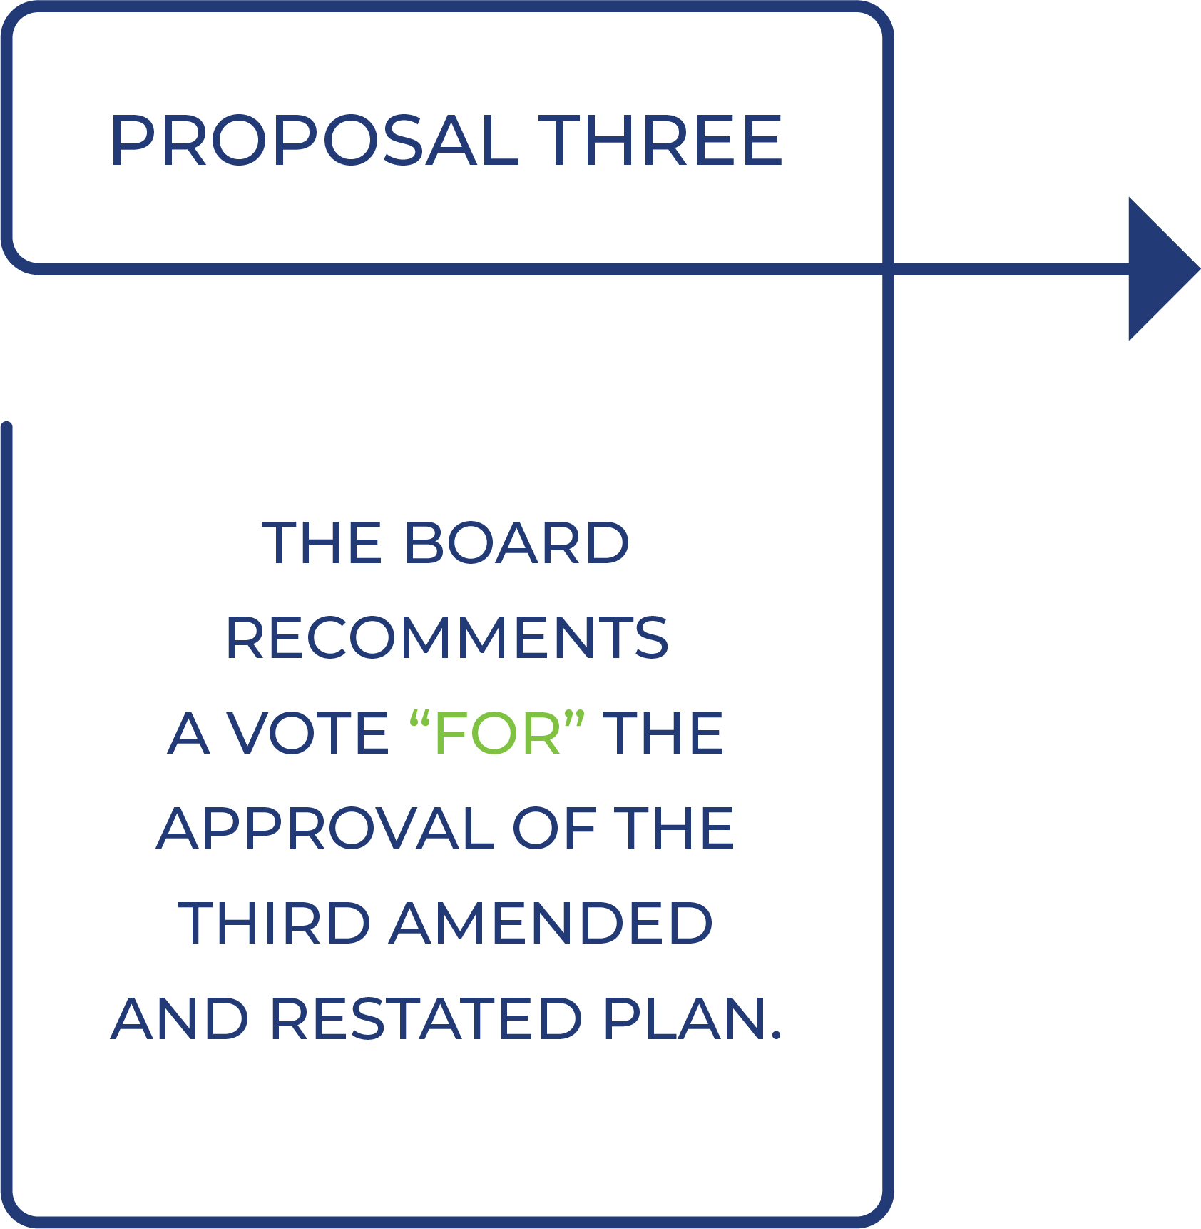
101

Table of Contents

PROPOSAL FOUR:

RATIFICATION OF SELECTION OF INDEPENDENT

REGISTERED PUBLIC ACCOUNTING FIRM
We are asking our stockholders to ratify the Audit Committee’s selection of Grant Thornton as our independent registered public accounting firm for the fiscal year ending December 31, 2026. Grant Thornton has served as our independent registered public accounting firm since 2018.
The Audit Committee annually reviews the independent registered public accounting firm’s independence, including reviewing all relationships between the independent registered public accounting firm and us and any disclosed relationships or services that may impact the objectivity and independence of the independent registered public accounting firm, and the independent registered public accounting firm’s performance. Although ratification is not required by our Bylaws or otherwise, the Board is submitting the selection of Grant Thornton to our stockholders for ratification as a matter of good corporate practice. If the selection is not ratified, the Audit Committee will consider whether it is appropriate to select another independent registered public accounting firm. Even if the selection is ratified, the Audit Committee in its discretion may select a different registered public accounting firm at any time during the year if the committee determines that such a change would be in the best interests of the Company and our stockholders.
We expect that a representative of Grant Thornton will attend the Annual Meeting, and the representative will have an opportunity to make a statement if he or she so chooses. The representative will also be available to respond to appropriate questions from stockholders.

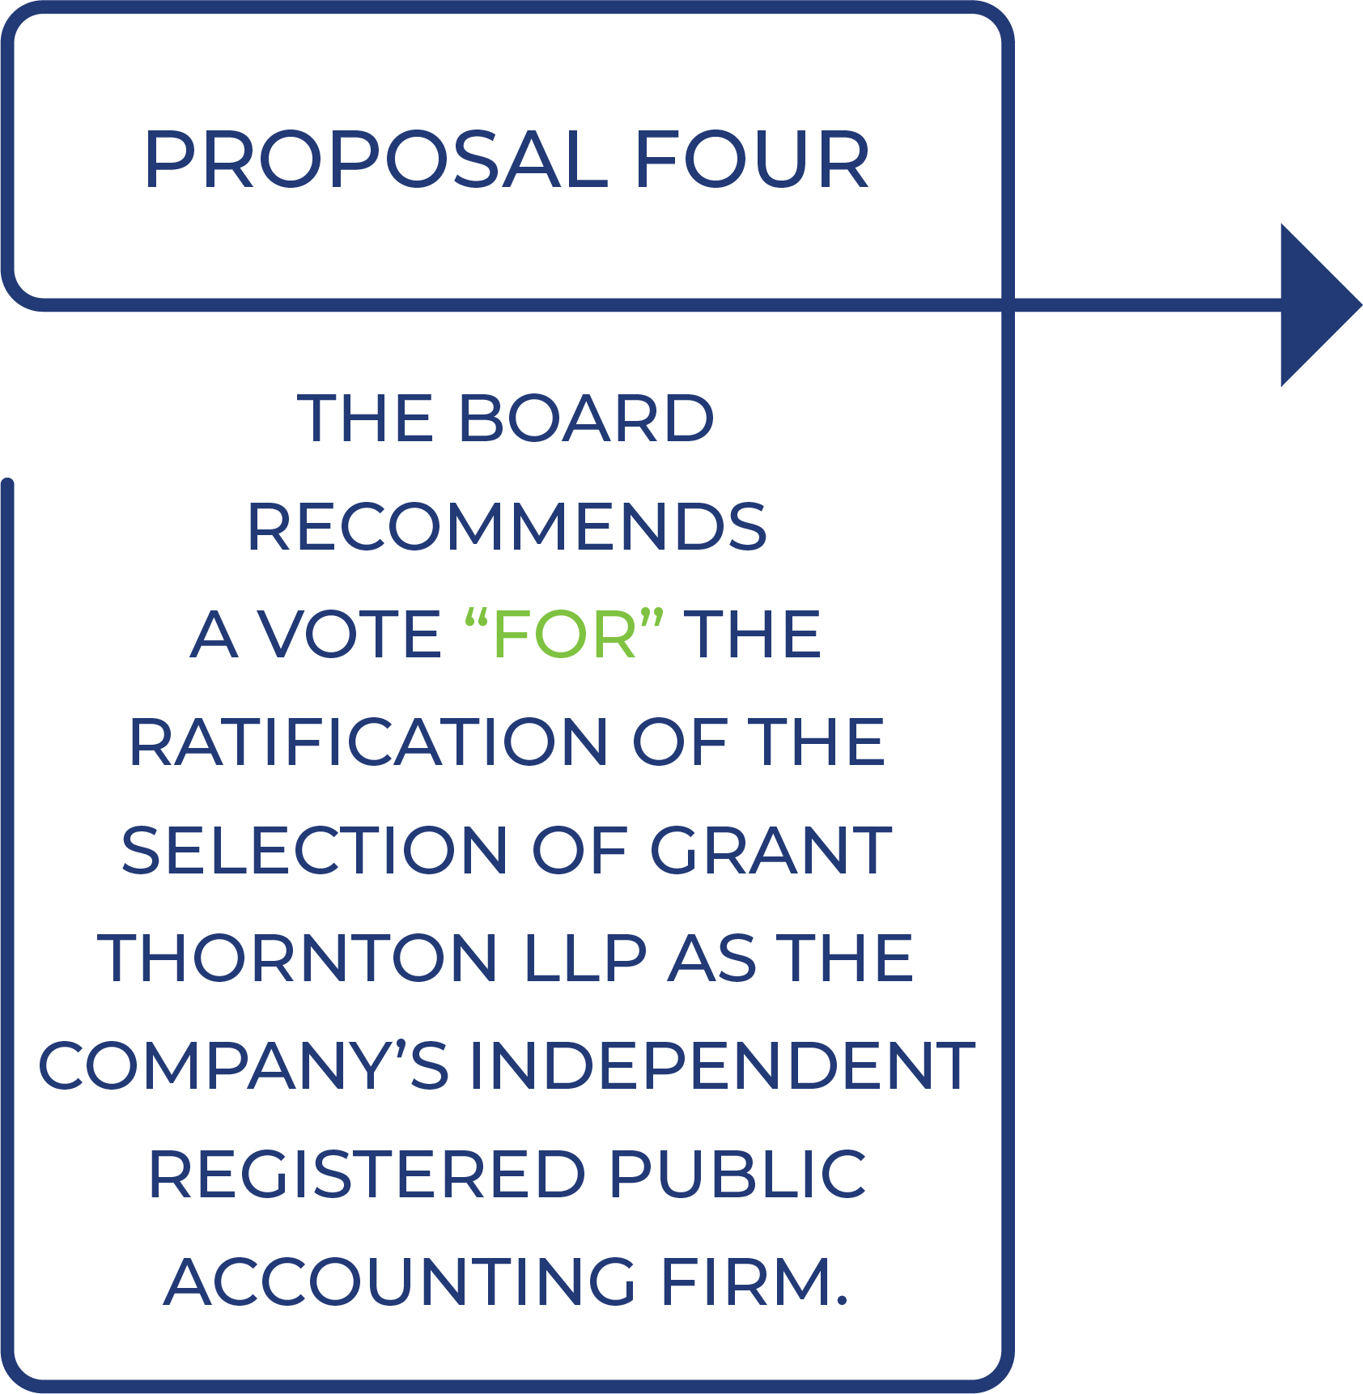

102

Table of Contents

STOCKHOLDER PROPOSALS
The 2027 annual meeting of stockholders (the “2027 Annual Meeting”) is anticipated to be held in 2027. Under Rule 14a-8 promulgated by the SEC under the Exchange Act, any proposal that a stockholder intends to be presented at the 2027 Annual Meeting via the proxy statement and form of proxy to be distributed by us in connection with the 2027 Annual Meeting, must be received by the Corporate Secretary of Repay at our principal executive offices no later than [●]. However, if the 2027 Annual Meeting is held on a date more than 30 days before or after [●] (the anniversary date of the 2026 Annual Meeting), stockholder proposals for the 2027 Annual Meeting must be submitted a reasonable time before we begin to print and send our proxy materials. Stockholder proposals received after this date will be considered untimely under Rule 14a-8. Any such proposals must also comply with the other requirements of Rule 14a-8 in order be eligible for inclusion in our proxy materials for the 2027 Annual Meeting.
If a stockholder desires to bring a matter before the meeting that is not the subject of a proposal meeting the SEC proxy rule requirements for inclusion in the proxy statement or a nomination of a director, the stockholder must follow procedures outlined in our Bylaws. One of the procedural requirements is timely notice in writing of the business the stockholder proposes to bring before the meeting. Written notice must be delivered to the Corporate Secretary of Repay no earlier than [●] and no later than[●]. In the event that our 2027 Annual Meeting is more than 30 days before or more than 70 days after [●] (the anniversary date of the 2026 Annual Meeting), the written notice must be so delivered not earlier than the close of business on the 120th day prior to the 2027 Annual Meeting and not later than the close of business on the later of (i) the 90th day prior to the 2027 Annual Meeting or (ii) the tenth day following the date on which public announcement of the meeting date was first made. Stockholders are advised to review our Bylaws carefully, as they set forth the information that must be included in the notice and other requirements that must be satisfied in order for business or a nomination to be properly brought before the 2027 Annual Meeting.
The SEC adopted final rules under Rule 14a-19 promulgated under the Exchange Act requiring the use of universal proxy cards by management and stockholders soliciting proxy votes for their candidates in director election contests. Under Rule 14a-19, the universal proxy card must include all director nominees presented by management and stockholders for election at the upcoming stockholder meeting. One of the procedural requirements is that stockholders presenting their own director candidates in the contest must solicit holders of a minimum of 67% of the voting power of shares entitled to vote in the election. In addition to complying with our Bylaws, stockholders who intend to solicit proxies of director nominees other than the Company’s director nominees must provide notice that sets forth the information required by Rule 14a-19 within the applicable deadlines as set forth in Rule 14a-19 and our Bylaws.
We reserve the right to decline to include in our proxy materials any stockholder’s proposal that does not comply with the rules of the SEC for inclusion therein or the requirements of our Bylaws, as applicable. We will furnish copies of the applicable Bylaw provisions that set forth the requirements for a stockholder’s written notice upon written request to the Corporate Secretary of Repay at the address listed above.

103

Table of Contents

ANNEX A

REPAY HOLDINGS CORPORATION

THIRD AMENDED AND RESTATED OMNIBUS INCENTIVE PLAN

(As Amended and Restated by the Board of Directors Effective as of April 30, 2026 Subject to Approval by the Stockholders on [●])

1.
Purpose and Stockholder Approval.
a.
Repay Holdings Corporation, a Delaware corporation (the “Company”), hereby amends and restates the Repay Holdings Corporation Second Amended and Restated Omnibus Incentive Plan (prior to this amendment and restatement, the “Prior Plan” and, after this amendment and restatement, the Repay Holdings Corporation Third Amended and Restated Omnibus Incentive Plan (the “Plan”)), effective as of April 30, 2026. The Plan is intended to recognize the contributions made to the Company and its Affiliates by its employees, directors, consultants and advisors of the Company, to provide such persons with additional incentive to devote themselves to the future success of the Company, to improve the ability of the Company to attract, retain, and motivate individuals upon whom the Company’s sustained growth and financial success depend, by providing such persons with an opportunity to acquire or increase their proprietary interest in the Company. To this end, the Plan provides for the grant of stock options, stock appreciation rights, restricted stock, restricted stock units and dividend equivalent rights. Any of these awards may, but need not, be made as performance incentives to reward attainment of annual or long-term performance goals at the Committee’s sole and absolute discretion. Stock options granted under the Plan may be non-qualified stock options or incentive stock options, as provided herein, except that stock options granted to any person who is not an employee of the Company or an Affiliate shall in all cases be non-qualified stock options.
b.
The Plan is contingent on and subject to its approval by the Company’s stockholders at the Company’s stockholders meeting scheduled for [●]. No grants or awards shall be made under the Plan if the Plan is not so approved. If the Plan is not so approved, the Prior Plan shall remain in effect pursuant to its original terms.
c.
The Plan shall affect only Awards granted under the Plan on and after its approval by the Company’s stockholders at the Company’s stockholders meeting scheduled for [●]. Awards granted under the Prior Plan shall be governed by the terms of the Prior Plan and the applicable Award Agreements. The terms of this Plan are not intended to affect the interpretation of the terms of the Prior Plan. If the Company’s stockholders approve the Plan, no further Awards shall be granted under the Prior Plan after the date of such approval.
2.
Definitions. Unless the context clearly indicates otherwise, the following terms shall have the following meanings:
a.
“Affiliate” means a corporation that is a parent corporation or a subsidiary corporation with respect to the Company within the meaning of Section 424(e) or (f) of the Code, and any other non-corporate entity that would be such a subsidiary corporation if such entity were a corporation. For purposes of ISOs, an Affiliate means only a corporate entity.
b.
“Award” means an award of Restricted Stock, Restricted Stock Units, Stock Options, Stock Appreciation Rights or Dividend Equivalent Rights granted under the Plan, designated
A-1

Table of Contents

by the Committee at the time of such grant as an Award, and containing the terms specified herein for Awards.
c.
“Award Document” means the written or electronic document that sets forth the terms and conditions of each grant of an Award. Awards shall be evidenced by an Award Document in such form as the Committee shall from time to time approve, which Award Document shall comply with and be subject to the terms and conditions of the Plan and such other terms and conditions as the Committee shall from time to time require that are not inconsistent with the terms of the Plan. Unless the Committee provides otherwise in the Award Document, a Grantee shall not have any rights with respect to an Award until and unless such Grantee shall have executed, or otherwise accepted in writing as required by the Committee, an Award Document containing the terms and conditions determined by the Committee.
d.
“Board of Directors” means the Board of Directors of the Company.
e.
“Cause” shall have the same definition as under any employment agreement between the Company or any Affiliate and the Grantee or, if no such employment agreement exists or if such employment agreement does not contain any such definition or words of similar import, “Cause” means, except as otherwise provided in an Award Document, that the Grantee was dismissed, or circumstances exist that would permit the Company or an Affiliate to dismiss the Grantee, as a result of
i.
any material breach by the Grantee of any agreement to which the Grantee and the Company or an Affiliate are parties,
ii.
any act (other than retirement) or omission to act by the Grantee, including without limitation, the commission of any crime (other than ordinary traffic violations) that may have a material and adverse effect on the business of the Company or any Affiliate or on the Grantee’s ability to perform services for the Company or any Affiliate, or
iii.
any material misconduct or neglect of duties by the Grantee in connection with the business or affairs of the Company or any Affiliate.
Notwithstanding the foregoing, during the first sixty days after the Grantee’s termination of employment or other service for any reason other than Cause, the Company or an Affiliate shall have the right to re-characterize such termination of employment or service as a termination or dismissal for Cause if such circumstances existed at the time of Grantee’s termination of employment or other service.
f.
“Change of Control” shall mean the first to occur of any of the following events:
i.
The date any transaction is consummated that constitutes the sale or other disposition of all or substantially all of the assets of the Company, other than where such transaction results in all or substantially all of the assets of the Company being held by an entity as to which at least a majority of the equity ownership of such entity immediately after the sale or disposition is held by the same persons and in the same proportions as the Company’s common stock was held immediately before such sale or other disposition;
ii.
The date any transaction is consummated that constitutes a merger or consolidation of the Company with or into another corporation, other than a merger or consolidation of the Company in which holders of shares of the Common Stock immediately prior to the merger or consolidation will hold at least a majority of the ownership of common stock of the surviving corporation (and, if one class of common stock is not the only class of
A-2

Table of Contents

voting securities entitled to vote on the election of directors of the surviving corporation, a majority of the voting power of the surviving corporation’s voting securities) immediately after the merger or consolidation, which common stock (and, if applicable, voting securities) is to be held in the same proportion as such holders’ ownership of Common Stock immediately before the merger or consolidation;
iii.
The date any entity, person or group, (within the meaning of Section 13(d)(3) or Section 14(d)(2) of the Securities Exchange Act of 1934, as amended), other than the Company or any of its Affiliates or any employee benefit plan (or related trust) sponsored or maintained by the Company or any of its Affiliates, shall have become the beneficial owner of, or shall have obtained voting control over, more than fifty percent (50%) of the outstanding shares of the Common Stock;
iv.
The first day after the date this Plan is effective when directors are elected such that a majority of the Board of Directors shall have been members of the Board of Directors for less than twenty four (24) months, unless the nomination for election of each new director who was not a director at the beginning of such twenty four (24) month period was approved by a vote of at least two thirds of the directors then still in office who were directors at the beginning of such period; or
v.
The date the stockholders of the Company (or the Board of Directors, if stockholder action is not required) approve a plan or other arrangement pursuant to which the Company will be dissolved or liquidated, the plan or other arrangement pursuant to which the Company will be dissolved or liquidated becomes irrevocable and no further contingences remain that could prevent the consummation of such plan or arrangement. For avoidance of doubt, any transaction done exclusively for the purpose of changing the domicile of the company shall not constitute a Change of Control.
Notwithstanding the foregoing, in the case of any Award that constitutes deferred compensation within the meaning of Section 409A of the Code, there shall not be a Change of Control unless there is a change in the ownership or effective control of the Company, or in a substantial portion of the assets of the Company, within the meaning of Section 409A of the Code where necessary for such Award to comply with Section 409A of the Code.
g.
“Code” means the Internal Revenue Code of 1986, as amended.
h.
“Committee” shall have the meaning set forth in Section 3(a).
i.
“Common Stock” means the Company’s Class A Common Stock, par value $0.0001 per share.
j.
“Disability” shall have the meaning set forth in Section 22(e)(3) of the Code, provided, however, in the case of an Award that constitutes deferred compensation within the meaning of Section 409A of the Code, Disability means as defined in regulations under Code Section 409A where necessary for such Award to comply with Section 409A of the Code.
k.
“Dividend Equivalent Right” means a right, granted to a Grantee under the terms of the Plan, to receive cash, Stock, other Awards or other property equal in value to dividends paid with respect to a specified number of shares of Stock, or other periodic payments.
l.
“Exchange Act” means the Securities Exchange Act of 1934, as amended, and all rules and regulations promulgated thereunder. Reference to a specific section of the Exchange
A-3

Table of Contents

Act or regulation thereunder shall include such section or regulation, any valid regulation or interpretation promulgated under such section, and any comparable provision of any future legislation or regulation amending, supplementing or superseding such section or regulation.
m.
“Fair Market Value” shall mean:
i.
If the Common Stock is traded on any national stock exchange or quotation system, then the Fair Market Value per Share shall be the last reported sale price per share thereof on the relevant date (or the closing price as of the most recent trading day prior to the relevant date if the relevant date is not a trading day), as reported on the stock exchange or quotation system that reflects the principal market on which the Common Stock is traded on such date; or
ii.
If the Common Stock is not traded on any national stock exchange or quotation system on the relevant date, the Fair Market Value shall be as determined in good faith by the Committee in a manner consistent with Treasury Regulation 1.409A-1(b)(5)(iv)(B).
n.
“Good Reason” shall have the same definition as under any employment agreement between the Company or any Affiliate and the Grantee or, if no such employment agreement exists or if such employment agreement does not contain any such definition or words of similar import, “Good Reason” shall mean, except as otherwise provided in an Award Document, the termination of employment by the Grantee following the occurrence, without the Grantee’s written consent, after a Change of Control of:
i.
a material reduction in the Grantee’s base salary or wage rate or target incentive opportunity; or
ii.
the relocation of the Grantee’s principal place of employment to a location more than fifty miles from the Grantee’s principal place of employment as of immediately prior to the Change of Control (if such relocation results in an increase in the Grantee’s commute);
provided, however, that the foregoing events shall constitute Good Reason only if the Grantee provides the Company with written objection to the event within thirty days following the occurrence thereof, the Company does not reverse or otherwise cure the event within thirty days after receiving that written objection and the Grantee resigns the Grantee’s employment within twenty days following the expiration of the Company’s thirty-day cure period without the Company having reversed or otherwise cured the event.

o.
“Grant Date” means the date established by the Committee as of which any Award has been granted to a Grantee.
p.
“Grantee” means any person who is granted an Award.
q.
“ISO” means an Option granted under the Plan that is intended to qualify as an “incentive stock option” within the meaning of Section 422(b) of the Code.
r.
“Non-Qualified Stock Option” means an Option granted under the Plan that is not intended to qualify, or otherwise does not qualify, as an “incentive stock option” within the meaning of Section 422(b) of the Code.
A-4

Table of Contents

s.
“Option” or “Stock Option” means either an ISO or a Non-Qualified Stock Option granted under the Plan.
t.
“Option Price” means the price at which Shares may be purchased upon exercise of an Option, as calculated pursuant to the applicable provisions of the Plan.
u.
“Restricted Stock” means Shares issued to a person pursuant to an Award.
v.
“Rule 16b-3” means Rule 16b-3 promulgated under the Act or any successor Rule.
w.
“Restricted Stock Unit” or “RSU” means a bookkeeping entry representing the right to receive the equivalent of one (1) share of Common Stock awarded to a Grantee under Section 8 of the Plan.
x.
“Shares” means the shares of Common Stock that are the subject of Awards.
y.
“Stock Appreciation Rights” or “SAR” means a right granted to a Grantee under Section 7 of the Plan.
z.
“Termination of Employment or Service in Connection with a Change of Control” shall be deemed to occur with respect to a Grantee if, within the one-year period (or such longer period as may be specified in an Award Document) beginning on the date of a Change of Control, the employment or service of the Grantee shall be terminated either (i) by the Company or an Affiliate involuntarily for any reason other than for Cause or Disability, (ii) voluntarily by Grantee for Good Reason or (iii) in the case of Directors, a required resignation or removal from the Board of Directors.
3.
Administration of the Plan.
a.
Committee. The Plan shall be administered by the Compensation Committee of the Board of Directors (the “Committee”) provided such committee consists of members of the Board of Directors, at least two, each of whom qualifies as a “non-employee director” (as that phrase is used for purposes of Rule 16b-3) and as an “independent director” (as that phrase is used by the rules of the stock exchange on which the Company’s shares are traded). The foregoing requirement for members of the Compensation Committee to act as the Committee shall not be applicable if the Company ceases to be a publicly traded corporation. Notwithstanding anything in this Section 3(a) to the contrary, except to the extent prohibited by applicable law or the applicable rules and regulations of any securities exchange or inter-dealer quotation system on which the securities of the Company are listed or traded, the Committee may allocate all or any portion of its responsibilities and powers to any one or more of its members. Any such allocation or delegation may be revoked by the Committee at any time. Without limiting the generality of the foregoing, the Committee may delegate to one or more officers of the Company or its Affiliates the authority to act on behalf of the Committee with respect to any matter, right, obligation, or election which is the responsibility of, or which is allocated to, the Committee herein, and which may be so delegated as a matter of law, except for grants of Awards to non-employee members of the Board of Directors and officers of the Company who are subject to Section 16 of the Exchange Act. Notwithstanding anything to the contrary contained in the Plan, the Board of Directors itself shall act as the Committee with respect to Awards made to non-employee members of the Board of Directors and may, in its sole discretion, at any time and from time to time, grant Awards and administer the Plan with respect to such Awards. In any such case, the Board of Directors shall have all the authority granted to the Committee under the Plan.
A-5

Table of Contents

b.
Grants. The Committee shall from time to time at its discretion direct the Company to grant Awards pursuant to the terms of the Plan. The Committee shall have plenary authority to (i) determine the Grantees to whom and the times at which Awards shall be granted, (ii) subject to Section 6(b) below, determine the price at which Options shall be granted, (iii) determine the type of Option to be granted and the number of Shares subject thereto, (iv) determine the number of Shares to be granted pursuant to each Award, (v) approve the form and terms and conditions of the Award Documents and of each Award, to the extent not inconsistent with the Plan, and (vi) to accelerate the exercisability or vesting of an Award upon the occurrence of one or more events other than completion of a service period, including without limitation upon the Grantee’s retirement, death, Disability, termination of employment or service involuntarily for any reason other than for Cause or voluntarily for Good Reason, a Change of Control, or, in the case of a director, a required resignation or removal from the Board of Directors in connection with a Change of Control; all subject, however, to the express provisions of the Plan, including, specifically, with respect to non-employee members of the Board of Directors, Section 10 regarding grants of Awards to non-employee members of the Board of Directors. In making such determinations, the Committee may take into account the nature of the Grantee’s services and responsibilities, the Grantee’s present and potential contribution to the Company’s success and such other factors as it may deem relevant. The interpretation and construction by the Committee of any provisions of the Plan or of any Award granted under it shall be final, binding and conclusive on all parties.
c.
Exculpation. No member of the Committee shall be personally liable for monetary damages as such for any action taken or any failure to take any action in connection with the administration of the Plan or the granting of Awards thereunder except to the extent such exculpation is prohibited by provisions of the applicable business corporations law; provided, however, that the provisions of this Section 3(c) shall not apply to the responsibility or liability of a member of the Committee pursuant to any criminal statute or to the liability of a member of the Committee for the payment of taxes pursuant to local, state or federal law.
d.
Indemnification. Service on the Committee shall constitute service as a member of the Board of Directors. Each member of the Committee shall be entitled without further act on his or her part to indemnity from the Company to the fullest extent provided by applicable law and the Company’s Certificate of Incorporation and/or Bylaws in connection with or arising out of any action, suit or proceeding with respect to the administration of the Plan or the granting of Options or Awards thereunder in which he or she may be involved by reason of his or her being or having been a member of the Committee, whether or not he or she continues to be such member of the Committee at the time of the action, suit or proceeding.
4.
Eligibility. All employees (including employees who are members of the Board of Directors or its Affiliates), directors, consultants and advisors of the Company or its Affiliates shall be eligible to receive Awards hereunder; provided, that only employees of the Company or its Affiliates shall be eligible to receive ISOs. The Committee, in its sole discretion, shall determine whether an individual qualifies as an employee of the Company or its Affiliates.
5.
Term of the Plan. No Award may be granted under the Plan after April 29, 2036.
6.
Stock Options and Terms. Each Option granted under the Plan shall be a Non-Qualified Stock Option unless the Option shall be specifically designated at the time of grant to be an ISO. Options granted pursuant to the Plan shall be evidenced by the Award Documents in such form as the Committee shall from time to time approve, which Award Documents shall comply with and be subject to the following terms and conditions and such other terms and conditions as the Committee shall from time to time require that are not inconsistent with the terms of the Plan.
A-6

Table of Contents

a.
Number of Shares. Each Award Document shall state the number of Shares to which it pertains. A Grantee may receive more than one Option, which may include Options that are intended to be ISOs and Options that are not intended to be ISOs, but only on the terms and subject to the conditions and restrictions of the Plan.
b.
Option Price. Each Award Document shall state the Option Price that shall be at least 100% of the Fair Market Value of the Shares at the time the Option is granted as determined by the Committee in accordance with this Section 6(b); provided, however, that if an ISO is granted to a Grantee who then owns, directly or by attribution under Section 424(d) of the Code, shares of capital stock of the Company possessing more than 10% of the total combined voting power of all classes of stock of the Company or an Affiliate, then the Option Price shall be at least 110% of the Fair Market Value of the Shares at the time the Option is granted.
c.
Exercise. No Option shall be deemed to have been exercised prior to the receipt by the Company of written or electronic notice of such exercise and of payment in full of the Option Price for the Shares to be purchased. Each such notice shall specify the number of Shares to be purchased and shall (unless the Shares are covered by a then effective registration statement or a Notification under Regulation A under the Securities Act of 1933, as amended (the “Act”)), contain the Grantee’s acknowledgment in form and substance satisfactory to the Company that (i) such Shares are being purchased for investment and not for distribution or resale (other than a distribution or resale that, in the opinion of counsel satisfactory to the Company, may be made without violating the registration provisions of the Act), (ii) the Grantee has been advised and understands that (A) the Shares have not been registered under the Act and are “restricted securities” within the meaning of Rule 144 under the Act and are subject to restrictions on transfer and (B) the Company is under no obligation to register the Shares under the Act or to take any action that would make available to the Grantee any exemption from such registration, (iii) such Shares may not be transferred without compliance with all applicable federal and state securities laws, and (iv) an appropriate legend referring to the foregoing restrictions on transfer and any other restrictions imposed under the Award Documents may be endorsed on the certificates. Notwithstanding the foregoing, if the Company determines that issuance of Shares should be delayed pending (I) registration under federal or state securities laws, (II) the receipt of an opinion that an appropriate exemption from such registration is available, (III) the listing or inclusion of the Shares on any securities exchange or in an automated quotation system or (IV) the consent or approval of any governmental regulatory body whose consent or approval is necessary in connection with the issuance of such Shares, the Company may defer exercise of any Option granted hereunder until any of the events described in this Section 6(c) has occurred.
d.
No Stockholder Rights Prior to Exercise. No Grantee shall, solely by reason of having been granted one or more Options, have any rights as a stockholder of the Company and shall have no right to vote Shares subject to the Option, nor any right to receive any dividends declared or paid with respect to such Shares unless and until the Grantee has exercised his or her Option and acquired such Shares.
e.
Medium of Payment. A Grantee shall pay for Shares (i) in cash, (ii) by certified check payable to the order of the Company, or (iii) by such other mode of payment as the Committee may approve, including, without limitation, payment through a broker in accordance with procedures permitted by Regulation T of the Federal Reserve Board. Furthermore, the Committee may provide in an Award Document that payment may be made in whole or in part in shares of Common Stock held by the Grantee. If payment is made in whole or in part in shares of Common Stock, then the Grantee shall deliver to the Company certificates registered in the name of such Grantee representing the shares of Common Stock owned by such
A-7

Table of Contents

Grantee, free of all liens, claims and encumbrances of every kind and having an aggregate Fair Market Value on the date of delivery that is at least as great as the Option Price of the Shares (or relevant portion thereof) with respect to which such Option is to be exercised by the payment in shares of Common Stock, accompanied by stock powers duly endorsed in blank by the Grantee. A Grantee may also pay for Shares by delivery of Shares to be acquired upon the exercise of such Option, with such Shares being valued at the Fair Market Value on the date of exercise. Notwithstanding the foregoing, the Committee may impose from time to time such limitations and prohibitions on the use of shares of Common Stock to exercise an Option as it deems appropriate.
f.
Termination of Options.
i.
No Option shall be exercised after the first to occur of the following:
1.
Expiration of the Option term specified in the Award Document, which shall not exceed (i) ten years from the Grant Date, or (ii) five years from the Grant Date of an ISO if the Grantee on the Grant Date owns, directly or by attribution under Section 424(d) of the Code, shares of capital stock of the Company possessing more than ten percent (10%) of the total combined voting power of all classes of capital stock of the Company or of an Affiliate;
2.
Except as otherwise provided in the Award Document, expiration of ninety (90) days from the date the Grantee’s employment or service with the Company or its Affiliate terminates for any reason other than Disability or death or as otherwise specified in this Section 6 or Section 13 below;
3.
Except as otherwise provided in the Award Document, expiration of one year from the date the Grantee’s employment or service with the Company or its Affiliate terminates due to the Grantee’s Disability or death;
4.
The date on which the employment or service of the Grantee shall be terminated for Cause or the Company or an Affiliate determines circumstances exist for the Company or an Affiliate to terminate the employment or service of the Grantee for Cause and so notifies the Grantee. In such event, in addition to immediate termination of the Option, the Grantee shall automatically forfeit all Shares for which the Company has not yet delivered the share certificates upon refund by the Company of the Option Price of such Shares; or
5.
The date, if any, set by the Board of Directors as an accelerated expiration date pursuant to Section 12 hereof.
ii.
Notwithstanding the foregoing, the Committee may extend the period during which an Option may be exercised to a date no later than the date of the expiration of the Option term specified in the Award Documents, as they may be amended, provided that any change pursuant to this Section 6(f)(ii) that would cause an ISO to become a Non-Qualified Stock Option may be made only with the consent of the Grantee, and further provided that such extension is permitted by law and does not violate Code Section 409A with respect to the Option.
iii.
During the period in which an Option may be exercised after the termination of the Grantee’s employment or service with the Company or any Affiliate, such Option shall only be exercisable to the extent it was exercisable immediately prior to such
A-8

Table of Contents

Grantee’s termination of service or employment, except to the extent specifically provided to the contrary in the applicable Award Document.
iv.
Notwithstanding the foregoing, in the event that on the last business day of the term of an Option (x) the exercise of the Option is prohibited by applicable law or (y) Shares may not be purchased or sold by, or issued to, certain employees or directors of the Company due to a “black-out period” of a Company policy or a “lock-up” agreement undertaken in connection with an issuance of securities by the Company, the Committee may provide that the term of the Option shall be extended but not beyond a period of thirty days following the end of the legal prohibition, black-out period or lock-up agreement and provided further that no extension will be made if the Option Price of such Option at the date the term of the Option would otherwise expire is above the Fair Market Value of the underlying Shares or if the extension would result in failure to comply with Section 409A of the Code.
g.
Transfers. Except as provided in Section 24, no Option may be transferred except by will or by the laws of descent and distribution. During the lifetime of the person to whom an Option is granted, such Option may be exercised only by him or her except as provided in Section 24. Notwithstanding the foregoing, a Non-Qualified Stock Option may be transferred pursuant to the terms of a “qualified domestic relations order” within the meaning of Sections 401(a)(13) and 414(p) of the Code or within the meaning of Title I of the Employee Retirement Income Security Act of 1974, as amended.
h.
Exercisability. No Option may be exercised except to the extent the Option has become vested and exercisable pursuant to its terms.
i.
Limitation on ISO Grants. In no event shall the aggregate Fair Market Value of the Shares (determined at the time the ISO is granted) with respect to which an ISO is exercisable for the first time by the Grantee during any calendar year (under all incentive stock option plans of the Company or its Affiliates) exceed $100,000 (determined as of the Grant Date or Dates).
j.
Other Provisions. The Award Documents shall contain such other provisions including, without limitation, provisions authorizing the Committee to accelerate the exercisability of all or any portion of an Option, additional restrictions upon the exercise of the Option or additional limitations upon the term of the Option, as the Committee shall deem advisable.
k.
Amendment. The Committee shall have the right to amend Award Documents issued to a Grantee, subject to the Grantee’s consent if such amendment is not favorable to the Grantee, except that the consent of the Grantee shall not be required for any amendment made under Section 13, and no amendment shall be made, without approval by the Company’s stockholders, to the extent required under Sections 11(b) or 15 of the Plan.
7.
Stock Appreciation Rights.
a.
An SAR is an Award in the form of a right to receive cash or Common Stock, upon surrender of the SAR, in an amount equal to the appreciation in the value of the Common Stock over a base price established in the Award. An SAR shall confer on the Grantee to whom it is granted a right to receive, upon exercise thereof, the excess of (A) the Fair Market Value of one share of Common Stock on the date of exercise over (B) the grant price of the SAR as determined by the Committee. The Award Document for an SAR shall specify the grant price of the SAR, which shall be at least the Fair Market Value of a share of Common Stock on the Grant Date. SARs may be granted in tandem with all or part of an Option granted under the
A-9

Table of Contents

Plan or at any subsequent time during the term of such Option, in tandem with all or part of any other Award or without regard to any Option or other Award; provided that an SAR that is granted in tandem with an Option must have a grant price that is no less than the Fair Market Value of one share of Common Stock on the Grant Date of the Option (no less than 110% of the Fair Market Value of one share of Common Stock on the Grant Date of the Option, if the SAR is granted in tandem with an ISO granted to a Grantee who then owns, directly or by attribution under Section 424(d) of the Code, shares of capital stock of the Company possessing more than 10% of the total combined voting power of all classes of stock of the Company or an Affiliate).
b.
The Committee shall determine at the Grant Date or thereafter, the time or times at which and the circumstances under which an SAR may be exercised in whole or in part (including based on achievement of performance goals and/or future service requirements), the time or times at which SARs shall cease to be or become exercisable following termination of employment or other service or upon other conditions, the method of exercise, method of settlement, form of consideration payable in settlement, method by or forms in which Shares will be delivered or deemed to be delivered to Grantees, whether or not an SAR shall be in tandem or in combination with any other Award, and any other terms and conditions of any SAR.
c.
Each SAR granted under the Plan shall terminate, and all rights thereunder shall cease, upon the expiration of not more than ten years from the date such SAR is granted, or under such circumstances and on such date prior thereto as is set forth in the Plan or as may be fixed by the Committee and stated in the Award Document relating to such SAR. Notwithstanding the foregoing, in the event that on the last business day of the term of a SAR (x) the exercise of the SAR is prohibited by applicable law or (y) Shares are issuable on exercise of the Option and Shares may not be purchased or sold by, or issued to, certain employees or directors of the Company due to a “black-out period” of a Company policy or a “lock-up” agreement undertaken in connection with an issuance of securities by the Company, the Committee may provide that the term of the SAR shall be extended but not beyond a period of thirty (30) days following the end of the legal prohibition, black-out period or lock-up agreement and provided further that no extension will be made if the SAR Price of such SAR at the date the term of the SAR would otherwise expire is above the Fair Market Value of the underlying Shares as of such date or if the extension would result in failure to comply with Section 409A of the Code.
d.
Holders of an SAR shall have no rights as stockholders of the Company solely by reason of having granted one or more SARs. Holders of an SAR shall have no right to vote such Shares or the right to receive any dividends declared or paid with respect to such Shares.
e.
A holder of an SAR shall have no rights other than those of a general creditor of the Company. An SAR represents an unfunded and unsecured obligation of the Company, subject to the terms and conditions of the applicable Award Document.
f.
Unless the Committee otherwise provides in an Award Document, in the event that a Grantee’s employment with the Company terminates for any reason other than because of death or Disability, any SAR held by such Grantee shall be forfeited by the Grantee and reacquired by the Company. In the event that a Grantee’s employment terminates as a result of the Grantee’s death or Disability, all remaining restrictions with respect to such Grantee’s SAR shall immediately lapse, unless otherwise provided in the Award Document. Upon forfeiture of an SAR, the Grantee shall have no further rights with respect to such Award.
g.
Except as provided in this Section 7, during the lifetime of a Grantee, only the Grantee (or, in the event of legal incapacity or incompetency, the Grantee’s guardian or legal
A-10

Table of Contents

representative) may exercise an SAR. Except as provided in this Section 7 or Section 24, no SAR shall be assignable or transferable by the Grantee to whom it is granted, other than by will or the laws of descent and distribution.
8.
Restricted Stock and Restricted Stock Units.
a.
Restricted Stock is an Award of shares of Common Stock that is granted subject to the satisfaction of such conditions and restrictions as the Committee may determine. In lieu of, or in addition to any Awards of Restricted Stock, the Committee may grant Restricted Stock Units to any Grantee subject to the same conditions and restrictions as the Committee would have imposed in connection with any Award of Restricted Stock. Each Restricted Stock Unit shall have a value equal to the fair market value of one share of Common Stock. Each Award Document shall state the number of shares of Restricted Stock or Restricted Stock Units to which it pertains. No cash or other consideration shall be required to be paid by a Grantee for an Award.
b.
At the time a grant of Restricted Stock or Restricted Stock Units is made, the Committee may, in its sole discretion, establish a period of time (a “restricted period”) applicable to such Restricted Stock or Restricted Stock Units. Each Award of Restricted Stock or Restricted Stock Units may be subject to a different restricted period. The Committee may, in its sole discretion, at the time a grant of Restricted Stock or Restricted Stock Units is made, prescribe restrictions in addition to or other than the expiration of the restricted period, including the satisfaction of corporate or individual performance objectives, which may be applicable to all or any portion of the Restricted Stock or Restricted Stock Units. Except as provided in Section 24, neither Restricted Stock nor Restricted Stock Units may be sold, transferred, assigned, pledged or otherwise encumbered or disposed of during the restricted period or prior to the satisfaction of any other restrictions prescribed by the Committee with respect to such Restricted Stock or Restricted Stock Units.
c.
The Company shall issue, in the name of each Grantee to whom Restricted Stock has been granted, stock certificates representing the total number of shares of Restricted Stock granted to the Grantee, as soon as reasonably practicable after the Grant Date. The Committee may provide in an Award Document that either (i) the Secretary of the Company shall hold such certificates for the Grantee’s benefit until such time as the Restricted Stock is forfeited to the Company or the restrictions lapse, or (ii) such certificates shall be delivered to the Grantee, provided, however, that such certificates shall bear a legend or legends that comply with the applicable securities laws and regulations and makes appropriate reference to the restrictions imposed under the Plan and the Award Document.
d.
Unless the Committee otherwise provides in an Award Document, holders of Restricted Stock shall have the right to vote such Shares. Under no circumstances shall the holder of Restricted Stock be entitled to receive any dividends declared or paid with respect to such Shares until such time as the Restricted Stock becomes vested. The Committee may provide that any dividends paid on Restricted Stock must be reinvested in shares of Common Stock, which shall then be subject to the same vesting conditions and restrictions applicable to such Restricted Stock. All distributions, if any, received by a Grantee with respect to Restricted Stock as a result of any stock split, stock dividend, combination of shares, or other similar transaction shall be subject to the restrictions applicable to the original Grant.
e.
Holders of Restricted Stock Units shall have no rights as stockholders of the Company. The Committee may provide in an Award Document evidencing a grant of Restricted Stock Units that the holder of such Restricted Stock Units shall be entitled to receive, upon the Company’s payment of a cash dividend on its outstanding Common Stock, a cash
A-11

Table of Contents

payment for each Restricted Stock Unit held equal to the per-share dividend paid on the Common Stock; provided, however, that such cash dividend shall not be distributed to the holder of such Restricted Stock Units until the Restricted Stock Units become vested. The Award Document may also provide that such cash payment will be deemed reinvested in additional Restricted Stock Units at a price per unit equal to the Fair Market Value of a share of Common Stock on the date that such dividend is paid, but such additional Restricted Stock Units shall in all cases be subject to the same restrictions that apply to the original Restricted Stock Units.
f.
A holder of Restricted Stock Units shall have no rights other than those of a general creditor of the Company. Restricted Stock Units represent an unfunded and unsecured obligation of the Company, subject to the terms and conditions of the applicable Award Document.
g.
Unless the Committee otherwise provides in an Award Document, in the event that a Grantee’s employment with the Company terminates for any reason other than death or Disability, any Restricted Stock or Restricted Stock Units held by such Grantee shall be forfeited by the Grantee and reacquired by the Company. In the event that a Grantee’s employment terminates as a result of the Grantee’s death or Disability, all remaining restrictions with respect to such Grantee’s Restricted Stock shall immediately lapse, unless otherwise provided in the Award Document. Upon forfeiture of Restricted Stock or Restricted Stock Units, the Grantee shall have no further rights with respect to such Award, including but not limited to any right to vote Restricted Stock or any right to receive dividends with respect to shares of Restricted Stock or Restricted Stock Units.
h.
Upon the expiration or termination of any restricted period and the satisfaction of any other conditions prescribed by the Committee, the restrictions applicable to shares of Restricted Stock or Restricted Stock Units settled in Stock shall lapse, and, unless otherwise provided in the Award Document, a stock certificate for such shares shall be delivered, free of all such restrictions, to the Grantee or the Grantee’s beneficiary or estate, as the case may be. Unless otherwise provided in the Award Document, the restrictions upon such Restricted Stock or Restricted Stock Units shall lapse only if the Grantee on the date of such lapse is, and has continuously been an employee of the Company or its Affiliate from the date such Award was granted. Neither the Grantee, nor the Grantee’s beneficiary or estate, shall have any further rights with regard to a Restricted Stock Unit once the share of Stock represented by the Restricted Stock Unit has been delivered.
i.
Restricted Stock and Restricted Stock Units are intended to be subject to a substantial risk of forfeiture during the restricted period, and, in the case of Restricted Stock (but not Restricted Stock Units) subject to federal income tax in accordance with section 83 of the Code. Section 83 generally provides that Grantee will recognize compensation income with respect to each installment of the Restricted Stock on the vesting date in an amount equal to the then Fair Market Value of the shares for which restrictions have lapsed. Alternatively, Grantee may elect, pursuant to Section 83(b) of the Code, to recognize compensation income for all or any part of the Restricted Stock at the Grant Date in an amount equal to the fair market value of the Restricted Stock subject to the election on the Grant Date. Such election must be made within 30 days after the Grant Date and Grantee shall immediately notify the Company if such an election is made.
9.
Dividend Equivalent Rights. A Dividend Equivalent Right is an Award entitling the Grantee to receive credits based on cash distributions that would have been paid on the shares of Common Stock subject to an equity-based Award granted to such Grantee, determined as though such shares had been issued to and held by the Grantee. Notwithstanding the
A-12

Table of Contents

foregoing, no Dividend Equivalent Right may be granted hereunder to any Grantee in connection with a Stock Option or SAR granted to such Grantee. The terms and conditions of Dividend Equivalent Rights shall be specified in the Award Document. Dividend equivalents credited to the holder of a Dividend Equivalent Right may be deemed reinvested in additional shares of Common Stock, which may thereafter accrue additional equivalents, or may be treated as a cumulative right to the cash amount of such dividends. Any reinvestment of deemed dividends in shares of Common Stock shall be at Fair Market Value on the date of the deemed dividend distribution. Dividend Equivalent Rights may be settled in cash or Common Stock or a combination thereof, and shall be paid or distributed in a single payment or distribution on (or as soon as practicable following) the date the underlying Award has vested (taking into account the extent of such vesting) and any such Dividend Equivalent Right shall expire or be forfeited or annulled under the same conditions and to the same extent as the underlying Award to which the Dividend Equivalent Right is related expires or is forfeited. Except as may otherwise be provided by the Committee in the Award Document, a Grantee’s rights in all Dividend Equivalent Rights or interest equivalents shall automatically terminate upon the Grantee’s termination of employment or service for any reason.
10.
Grants of Awards to Non-Employee Directors. Notwithstanding anything herein to the contrary, no Awards shall be granted under the Plan to any non-employee member of the Board of Directors except as provided for in this Section 10. Specifically, non-employee members of the Board of Directors shall only receive Awards as follows:
a.
Grants may be in the form of any Option (other than an ISO) or other Award permitted under the Plan;
b.
The fair value of Awards (based on the grant date fair value of such Awards for financial accounting purposes) granted to any non-employee member of the Board of Directors during any one calendar year, along with cash compensation paid and/or payable to such non-employee member of the Board of Directors in respect of such director’s service as a member of the Board of Directors during such year (including service as a member or chair of any committees of the Board of Directors) during such fiscal year shall not be in excess of Six Hundred Fifty Thousand Dollars ($650,000).
11.
Limitations on Awards.
a.
Shares Subject to Plan. Subject to adjustment as provided in Section 13, the aggregate maximum number of Shares that may be issued pursuant to Awards granted under the Plan after its approval by the Company’s stockholders at the Company’s stockholders meeting scheduled for [●] shall be increased by 2,500,000 Shares, which will increase the number of Shares authorized for Awards under the Plan from 22,226,728 Shares to 24,726,728 Shares. The aggregate number of Shares available for Awards under the Plan shall be reduced on a one-for-one basis by the number of Shares issued under the Plan and/or the Prior Plan and increased by that number of Shares subject to Awards granted under the Plan or the Prior Plan which later become available in accordance with the provisions below. All 24,726,728 of such Shares may be granted as ISOs.
i.
The Shares shall be issued from authorized and unissued Common Stock or Common Stock held in or hereafter acquired for the treasury of the Company.
ii.
Shares covered by an Award shall be counted against the limit as set forth in this Section 11(a). A Share issued in connection with an Award under the Plan shall reduce the total number of Shares available for issuance under the Plan by one; provided, however, that, upon settlement of a stock-settled SAR, the total number of Shares available for
A-13

Table of Contents

issuance under the Plan shall be reduced by the gross number of Shares with respect to which the SAR is exercised.
iii.
If any Shares covered by an Award granted under the Plan or the Prior Plan are not purchased or are forfeited or expire, or if such an Award otherwise terminates without delivery of any Common Stock subject thereto, such as, for example, as a result of a cash settlement of the Award, then the number of Shares subject to such Award shall, to the extent of any such forfeiture, termination, cash-settlement or expiration, again be available for the grant of Awards under the Plan. Notwithstanding the foregoing, upon the exercise of any Award granted under the Plan or the Prior Plan granted in tandem with any other Award, such related Award shall be cancelled to the extent of the number of Shares as to which the corresponding Award is exercised and such number of Shares shall no longer be available for Awards under the Plan.
iv.
To the extent Shares subject to an Option or stock-settled SAR are withheld by the Company for payment of the purchase price of the Shares or as a means of paying the exercise price, or for payment of federal, state or local income or wage tax withholding requirements, the Shares that are so withheld shall be treated as granted and shall not again be available for subsequent grants of Awards under the Plan.
v.
To the extent Shares subject to a full-value Award (i.e., an equity-based Award other than an Option or SAR) are not actually issued to the Grantee at the time the Award is exercised or settled, including where Shares are withheld for payment of federal, state or local income or wage tax withholding requirements, the Shares that are so withheld shall again be available for grants of Awards under the Plan.
vi.
The number of Shares available for issuance under the Plan may not be increased through the Company’s purchase of Shares on the open market with the proceeds obtained from the exercise of any Options or other purchase rights granted under the Plan or the Prior Plan.
b.
No Repricing. Other than pursuant to Section 13, the Committee shall not without the approval of the Company’s stockholders (a) lower the exercise price per Share of an Option or the grant price per Share of an SAR after it is granted, (b) cancel an Option or SAR when the exercise price or grant price, as applicable, per Share exceeds the Fair Market Value of one Share in exchange for cash or another Award (other than in connection with a Change of Control), or (c) take any other action with respect to an Option or SAR that would be treated as a repricing under the rules and regulations of the principal U.S. national securities exchange on which the Shares are listed. The foregoing limitations on modifications of SARs and Options shall not be applicable to changes the Committee determines to be necessary in order to achieve compliance with applicable law, including Internal Revenue Code Section 409A.
c.
Minimum Vesting Requirements. Notwithstanding any other provision of the Plan to the contrary and subject to the immediately following proviso, equity-based Awards granted under the Plan after the Company’s stockholders meeting scheduled for [●] shall vest no earlier than the first anniversary of the date the Award is granted, and performance-based Awards granted under the Plan after the Company’s stockholders meeting scheduled for [●] must have a performance period of at least one year; provided, however, the following Awards shall not be subject to the foregoing minimum vesting requirements: any (i) Awards granted after the Company’s stockholders meeting scheduled for [●] in connection with awards that are assumed, converted or substituted pursuant to Section 14 of this Plan; (ii) Shares delivered after the Company’s stockholders meeting scheduled for [●] in lieu of fully vested cash obligations; (iii) Awards granted after the Company’s stockholders meeting scheduled for [●] to
A-14

Table of Contents

non-employee directors that vest on the earlier of the one-year anniversary of the date of grant of the Award and the next annual meeting of the Company’s stockholders which is at least 50 weeks after the immediately preceding year’s annual meeting of the Company’s stockholders; and (iv) additional Awards that the Committee may grant after the Company’s stockholders meeting scheduled for [●] without regard to the foregoing minimum vesting requirements up to a maximum of five percent (5%) of the number of Shares that are available for issuance under the Plan as of immediately after the Company’s stockholders meeting scheduled for [●] (subject to adjustment under Section 13). For the avoidance of doubt, the foregoing restriction does not apply to the Committee’s discretion to provide in the terms of the Award Document or otherwise for accelerated exercisability or vesting of any Award upon the occurrence of one or more events other than completion of a service period, including without limitation the Grantee’s retirement, death, Disability, termination of employment or service involuntarily for any reason other than for Cause or voluntarily for Good Reason, a Change of Control, or, in the case of a director, a required resignation or removal from the Board of Directors in connection with a Change of Control.
d.
Dividends on Performance-Based Awards. The Committee may provide in an Award Document evidencing a grant of a performance-based Award that the holder of such performance-based Award shall be entitled to receive, upon the Company’s payment of a cash dividend on its outstanding Common Stock, a cash payment for each Share covered by such performance-based Award held equal to the per-share dividend paid on the Common Stock; provided, however, that such cash dividend shall not be distributed to the holder of such performance-based Award until the performance-based Award becomes vested. The Award Document may also provide that such cash payment will be deemed reinvested in additional performance-based Awards at a price per unit equal to the Fair Market Value of a share of Common Stock on the date that such dividend is paid, but such additional performance-based Awards shall in all cases be subject to the same restrictions that apply to the original performance-based Award.
12.
Change of Control. In the event of a Change of Control, except to the extent otherwise provided in an Award Document, the following provisions shall apply:
a.
Awards Assumed or Substituted by Surviving Entity. Awards assumed by an entity that is the surviving or successor entity following a Change of Control (the “Surviving Entity”) or are otherwise equitably converted or substituted in connection with a Change of Control shall have the same vesting schedule in effect following the Change of Control. Following the Change of Control, if a Termination of Employment or Service in Connection with a Change of Control occurs, then all of the Grantee’s outstanding Awards shall become fully exercisable and/or vested as the case may be as of the date of termination, with payout to such Grantee within 60 days following the date of termination of employment, provided that the payment date of any Awards that are considered to be deferred compensation shall not be accelerated. With respect to any Award with respect to which the grant, vesting, payment and/or settlement is contingent upon the satisfaction of specified performance measures in the specified performance period and which is assumed by the Surviving Entity or otherwise equitably converted or substituted in connection with the Change of Control, unless the Award Agreement provides otherwise, the Award shall be converted into a time-based Award as of the Change of Control at target, subject to the Grantee’s continued employment or other service, and, following the Change of Control, if a Termination of Employment or Service in Connection with a Change of Control occurs, then all of the Grantee’s outstanding time-based Awards shall become fully exercisable and/or vested as the case may be as of the date of termination, with payout to such Grantee within 60 days following the date of termination of employment, provided that the payment date of any Awards that are considered to be deferred compensation shall not be accelerated.
A-15

Table of Contents

b.
Awards not Assumed or Substituted by Surviving Entity. Upon the occurrence of a Change of Control, and except with respect to any Awards assumed by the Surviving Entity or otherwise equitably converted or substituted in connection with the Change of Control in a manner approved by the Committee or the Board of Directors, all outstanding Awards shall become immediately vested and exercisable, as the case may be, at or immediately prior to the consummation of the event that constitutes the Change of Control, and all such vested Awards shall be cancelled in exchange for a payout of the Award (to the extent applicable under the terms of the Award) to Grantees within sixty days following the Change of Control, in an amount equal to the amount that the Grantee would have received (net of the exercise or grant price, as applicable, with respect to any Awards in the nature of Options, SARs or other purchase rights) and on the same terms (including without limitation any earn-out, escrow or other deferred consideration provisions) as if such vested Awards were settled or distributed or such Awards in the nature of vested Options, SARs or other purchase rights were exercised immediately prior to the consummation of the Change of Control. Notwithstanding the foregoing, if an Option, SAR or other purchase right is not assumed or substituted by the Surviving Entity or otherwise equitably converted or substituted in connection with a Change of Control and the exercise or grant price, as applicable, with respect to the outstanding Option, SAR or other purchase right equals or exceeds the amount payable per Share in the Change of Control, such Awards shall be cancelled without any payment to the Grantee. With respect to any Award with respect to which the grant, vesting, payment and/or settlement is contingent upon the satisfaction of specified performance measures in the specified performance period and which is not assumed by the Surviving Entity or otherwise equitably converted or substituted in connection with the Change of Control, unless the Award Agreement provides otherwise, the Award shall become vested, and be paid and settled at target and prorated based on the number of days in the specified performance period prior to and including the date of the Change of Control over the number of days in the specified performance period.
c.
Other Considerations. Notwithstanding the forgoing provisions of this Section 12, if an Award constitutes deferred compensation within the meaning of Code Section 409A, no payment or settlement of such Award shall be made pursuant to this Section 12, unless the Change of Control constitutes a change in ownership or effective control of the Company or a change in ownership of a substantial portion of the assets of the Company as described in Treasury Regulation Section 1.409A-3(i)(5) and such payment or settlement does not result in a violation of Section 409A of the Code.
13.
Adjustments on Changes in Capitalization. The aggregate number of Shares and class of Shares as to which Awards may be granted hereunder, the limitation as to grants to individuals set forth in Section 10(b) hereof, the number of Shares covered by each outstanding Award, and the exercise or grant price for each related outstanding Option, SAR or other purchase right, shall be appropriately adjusted in the event of (i) a stock dividend, stock split, recapitalization or other change in the number or class of issued and outstanding equity securities of the Company resulting from a subdivision or consolidation of the Common Stock and/or, if appropriate, other outstanding equity securities or a recapitalization or other capital adjustment (not including the issuance of Common Stock on the conversion of other securities of the Company that are convertible into Common Stock) affecting the Common Stock which is effected without receipt of consideration by the Company or (ii) an extraordinary cash dividend, rights offering to purchase Shares at a price that is substantially below Fair Market Value or any other similar corporate event or transaction. The Committee shall have authority to determine the adjustments to be made under this Section, and any such determination by the Committee shall be final, binding and conclusive; provided, however, that no adjustment shall be made that will cause an ISO to lose its status as such without the consent of the
A-16

Table of Contents

Grantee, except for adjustments made pursuant to Section 12 hereof, or that would result in a violation of Section 409A of the Code.
14.
Substitute Awards. Notwithstanding anything in the Plan to the contrary, the Committee may grant Awards under the Plan in substitution for stock and stock-based awards held by employees of another entity who become employees of the Company or an Affiliate as a result of a merger or consolidation of the former employing entity with the Company or an Affiliate or the acquisition by the Company or an Affiliate of property or stock of the former employing corporation. The Committee may direct that the substitute awards be made on such terms and conditions as the Committee considers appropriate in the circumstances notwithstanding any other terms of this Plan. In the case of any such substitute awards, Shares delivered or deliverable in connection with such substitute awards shall not be counted against the number of Shares reserved under the Plan (to the extent permitted by the rules of Nasdaq and any other stock exchange or automated quotation system upon which the Shares are listed or quoted), and available shares of stock under a stockholder-approved plan of any such employing corporation (as appropriately adjusted to reflect the transaction) also may be used for Awards under the Plan, which also shall not reduce the number of Shares otherwise available under the Plan (subject to applicable requirements of Nasdaq and any other stock exchange or automated quotation system upon which the Shares are listed or quoted).
15.
Amendment of the Plan. The Board of Directors may amend the Plan from time to time in such manner as it may deem advisable; provided that, without obtaining stockholder approval, the Board of Directors may not: (i) increase the maximum number of Shares as to which Awards may be granted, except for adjustments pursuant to Section 13, (ii) materially expand the eligible participants or (iii) otherwise adopt any amendment constituting a change requiring stockholder approval under applicable laws or applicable listing requirements of the Nasdaq Stock Market or any other exchange on which the Company’s securities are listed. No amendment to the Plan shall adversely materially affect any outstanding Award, however, without the consent of the Grantee.
16.
No Commitment to Retain. The grant of an Award shall not be construed to imply or to constitute evidence of any agreement, express or implied, on the part of the Company or any Affiliate to retain the Grantee in the employ of the Company or an Affiliate and/or as a member of the Company’s Board of Directors or in any other capacity.
17.
Withholding of Taxes. Whenever the Company proposes or is required to deliver or transfer Shares in connection with an Award or the exercise of an Option, the Company shall have the right to (a) require the recipient to remit or otherwise make available to the Company an amount sufficient to satisfy any federal, state and/or local withholding tax requirements prior to the delivery or transfer of any certificate or certificates for such Shares or (b) take whatever other action it deems necessary to protect its interests with respect to tax liabilities. The Company’s obligation to make any delivery or transfer of Shares shall be conditioned on the Grantee’s compliance, to the Company’s satisfaction, with any withholding requirement. The Grantee may elect to make payment for the withholding of federal, state and local taxes by one or a combination of the following methods: (i) payment of an amount in cash equal to the amount to be withheld (including cash obtained through the sale of the Shares acquired on exercise of an Option or SAR, upon the lapse of restrictions on Restricted Stock, or upon the transfer of Shares, through a broker-dealer to whom the Grantee has submitted irrevocable instructions to deliver promptly to the Company, the amount to be withheld); (ii) delivering part or all of the amount to be withheld in the form of Shares valued at Fair Market Value; (iii) requesting the Company to withhold from those Shares that would otherwise be received upon exercise of the Option or SAR, upon the lapse of restrictions on Restricted Stock or Restricted Stock Unit, or upon the transfer of Shares, a number of Shares having a Fair Market
A-17

Table of Contents

Value; or (iv) withholding from any cash compensation otherwise due to the Grantee. The maximum amount of tax withholding upon exercise of an Option or SAR, upon the lapse of restrictions on Restricted Stock, or upon the transfer of Shares, to be satisfied by withholding Shares upon exercise of such Option or SAR, upon the lapse of restrictions on Restricted Stock, or upon the transfer of Shares, shall not exceed the minimum amount of taxes required to be withheld under federal, state and/or local law that will not result in adverse financial accounting consequences with respect to such Awards and is permitted under applicable withholding rules promulgated by the Internal Revenue Service or another applicable governmental entity. Notwithstanding the foregoing, any Grantee who makes a disqualifying disposition of Shares acquired under an ISO or an election under Section 83(b) of the Code with respect to Restricted Stock shall remit to the Company an amount, if any, sufficient to satisfy all resulting tax withholding requirements in cash equal to the amount to be withheld (including cash obtained through the sale of the Shares acquired on exercise of an Option or SAR, upon the lapse of restrictions on Restricted Stock, or upon the transfer of Shares, through a broker-dealer to whom the Grantee has submitted irrevocable instructions to deliver promptly to the Company, the amount to be withheld), or by withholding from any cash compensation otherwise due to the Grantee.
18.
Source of Shares; Fractional Shares. The Common Stock that may be issued (which term includes Common Stock reissued or otherwise delivered) pursuant to an Award under the Plan shall be authorized but unissued Stock. No fractional shares of Stock shall be issued under the Plan, and shares issued shall be rounded down to the nearest whole share, but fractional interests may be accumulated pursuant to the terms of an Award. Notwithstanding anything in the Plan to the contrary, the Company may satisfy its obligation to issue Shares hereunder by book-entry registration.
19.
Deferred Arrangements. The Committee may permit or require the deferral of any award payment into a deferred compensation arrangement, subject to such rules and procedures as it may establish, which may include provisions for the payment or crediting of interest or Dividend Equivalents, including converting such credits into deferred Common Stock equivalents. Any such deferrals shall be made in a manner that complies with Code Section 409A.
20.
Parachute Limitations. Notwithstanding any other provision of this Plan or of any other agreement, contract, or understanding heretofore or hereafter entered into by a Grantee with the Company or any Affiliate, except an agreement, contract, or understanding that expressly addresses Section 280G or Section 4999 of the Code (an “Other Agreement”), and notwithstanding any formal or informal plan or other arrangement for the direct or indirect provision of compensation to the Grantee (including groups or classes of Grantees or beneficiaries of which the Grantee is a member), whether or not such compensation is deferred, is in cash, or is in the form of a benefit to or for the Grantee (a “Benefit Arrangement”), if the Grantee is a “disqualified individual,” as defined in Section 280G(c) of the Code, any Option, Restricted Stock, Restricted Stock Unit, Stock Appreciation Right or Dividend Equivalent Right held by that Grantee and any right to receive any payment or other benefit under this Plan shall not become exercisable or vested to the extent that such right to exercise, vesting, payment, or benefit, taking into account all other rights, payments, or benefits to or for the Grantee under this Plan, all Other Agreements, and all Benefit Arrangements, would cause any payment or benefit to the Grantee under this Plan to be subject to excise tax under Code Section 4999; provided, however, that the foregoing limitation on Options or Awards under the Plan shall only be applicable to the extent that the imposition of such limitation is, on a net after tax basis, beneficial to the Grantee. The Committee shall have the authority to determine what restrictions and/or reductions in payments shall be made under this Section 20 in order to avoid the detrimental tax consequences of Code Section 4999, and may use such
A-18

Table of Contents

authority to cause a reduction to payments or benefits that would be made by reason of contracts, agreements or arrangements that are outside the scope of the Plan, to the extent such a reduction would result in a greater, net after-tax benefit to the Grantee. Any such reduction shall be in the order specified by first reducing or eliminating any cash benefits, then by reducing or eliminating any accelerated vesting of equity awards in the manner that results in the largest amount being paid to Grantee and then by reducing or eliminating any other remaining payments, in each case in reverse order beginning with the payments which are to be paid the farthest in time from the date of the transaction triggering the reduction and reducing first any such payments within each category that are not subject to Section 409A of the Code.
21.
Section 409A. The Committee intends to comply with Section 409A of the Code (“Section 409A”) with regard to any Awards hereunder that constitute nonqualified deferred compensation within the meaning of Section 409A, and otherwise to provide Awards that are exempt from Section 409A. Except as otherwise permitted or required by Code Section 409A, no distribution in settlement of an Award that constitutes nonqualified deferred compensation within the meaning of Section 409A may commence earlier than (i) Grantee’s separation from service; (ii) the date the Grantee incurs a Disability; (iii) the date of the Grantee’s death; (iv) a specified time (or pursuant to a fixed schedule) that is either (a) specified by the Committee upon the grant of the Award and set forth in the Award Agreement or (b) specified by the Grantee in an election complying with the requirements of Section 409A of the Code; or (vi) a change in control of the Company within the meaning of Treasury Regulation Section 1.409A-3(h)(5). Notwithstanding anything herein or in any Award Agreement or election to the contrary, to the extent that distribution of an Award that constitutes nonqualified deferred compensation within the meaning of Section 409A is triggered by the Grantee’s separation from service, if the Grantee is then a “specified employee” (as defined in Treasury Regulation Section 1.409A-1(i)), no distribution may be made before the date which is six (6) months after such Grantee’s separation from service, or, if earlier, the date of the Grantee’s death, to the extent required to comply with Code Section 409A. With respect to any Award subject to Section 409A of the Code, termination of employment or other service shall be construed consistent with the meaning of a “separation from service” under Section 409A of the Code. If an Award Agreement does not specify a payment date, payment of the Award will be made no later than the 15th day of the third month following the end of the taxable year of the Grantee during which the Grantee’s right to payment is no longer subject to a substantial risk of forfeiture under Section 409A of the Code.
22.
Unfunded Status of Plan. The Plan shall be unfunded. Neither the Company, nor the Board of Directors nor the Committee shall be required to segregate any assets that may at any time be represented by Awards made pursuant to the Plan. Neither the Company, nor the Board of Directors, nor the Committee shall be deemed to be a trustee of any amounts to be paid or securities to be issued under the Plan.
23.
Compensation Recovery.
a.
In the event the Company is required to provide an accounting restatement for any of the prior three fiscal years of the Company for which audited financial statements have been completed as a result of material noncompliance with financial reporting requirements under federal securities laws (a “Restatement”), the amount of any Excess Compensation (as defined below) realized by an any Executive Officer (as defined below) may be subject to recovery by the Company.
b.
For purposes of this Section 23:
A-19

Table of Contents

i.
An “Executive Officer” shall mean any officer of the Company who holds an office of executive vice president or above; and
ii.
“Excess Compensation” shall mean the excess of (i) the actual amount of cash-based or equity-based incentive compensation received by an Executive Officer over (ii) the compensation that would have been received based on the restated financial results during the three-year period preceding the date on which the Company is required to prepare such restatement.
c.
Recovery of Excess Compensation under this Section 23 shall not preclude the Company from seeking relief under any other agreement, policy or law or any other recoupment policy currently in effect or subsequently adopted by the Board of Directors of the Company. The Company’s recoupment rights under this Section 23 shall be in addition to, and not in lieu of, actions that the Company may take to remedy or discipline any act of misconduct by an Executive Officer including, but not limited to, termination of employment or initiation of appropriate legal action.
d.
The recovery of compensation under this Section 23 is separate from and in addition to (i) the compensation recovery requirements of Section 304 of the Sarbanes-Oxley Act of 2002 that are applicable to the Company’s Chief Executive Officer and Chief Financial Officer and (ii) the compensation recoupment rights set forth under the Repay Holdings Corporation Clawback Policy that are applicable to covered executives within the meaning of such policy, provided that in each case there shall be no duplication of recovery of the same compensation, unless required by applicable law.
24.
Permitted Transfers. Notwithstanding anything contained herein to the contrary, Awards (other than ISOs and corresponding Awards), may be transferred, without consideration, to a Permitted Transferee. For this purpose, a “Permitted Transferee” in respect of a Grantee means any member of the Immediate Family of such Grantee, any trust of which all of the primary beneficiaries are such Grantee or members of his or her Immediate Family, or any partnership (including limited liability companies and similar entities) of which all of the partners or members are such Grantee or members of his or her Immediate Family; and the “Immediate Family” of a Grantee means the Grantee’s spouse, any person sharing the Grantee’s household (other than a tenant or employee), children, stepchildren, grandchildren, parents, stepparents, siblings, grandparents, nieces and nephews. Such Award may be exercised by such Permitted Transferee in accordance with the terms of the Award Document. If so determined by the Committee, a Grantee may, in the manner established by the Committee, designate a beneficiary or beneficiaries to exercise the rights of the Grantee, and to receive any distribution with respect to any Award upon the death of the Grantee. A transferee, beneficiary, guardian, legal representative or other person claiming any rights under the Plan from or through any Grantee shall be subject to and consistent with the provisions of the Plan and any applicable Award Document, except to the extent the Plan and Award Document otherwise provide with respect to such persons, and to any additional restrictions or limitations deemed necessary or appropriate by the Committee.
25.
Governing Law. The validity, performance, construction and effect of this Plan shall, except to the extent preempted by federal law, be governed by the laws of the state of Delaware, without giving effect to principles of conflicts of law.
A-20

Table of Contents

ANNEX B

NON-GAAP RECONCILIATIONS
Non-GAAP Financial Measures
This Proxy Statement includes certain non-GAAP financial measures that management uses to evaluate the Company’s operating business, measure performance, and make strategic decisions. Adjusted EBITDA is a non-GAAP financial measure that represents net income prior to interest expense, tax expense, depreciation and amortization, as adjusted to add back certain charges deemed to not be part of normal operating expenses, non-cash charges and/or non-recurring charges, such as gain on extinguishment of debt, non-cash impairment loss, non-cash change in fair value of assets and liabilities, share-based compensation charges, transaction expenses, restructuring and other strategic initiative costs, loss on business disposition and other non-recurring charges. Free Cash Flow is a non-GAAP financial measure that represents net cash flow provided by operating activities less total capital expenditures. Free Cash Flow Conversion represents Free Cash Flow divided by Adjusted EBITDA. Normalized revenue growth represents year-over-year revenue growth that excludes incremental gross profit attributable to political media spending associated with the 2024 election cycle in our media payments business. Normalized gross profit growth represents year-over-year gross profit growth that excludes incremental gross profit attributable to political media spending associated with the 2024 election cycle in our media payments business. REPAY believes that Adjusted EBITDA, Free Cash Flow, Free Cash Flow Conversion, Normalized revenue growth and Normalized gross profit growth provide useful information to investors and others in understanding and evaluating its operating results in the same manner as management. However, these non-GAAP financial measures are not financial measures calculated in accordance with GAAP and should not be considered as a substitute for net income, operating profit, net cash provided by operating activities, or any other operating performance measure calculated in accordance with GAAP. Using these non-GAAP financial measures to analyze REPAY’s business has material limitations because the calculations are based on the subjective determination of management regarding the nature and classification of events and circumstances that investors may find significant. In addition, although other companies in REPAY’s industry may report measures titled as the same or similar measures, such non-GAAP financial measures may be calculated differently from how REPAY calculates its non-GAAP financial measures, which reduces their overall usefulness as comparative measures. Because of these limitations, you should consider REPAY’s non-GAAP financial measures alongside other financial performance measures, including net income, net cash provided by operating activities and REPAY’s other financial results presented in accordance with GAAP.

Reconciliation of Revenue Growth to Normalized Revenue Growth by Segment

For the Year-over-Year Change Between the Year Ended December 31, 2025 and 2024 (Unaudited)

 |  | Consumer Payments |  |  |  |  | Business Payments |  |  |  |  | Total
Total Revenue growth |  |  | 2 | % |  |  |  | (9 | %) |  |  |  | (1 | %)
Less: Growth from contributions related to political media |  |  | — |  |  |  |  | 31 | % |  |  |  | 4 | %
Normalized revenue growth |  |  | 2 | % |  |  |  | 22 | % |  |  |  | 3 | %

B-1

Table of Contents

Reconciliation of GAAP Net Income (Loss) to Non-GAAP Adjusted EBITDA (Unaudited)

 |  | Year Ended December 31,
($ in thousands) | 2025 |  |  |  |  | 2024
Total Revenue |  | $ | 309,261 |  |  |  | $ | 313,042
Net loss |  | $ | (271,088 | ) |  |  | $ | (10,345 | )
Add:
Interest income |  |  | (4,061 | ) |  |  |  | (5,992 | )
Interest expense |  |  | 13,947 |  |  |  |  | 7,837
Depreciation and amortization |  |  | 102,046 |  |  |  |  | 103,710
 |  | ) |  |  |  |  | )
Income tax benefit |  |  | (5,869 | ) |  |  |  | (575 | )
EBITDA |  | $ | 94,671 |  |  |  | $ | 94,671
Gain on extinguishment of debt (1) |  |  | (1,374 | ) |  |  |  | (13,136 | )
Non-cash impairment loss (2) |  |  | 242,688 |  |  |  |  | —
Non-cash change in fair value of assets and liabilities (3) |  |  | 13,507 |  |  |  |  | 14,453
Share-based compensation expense (4) |  |  | 19,031 |  |  |  |  | 25,195
Transaction expenses (5) |  |  | 1,712 |  |  |  |  | 2,325
Restructuring and other strategic initiative costs (6) |  |  | 10,135 |  |  |  |  | 12,494
Other non-recurring charges (7) |  |  | 7,915 |  |  |  |  | 4,718
Adjusted EBITDA |  | $ | 128,589 |  |  |  | $ | 140,810
Adjusted EBITDA Margin |  |  | 42 | % |  |  |  | 45 | %

(1)
Reflects a gain on the repurchase of 2026 Notes principal, net of a write-off of debt issuance costs relating to the repurchased principal.
(2)
Reflects non-cash goodwill impairment loss primarily related to the Consumer Payments segment and non-cash impairment loss related to operating lease ROU assets.
(3)
Reflects the changes in management’s estimates of the fair value of the liability relating to the TRA.
(4)
Represents compensation expense associated with equity compensation plans.
(5)
Primarily consists of professional service fees incurred in connection with prior transactions.
(6)
Reflects costs associated with reorganization of operations, consulting fees related to our processing services and other operational improvements, including restructuring and integration activities related to our acquired businesses, that were not in the ordinary course.
(7)
For the year ended December 31, 2025, reflects franchise taxes and other non-income based taxes, non-recurring legal and other litigation expenses and payments made to third-parties in connection with our IT security and personnel. For the year ended December 31, 2024, reflects one-time processing settlements, franchise taxes and other non-income based taxes, non-recurring legal and other litigation expenses and payments made to third-parties in connection with our IT security and personnel.

B-2

Table of Contents

Reconciliation of Operating Cash Flow to Free Cash Flow (Unaudited)

 |  | Year Ended December 31,
($ in thousands) |  | 2025 |  |  |  |  | 2024
Net cash provided by operating activities |  | $ | 91,112 |  |  |  | $ | 150,090
Capital expenditures
Cash paid for property and equipment |  |  | (286 | ) |  |  |  | (989 | )
Purchases of intangible assets |  |  | (200 | ) |  |  |  | (43,864 | )
Capitalized software development costs |  |  | (41,497 | ) |  |  |  | (43,864 | )
Total capital expenditures |  |  | (41,983 | ) |  |  |  | (44,853 | )
 |  | ) |  |  |  |  | )
Free cash flow |  | $ | 49,129 |  |  |  | $ | 105,237
Free cash flow conversion |  |  | 38 | % |  |  |  | 75 | %

B-3

Table of Contents

ANNEX C

ADDITIONAL INFORMATION REGARDING PARTICIPANTS IN THE SOLICITATION
Under applicable SEC rules and regulations, members of our Board and nominees for director are, and certain of our executive officers may be deemed, “participants” with respect to the Company’s solicitation of proxies in connection with the Annual Meeting. The following sets forth certain information about such persons (the “Participants”).
Directors, Nominees and Executive Officers
The names of our directors, director nominees and executive officers, each a Participant, are set forth below. The executive officers that may be deemed Participants are Tyler B. Dempsey, General Counsel, and Robert S. Houser, Chief Financial Officer. The principal occupations or employment of each such person is contained in the accompanying Proxy Statement. The business address of each such person is 3060 Peachtree Road NW, Suite 1100, Atlanta, Georgia 30305.

•  Tyler B. Dempsey (General Counsel)  •  Paul R. Garcia  •  Maryann Goebel  •  Robert S. Houser (Chief Financial Officer) | •  Peter J. Kight (Chairman of the Board)  •  John Morris (Chief Executive Officer and Co-Founder of the Company)  •  Emnet Rios  •  Richard E. Thornburgh
Information Regarding Ownership of the Company’s Securities by Participants
The number of securities of the Company beneficially owned by directors and executive officers who are Participants as of the Record Date is set forth under the title “Security Ownership of Certain Beneficial Owners and Management” in the accompanying Proxy Statement.
Information Regarding Transactions in the Company’s Securities by the Participants
The following table sets forth purchases and sales of the Company’s securities by the Participants during the past two years by the persons listed above under the titles “Directors, Nominees and Executive Officers.” None of the purchase price or market value of the securities listed below is represented by funds borrowed or otherwise obtained for the purpose of acquiring or holding such securities.
C-1

Table of Contents

Name | Date | Title of Security | Number of  Shares | Transaction Type
Tyler B. Dempsey | 03/19/2026 | Class A Common Stock | (5,723) | Payment of exercise price or tax liability
 | 03/11/2026 | Class A Common Stock | 176,056(1) | Grant, award or other acquisition
 | 03/05/2026 | Class A Common Stock | (6,776) | Payment of exercise price or tax liability
 | 02/23/2026 | Class A Common Stock | (2,239) | Payment of exercise price or tax liability
 | 02/19/2026 | Class A Common Stock | (5,471) | Payment of exercise price or tax liability
 | 03/19/2025 | Class A Common Stock | (5,762) | Payment of exercise price or tax liability
 | 03/05/2025 | Class A Common Stock | 80,000(1) | Grant, award or other acquisition
 | 02/24/2025 | Class A Common Stock | (1,376) | Payment of exercise price or tax liability
 | 02/23/2025 | Class A Common Stock | (1,911) | Payment of exercise price or tax liability
 | 02/19/2025 | Class A Common Stock | (4,802) | Payment of exercise price or tax liability
 | 02/12/2025 | Class A Common Stock | 14,677(2) | Grant, award or other acquisition
 | 02/12/2025 | Class A Common Stock | (5,143) | Payment of exercise price or tax liability
Paul R. Garcia | 06/12/2025 | Class A Common Stock | 34,000(3) | Grant, award or other acquisition
 | 05/30/2024 | Class A Common Stock | 17,525(3) | Grant, award or other acquisition
Maryann Goebel | 06/12/2025 | Class A Common Stock | 34,000(3) | Grant, award or other acquisition
 | 05/30/2024 | Class A Common Stock | 17,525(3) | Grant, award or other acquisition
Robert S. Houser | 03/11/2026 | Class A Common Stock | 193,661(1) | Grant, award or other acquisition
 | 09/08/2025 | Class A Common Stock | 118,243(4) | Grant, award or other acquisition
Peter J. Kight | 06/12/2025 | Class A Common Stock | 50,000(3) | Grant, award or other acquisition
 | 05/30/2024 | Class A Common Stock | 25,773(3) | Grant, award or other acquisition
John Morris | 03/19/2026 | Class A Common Stock | (51,905) | Payment of exercise price or tax liability
 | 03/11/2026 | Class A Common Stock | 968,309(1) | Grant, award or other acquisition
 | 03/05/2026 | Class A Common Stock | (38,402) | Payment of exercise price or tax liability
 | 02/23/2026 | Class A Common Stock | (12,140) | Payment of exercise price or tax liability
 | 02/19/2026 | Class A Common Stock | (32,191) | Payment of exercise price or tax liability
 | 05/15/2025 | Class A Common Stock | 86,761 | Open market or private purchase
 | 05/14/2025 | Class A Common Stock | 163,041 | Open market or private purchase
 | 03/19/2025 | Class A Common Stock | (59,301) | Payment of exercise price or tax liability
 | 03/05/2025 | Class A Common Stock | 520,000(1) | Grant, award or other acquisition
 | 02/24/2025 | Class A Common Stock | (11,631) | Payment of exercise price or tax liability
 | 02/23/2025 | Class A Common Stock | (18,386) | Payment of exercise price or tax liability
 | 02/19/2025 | Class A Common Stock | (39,078) | Payment of exercise price or tax liability
 | 02/12/2025 | Class A Common Stock | 93,871(2) | Grant, award or other acquisition
 | 02/12/2025 | Class A Common Stock | (28,886) | Payment of exercise price or tax liability
 | 05/10/2024 | Class A Common Stock | (1,028,385)(5) | Bona fide gift
Emnet Rios | 06/12/2025 | Class A Common Stock | 34,000(3) | Grant, award or other acquisition
 | 05/30/2024 | Class A Common Stock | 17,525(3) | Grant, award or other acquisition
Richard E. Thornburgh | 11/17/2025 | Class A Common Stock | (4,500) | Open market or private sale
 | 06/12/2025 | Class A Common Stock | 34,000(3) | Grant, award or other acquisition
 | 05/14/2025 | Class A Common Stock | 101,265(6) | Open market or private purchase
 | 05/30/2024 | Class A Common Stock | 17,525(3) | Grant, award or other acquisition

(1)
Represents a grant of restricted Class A common stock of the Company that vests in four equal annual installments one year from the grant date.
(2)
Represents the issuance of Class A common stock of the Company that became earned and vested in respect of performance-based restricted stock units (the “PSUs”) that related to a three-year performance period that began on January 1, 2022 and ended on December 31, 2024.
(3)
Reflects a grant of restricted stock units that vest on the earlier of: (a) the one-year anniversary of the grant date, and (b) the next regularly scheduled annual meeting of stockholders of Company that is at least 50
C-2

Table of Contents

weeks after the grant date. The shares subject to the units will be issued to the Participant after the Participant ceases to be a director of the Company pursuant to the terms of the award agreement.
(4)
Represents a grant of restricted Class A common stock of the Company that vests in four equal annual installments commencing one year from the grant date.
(5)
Represents a transfer of securities to a trust (the “Family Trust”) for no consideration. Mr. Morris’s spouse is the trustee of the Family Trust, and Mr. Morris’s spouse and descendants are the beneficiaries of the Family Trust. Mr. Morris remains the beneficial owner of the securities held by the Family Trust.
(6)
Represents shares of Class A common stock acquired by Thornburgh Family Foundation (for which Mr. Thornburgh has shared voting power and shared investment power).
Miscellaneous Information Concerning the Participants
Other than as set forth in this Annex C or elsewhere in the accompanying Proxy Statement and based on the information provided by each Participant, none of the Participants or their associates (a) beneficially owns (within the meaning of Rule 13d-3 under the Exchange Act), directly or indirectly, or owns of record but not beneficially, any shares of common stock or other securities of the Company or any of its subsidiaries, or (b) beneficially owns, directly or indirectly, securities of any parent or subsidiary of the Company.
Other than as set forth in this this Annex C or elsewhere in the accompanying Proxy Statement and based on the information provided by each Participant, none of the Participants or their associates has any substantial interest, direct or indirect, by security holdings or otherwise, in any matter to be acted upon at the Annual Meeting. In addition, other than as set forth in this this Annex C or elsewhere in the accompanying Proxy Statement and based on the information provided by each Participant, none of the Participants listed above is now, or has been within the past year, a party to any contract, arrangement, or understanding with any person with respect to any of the Company’s securities, including, but not limited to, joint ventures, loan or option arrangements, puts or calls, guarantees against loss or guarantees of profit, division of losses or profits, or the giving or withholding of proxies. No Participant has been convicted in a criminal proceeding (excluding traffic violations and similar misdemeanors) during the past ten years.
Other than as set forth in this this Annex C or elsewhere in the accompanying Proxy Statement and based on the information provided by each Participant, neither the Company nor any of the Participants listed above or any of their associates have or will have (a) any arrangements or understandings with any person with respect to any future employment by the Company or its affiliates or with respect to any future transactions to which the Company or any of its affiliates will or may be a party or (b) a direct or indirect material interest in any transaction or series of similar transactions since the beginning of the Company’s last fiscal year, or any currently proposed transactions, or series of similar transactions, to which the Company or any of its subsidiaries was or is to be a party in which the amount involved exceeds $120,000.
C-3

Table of Contents
PRELIMINARY PROXY CARD – SUBJECT TO COMPLETION
DATED MAY 1, 2026

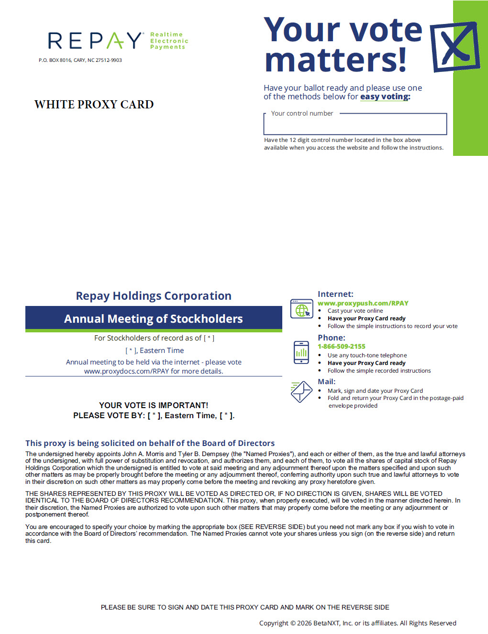

Table of Contents
PRELIMINARY PROXY CARD – SUBJECT TO COMPLETION
DATED MAY 1, 2026



